**Joint Strategic Needs Assessment: Children in the Youth Justice Service**

**Eden Keyar, Public Health Programme Manager  
Katie Cole, Associate Director of Public Health for Children and Families**

02/11/2023

Contents

Acknowledgements 2

Executive summary 4

Aim 6

Method 7

Background – Health and youth justice 7

Methods 9

Local Youth Justice Service cohort 10

Demographics 11

Wider determinants of health 15

Special Educational Needs or Disabilities (SEND) 16

Looked After Children 19

Carers 19

Adverse Childhood Experiences 21

Physical Health 26

Serious Youth Violence 29

Mental Health 31

Sexual health 37

Substance Misuse 39

Oral health 42

Health Partners workshop 43

Recommendations 44

Next steps 48

# Acknowledgements

### Report authors:

Eden Keyar, Public Health Programme Manager

Katie Cole, Associate Director of Public Health for Children and Families

Phoebe Kalungi, Public Health Programme Lead

### Thank you to the following people and organisations for their contributions to this report:

* All participants (children) of the Voices of Young People Survey, End of Intervention Self-Assessment Survey and interviews.
* Christopher Lamb, Senior Public Health Intelligence Analyst, London Brough of Tower Hamlets
* Luke Norbury, Deputy Head of Service, Youth Justice Service, London Brough of Tower Hamlets
* Bilal Awan, Youth Justice Service Manager, Youth Justice Service, London Brough of Tower Hamlets
* Akhtar Rahim – Youth Intervention and Support Manager, Breaking the Cycle, London Brough of Tower Hamlets
* Tower Hamlets Youth Justice Service - Breaking the Cycle and Youth Justice Team case workers
* Peter Bullen, Consultant Data Analyst, Youth Justice Service
* Schalk van Heerden, Youth and CCM Team Lead
* Sarah Blair, Public Health Programme Lead, London Brough of Tower Hamlets
* Simon Twite, Public Health Programme Lead, London Brough of Tower Hamlets
* Sumaira Tayyab, Public Health Programme Lead, London Brough of Tower Hamlets
* Haileybury Youth Centre
* Attendees of the Health Partners workshop

## List of abbreviations

|  |  |
| --- | --- |
| BTC | Breaking the Cycle |
| CAMHS | Child and Adolescent Mental Health Services |
| GDPR | General Data Protection Regulation |
| LAC | Looked after Children |
| NHS | National Health Service |
| TH+C | Tower Hamlets and City of London |
| YJB | Youth Justice Board |
| YJS | Youth Justice Service |

# Executive summary

This Joint Strategic Needs Assessment (JSNA) seeks to understand the health and wellbeing needs of children in the youth justice service and Breaking the Cycle team. Using rich datasets, surveys and interviews with children, it aims to assess how well their needs are identified and reported, and makes recommendations for system improvements.

The JSNA has identified high and complex needs of children in the Tower Hamlets and City youth justice service and set out the impact that these needs are having on their health and wellbeing.

Tower Hamlets has the highest child poverty rate in the UK, and this cohort has experienced significant adverse childhood experiences, which are closely associated with poverty and shown to drive offending behaviour. Despite high levels of child poverty, as a total population, children in Tower Hamlets outperform their national peers in education at KS1, 2 and 3 showing that services can mitigate the effects of poverty and support intergenerational change.

Throughout the JSNA, there is a recurrent theme that services have not identified children’s needs or provided adequate early intervention to support their development, health and wellbeing and prevent escalation of need. This manifests as over half of children not in education, employment or training; high rates of school exclusions; under-recording or under-identification of special educational needs and disabilities including speech and language needs and possibly cognitive impairment; gaps in support for young carers (who represent 40% of this cohort); under-recording or under-identification of physical and mental health conditions; high drug and alcohol use; poor access to oral health services; high levels of poor mental health (40%) and suicide risk (8%). Further work to understand the impact of bereavement and access to other health services (e.g. eye tests) would build a more complete picture of health needs. There is clear evidence that these unmet needs are risk factors for offending behaviour and are amendable to intervention.

Children clearly articulated in interviews how much they wanted to protect their health and wellbeing and generously shared ways in which services can help them, which, together with health partners’ input, form the basis of the following recommendations.

The JSNA identified similar issues with data recording in ChildView as in a similar JSNA conducted in 2018. This impairs the YJS partnership’s ability to assess and therefore develop strategic responses to children’s health needs.

There were significant inequalities identified, particularly by sex and ethnicity, in most areas of need, with over-representation of Black- and Black British children, particularly girls, in the YJS and under-identification of need for both Black or Black British and Asian or Asian British children.

## Recommendations

A series of recommendations have been made for the YJS and wider system partners. These sit within the following high-level recommendations:

* Develop and utilise **data sharing systems** across the Youth Justice Service, health professionals and other partners to ensure wellbeing needs are identified, measured, analysed and predicted.
* Utilise a whole-systems approach to improve the **accessibility** of health services and reduce inequalities
* Improve **earlier identification and intervention** to prevent offending and poor health outcomes
* Integrate a multi-faceted **sexual health education** offer in which emotional and overall wellbeing is addressed.
* Identify an opportunity for a health professional to undertake a **holistic health screening** of children in the YJS, in additional to continuing access to the current specialist health services (e.g. sexual health, mental health, substance misuse).
* Explore ways to strengthen the **physical activity** offer for children in the YJS to protect their mental and physical health and wellbeing.

# Aim

* To understand the health and wellbeing needs of children in the youth justice service and Breaking the Cycle team.
* To understand how well their needs are identified and supported
* To make recommendations for system improvements to better support the needs of this group of children.

# Method

This JSNA has arrived at is recommendations through the following activities conducted in 2022/23:

* A review of risk factors for offending behaviour, including exploring the evidence base for interventions to address adverse childhood experiences (ACEs)
* A data analysis of ChildView records of 813 children in the YJS over the preceding five years
* A survey of health needs amongst the children in the YJS
* Interviews with children in the YJS
* A partnership workshop with youth justice and health partners to explore preliminary JSNA findings and develop recommendations.

# Background – Health and youth justice

## The Youth Justice System

Nationally, the Youth Justice System is overseen by the Youth Justice Board. Within each local authority, a youth justice service offers support to children via two streams. The local service serves both children in Tower Hamlets and the City of London.

Children aged 10-17 years placed in the Youth Justice Service are those who have attended court and received a statutory court order. The Youth Justice Service seeks to support the needs of children before, during and following their involvement with the court to prevent factors that lead to criminal behaviour. The YJS is a multi-agency team provided to meet the obligations stipulated in the Crime and Disorder Act (1998). Children identified as at risk of offending due to the various vulnerabilities they are experiencing, but who have not offended, can use the Breaking the Cycle service within the Supporting Families division. This team’s core focus is to prevent offending through offering services and support that address factors leading to offending. Both teams provide holistic and preventative support for children and often involve parents, teaching staff and local youth centre staff to deliver a well-rounded approach.

## Health, wellbeing and offending behaviour

The likelihood of engaging in offending behaviour can be influenced by a range of determinants. Almost all these determinants and their preventative elements do not lie within the scope of the youth justice service influence. It is important that a collaborative, whole systems approach is taken. It is known that overall, children and young people who offend experience a range of poorer health outcomes than their counterparts who have not offended[1]. Examples include poor mental health status which for some may lead to suicidal thoughts or self-harming behaviour, substance misuse difficulties and reduced physical health outcomes. Wider determinants influencing and impacted by offending behaviour can include low educational attainment, unemployment or gang related concerns. Preventing children from offending and re-offending is considered to be a key component to improving the wellbeing and health of children, their families and the communities in which they interact with. Addressing these issues and other factors contributing to offending behaviour can be complex and involves a range of professionals, partners, services and a whole systems approach.

## **Wider determinants** of health and wellbeing 


The wider determinants of health refer to a range of socio-economic and environmental factors which impact people’s health and wellbeing[2]. Many determinants of offending behaviour are also the same determinants which predict a person’s health and wellbeing. Determinants of health can interact and cluster to worsen or improve the wellbeing of an individual. Children who partake in offending behaviour are more likely to present with complex health and wellbeing needs as a result of their living or working conditions, housing situation, level of education and financial standing. Other aspects such as race, gender and household dynamics also influence offending and reoffending behaviour.

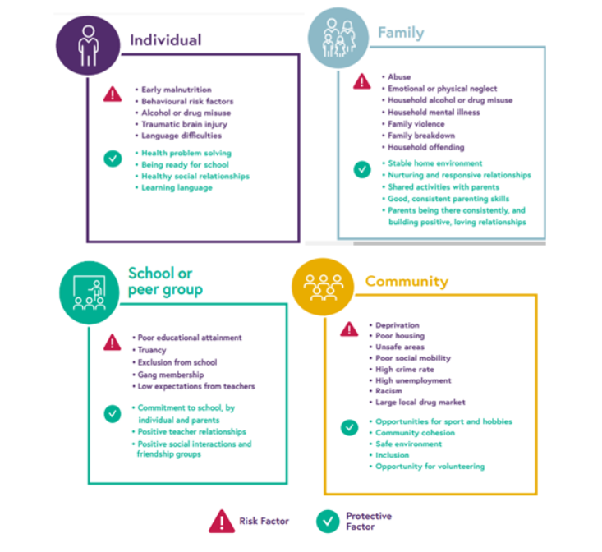

**Summary of risk and protective factors for offending behaviour.** (Credit to Westminster Council public health team for this graphic)

# Methods

Information has been collated and analysed to understand the health needs of children in contact with the youth justice system and to devise recommendations to improve the health needs of this cohort.

Health needs were divided into key areas in which children linked to the criminal justice system commonly experience poorer outcomes in. These areas are mental health, sexual health, physical health and substance misuse. Meaningful results around oral health and the impacts of being a young carer were included.

Tower Hamlets Council aims to utilise co-production and meaningful engagement with children and communities. In order to understand the health needs of children in the local youth justice system a survey and focus interviews were held.

Interviews and surveys aimed to highlight commissioned and non-commissioned service use in relation to these areas. In total 10 interviews were completed with children from the Breaking the Cycle and Youth Justice Services. 21 questionnaires were completed by children in the local Youth Justice Service. Information collected helped to clarify gaps in data on ChildView.

Quantitative data sources include the National Youth Justice Board (England and Wales) reports and an analysis of ChildView records (YJS record system) for all children in the YJS over a 5 year period (2018-22).

Findings from a separate data analysis of 60 children in the YJS in November 2022 has also been included for additional depth.

# Local Youth Justice Service cohort

This section of the report will bring together key information about the children involved with the local Youth Justice Service. The profile includes a review of key demographic indicators that can impact offending and reoffending behaviour.

### The number of children in the YJS has steadily fallen locally and nationally over the past 10 years

Figure 1: Numbers of children in the youth justice service by year, 2018-22

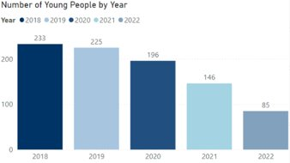

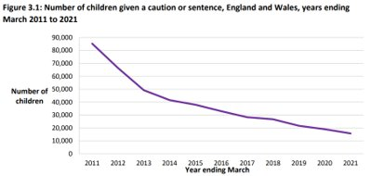

Figure 2: Number of children in the YJS given a caution or sentence, England and Wales per year (2011-21)

13,800 children received a caution or sentence in England and Wales (2022). This figure has declined by 13% in the last year and 79% over the last decade. Similarly, Tower Hamlets has seen a downward trend in the number of children cautioned or sentenced. Between 2018-19, 225 children were cautioned or sentence with this figure declining to 85 by 2021-22. Across England, the reoffending rate decreased by three percentage points in the last year and is the lowest on record. This is likely to have been impacted by the COVID-19 pandemic.

# Demographics

## Age

Figure 4: Number of children by age at intervention start date (City and LBTH, 2011-21)

Figure 4: Number of children by age at intervention start date (City and LBTH, 2011-21).


Of the children in the Tower Hamlets Youth Justice Service at the start of the intervention.

* 90% (705) of the group were aged 15-18
* 10% (108) were aged 11-14

In comparison, across England or Wales children were slightly younger: at the start of their intervention 82% of children were aged 15-17 and 18% were aged 10-14.

## Gender

In Tower Hamlets in 2022, **85 children** were involved in the Youth Justice Service.

* 93% were recorded as male
* 7% were recorded as female

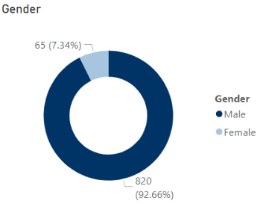

Comparatively, across England and Wales girls make up 13% of children who receive a sentence or caution, and boys make up 87%.

The data system did not have a facility to record other genders or preferred pronouns.

Recommendation: Explore opportunities to improve gender inclusive practices in the YJS.

## Ethnicity

Most children in the YJS were of Bangladeshi or British Bangladeshi ethnicity.

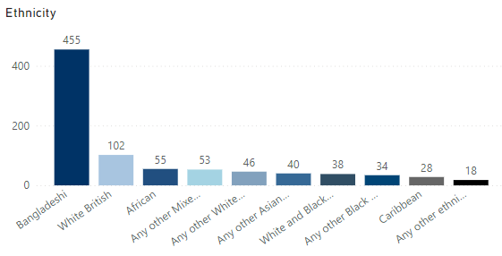

Black or Black British children and children of mixed ethnicity were significantly over-represented. Similar findings can be found across England or Wales.

The table below shows that Bangladeshi or British Bangladeshi children are slightly over-represented in the local YJS cohort. In England and Wales, those from Asian backgrounds are under-represented in the YJS cohort. In Tower Hamlets, the reverse is true.

White British children are under-represented in the local YJS cohort.

There were noticeable differences in gender by ethnicity. Girls of Black/Black British or mixed ethnicity were significantly over-represented compared to boys of the same ethnicity (approximately two-fold); and girls of White and Asian/Asian British ethnicity were significantly under-represented compared to boys of the same ethnicity.

National data and trends demonstrate that children from ethnic minority groups are more likely to be involved in the youth justice system than their white counterparts. Across England, in almost all cases children from Black, Asian and Mixed ethnic groups were more likely to receive harsher sentences than those of White ethnicity. Black children were between 2 and 10 percentage points less likely to receive a first tier outcome and 2 and 8 percentage point more likely to receive a custodial sentence instead of a Youth Rehabilitation Order than White children. Black and Mixed children overall received more restrictive remand outcomes. The extent of disproportionality relating to Black and ethnic minority groups in the youth justice system cannot be fully explained by the available data, but its occurrence is clearly observed.

Disproportionality in the youth justice system has been explored in other work both at a national level (e.g. [Lammy Review](https://www.gov.uk/government/publications/lammy-review-final-report)) and local level through a series of ‘Disproportionality’ Youth Justice system ‘spotlight’ sessions.

**Recommendation**: Further work to understand why Black/Black British and Mixed ethnicity girls are over-represented compared to boys of the same ethnicity and compared to girls overall.

**Recommendation**: Further work to understand the impact of the disproportionality through the YJS on children’s health and wellbeing.

Table 1.

|  |  |  |  |  |
| --- | --- | --- | --- | --- |
|  | Male | Female | YJS cohort (male and female) | All Tower Hamlets children aged 15-18 Years |
| Asian / Asian British | 59% | 23% | 57% | 56% |
| White | 30% | 16% | 17% | 25% |
| Black or Black British | 12% | 23% | 13% | 9% |
| Mixed ethnicity | 10% | 20% | 11% | 7% |
| All ethnicities | 100% | 100% | 100% | 100% |

# Wider determinants of health

## Deprivation and poverty

“People living in poorer areas are less likely to access services and less likely to show clinical improvement compared to those in more economically advantaged areas.”

Poverty impacts health and wellbeing by restricting access to services, clean air, nutritious food, training and housing. Childhood poverty can predict many adverse outcomes across the life-course. These include poor employment prospects, reduced mental and physical health, behavioural problems and increased exposure to violence. Children who have grown up in low-income homes or deprived areas have been found to be more likely to commit a violent crime and also engage in self-harming behaviours. The longer a child sits within a low socioeconomic environment, the likelihood that they will offend increases. Despite experiencing poorer wellbeing outcomes, those living in deprived areas are less likely to access health services. This in turn exacerbates the severity and proportion of adverse implications. Addressing causes of offending behaviour such as poverty may potentially alleviate the burden associated factors have on children.

### What does the data tell us about poverty and crime?

London’s poverty profile highlights that 8 in 10 crimes committed during 2021-22 occurred in the most the city’s most income deprived areas. Drug and weapon offenses were 2.3 times higher in the cities most income deprived wards.

Tower Hamlets has the highest rate of child poverty in the UK[3].

## Education

Research suggests that participation in education and training is a key way to decrease childhood offending. Studies tell us that children who receive a quality education are more likely to enjoy higher self-esteem, strong employment prospects, sound problem-solving skills and are less likely to engage in criminal activity. It is well noted that children with unmet Special Educational Needs or a Disability are vulnerable to experiencing exclusion from school or may find coursework difficult to navigate.

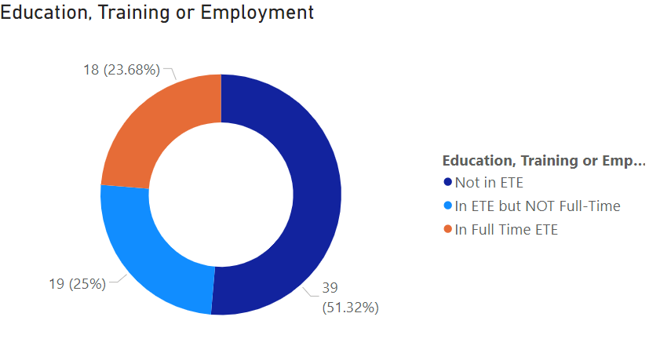

Number of children in local YJS in Education, Training or Employment

Figure 3 Education, training or employment figures for children in Tower Hamlets YJS 2020-21.

In Tower Hamlets, around half (51%) of children involved in the Youth Justice Service were not in education, training or employment during their intervention. One quarter were in education, training or employment on a part-time basis. Children who are either temporarily or permanently excluded from school are more likely to engage crime. This is true for **9 in 10 children** in the local youth offending cohort.

# Special Educational Needs or Disabilities (SEND)

15% of children in the Tower Hamlets youth offending cohort had identified Special Educational Needs or Disabilities (SEND). This compares with 12.6% of the general school population in England during the 2021-22 academic year. Nationally, 46% of children sentenced to a Youth Rehabilitation Order were recorded as having a special educational need or disability (2014). This may suggest an under-recording or under-identification of SEND needs in this cohort.

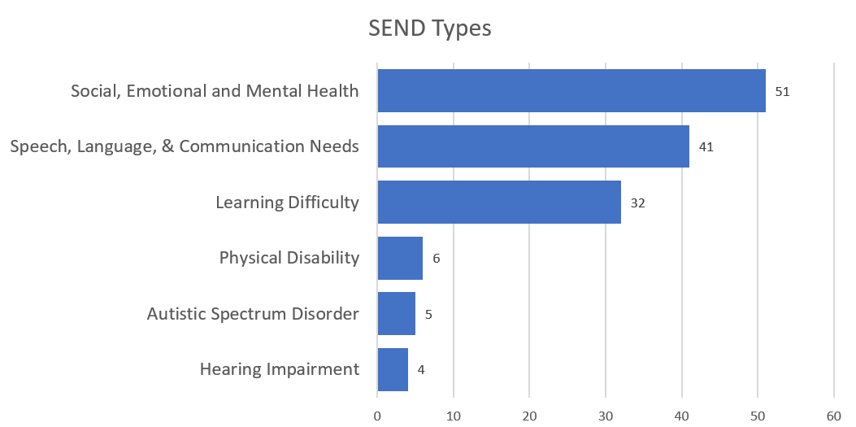

There was considerable variation in identified SEND by Ethnicity in the group. Asian or Asian British had the lowest rate (9.8%, CIs = 8.8 - 11.4%).

Black or Black British (13.7%, CIs = 11.7 - 18.0%), Mixed (25.8%, CIs = 22.3 - 31.2%) and White (27.81%, CIs = 24.8 - 32.0%) were all more likely to be identified as having SEND than the Asian or Asian British group. These results are statistically significant at a 95% confidence level.

The rates by ethnicity are quite similar to rates in England. Asian or Asian British had the lowest rates while Whites and Mixed ethnicities had the two highest rates.(1)

There were no significant differences in SEND identified by gender or year of intervention.

Other metrics on ChildView may suggest underlying SEND needs. In the November 2022 cohort:

* Social communication skills were a cause for concern in 13 cases (22%)
* 2 cases (3%) had diagnosed social difficulties
* 12 cases (20%) reported difficulties maintaining friends
* 11 cases (18%) were assessed as sometimes having difficulty showing emotions
* 10 cases (16%) were assessed as being or sometimes being socially awkward
* 23 cases (38%) were assessed as having significant problems relating to others
* 10 cases (16%) were assessed as having significant over-activity problems

## Speech & Language

Further data from the November 2022 cohort analysis found:

* 13 cases (22%) had or sometimes had reading or writing difficulties

Basic literacy skills are shown in the following table

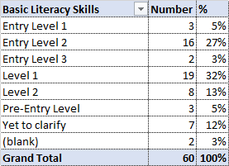

Basic numeracy skills are shown in the following table

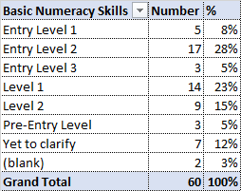

* 11 cases (19%) only used or sometimes used simple vocabulary
* 12 cases (20%) often or sometimes had a problem remembering things
* 14 cases (23%) often or sometimes had a problem explaining their feelings
* 14 cases (23%) often or sometimes had a problem explaining things
* 13 cases (22%) often or sometimes had difficulty with the meaning of words
* 14 cases (23%) often or sometimes had a problem with spoken instructions
* 11 cases (19%) often or sometimes had difficulty thinking of words
* 4 cases (7%) often or sometimes had difficulty understanding speech
* 9 cases (15%) often or sometimes had difficulty using non-verbal communication
* 4 cases (7%) often or sometimes had difficulty understanding time concepts

There is evidence that there are fluctuating interpretations and practices across professional, schools and local authorities. This can contribute to challenges associated with obtaining a formally recorded special educational need or disability. Amongst the local youth offending cohort, the most common type of primary need are social, emotional and mental health needs. Comparatively, across all SEND pupils in England, speech, language and communication needs are most prevalent.

This might suggest missed opportunities to identify SLC needs which are a risk factor for offending behaviour, and/or an increased burden of social, emotional and mental health needs, which may reflect a higher burden of adverse childhood experiences in this cohort.

### Recommendations

Explore findings on SEND data with health partners to develop further recommendations on low recorded prevalence and a different SEND need profile in this cohort compared to all children in the borough.

Understand drivers for the inequalities seen in SEND identification by ethnicity. Develop a plan to increase identification in Asian/Asian British children.

# Looked After Children

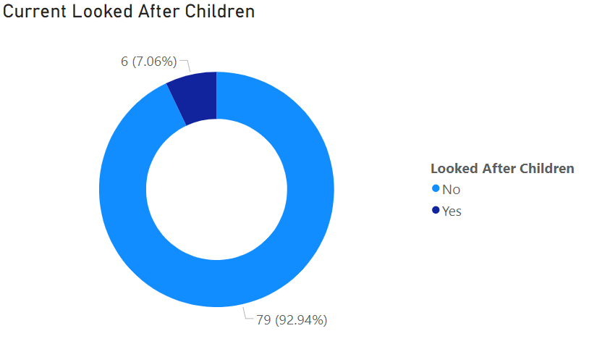

Number of Looked After Children

7% of the children in the local youth justice service were recorded as being looked after. To provide the most effective care to Looked After children, a whole systems approach is needed. Looked After child who have offended or are thought to be at risk offending are required to have a Care Plan and Placement Plan. The purpose of this plan is to outline support measures individual children may need to reduce offending behaviour. It is the responsibility of the Independent Reviewing Officer and YJS case managers to ensure these plans are maintained.

# Carers

40% of participants stated they had caring responsibilities for someone in their family due to problems around mental health, physical health or drug related issues.

Nationally, children do not disclose their caring responsibilities or do not have the appropriate tools to recognise they are a career. As a result, professionals are not able to provide adequate support. Duties of care vary but usually involve helping with personal tasks such as changing, bathing or practical tasks such as cooking or shopping. Carers can also provide emotional support for the person they are looking after or other members of the household.

Caring responsibilities typically stem from a household member experiencing a mental health, physical health or substance misuse concern. Many young carers feel overwhelmed due to competing school, extracurricular and caring duties. As a result, 38% of young carers experience poor mental health outcomes and often behavioural issues.

During focus interviews children who were engaged in the young carers group stated a need for more support to engage in social activities, preferably with other children in similar circumstances. This stemmed from a desire to widen their social environment and break away from their usually repetitive daily routines. Children highlighted the difficulties associated with having parents or guardians not involved in the case management process. Engaging parents and families into the changes children are making as they occur will allow children to share accountability towards their development.

“I’d like the opportunity to have more days out exploring and socialising with other young carers”.

“While being in YJS I have learnt a lot of tools to help me improve my life, but not many people around me have so its only up to me to make those changes.”

### What is currently provided to caring address the needs of the children in local youth offending cohort?

|  |  |  |  |
| --- | --- | --- | --- |
| Service | Provision | Provider | Commissioner |
| The Young Carers Project | 2 days a week | Haileybury Youth Centre | LBTH |

**Recommendations**

* Professionals within the youth justice service should be provided with training to identify signs indicating a child is a young carer. This will assist to ensure all care plans across are modified to accommodate for their complex needs.
* Co-produce ‘day out’ programmes with children to engage them in planning and ensure social activities are meeting their needs.

# Adverse Childhood Experiences

Adverse Childhood Experiences (ACEs) are “traditionally understood as a set of 10 traumatic events or circumstances occurring before the age of 18 that have been shown through research to increase the risk of adult mental health problems and debilitating diseases.” ([Early Intervention Foundation](https://www.eif.org.uk/report/adverse-childhood-experiences-what-we-know-what-we-dont-know-and-what-should-happen-next), 2020)

Examples of Adverse Childhood Experiences
Physical Abuse
Sexual Abuse
Psychological abuse
Physical neglect 
Psychological neglect 
Licing with someone who abused drugs or alcohol 
Witnessing domestic violence 
Living with somoene who has gone to prison
Living with someone with mental health problems
Losing a parent through divorce, death or abandonment 

### What are the impacts of ACE's?

Adverse childhood experiences can act as barrier to optimal wellbeing. Experiencing one or more adverse childhood experience can result in a range of poorer health outcomes. Such outcomes include poorer mental health outcomes with increased likelihood of experiencing depression, post-traumatic stress disorder and social isolation. Physical health outcomes that may be impacted by ACE’s include a heightened risk of developing cancer, heart disease or self-harming behaviour. Children who experience ACE’s may struggle to manage, recognise and control emotions and behaviours in difficult situations.

### What is needed to address ACEs?

The first ACE study[4] concluded with recommendations for adopting a comprehensive public health strategy involving evidence-based interventions that would be offered at the universal, selected and targeted level. A review of the ACEs approach by the Early Intervention Foundation[5] makes the same conclusion. It assesses 33 interventions with robust evidence for preventing at least one of the 10 original ACE categories, reducing health-harming behaviours associated with ACEs and specifically reducing ACE-related trauma.

Many of the 33 interventions reviewed, which EIF recognise is not exhaustive, are not applicable to the YJS (e.g. perinatal mental health screening and schools-based programmes). The following tables show selected interventions that may be implemented by services within the wider YJ system (e.g. mental health services and Supporting Families) for the YJS age cohort (age 12-18 years).

Table: EIF review of interventions for Adverse Childhood Experiences – selected for YJS cohort.

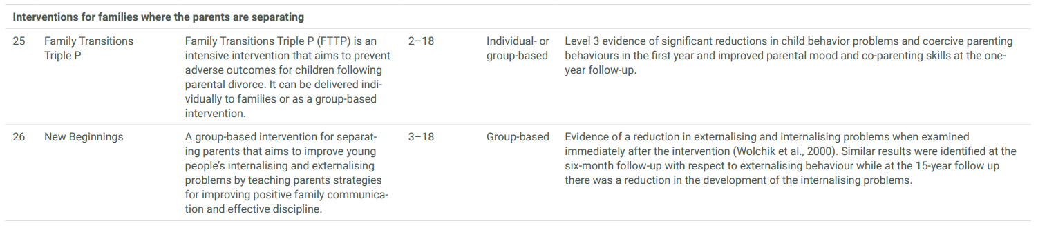

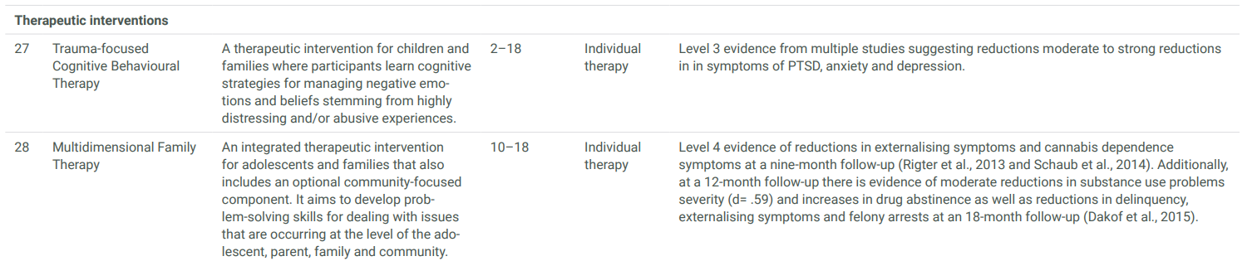

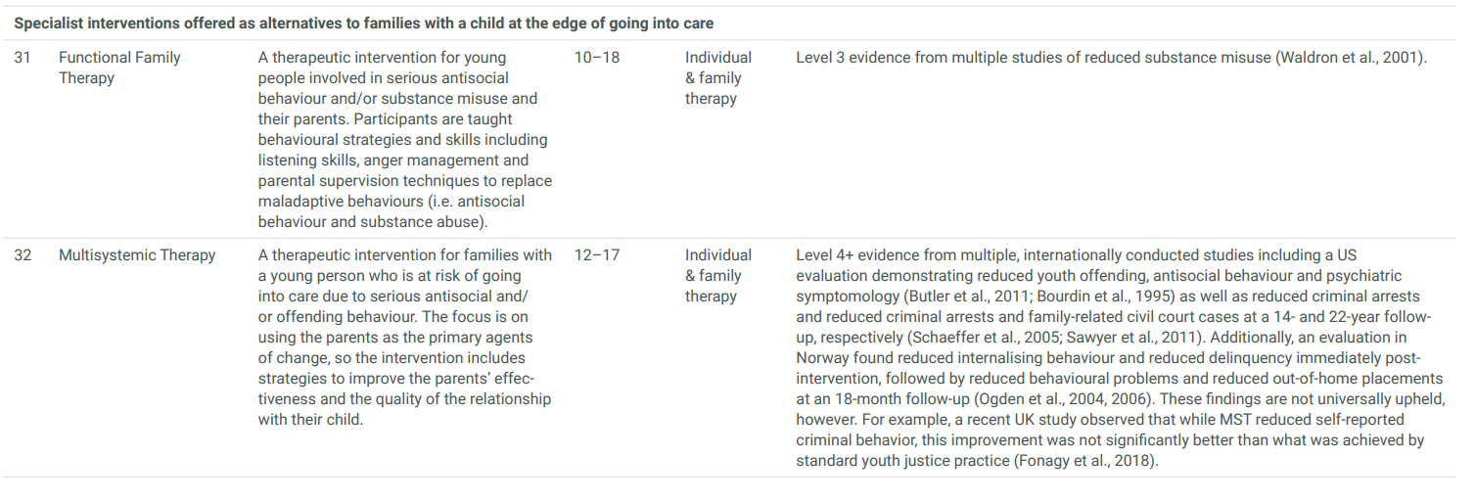

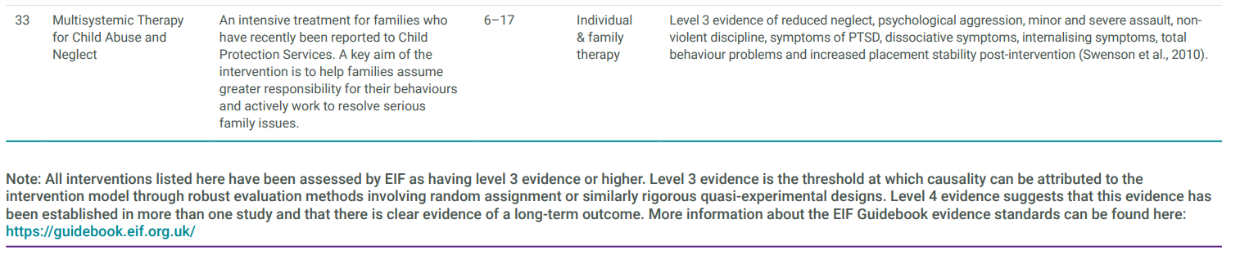

### What is the prevalence of ACEs in the YJS cohort?

At a national level, there is no single precise prevalence statistic both because of underreporting of child maltreatment and because some children will experience multiple ACEs and others just one but over a longer period of time. We do know that about 80% of children in need had experienced at least one ACE. 10% of adults have reported some from of abuse during childhood.

EIF have raised concerns about the ethics of some ACE screening practices including routine enquiry. These concerns includes a lack of evaluations of the effectiveness of screening, a concern about inadvertently retraumatising children or causing other harm, and an ethical concern in the absence of referral to effective treatment options. It encourages a recognition that screening tools are unlikely to be a substitute for empathetic conversations by skilled and supervised practitioners.

The needs assessment has therefore not sought to assess ACEs through surveying children in the YJS. An approximation of high levels of ACEs

The approach taken for this needs assessment was to assess caring responsibilities as a proxy for exposure to mental health and alcohol and drug use; and to use Child Looked After status as a proxy for higher-level forms of abuse, neglect and parental loss (not withstanding limitations to this approach, e.g. underestimation and other reasons for being looked after).

An analysis of the YJS caseload (60 children) in November 2022 found:

* Concerns around the young person’s safety and wellbeing were identified in 52 cases (87%)
* Family concerns about the young person’s safety and wellbeing were identified in 28 cases (47%)
* Previous safeguarding incidents were reported in 9 cases (15%)
* 31 cases (52%) were identified as vulnerable to criminal exploitation
* 4 cases (7%) were identified as at risk of sexual exploitation
* 7 cases (12%) were identified as at risk of self-harm
* 12 cases (20%) were identified as victims of violence or abuse
* 16 cases (27%) had witnessed violence or abuse

### Recommendations

Given a range of indicators that highlight that a significant proportion of the YJS caseload has or is being exposed to adverse childhood experiences; a review of the current intervention offer with respect to the EIF review of ACE interventions is recommended.

# Physical Health

Figure 4 Children in local YJS with symptom(s) of poor physical health

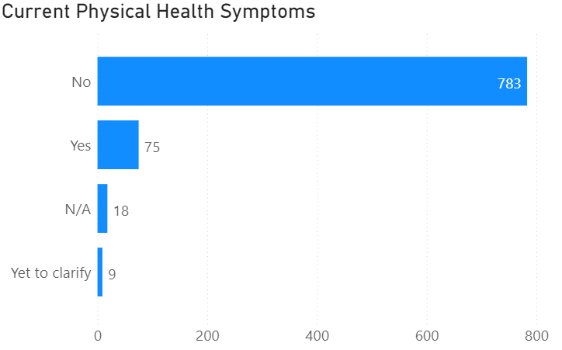

Figure 5 Children in local YJS with a physical health condition diagnosis

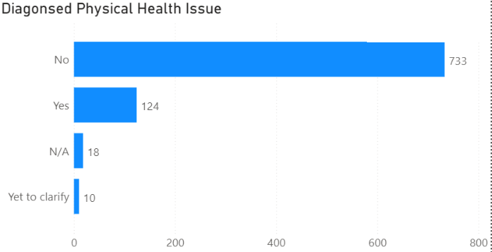

In Tower Hamlets, 8.5% of children in the youth offending cohort had recorded symptoms of poor physical health at the end of their intervention. Just under 15% of children had a physical health condition diagnosis. Of those diagnosed, around 23% experienced symptoms. Comparatively, in Westminster 20% of the youth offending cohort had received a diagnosis for a medical condition. Nationally, this figure sits at 14% for the same cohort.

Studies have established that poor physical health can directly have a significant impact on a child’s mental health and overall wellbeing. As a result, these risk factors can accumulate and interact to exacerbate vulnerabilities impacting offending. Children involved with the criminal justice system typically engage in high rates of risky behaviour and as a result, high rates of admission into hospital emergency hospital services. Research undertaken by the Youth Justice Board has highlighted that physical activity can act as a protective factor against offending behaviour. Engaging in sport of any form increases self-esteem, discipline and provides children with an acceptable with an acceptable outlet for energy and frustration. Crime reduction organisation NACRO has established that 78% of children who partake in illegal activity attribute much of their behaviour to boredom. The Youth Justice Service provides children with the opportunity to engage in physical activity through referrals to structured activities, linking children with local youth service sports groups and specific programmes.

### Physical health needs

9 in 10 children **who participated in the survey** state**d** that being physically active is important to them**.**

20% of **participants** are not satisfied with their current physical health**.**

Almost 70% of children expressed a need for **increased** support accessing physical activity services (gym, sports teams, swimming centres)

### How have children in this cohort identified their health needs?

Overall, there was high awareness amongst this cohort around how to access services that helped them be physically active. Children identified the state of their physical health as a priority, however low proportions engaged in physical activity more than once a week. The sport children most wanted more help to gain involvement in was swimming. Children expressed interest in attending swim programmes and for most, this service was deemed worth paying a fee. There were no strong themes around the type of swim support participants would like to receive (lessons or free play), so long as spaces remained safe and easy to get to. Other notable areas children demonstrated an interest in engaging in, if support was provided, include gyms and sports teams. The high cost of gym memberships and low confidence around how to use equipment were the most commonly identified barriers to physical activity. For boys, joining a basketball or soccer team on a formal or non-formal basis was noted to be a priority due to the self-assessed mental health benefits. Many felt they struggled finding the right team or location due to concerns around safety. Many of those who were already engaged in a local sport offer identified the days they participated as their weekly highlights. Overall, more boys than girls engaged in physical activity. Girls who declined a need for support in this area stated they did so partially due to lack of confidence.

“I go to the gym because you can’t put a price on mental health”.

“For most of us, unless the gym is your passion the money for a membership could be better spent on necessities.”

### What is currently provided to address the physical health needs of the children in local youth offending cohort?

|  |  |  |  |
| --- | --- | --- | --- |
| Service | Provision | Provider | Commissioner |
| Haileybury Youth Centre | Multiple programmes offered throughout the week | Haileybury Youth Centre | LBTH |
| Osmani Trust | Multiple programmes offered throughout the week | Osmani Trust Group |  |

YJS staff work from these centres and are able to link children directly with these programmes. The universal physical activity offer for children in the borough, (youth services, schools, leisure centres, private gyms etc.) is not covered here.

### Recommendations

* Work with children to co-produce a support offer to further understand barriers to access and to build skills and confidence to access leisure and physical activity services in the borough, particularly for girls.
* Promote swimming and other physical activity opportunities to all children in the YJS.
* Consider opportunities for discounted swimming activities in the borough
* Ensure sports activities are well spread across the borough and are safe for children to access.

# Serious Youth Violence

Serious Youth Violence refers to violence committed against or by a child. Youth violence places huge cost to health systems, social care, the wider community and the criminal justice system. Serious youth violence is a complicated and multifaceted symptom of broader issues. Involvement and exposure to violence at a young age can result in a variety of damaging impacts to a child’s mental, physical health and overall wellbeing.

### What is the public health approach to SYV?

Reasons for youth violence are complicated and risk of committing these types of crime are associated with ACE’s, access to wellbeing support and deprivation. The public health approach proposes that there are an array of factors relating to the individual, their relationships, community and society which increase a child’s risk to committing a violent crime[6]. These are:

Societal

* Gender inequalities
* Cultural norms supporting violence
* Marginalisation

Community

* Deprivation or high unemployment
* High crime rates / illicit drug trade
* High residential mobility

Relationships

* Domestic abuse
* High risk peer groups
* Exploitation / coercion concerns

Individual

* Experience of abuse or neglect
* Household criminality
* Household mental illness or substance misuse
* Family breakdown

### How have children in this cohort experienced serious youth violence?

* England is the only country in the United Kingdom where rates of youth violence are **increasing** across all age groups.
* Tower Hamlets recorded the **highest volume of serious violence affecting young people** (49), across all London boroughs in 2022.
* Tower Hamlets recorded the **largest** upwardmove in the number of knife crimes (+11 places) in 2021 and highest increase in victims of wounding via **knife crime.**
* The highest rates of serious youth violence are **most** prevalent in the **most deprived wards.** This is consistent across all boroughs.
* In a separate analysis of 60 children in the YJS in November 2022, 12 cases (20%) were identified as victims of violence or abuse and 16 cases (27%) had witnessed violence or abuse.

Further discussion on serious youth violence was included in the health partners workshop and incorporated into the final recommendations.

# Mental Health

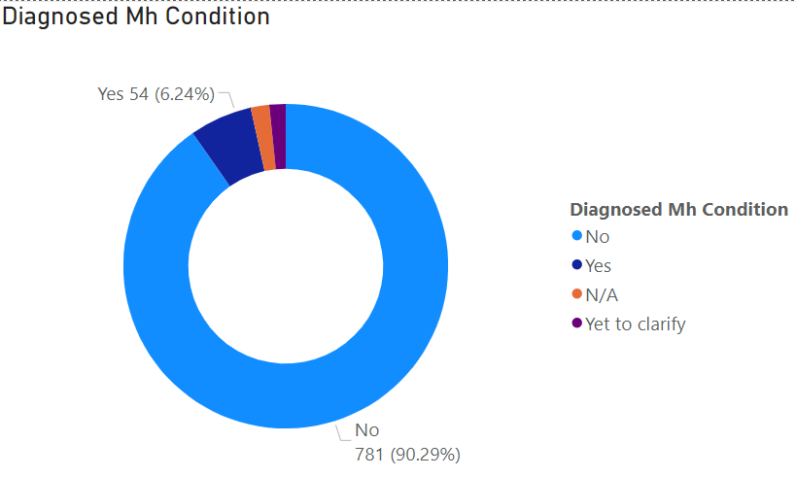

Figure 6 Prevalence of diagnosed mental health conditions in amongst children in the local youth offending cohort.

In the Tower Hamlets youth offending cohort, 54 (6%) of children have been diagnosed with a mental health condition. 14% of children involved in the Westminster youth offending cohort have a formally diagnosed mental health condition. Comparatively, NHS digital reported that 14% of 11-16 year olds and 17% of 17-19 year olds have a mental health disorder (2014).

Amongst children in the YJS in November 2022:

* 23 cases (38%) presented a risk or concern regarding mental health
* 6 cases (10%) had a diagnosed mental health condition
* 25 cases (42%) had had contact with mental health services
* 22 cases (37%) reported feeling sad, anxious or stressed
* 7 cases (12%) had a history of deliberate self-harm
* 5 cases (8%) were assessed as at risk of suicide
* 3 cases (5%) had previously attempted suicide

### How do ethnicity vs mental health conditions compare?

There is some variation in the rates of diagnoses by ethnicity when comparing the children in the Tower Hamlets YJS to the figures produced by NHS digital. Asian or Asian British children in the Tower Hamlets Youth Justice Service are less likely to be diagnosed with a mental health condition than other ethnicities. Similarly, NHS digital’s rate for any Asian or Asian British aged 5-19 with a mental health disorder was 5.2% which is the lowest of any ethnic category. The differences in diagnosed mental health conditions between these groups are statistically significant at a 95% confidence level. ​No statistically significant differences were observed for gender.

As well as diagnosis levels, YJS staff also record rate of risk or concern for mental health as shown below.

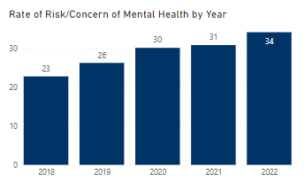

Significant differences exist between the group as a whole and for the Chinese or other ethnic group (40%, CIs = 31.5 - 51.7%). The team were also more likely to record a risk/concern about mental health for children of white ethnicity too (33.8%, CIs = 30.4 – 38.0%), reflecting similar inequalities seen in diagnosed mental health conditions.

There were no significant differences for gender observed.

### Self-harm

Self-harm risk is also assessed by YJS staff.

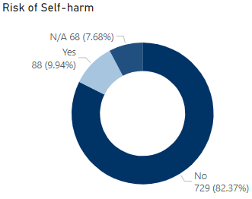

87 people (10.1%) were assessed as being at risk of self-harm. The confidence intervals for the whole group were 9.2% LCI and 11.3% UCI.

Again, there was considerable differences by ethnicity. Asian or Asian British people were statistically below this level (7.6%, CI = 6.7-9.1%). Mixed ethnicities (11.8%, CI = 10 - 16.7%), White ethnicities (13.3%, CI 11.4 - 16.9%) and Black or Black British (15.4%, CI = 13.2 - 19.8%) were all above the group rate.

There were also marked differences by gender. Female rates were at 20% (CI = 16.8-26.6%) – significantly higher than the group as a whole (10%).

Of the group, 60 (6.8%) had a history of self-harm.

In the years 2018 to 2021 the rate of risk of self-harm was consistently above the rate of history of self-harm but in 2022, the rates of both measures were the same.

There are large differences between risk of self-harm rates and history of self-harm rates by ethnicity.

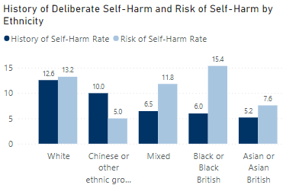

### What does this mean?

The % of children in Tower Hamlets youth offending cohort with a diagnosed mental health condition is less than half of that in Westminster’s YJS and national figures. This suggests either a lower prevalence of mental health conditions (which is unlikely given the increased risk factors for poor mental health in Tower Hamlets e.g. child poverty), under-diagnosis or under-recording by YJS staff on ChildView. It may be that staff use free-text to record mental health issues.

Lower levels of diagnosis in the Asian or Asian British population may also contribute to lower overall diagnosis prevalence in the YJS cohort, given the high proportion of children of Bangladeshi or British-Bangladeshi ethnicity in the YJS – but this does not mean that mental health need is therefore lower.

Comparing the past and current risk of self-harm raises questions about whether the mental health of children with mixed or Black/Black British ethnicities has acutely deteriorated, compared to children from White ethnicities who may have had long-standing mental health concerns.

### How have children in this cohort identified their health needs?

**1 in 4** children involved in the local youth justice service survey recorded that they would like more support to **access** mental health services.

**Face-to-face** was the **preferred** way to access a mental health service (50%), followed by online or over the phone (35%) then hybrid of both services (15%).

Over 40% of children felt they did not have **good understanding** of the mental health supports available and how to begin using them.

Studies indicate that the proportion of adolescents experiencing a mental health condition is much higher than those receiving treatment. The results of the focus groups survey reflect this. The proportion of children who reported receiving a diagnosis with a mental health condition (25%) was considerably higher than the proportion of those accessing a mental health service (14%).

Negative stigmas are often known to be associated with many mental health conditions. Participants frequently highlighted that these stigmas are present within adolescent peer groups and may contribute to their reluctancy to seek professional mental health help. A considerable proportion of participants expressed interest in receiving ‘emotional or wellbeing support’ in favour of support labelled ‘mental health’. This may assist in enticing more children to engage with these services with less concerns.

A quarter of participants did not feel confident in their understanding of the types of mental health services and how to access them. Low awareness of mental health services is a factor to reduced accessibility. Most felt as though mental health services were difficult to gain a referral to and were unsure how to access these services at a reduced cost. Research firmly indicates that those living in income deprived areas, such as Tower Hamlets use mental health services at lower rates than their wealthier counterparts.

Children who had already received mental health support highlighted a need for these to occur more frequently, particularly during sensitive periods (family breakdown, court dates). Those in the 16-17 year old group who had already accessed mental health supports commonly highlighted a need for counselling to be provided earlier in their youth justice journey. Those who agreed acknowledged that during early high school they had felt a need for some form of wellbeing support but did not receive it. When prompted to discuss their reasoning for this, most stated they felt “embarrassed” to seek help or felt “unsure” about how to.

Children stated mental health support in which they were encouraged to pray or perform other acts of worships had positive impacts on their wellbeing. Only one third of participants had received mental health support that aligned treatment with cultural or religious values.

“Sometimes you have so many thoughts and you just need someone you can trust to talk to during those times.”

“It’s hard to get mental health support if you don’t know you need it the first place”.

### What is currently provided to address the mental health needs of the children in local youth offending cohort?

|  |  |  |  |
| --- | --- | --- | --- |
| Service | Provision | Provider | Commissioner |
| CAMHS | 2 days a week | East London NHS Foundation Trust | Children’s Integrated Commissioning Team |
| Kooth (online counselling for young people) |  | XenZone | Children’s Integrated Commissioning Team |
| Low-moderate mental and emotional health support | [In development] | Barnados | Children’s Integrated Commissioning Team |

### Recommendations

* Improve screening and recording of mental health issues of children in the YJS.
* Reframe ‘mental health’ as ‘emotional or wellbeing support’ when speaking with children.
* Mental health support should be offered through phone and hybrid systems, as well as face-to-face to support accessibility.
* Mental wellbeing should be a shared check for all professionals that a child has contact with, operating under a holistic and public health approach.
* Ensuring all mental health staff are provided with culturally appropriate training.
* Ensure children’s spirituality and faith-based practices are incorporated into mental health conversations.
* Further explore drivers for inequalities seen in mental health issues between children of different ethnicities and develop evidence-based recommendations for system-wide changes.

# Sexual health

* 15% of participants have never used any form of sexual health service e.g., free condom programs, STI testing.
* **Over half** of children who completed the survey felt they did **not** have a good understanding of the available sexual health services or how to begin using them.
* **More than** half the participants preferred to attend general sexual health services (as opposed to young people centred services).

### How have children in this cohort described their sexual health needs?

53% of children who participated in the survey recorded that they did not have a good understanding of the sexual health offers available or how to navigate sexual health services once they started using them. Children felt that existing sexual health services were not promoted readily within spaces children attend such as schools or youth centres or allied health services.

For children who felt confident in their ability to use sexual health services, increased support in healthy relationships and emotional support was highlighted as key priorities. Around half the participants recorded that they preferred to use sexual health services designed for all ages in favour of targeted clinics. Reasons for preference varied but those in favour of mainstream services stated confidentiality hesitations around being seen by peers influenced their decision. The notion that mainstream sexual health services delivered ‘grown up’ care and wanting to receive this was present for some. For those leaning towards targeted youth clinics, receiving treatment and advice tailored to their age group was the main reason for preference. Interview results indicated similar results.

Children highlighted a need for increased wellbeing support to address the emotional challenges associated with sexual relationships to be incorporated into sexual health education modules. Interest for increased sexual education across different developmental stages was high. A key reason for this was due to the change in attitudes and expectations that occur with sexual and intimate relationships as adolescents age. Having a health professional of the same gender was noted as a priority and overall, participants felt the service offered a diverse range of staff. When asked about access preferences, the most popular way to receive sexual health support was in person, followed by over the phone. Seeking sexual health support in confidentiality, away from household members was noted as a priority for this cohort.

“There’s a lot I don’t know about using a sexual health service. Which services are free, and which do I need to pay for?”

“I don’t know what healthy relationships look like so I would like to learn more.”

### What is currently provided to address the sexual health needs of the children in local youth offending cohort?

|  |  |  |  |
| --- | --- | --- | --- |
| Service | Provision | Provider | Commissioner |
| Safe East | 2 days a week | Compass | LBTH Public Health / Youth Justice service (YJS Grant) |

### Recommendations

* Offer sexual health service referrals to Safe East for children in the YJS for education and advice around safe sex, healthy relationships, consent, emotional support.
* Studies indicate that advertising, particularly through social media and online promotion can increase the rate at which young people engage with sexual health services[7]. Children in the youth offending cohort have expressed a need for more information around these types of services. Utilising social media can assist in raising awareness using an evidence-based approach.
* Children felt that existing sexual health services were not known to them despite Safe East being a sexual health (and substance misuse) service with direct delivery for this cohort. Further work with YJS staff to raise awareness of Safe East’s full offer to achieve parity with its substance misuse offer may help improve children’s awareness.

# Substance Misuse

Adolescence is a period of rapid physical, emotional and social development. There is firm evidence to suggest that the consumption of alcohol and other illicit substances during this time can impair a child’s ability to fully thrive emotionally, academically, socially, physically. Data highlights that a high proportion of child accessing drug and alcohol support services commonly present with a range of vulnerabilities and have been involved with the youth justice system.

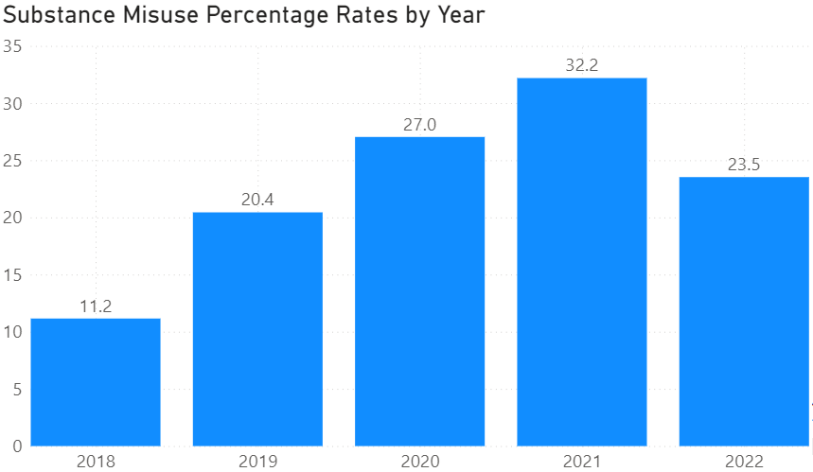

Figure 7: % children with substance misuse in the YJS cohort by year

Substance misuse rates amongst the local youth offending team have varied over the years. In 2021, Tower Hamlets youth offending team identified the highest proportion (32%) of children with a substance misuse problem. These figures may have been affected by the impacts of the pandemic. 22% of children in the local youth justice service between 2021-22 were known to the youth justice services as struggling with substance misuse. Across Tower Hamlets, cannabis is the most used illicit substance with alcohol coming second. Trends across popularity of different drugs remain similar across the years, however, there has been a sharp increase in use of nitrous oxide amongst adolescents.

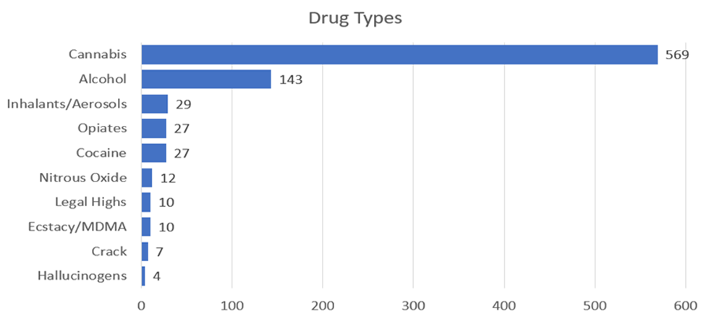

25% of children believe that they had currently or previously struggled with an alcohol or drug use.

Almost half the children who participated in the survey stated they consume drugs and or alcohol at least once a day, with cannabis being the choice of drug for almost all children.

6 in 10 children from both the survey and focus interviews felt that settings for children such as youth centres, school, YJS etc do not successfully stop the consumption or trade drugs, alcohol, vapes, whippets and cigarettes; because even when they are in children-centred spaces, those around them are consuming and selling prohibited items.

### How have children in this cohort identified their health needs?

Cannabis, followed by alcohol were recorded as the most frequently consumed drug within this cohort. Around half the participants use their drug of choice at least once a day. A quarter felt that they had in the past, or at the time of completing the survey struggled with substance misuse. Children felt that gaining access to prohibited items such as drugs, vapes and alcohol in settings for children (schools, youth centres) was not difficult. For some it was through peer groups in these settings that their consumption of drugs or alcohol begun. Due to this, peer pressure was a key barrier to using an alcohol or drug support service. Many children discussed that seeking support for their substance misuse may cause concerns or discomfort within friendship groups. This was due to fears around information sharing with families, schools or other services. Participants highlighted their anxieties around the level of privacy and confidentiality drug and alcohol services provided for not only their friends, but themselves.

“It can be hard getting help for drugs if your friends are still using or introduced you to the drugs in the first place. They might think you are betraying them”.

In comparison to their awareness of sexual health services, children had more knowledge around the best first steps needed to access a drug and alcohol service. For most, this was due to tools provided to them by their assigned case worker.

Around half of those who took part in the survey stated they preferred face-to-face communication with drug and alcohol services. For most, forming a connection with staff helped in promoting transparent communication. Face-to-face meetings also were viewed as helping to promote accountability. Over the phone or online consultations were favoured as the preferred access method for just over a third of children. This was particularly true for initial consultations to aid during initial meetings.

### What is currently provided to address the drug and alcohol needs of the children in local youth offending cohort?

|  |  |  |  |
| --- | --- | --- | --- |
| Service | Provision | Provider | Commissioner |
| Safe East: substance misuse and prevention treatment | 2 days a week | Compass | LBTH Public Health / YJS (YJS Grant) |

### Recommendations

Whilst there is good evidence that the current service provision in the YJS is accessible for children; children have raised concerns about peer and environmental influences that prevent them achieving good outcomes.

This finding should be incorporated into partnership substance misuse strategies for wider consideration and action.

# Oral health

Dental checks on apparently healthy teeth are recommended on a 3-12 monthly basis depending on dentists’ advice for children under 18 years. Dental checks are free for under 18s in England[8].

**1 in 3** children who participated in the survey had not visited a dentist in 2 or more years. Cost was **not** recorded as a key barrier to accessing oral health. Survey findings highlight that **uncertainty** around **how to book an appointment** was the most common reason for not visiting the dentist. Many children felt that they did not need to receive oral health care, except where they could see or feel a tooth required attention. This was true even if they had not attended a dental clinic for longer than 6 months.

### What is currently provided to address the oral needs of the children in local youth offending cohort?

There is no specific oral health service for children in the YJS. There is no standard screening assessment of oral health by youth justice practitioners.

### Recommendations

Improve children’s understanding of the need for regular check-ups of teeth when there are no known dental problems.

Improve access to dental health services by building skills in booking appointments. In doing so, assess other barriers to accessing services e.g. availability of NHS dentists in the borough and incorporate this into future health work in the YJS.

# Health Partners workshop

This Health Needs Assessment was presented to the health partners in the youth justice system to validate findings and develop final recommendations.

The workshop was held on 9th May 2023 and was well attended with representatives from all services delivering support to children in the YJS, strategic leaders from primary and secondary care in the ICB; public health; and young people and youth justice services.

The YJS Health Needs Assessment was presented initially and was followed by a discussion of the findings. There was a general acceptance of the JSNA findings and support for the approach of incorporating the voices of children and staff. Partners recommended areas for future exploration (e.g. bereavement support, access to dental services and eye tests), identified significant gaps in care for children who experience serious violent trauma, and discussed opportunities for earlier identification and assessment of vulnerabilities in the primary school period; including improved communication between schools and health needs of SEN support level needs.

This was followed by a presentation on the YJS improvement journey with a focus on the health-related findings of the external diagnostic review. The vision and priorities were well accepted.

Partners were updated on the recent news that funding had been secured for a nurse to work with children in the YJS. This was also welcomed and led to a discussion about the role of the nurse in care coordination, the need to embed the role in another health service, and the need to start with a flexible learning approach to create a model that integrates well with existing services to ensure longer-term engagement of children in health services.

A full workshop report is available.

# Recommendations

### Develop and utilise data sharing systems across the Youth Justice Service, health professionals and other partners to ensure wellbeing needs are identified, measured, analysed and predicted.

* 1. To address under-recording of health needs in ChildView data fields, review practice of using free-text boxes and develop an action plan.
  2. Report findings from health partners workshop to other Boards (e.g. the Children and Families Executive Board) to develop a plan to address issues with communication of SEND needs (EHCPs and SEN support) between schools and health services, including primary care.
  3. Review opportunities to improve gender inclusive practices in the YJS, including but not limited to improving the recording of gender, preferred pronouns and family sensitivities in ChildView.

### Utilise a whole-systems approach to improve the accessibility of health services and reduce inequalities

* 1. Improve screening and recording of mental health issues of children in the YJS
  2. Reframe ‘mental health’ as ‘emotional or wellbeing support’ when speaking with children.
  3. Mental wellbeing should be checked by all professionals that a child has contact with, operating under a holistic and public health approach.
  4. Ensuring all mental health staff are provided with culturally appropriate training.
  5. Ensure children’s spirituality and faith-based practices are incorporated into mental health conversations.
  6. Whilst there is good evidence that the current substance misuse service provision in the YJS is accessible for children; children have raised concerns about peer and environmental influences that prevent them achieving good outcomes. This finding should be incorporated into partnership substance misuse strategies for wider consideration and action.
  7. Improve children’s understanding of the need for regular check-ups of teeth when there are no known dental problems.
  8. Improve access to dental health services by building skills in booking appointments. In doing so, assess other barriers to accessing services e.g. availability of NHS dentists in the borough and incorporate this into future health work in the YJS.
  9. Assess the impact of bereavement on children in the YJS and undertake a system-wide assessment of access to bereavement support for children.
  10. Provide predominately face-to-face mental health services, with some telephone / hybrid offer as additional support.
  11. Provide a mix of face-to-face, phone and text support for sexual health and substance misuse services.

### Improve earlier identification and intervention to prevent offending and poor health outcomes, and reduce inequity.

3.1 Further work to understand why Black/Black British and Mixed ethnicity girls are over-represented compared to boys of the same ethnicity and compared to girls overall.

3.2 Explore opportunities to improve care for patients who have are injured through interpersonal weapon enabled violence to prevent reattendance with further trauma, offending and other adverse health and social outcomes.

3.3 Further work to understand the impact of the disproportionality through the YJS on children’s health and wellbeing.

3.4 Explore opportunities to improve mental health support for children falling between THEWS and CAMHS thresholds in primary schools.

3.5 Explore findings on SEND data with health partners to develop further recommendations on low recorded prevalence and a different SEND need profile in this cohort compared to all children in the borough.

3.6 Understand drivers for the inequalities seen in SEND identification by ethnicity. Develop a plan to increase identification in Asian/Asian British children.

### Integrate a multi-faceted sexual health education offer in which emotional and overall wellbeing is addressed.

* 1. Offer sexual health service referrals to Safe East for children in the YJS for education and advice around safe sex, healthy relationships, consent, emotional support.
  2. Use social media and online promotion to increase the rate at which young people engage with sexual health services.
  3. Further work with YJS staff to raise awareness of Safe East’s full sexual health offer to achieve parity with its substance misuse offer may help improve children’s awareness of sexual health services.

### Identify an opportunity for a health professional to undertake a holistic health screening of children in the YJS, in additional to continuing access to the current specialist health services (e.g. sexual health, mental health, substance misuse).

* 1. Recruit a YJS nurse to undertake holistic health screening of children, provide care coordination through an MDT approach and help children access ongoing support after they leave the YJS.
  2. Convene a steering group of YJS staff and health partners to develop the YJS nurse role through a test-and-learn approach to ensure the role is embedded in the wider health system.

### Explore ways to strengthen the physical activity offer for children in the YJS to protect their mental and physical health and wellbeing.

* 1. Work with children to co-produce a support offer to further understand barriers to access and to build skills and confidence to access leisure and physical activity services in the borough, particularly for girls.
  2. Promote swimming and other physical activity opportunities to all children in the YJS.
  3. Consider opportunities for discounted swimming activities in the borough, such as through the planned insourced leisure service.
  4. Ensure sports activities are well spread across the borough and are safe for children to access.

1. **Better identify and provide support for children who are young carers**
   1. Professionals within the youth justice service should be provided with training to identify signs indicating a child is a young carer. This will assist to ensure all care plans across are modified to accommodate for their complex needs.
   2. Co-produce ‘day out’ programmes with children to engage them in planning and ensure social activities are meeting their needs.

# Next steps

Future health needs assessments could explore the following topics:

* impact of disproportionality on health and wellbeing of children
* scale of bereavement and support available
* access to eye tests
* suicide prevention and support

The introduction of a YJS nurse provides a valuable opportunity to review and refresh health service partnerships. There is strong support for health partners to form a steering group to help develop this model and a commitment to collaborate to create a system that better supports the health and wellbeing of children in the YJS.

Proposed recommendations will be discussed at the Youth Justice Board to agree next action steps.

1. Lader, D., Singleton, N. and Meltzer, H. (2000): Psychiatric Morbidity among Young Offenders in England and Wales, London: Office for National Statistics
2. Dahlgren G, Whitehead M. European strategies for tackling social inequities in health: levelling up Part 2. Copenhagen: WHO Regional Office for Europe, 2007
3. Census 2021, [Income, poverty and welfare (towerhamlets.gov.uk)](https://www.towerhamlets.gov.uk/lgnl/community_and_living/borough_statistics/Income_poverty_and_welfare.aspx)
4. Felitti, V. J., Anda, R. F., Nordenberg, D., Williamson, D. F., Spitz, A. M., Edwards, V., ... & Marks, J. S. (1998). Relationship of childhood abuse and household dysfunction to many of the leading causes of death in adults: The Adverse Childhood Experiences (ACE) Study. American Journal of Preventive Medicine, 56(6), 774–786.
5. Asmussen K, Fischer F, Drayton E, McBride T. Adverse childhood experiences. What we know, what we don’t know and what should happen next. Early Intervention Foundation. February 2020. https://www.eif.org.uk/report/adverse-childhood-experiences-what-we-know-what-we-dont-know-and-what-should-happen-next
6. [**Youth violence – RCPCH – State of Child Health**](https://stateofchildhealth.rcpch.ac.uk/evidence/injury-prevention/youth-violence/#page-section-5)
7. Nadarzynski T, Burton J, Henderson K et al. Targeted advertisement of chlamydia screening on social media: A mixed-methods analysis. Digit Health. 2019 Jan-Dec; 5: 2055207619827193. Published online 2019. [Link](https://www.ncbi.nlm.nih.gov/pmc/articles/PMC6360644/)
8. [Dental check-ups - NHS (www.nhs.uk)](https://www.nhs.uk/live-well/healthy-teeth-and-gums/dental-check-ups/)