Cardiovascular Disease Health Needs Assessment

Tower Hamlets Public Health

23/05/2023

Table of Contents

Summary 4

Top lines: 4

Summary of CVD in Tower Hamlets 4

Summary of HNA findings and recommendations 6

Introduction: Tower Hamlets population and the case for CVD prevention 19

Our population 19

Healthy life expectancy and long term conditions 19

Why is CVD important? 20

HNA Scope 21

About CVD 21

What is CVD? 21

How can CVD be prevented and treated? 22

What are the risk factors for CVD, and their rates in TOWER HAMLETS? 23

Non-modifiable risk factors 24

Modifiable non-clinical risk factors 26

Modifiable clinical risk factors 31

Complex drivers of CVD risk, or ‘wider determinants’ of health 35

CVD in Tower Hamlets 41

Prevalence 42

Inequalities 42

Geographical comparisons 42

Trends over time 43

Admissions 44

Trends over time 44

Inequalities 47

Mortality 49

Inequalities 51

Premature mortality 53

Policy context 55

National 55

Local 56

What works, what is on offer in TOWER HAMLETS, and have any gaps or issues been flagged? 57

Overview: cost-effective and evidence-based preventative interventions 57

Context for CVD support offers: the COVID19 pandemic 59

Detecting CVD risk 60

NHS Health Checks 60

NHS Community Pharmacy Hypertension Case Finding Service 66

Tower Hamlets Health Festivals and outreach events 67

Barts Health NHS Trust East London PrEvention programme (ELoPE) 69

Reducing CVD risk 70

Education 70

Connecting people to services 71

Reducing non-clinical risk factors 75

Reducing clinical risk factors 86

Managing CVD 91

Summary of CVD management data 91

*Cardiac rehab* 91

Stroke 94

Ongoing support in primary care 95

Support for specific groups 96

Mental health and severe mental illness 96

People experiencing homelessness 100

Learning disabilities 101

Carers 102

Recommendations summary 103

Overall recommendations 103

Topic-specific recommendations 104

Detecting risk factors 104

Reducing risk factors once found 105

Reducing clinical risk factors 106

Managing CVD 107

Support for specific groups 107

# Summary

## Top lines:

* Tower Hamlets has low healthy life expectancy, and CVD is a major driver of this.
* Prevention is better than treatment – we should be detecting and reducing CVD risk factors throughout people’s lives, and working to reduce inequalities.
* We know what works to do this; there is a good evidence base on priority areas for detecting and reducing CVD risks.
* Although a range of offers exist in Tower Hamlets to detect and reduce CVD risks and to support those with CVD, there remain some important issues which require action.
* This slide pack outlines the road to action, recommending a Heart Health Strategy to bring local partners together in order to detect and reduce CVD risks more effectively.

## Summary of CVD in Tower Hamlets

This is covered in more detail throughout the rest of the HNA, including data visualisations.



CVD prevalence, admissions and mortality:

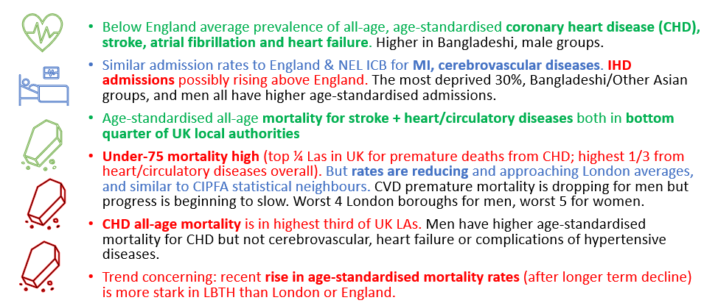

Key CVD risk factors:

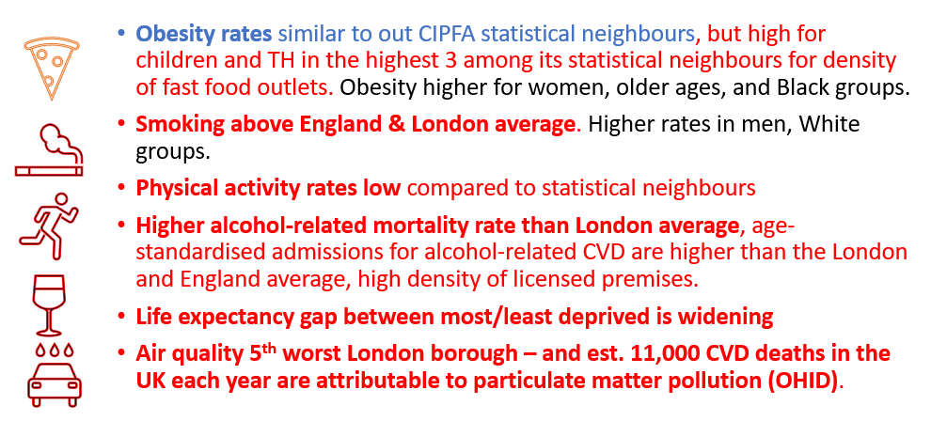

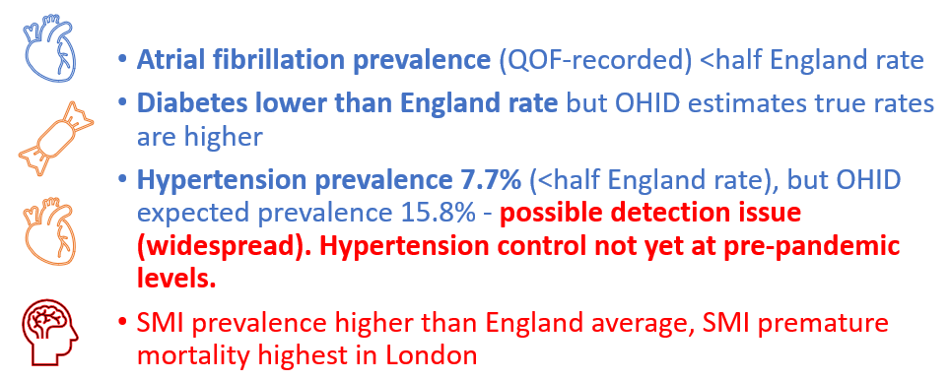

## Summary of HNA findings and recommendations

|  |  |  |  |  |
| --- | --- | --- | --- | --- |
| **Theme[1]** | **Why is this important?** | **Positives in Tower Hamlets** | **Issues and gaps in Tower Hamlets** | **Recommendation** |
| Overall recommendation: Local partners working on CVD to develop a Heart Health Strategy for Tower Hamlets which links closely to related CVD Prevention Plans at the NEL ICB level, sets out clear milestones and timelines for actions building on the below recommendations, and proceeds with the following broad principles:   * A population health approach with community outreach at its core * Focus on existing assets * Focus on secondary prevention but with links to primary prevention efforts * Collaborative working across professionals and across local health and community organisations |  |  |  |  |
| **Tobacco dependence identification and treatment**, in particular peer-led group support to quit smoking | Quitting **smoking** is one of the highest impact interventions to reduce risk of developing or worsening CVD. For those who quit, the risk of heart attack is halved after one year of quitting.[2] | Tower Hamlets is in the top 5 London boroughs for 4-week quit rates with 3,976 quits per 100,000 smokers, almost double the London region average of 1,665 per 100,000 smokers (2019/20).[3]  There is a wide range of smoking cessation offers including a local authority funded 12-week programme of behaviour support and nicotine replacement therapy, the London Tobacco Alliance helpline, NHS programmes for inpatients, pregnant women and those with SMI or a learning disability, a new community pharmacy smoking cessation programme and a new national drive to provide e-cigarettes to 1 in 5 smokers. | Recording of smoking status and GP-recorded offers of support/treatment for smokers have been falling since 2017/18 and are now below national average.  Residents in the E2 and E3 postcodes, White groups and younger people are less likely to access local authority-funded smoking cessation services. | Provider of the smoking cessation service to pick up the recommendations of the local authority tobacco cessation services review (for example targeting support efforts in the E2 and E3 postcodes and to White ethnic groups and younger people) and expand peer support and group offers. |
| **Hypertension detection, monitoring and treatment** | Hypertension is associated with half of all CVD cases. It is often symptomless and goes undetected. Blood pressure checks – through health checks, outreach initiatives or community pharmacy – are key to detecting and controlling hypertension. Such services can also pick up wider risks like smoking and inactivity.  A major systematic review found that every 10mmHg reduction in BP resulted in a 17% reduction in coronary heart disease, a 27% reduction in stroke, a 28% reduction in heart failure, and a significant 13% reduction in all-cause mortality.[4] | Detection: Community pharmacy hypertension case finding service has now been rolled out in Tower Hamlets, with 44/49 pharmacies on the public health contract signed up. | Comparing OHID-estimated hypertension prevalence for Tower Hamlets (15.8%) with QOF-recorded diagnosed hypertension (7.7%), we are currently only recording 48% of expected hypertension.  The % of GP-registered patients over 45 with a record of blood pressure in the last 5 years has been steadily falling since 2014/15 and is now below England average. | PCN community pharmacy leads to liaise with community pharmacy on effective ways to promote lifestyle changes following blood pressure checks, linking this to existing GP and VCS offers.  NEL ICB, LPC and PCN community pharmacy leads to jointly review care pathways following BP checks under the scheme and continually review any variation in uptake of the service across pharmacies and follow-up support offers. This could include learning from other local authorities working on similar issues, for example the Lambeth centralised recall system pilot to reduce variation in hypertension detection.[5]  Community pharmacy to continually link this service to other related community pharmacy services – like smoking cessation |
|  |  | Monitoring: Range of offers through GP surgeries, pharmacies and the BP@home service. | BP@Home monitoring is only offered to 12.9% of hypertensives in Tower Hamlets, with variation across GP practices from 7-25.5%.  15% for those on the hypertension register do not have a blood pressure measurement recorded in the last 12 months. | Tower Hamlets PCNs to review the causes of variation in uptake of blood pressure monitoring at home service by GP practice, linking to NEL ICB long-term conditions commissioners who are reviewing eligibility and targeting under the programme |
|  |  | Treatment: GPs routinely seek to optimise hypertension treatment, and to support this in Tower Hamlets there is a Barts ‘Community Cardiovascular Prevention team’ running clinics for people with CVD and complex needs, hypertension and raised cholesterol. These include medicines optimisation. | 22% of people on the hypertension register in Tower Hamlets are defined as ‘uncontrolled’ (i.e. their last blood pressure measurement was greater than 140/90 (under-80s) or 150/90 (80 and older)). | *No recommendation from this HNA – to consider under the Heart Health Strategy.* |
| **Weight management** services and **physical activity** for those suffering from obesity, particularly those with diabetes and/or hypertension. | Around 1 in 6 heart and circulatory disease deaths are associated with a high body-mass index.[6]  Effective weight management leads to improvements in blood pressure, blood glucose, HbA1C and triglycerides.[7]  A reduction in body weight of approximately 4 kg would achieve a reduction of approximately 4.5 mmHg systolic blood pressure and of approximately 3.2 mmHg diastolic blood pressure.[8] | Adult obesity in Tower Hamlets is not particularly high, but childhood obesity is and so this is likely to change in the coming years. | There is limited support for those with BMI under 30 (but over 25), though some ethnic minorities are eligible for support at a BMI of 27.5 due to heightened risk.  - The Change for Good programme showed high dropout rates;  - A limited targeted support offer for some groups – such as those with severe mental illness;  - White British groups were less likely to remain on the programme at 12 weeks (12.3%) compared with Bangladeshi groups (27.7%).  - There is a gap in Tier 3 services. | NEL ICB already leading on recommissioning Tier 3 services.  TOWER HAMLETS to review uptake, targeting and eligibility of its weight management programmes (for example, considering lower eligibility criteria for individuals with other health conditions), and to ensure professionals across the health system and community groups are clear on service changes and referral pathways.  Providers to expand face to face provision and peer support offers, and review accessibility of the service.  Tower Hamlets Public Health team, with NEL ICB long-term conditions commissioners, to review subsidised exercise offers to those with or at risk of long-term conditions (including CVD), in moving to in-house provision of leisure centres. |
| **Cardiac rehabilitation** for people after acute coronary syndrome and diagnosis of heart failure | This is a high risk cohort for further CVD events. There is strong evidence that cardiac rehabilitation reduces cardiac-related morbidity, and reduces readmissions by an estimated 31% over 6-12 months.[9] | Wider offer than other boroughs in NEL, including a 6-week follow-up exercise offer at leisure centres. Continually adapted for different population groups (e.g. women-only options). | Cardiac rehab staff flagged the following issues during a visit for this HNA. | Cardiac Rehab service to review issues raised: improve data systems to gain rapid data on uptake and outcomes, review funding for transport to the service for those on low incomes, review eligibility criteria and referral routes, consider the risk of digital exclusion and link to local VCS offers. |
| Identification of people with **alcohol dependency**, provision of specialist interventions and referral into community services for ongoing support and treatment | Drinking, smoking, and drug use is linked to premature heart disease in young people, particularly younger women.  A pilot of alcohol care teams in acute hospitals showed a 3% reduction in readmissions during its first year and a return on investment of £3.85 for every £1 invested in the programme.[10] | There are a range of local offers including for outreach, treatment and recovery support as well as screening support from Drink Coach which has been shown to reduce drinking to low-risk levels for 1/8 people using the tool. | The substance misuse health needs assessment highlighted areas for improvement | Increase capacity in RESET treatment offer and improve cultural competency across the wider alcohol and substance misuse support system (s*ee substance misuse needs assessment*) |
| **Detecting a range of CVD risk factors: Health checks** | Across England, 1 in 4 NHS Health Check attendees are identified as at risk of CVD. NHS England calculates that at a 50% take up rate, every £1 spent on the current NHS Health Check programme achieves a return of £2.93.[11] | Outperforms England average for the % of eligible people invited for and attending a health check.  Tower Hamlets above national target for recording pulse check and carer status | Recent trend in health check uptake is downwards.  Lifestyle referral discussions following health checks are at just 51% (national target is 80%), with variation across GP practices from 10%-96%.  Only 32.2% of those with a QRisk score over 20 received an annual review in 2022/23, with variation across GP practices from none recorded or just 2.4%, to 79.7%. | Tower Hamlets Local Authority to conduct a review of GP practice health checks uptake variation and possible causes, a review of high risk CVD annual review variation by GP practice, and a review of post-health check referral rates to different programmes. |
| **Detecting a range of CVD risk factors: Health checks** | Across England, 1 in 4 NHS Health Check attendees are identified as at risk of CVD. NHS England calculates that at a 50% take up rate, every £1 spent on the current NHS Health Check programme achieves a return of £2.93.[12] | Outperforms England average for the % of eligible people invited for and attending a health check.  Tower Hamlets above national target for recording pulse check and carer status | Recent trend in health check uptake is downwards.  Lifestyle referral discussions following health checks are at just 51% (national target is 80%), with variation across GP practices from 10%-96%.  Only 32.2% of those with a QRisk score over 20 received an annual review in 2022/23, with variation across GP practices from none recorded or just 2.4%, to 79.7%. | Tower Hamlets Local Authority to conduct a review of GP practice health checks uptake variation and possible causes, a review of high risk CVD annual review variation by GP practice, and a review of post-health check referral rates to different programmes. |
| **Detecting a range of CVD risk factors: Community outreach** | Although health check attendance is high, there remain gaps in risk detection (for example c50% of hypertension cases undetected in Tower Hamlets). | There are both ad hoc offers (such as health festivals) and more targeted outreach such as for those experiencing homelessness | Current offers are not targeted and may not be reaching the highest need groups (for example 80% of those with detected high blood pressure in one event already knew this). | Tower Hamlets Local Authority to trial a community outreach programme for CVD risk factor detection and reduction, with a focus on blood pressure checks and rigorous data collection to determine cost effectiveness. This should:   * Have carefully planned target populations * Consider the training, skills and cultural competence of outreach teams * Ensure links back to relevant services for follow-up * Link to wider NEL ICB CVD Prevention Plans   Engage communities throughout |
| **Targeted support for populations at risk: SMI** | Having a severe mental illness and being on atypical antipsychotics raise the risk of developing CVD.[13],[14] A key way to detect risk is through the physical health checks for SMI programme. | There are plans to expand the physical health checks programme further with outreach to those with SMI not currently reached through the primary care offer.  There is also a local addition to the programme to offer health checks to those on antipsychotics (some of whom may not have a SMI).  A quality improvement scoping project in 2022 found that most GP practices maintain an up-to-date SMI register, have a process to monitor delivery of SMI health checks, use a range of communication methods to invite people and have clear pathways to community services.  MH personal budgets have been launched in Tower Hamlets | The % of people with SMI on the GP register in Tower Hamlets receiving all six physical health checks is only 46.7%, below the national target of 60%  A quality improvement scoping project in 2022 flagged a need to risk stratify patients on the SMI register, expand staff capacity to follow up on results, expand training for other staff groups to detect risk outside the health checks process and increase engagement with local service users. | NEL ICB to review the need for further outreach for physical health checks for those with severe mental illness, and peer support to improve service user engagement and motivation |
| **Targeted support for populations at risk: homeless groups** | People experiencing homelessness have an approximately three times greater risk of CVD than housed people, and a CVD mortality risk at least 2.6 times higher.[15] | NEL ICB is in the process of commissioning a pan-NEL outreach service to serve rough sleepers, hostels and asylum settings. | Current outreach for homeless groups in Tower Hamlets, and data on their needs, is limited, and GP outreach services are renewed every 3 months which puts pressure on recruitment. | Tower Hamlets Local Authority to conduct a health needs assessment for people experiencing homelessness in Tower Hamlets. |
| **Diabetes detection and control** | Diabetes is closely linked to inflammation and atherosclerosis which is a major risk factor for CVD.[16] | *See Diabetes HNA for TOWER HAMLETS situation and recommendations* |  |  |
| Cholesterol detection and lipid management | Cholesterol is associated with a higher risk of CVD death.[17] Every 1mmol/l reduction in low-density lipoproteins (LDL) cholesterol reduces risk of a cardiovascular event by 25%.[18] | Barts Community Cardiovascular Prevention team supports GPs with managing complex needs, hypertension and cholesterol. | GP practice variation in the % of those with a QRisk score over 20 being prescribed statins from 37.5% to 83.3% (national target is 60%). | *No recommendation from this HNA – to consider under the Heart Health Strategy.* |
| Atrial fibrillation detection and treatment | Patients with an irregular heartbeat (atrial fibrillation) have an increased risk of stroke and coronary artery disease. | there are incentives to anticoagulate those with atrial fibrillation in the GP population heath medicines optimisation specification and a local enhanced specification for GP-delivered anticoagulation. | However, community anti-coagulation services, commissioned via individual practices, are not offered by all GPs as it requires extensive training and is a high risk prescription. | Tower Hamlets PCNs to consider whether there are training needs among GPs to enable anticoagulation prescription, and share these findings with NEL ICB and Barts |
| ELoPE Secondary Care CVD support | Secondary care is a key opportunity to detect and reduce CVD risk | A wide range of offers to detect and reduce CVD risks in Barts staff and patients, including a staff and patients health checks project, a ‘make every contact count’ CVD risk factor detection pilot, educational programmes on heart health and a new secondary care social prescribing offer. | There’s an ongoing need to link to wider services and ensure these offers are reaching those in most need. | ELoPE colleagues at Barts NHS Trust to continue to evaluate the ELoPE programme and instigate potential improvements, including linking to Public Health, primary care and VCS colleagues and to new local CVD initiatives.  More broadly, Barts CVD Secondary Prevention team to systematically assess secondary prevention of patients moving through Barts services and consider targeting outreach events and support for patients by higher risk demographics. |
| Social prescribing | Social prescribing is a key element of support for long term conditions highlighted in the NHS Long Term Plan. However there remains an evidence gap for its cost effectiveness. | Tower Hamlets was an early adopter of social prescribing and sees the highest social prescribing activity of all NEL boroughs | A number of ongoing service issues were flagged by the NEL ICB social prescribing commissioner for Tower Hamlets. | NEL ICB Tower Hamlets social prescribing commissioners to work with Barts and the GP Care Group to continually improve data collection systems, return to face to face support and (where possible) support national efforts to evaluate the cost effectiveness of the Tower Hamlets social prescribing model.  ELoPE social prescribing lead to work jointly with NEL ICB social prescribing commissioners and the GP Care Group to continually review accessibility of materials and adaptation of support for those with specific needs (such as carers or women). |
| Joined-up care to manage CVD | Joined-up care is important for supporting people with long term conditions and complex needs. | PCNs are piloting different staff mixes to understand the best staff groups to support those with long term conditions including CVD. | *[none highlighted by this HNA]* | GP practices to continue to share learning on models of support for those with CVD, including risk stratification, recall systems and appropriate staff mixes – including at an ICB level.  PCNs to conduct a health outcomes evaluation of care planning in primary care. |

# Introduction: Tower Hamlets population and the case for CVD prevention

## Our population

Our population is relatively young, with a large number of people from 20-50 years old. We have slightly more men than women and a majority of people in the two most deprived quintiles. The proportions of people in different deprivation quintiles varies across age groups, with a higher proportion of more deprived people from ages 0-20 and 50-85+, and a higher proportion of less deprived people from ages 20-50 (Figure 3). There is a high degree of population churn in the borough.

## Healthy life expectancy and long term conditions

Tower Hamlets has historically had poor Healthy Life Expectancy, and in the years 2018-20 women in Tower Hamlets experienced on average just 54.3 years of healthy life before poor health set in. The 2021 Census showed that whilst the percentage of people reporting their health to be ‘very good’ had risen from 38.7% in 2011 to 42.5% in 2021, it still tracked behind the London average which rose from 44.5% in 2011 to 49.0% in 2021.[19]

There are clear age, sex, ethnicity and deprivation inequalities in how many people have a long term condition (including cardiovascular disease) in Tower Hamlets (Figure 1).

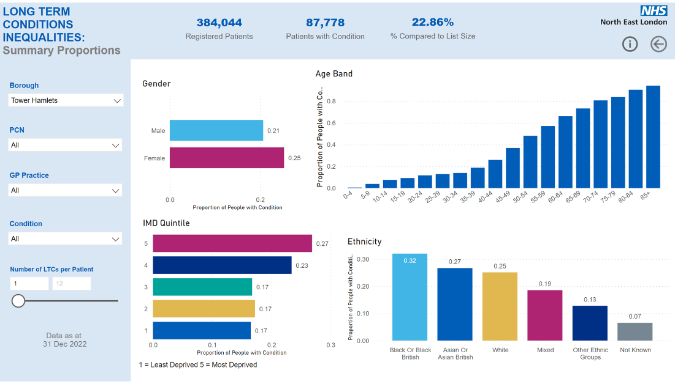

Figure 1: Proportion of GP-registered people with a long-term condition in Tower Hamlets by sex, age, national IMD quintile and ethnicity.

Inequalities by deprivation and ethnicity both start to emerge in middle age (30-59 years) (Figures 2,3)

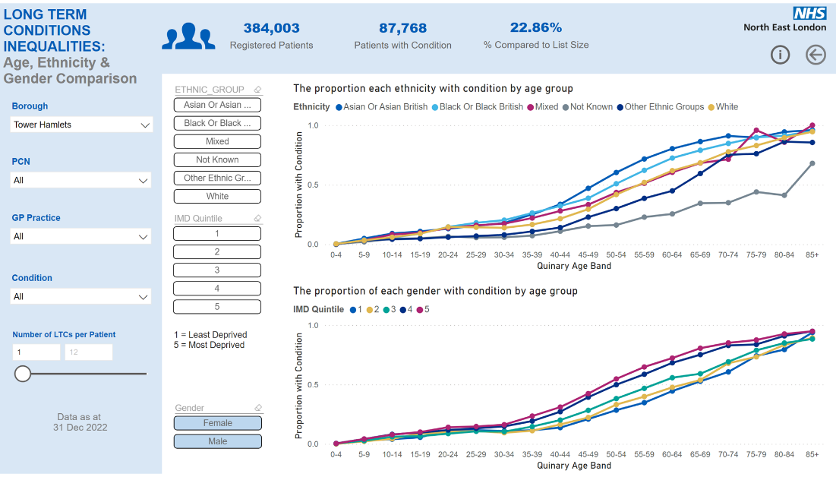

The proportion of people in each ethnic group with a long-term condition, by age band

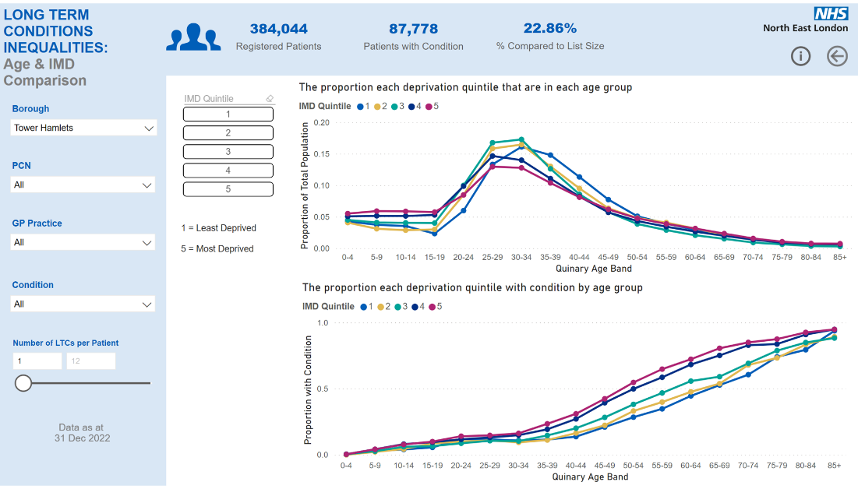

The proportion of people in each deprivation quintile with a long-term condition, by age band

Figures 2, 3: The proportion of GP-registered people with a long-term condition by ethnicity and age band, and by IMD quintile (5 = most deprived, 1 = least deprived) and age band. Source. NEL LTC dashboard.

## Why is CVD important?

1. **It is very common.** One in ten people live with CVD in England.[20]
2. **It leads to a high proportion of deaths and disability**, including premature deaths. CVD is the second biggest cause of death in England with 200 people dying each day from a heart attack or stroke.[21] It accounts for a quarter of deaths in England.[22] The majority of deaths are due to CHD and stroke.[23] One in four premature deaths are caused by CVD, and 1.6 million disability adjusted life years can be attributed to it.[24] Across the UK, CVD mortality and premature mortality gains have stalled since 2012, with a slight rise 2019-20.[25]
3. **It creates pressures on the health system.** CVD is the leading cause of emergency admissions for chronic ambulatory care sensitive conditions, and costs the NHS £7 billion a year.[26],[27] Every day there are over 1200 admissions to accident and emergency because of heart problems and 290 as a result of cerebrovascular problems.[28] There are 4,800 out of hospital cardiac arrests in London each year, and this carries high risk of death: in London, only 1 in 14 people survive an out-of-hospital cardiac arrest.[29]
4. **It is a major driver of health inequalities** and a major contributor to the life expectancy gap between most and least deprived groups in England.[30]
5. **It is largely preventable**. The World Health Organisation has estimated that 75% of premature CVD is preventable.[31]

## HNA Scope

A health need is defined as a need for which a person has the capacity to benefit from a particular health intervention.

This health needs assessment looks at what we know about CVD-related needs in Tower Hamlets, what we have in place to address those, and any gaps and issues. It sets out:

* **What CVD is, its key risk factors**, how prevalent these are in Tower Hamlets and (where possible) any inequalities in risk factors in Tower Hamlets.
* **CVD prevalence, admissions and mortality in Tower Hamlets.** Where possible, comparisons with similar local areas (neighbouring or similar populations) are made. Similarly, where possible age-standardised rates are used (so we are not falsely comparing two very different populations), and where this isn’t possible it is highlighted.
* **The offer in** Tower Hamlets **to detect and reduce CVD risk factors and to manage CVD.** The HNA focuses on ‘secondary prevention’ which is defined as detecting risk factors (both modifiable and non-modifiable, clinical and non-clinical) and working to reduce them once detected. In reality it includes some elements of wider, universal prevention, and some elements of treatment which are relevant to preventing disease progression. The HNA does not include a detailed overview of CVD treatment but in some places this is referenced as much of the treatment and management of CVD relates to reducing ongoing risk factors for further CVD events.
* **A summary of available performance data, and any gaps or issues highlighted by stakeholders –** though this remains a needs assessment rather than a formal or complete evaluation of services.
* **Recommendations**.

# About CVD

## What is CVD?

Cardiovascular disease (CVD) is an umbrella term that covers a range of chronic, non-communicable diseases in the circulatory system, including:

* Coronary heart disease, which is when the flow of oxygen-rich blood to the heart muscle is blocked or reduced and can lead to angina, heart attacks and heart failure;
* Transient ischaemic attacks and strokes, where blood flow to part of the brain is restricted or cut off;
* Peripheral arterial disease, when there's a blockage in the arteries to the limbs, usually the legs
* Aortic disease, which is a group of conditions affecting the largest blood vessel in the body, the aorta.[32]

It includes conditions which can be easily managed at home or in primary care, or issues like stroke or heart attack which can result in people needing acute care and often substantial formal or informal care needs.

**How does it develop?**

Cardiovascular disease generally arises as a result of blood flow being restricted or blocked.

When a person is exposed to particular risk factors (see below section 3.3: ‘risk factors’), their body starts to experience chronic inflammation. This leads to fatty deposits forming in the person’s medium and large arteries, which in turn causes hardening of the artery wall and a build-up of hard ‘plaques’. Over time, these grow and there is less space for blood to flow through the artery and so the person experiences reduced blood flow (as seen in angina or peripheral vascular disease). This is called atherosclerosis. The plaques may rupture and a plaque fragment block an artery, leading to ischaemia (stopping of blood flow to a part of the body) or a heart attack. This is a higher risk if the person has high blood pressure (hypertension).

## How can CVD be prevented and treated?

Figure 4 provides a summary of the progression of CVD, with opportunities to reduce risk of harms from CVD in blue arrows and risk of escalating harms in orange arrows. The likelihood of CVD itself, and the severity of harms arising from it, can be reduced by addressing CVD risk factors (including both clinical and non-clinical), detecting modifiable risk factors as early as possible and mitigating them, and detecting CVD and CVD events (again, as early as possible) in order to treat and minimise harm. In this HNA, our focus is on detecting and reducing CVD risk factors rather than CVD treatment.

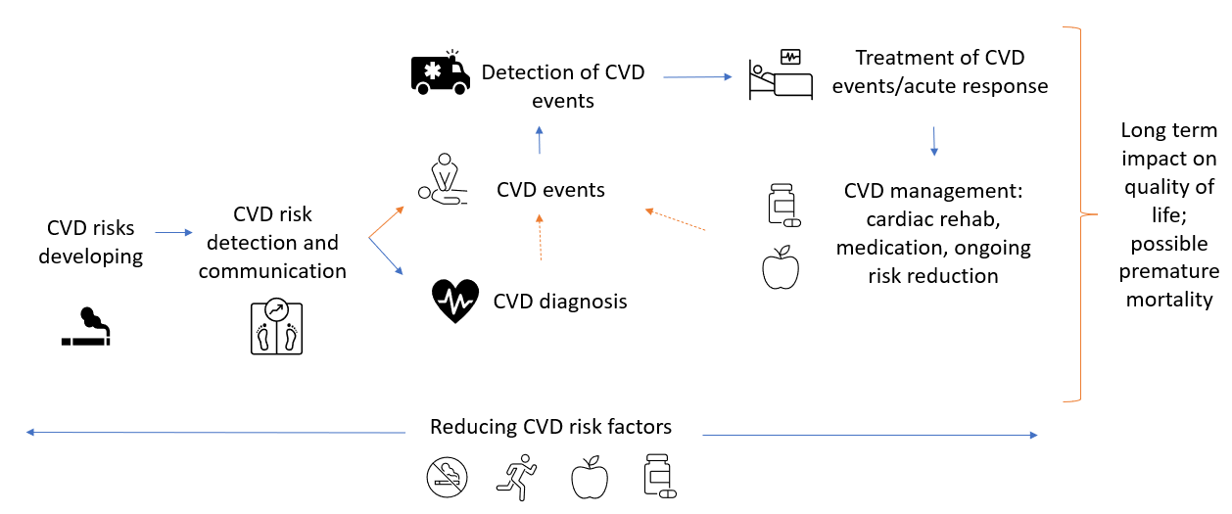

Figure 4: Diagram of progression of CVD risk factors (made for this HNA).

There are different levels of prevention for CVD with slightly different priorities – they can be grouped as[33]:

1. **Primary prevention:** Public health interventions that stop the development of a disease. For CVD it can be taken to mean a focus on stopping modifiable risk factors from developing – for example, stopping smoking uptake or weight gain to risky levels. This can be done at a universal level, or targeted to higher risk groups.
2. **Secondary prevention:** Interventions to systematically detect the early stages of disease and intervene before full symptoms develop. For CVD this can be taken to mean detecting risk factors (both modifiable and non-modifiable, clinical and non-clinical) and working to reduce them once detected. This might take place before a person has experienced a CVD event such as a heart attack (for example through NHS Health Checks), or as a result of experiencing a CVD event. Interventions for secondary prevention might include prescribing statins to reduce cholesterol or offering smoking cessation support, and these can be targeted at different levels of CVD risk.
3. **Tertiary prevention:** Interventions to soften the impact of an ongoing illness, helping people manage long-term, and often complex, health problems in order to improve their ability to function, their quality of life and their life expectancy. For CVD, this could include offers under secondary prevention (such as support for increasing physical activity) as well as treatment options like surgery or medication.

**Note**: in healthcare, primary prevention is used to mean preventing CVD developing, whilst secondary prevention is used to mean reducing the risk of further CVD events once it has been diagnosed. This HNA uses the above definitions, and has explained where titles of healthcare programmes include ‘primary’ or ‘secondary’ prevention that does not match the above definitions.

## What are the risk factors for CVD, and their rates in TOWER HAMLETS?

The importance of different risk factors varies slightly by type of CVD – for example, the majority of risk factors for abdominal aortic aneurysm are non-modifiable.[34] However, the risk factors set out here are the main CVD risks and addressing them can significantly lower CVD rates and improve CVD outcomes.[35]

They are split into:

* Non-modifiable risk factors, such as age, ethnicity, sex and family history of CVD.
* Modifiable risk factors. This is split into non-clinical modifiable risk factors (such as smoking or obesity), and clinical modifiable risk factors (such as hypertension or diabetes).
* Complex drivers of CVD risk. Sometimes termed ‘the wider determinants of health’, these are wider environmental, social or economic factors that may drive higher exposure to certain risks. For example, deprivation is a ‘wider determinant’ of health linked to higher rates of smoking and obesity, both CVD risk factors.

For each risk, there is a brief summary of the evidence base for its impact on CVD and a summary of what we know about rates in Tower Hamlets. It is worth noting that the accuracy of recorded and reported rates for risk factors varies, and in some cases data is not available locally. For smaller groups such as those with a learning disability or severe mental illness, caution should be taken when interpreting data as there is less data to work with. Registers used to estimate population group sizes achieve varying levels of completeness – where this is available, we have included estimated expected prevalence of risk factors, based on our population (for example for hypertension and atrial fibrillation). We have signalled throughout where datasets may be limited or systematically miss some groups.

### Non-modifiable risk factors

#### Age

Age is one of the most important risk factors for CVD, which is most common in over-50s; CVD risk rises almost linearly with age. Tower Hamlets has a relatively young population, which may distort some of our CVD-related statistics – where possible we have included age-standardised rates.

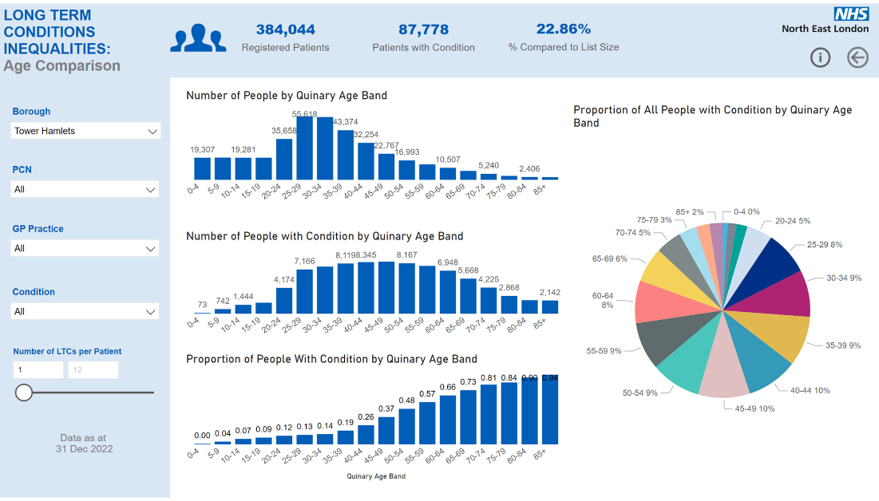

Figure 5: Number of GP-registered patients by 5-year (‘quinary’) age band (NEL LTC dashboard)

#### Sex

To note – ‘sex’ in this document means the sex assigned to a person in the relevant dataset referred to, rather than how they identify (their gender). Datasets and the wider evidence base on CVD typically split this into male/female, though of course there are wider non-binary definitions of sex (such as intersex) which are not captured by this. There may well also be complex interactions between risk factors and both sex (i.e. biological factors) and gender, though the distinction between these in the evidence base and CVD datasets is limited.[36] Trans and non-binary people with or at risk of CVD may well have specific needs that are not fully captured as a consequence of this ongoing limitation in both the evidence base and CVD datasets. This is particularly important in Tower Hamlets because our population has roughly double the proportion of people whose gender identity is different to their sex registered at birth, compared to the national average (1% vs 0.5%).[37]

The prevalence of GP-recorded cardiovascular disease is higher in males than females in every age group, though the difference is much less marked for stroke.[38] The gap between men and women has been narrowing over recent decades for both all-age age-standardised death rate per 100,000 people from heart and circulatory diseases, and from coronary heart disease.

Sex interacts with age and a number of other risk factors to influence CVD risk. For example, men have higher risk of hypertension than women overall and the risk of hypertension for both increase with age.[39]

#### Ethnicity

Some ethnic groups are at higher risk of developing CVD, due to the combined effects of many factors, including genetic variation, socio-economic differences (affecting poverty, nutrition and housing conditions), and differences in social and cultural beliefs and lifestyle practices (e.g. differences in diet/food habits, in taking exercise, and in treatment-seeking behaviour).

* Pakistani men have the highest rate of heart disease in UK.[40]
* The risk of South Asian women dying early from heart disease is 65% higher than the general population.[41]
* A small percentage of South Asian people carry a genetic variant in a gene called MYBPC3 that increases the risk of heart failure and heart attacks in later life.[42]
* Data from 2011-19 in England shows that age-standardised hypertension is highest among black Caribbean, black African and Pakistani adults and lowest among adults from Chinese and Other white backgrounds.[43]

However, some elements of preventative treatment are higher for certain ethnic minorities: CVDPREVENT found that in 2020-21 across England, Asian groups with no GP recorded CVD and a GP recorded QRISK score of 10% or more, were most likely to be on lipid lowering therapy (56.1%, compared to 42.0% for White groups).[44]

In Tower Hamlets, our population is predominantly Asian/Asian-British and White ethnicity (Figure 6). However, when we look at the proportion of people with a long-term condition by ethnicity (Figure 7), Black/Black-British groups are highest, followed by Asian/Asian-British and then White.

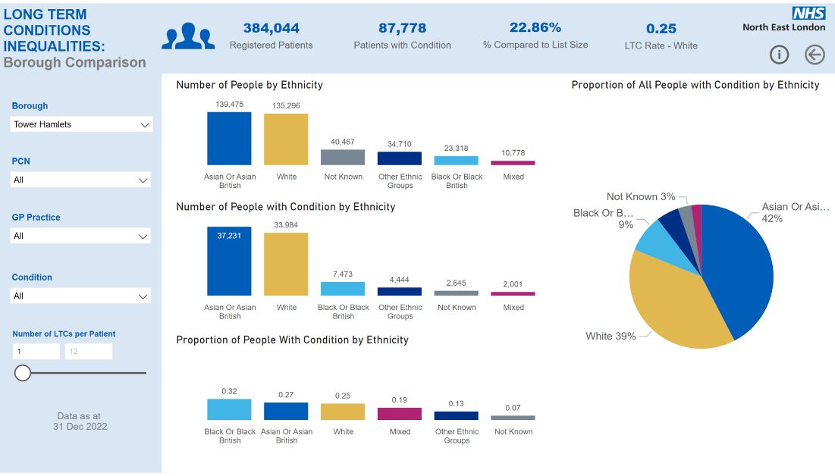

Figure 6: Number of GP-registered patients in Tower Hamlets, by ethnicity. Source: NEL LTC dashboard.



Proportion of people with a long-term condition, by ethnicity

Figure 7: Proportion of GP-registered patients in Tower Hamlets with a long-term condition, by ethnicity. Source: NEL LTC dashboard.

#### Family history of CVD

Family history of CVD impacts your CVD risk both by genetic factors and by the fact that families often share a similar environment and habits. The extent to which family history impacts your CVD risk depends on the number and age of your affected first-degree relatives. One estimate is that siblings of patients with CVD have about a 40% risk increase, while children of parents with premature CVD have a 60% to 75% risk increase – though definitions of premature CVD can vary and so these estimates of attributable risk remain disputed.[45]

The East London Genes and Health programme is helping us to understand the risks of different genetic factors and how they might interact with the environment we live in.[46]

### Modifiable non-clinical risk factors

**These include:**

* Smoking
* Air pollution
* Alcohol and drug misuse
* Inactivity
* Overweight/obese
* Diet high in saturated fats, trans fats, cholesterol

#### Smoking

Smoking remans the leading cause of preventable death in England. An estimated 15,000 CVD deaths each year in the UK are attributable to smoking, and at a national level, there is a clear trend that local authorities with higher smoking prevalence tend to have higher levels of under-75 CVD mortality.[47],[48]

Estimates of smoking prevalence from the Annual Population Survey (APS) show that in Tower Hamlets it is 12%, compared to 11.5% London and 13% England averages.[49]

It is estimated that each year in NEL, 212 people die from CVD caused by smoking.[50]

##### Population variation in smoking rates

**Rates of GP-recorded current smokers by age, sex and ethnicity , ages 16 to 65.**

Key findings:

* The group with consistently highest smoking rates were South Asian men across ages 25-64, with 31-33% - though rates among men in other ethnicities are similarly high from ages 25-63 (26-29% among Black groups and 26-27% among White groups).
* Age. Combining men and women and all ethnicities, smoking rates are the same (21%) across all age bands 25-64, with the 16-24 group slightly lower at 15%. Note: this data, which is taken from primary care records, may be more complete for age groups over 40 as smoking status is then systematically collected through the health checks process, rather than opportunistically if and when a person presents to their GP.
* Sex. Combining all age groups and ethnicities, smoking rates are most than twice as high in men than women (26.7% vs 13.2%).
* Ethnicity. Combining the sexes and all ages, White groups had the highest smoking rates across 16-64 year olds, followed by ‘Mixed’ and ‘Not Classified’. This is perhaps accounted for by notably higher smoking rates in White groups aged 16-24 (25% and 23% respectively for White men and women, compared to for example 13% and 12% for Black men and women and 20% and 6% for South Asian men and women).
* Ethnicity, age and sex: The difference between male and female smoking rates is similar across age groups for White groups, whilst it widens as age progresses for Asian, Black and Mixed groups.

Figure 8: the percentage of people recorded as smokers by ethnic group, ages 16-65. Source: QOF data.

#### Air pollution

It is estimated that up to 11,000 CVD deaths in the UK each year are attributable to particulate matter pollution, and Tower Hamlets has the fifth worst air quality of any London borough.[51] Air pollution disproportionately affects older people and more deprived groups, who are also at risk of a number of other CVD risk factors.[52]

Looking at the Access to Healthy Assets & Hazards (AHAH) index (2022), Tower Hamlets is in worst 3 among its statistical neighbours. 96.6% of residents live in LSOAs which score in the poorest performing 20% on the AHAH index. This combines access to retail, health services, the physical environment and air pollution.

#### Alcohol and substance misuse

Alcohol and substance misuse is associated with CVD and even recreational drinking, smoking, and drug use is linked to premature heart disease in young people, particularly younger women.[53]

Although Tower Hamlets has a large population of non-drinkers, it still has a higher alcohol-related mortality rate than the London average (40.1 per 100,000 compared to 37.8 per 100,000).[54] Age-standardised admissions for alcohol-related CVD are higher than the London and England average (913 per 100,000 compared to 827 and 759 respectively).[55] They are much higher in men than women (1,667 vs 280 per 100,000).

Tower Hamlets has a relatively high density of premises licensed to sell alcohol: at 50.8 per km squared, Tower Hamlets is in the highest third among its statistical neighbours.[56]

The Substance Misuse Needs Assessment covers the complexities of local alcohol and substance misuse, and their multiple health impacts, in more detail.

#### Inactivity

At a national level, there is a clear trend that local authorities with higher physical activity levels tend to have lower levels of under-75 CVD mortality.[57] In 2020/21, Tower Hamlets had relatively low levels of physical activity (60.3%, compared to a London average of 64.9% and on a downward trend of around 3% lower per year since 2018/19) and middling levels of under-75 CVD mortality (74.5 per 100,000).[58]

Figure 9: Percentage of physically active adults (y axis, 2020/21) against Under-75 mortality rate from CVD (x axis, directly standardised rate per 100,000, 2020). Fingertips.

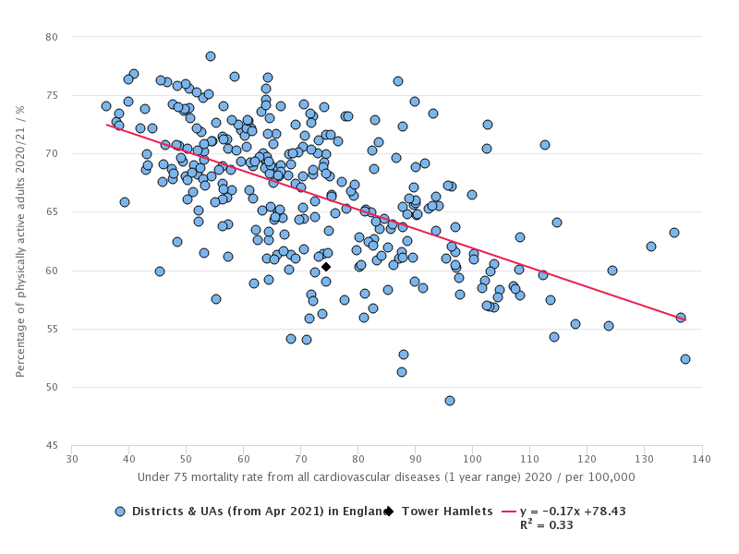

In comparison to its 15 closest statistical neighbours (CIPFA), Tower Hamlets is in the lowest 6 local authorities for the % of adults that are physically active.

#### Overweight/obesity

Around 1 in 6 heart and circulatory disease deaths are associated with a high body-mass index.[59] This may be because high fat body content (in particular around the organs) is associated with inflammation and can also mean there is more fat in the blood to deposit in arteries. The percentage of adults classified as overweight or obese in Tower Hamlets is lower than the London average, but it remains high at 53.5% and is likely to soon become higher if childhood obesity trends continue into adulthood. Among children in year 6, 45.4% of children are overweight or obese which is above the London average (40.5%).[60] It is also important to note the differing risks of obesity and its impacts across our population: people with South Asian heritage are more prone to central adiposity and their cardiometabolic risk occurs at lower BMI than their White counterparts.

##### Population variation in obesity rates

**Rates of GP-recorded people of BMI over 30 by age, sex and ethnicity, ages 16 to 65[61] show that in Tower Hamlets**:

* Age. Obesity rates rise almost linearly with age.

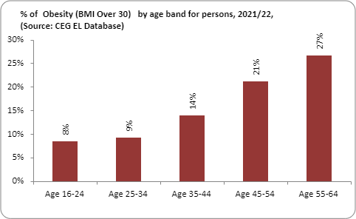

Figure 10: % of those with obesity by age band, 2021/22. Source: CEG EL Database.

* Sex. Looking at 16-65 year olds, women have higher obesity rates than men (17.1% vs 11%)
* Ethnicity. Looking at 16-65 year olds, Black ethnic groups have the highest rates of obesity by almost 10%, and more than double the rate of White ethnic groups. If you split those living with obesity by ethnicity, however, in Tower Hamlets White and Bangladeshi ethnic groups account for the majority.

Figure 11: The percentage of those with obesity by ethnic group, ages 16-65. Source: CEG EL Database.

* Age and ethnicity: obesity rates rise with age across all ethnicities. This is less stark for Asian groups: Asian women rise from 12% obesity in the 16-24 age group to 29% obesity in the 55-64 age group, whilst Asian men remain at 10-12% obesity in all age groups up to 65. In contrast, obesity rates in Black groups rise from 14% and 7% respectively for women and men ages 16-24 to 53% and 25% respectively in ages 55-64.
* Sex and ethnicity: Female recorded obesity rates are higher across all ethnicities and age groups, except for the ‘other’ ethnicity group for 16-24 year olds.
* Ethnicity, age and sex: The size of the difference between male and female obesity rates varies considerably across different ethnicities. The gender difference is most stark in Black ethnic groups, where in all age groups there are around double the number of obese women than men.

#### A diet high in saturated fats, trans fats, salt, sugar and cholesterol

Eating a diet high in saturated fats, trans fat, and cholesterol has been linked to atherosclerosis and heart disease, whilst high levels of salt in the diet can raise blood pressure.[62] Realistic modifications of diet and lifestyle can prevent most stroke, coronary-artery disease diabetes, colon cancer and smoking-related cancers.[63],[64] Alongside this, high sugar diets can increase risk of type 2 diabetes which is a risk factor for CVD.

There is limited data available on diets in Tower Hamlets and how these vary by demographic or other characteristics. However, we do know that Tower Hamlets is in the highest 3 among its statistical neighbours for density of fast food outlets, which tend to have higher fat, trans fat and salt content than home-cooked food.[65]

#### Poor sleep

Insomnia or poor sleep with short sleep has been associated with higher risk of incident CVD, and epidemiological studies have revealed relationships between sleep deprivation and hypertension (HT), coronary heart disease (CHD), and diabetes mellitus (DM). [66],[67] This association with CVD risk appears to be present for women but not men.[68]

There is no prevalence survey offering statistics for rates of insomnia, disturbed or short sleep in Tower Hamlets.

### Modifiable clinical risk factors

These include:

* Hypertension
* Diabetes
* High cholesterol
* Chronic kidney disease
* Atrial fibrillation
* Inflammatory diseases such as rheumatoid arthritis (as cardiovascular disease is an inflammatory process)

These clinical risk factors are also closely linked to the modifiable non-clinical risk factors outlined above, which may be a related part of managing clinical risks (for example by increasing physical activity or stopping smoking).

#### Hypertension

High BP greatly increases the chance of an MI or stroke and is associated with half of all CVD cases. High BP affects around 28% of UK adults, yet as many as 8 million of those with this symptomless risk factor are either undiagnosed or uncontrolled without effective treatment.[69] In fact, it is the third most common risk factor attributable to early death in the UK, after poor diet and smoking.

Figure 12: % of CHD patients in England with selected conditions. Source: BHF statistical compendium.

Overall, TH has average or lower rates of diagnosed hypertension than its geographic neighbours – this is likely due to the fact our population is young, with 71% under 40 years old.

OHID published an expected prevalence of hypertension in Tower Hamlets of 15.8% (95%CI 12.9%-18.9%) in March 2020, primarily using data from 2017.[70] This is well above GP-recorded rates for Tower Hamlets under the national QOF programme, which were 7.7% in 2016/17 and remain well below national rates. It is similar to NEL-wide rates of hypertension detection: OHID estimates a NEL-wide hypertension prevalence of 20.2 %, with just 10.3% reported on QOF.[71] GP-recorded rates of hypertension have also been reducing in Tower Hamlets over the past decade, at the same time that the national average recorded prevalence has been slowly rising. It is not possible to tell if this is a downward trend in detecting and/or recording hypertension, or in hypertension rates themselves, as OHID expected prevalence just gives a single estimate.

￼

A graph showing hypertension QOF prevalence for all ages, in Tower Hamlets over a period compared to England. 


Figure 13: % of GP-registered population in Tower Hamlets (blue) and England (red) with hypertension recorded over time. Source: QOF.

Diagnosis of hypertension, atrial fibrillation and chronic kidney disease all dropped across England during the COVID-19 pandemic with a particularly dramatic drop in hypertension diagnosis.

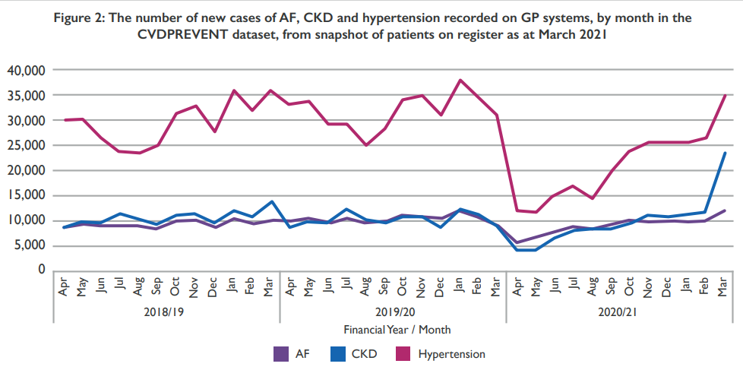

Figure 14: The number of new cases of atrial fibrillation, chronic kidney disease and hypertension recorded on GP systems in England over time. Source: CVDPrevent.

#### Atrial Fibrillation (AF)

Patients with an irregular heartbeat (atrial fibrillation) have an increased risk of stroke and coronary artery disease. There are a number of possible mechanisms through which AF can contribute to the development of myocardial infarction, such as through promoting systemic inflammation – though there are key risk factors associated with AF that may also be driving this inflammation.[72]

OHID has estimated an expected atrial fibrillation prevalence of 0.9% (95% CI 0.9-1%) in the boundaries of the previous Tower Hamlets CCG, though QOF-reported figures show only around 0.5% of the population recorded as having atrial fibrillation.[73] Atrial fibrillation prevalence has remained relatively constant in Tower Hamlets whilst England averages have been rising.

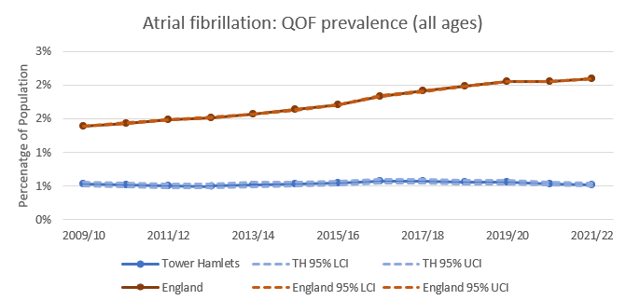

Figure 15: % of GP-registered population in Tower Hamlets (blue) and England (red) with atrial fibrillation recorded over time. Source: QOF.

#### Diabetes

Diabetes is closely linked to inflammation and atherosclerosis which is a major risk factor for CVD.[74] People may not always realise they have diabetes: an estimated 850,000 people in the UK have undiagnosed type-2 diabetes (OHID). QOF-recorded prevalence of diabetes is 6.7% in Tower Hamlets compared to 7.1% in England (2019/20).[75] However, the OHID Diabetes Prevalence Model[76] estimated true prevalence in over-16s as 8.6%, and that in 2030 the prevalence will increase to 9.7% and by 2035 will increase to 10.3%.

#### High cholesterol

High cholesterol, which is associated with a number of other factors such as saturated fat in the diet, physical inactivity, smoking, older age, being male or being from a south Asian background, is an important clinical risk factor for CVD.[77] Cholesterol is associated with a higher risk of CVD death.[78] A third of ischaemic heart disease is attributable to high cholesterol.[79] It's characterised by the build-up of fatty deposits in arteries, so tends to increase as we age.

It is estimated that nearly halfof adults in the UK have cholesterol levels above national guidelines (OHID). NEL ICB has similar levels of those with CVD with controlled cholesterol to the national average (25.8% vs 25%).[80] Tower Hamlets has slightly lower levels at 21.2%, and this looks similar across all PCNs, though around 40% of patients registered in Tower Hamlets have no cholesterol reading (Figure 16).

Figure 16: Percentage of patients registered to each Primary Care Network (PCN) with high, low/normal and no cholesterol recorded on 1st April 2022. High cholesterol is classed as a reading over 5mmol/L. Source: East London Database.

#### Mental health and severe mental illness (SMI)

Having a mental health condition raises the risk of developing CVD, particularly a severe mental illness (SMI) such as schizophrenia or bipolar affective disorder.[81] Anxiety and emotional stress can raise blood pressure through increased adrenaline and cortisol levels, but blood pressure should return to normal once stress has subsided (NICE, 2011). It is thought that the primary risk with stress is the tendency to form unhealthy habits (such as smoking or a poor diet) which themselves are risk factors for CVD.

There is an association between SMI and wider social and environmental determinants of poor health including homelessness and poorer housing, poverty, increased behaviours that can impact on health such as smoking and poor diet, and also lack of support to access health and preventative care.[82] SMI patients also experience a higher prevalence of physical co-morbidities and multi-morbidities. Those with SMI experience stark health inequalities, dying on average 20 years younger than the general population – and two-thirds of this premature mortality is preventable and treatable chronic physical health conditions such as cardiovascular disease.[83] Atypical antipsychotics, such as some prescribed to manage schizophrenia, are also a risk factor for CVD[84].

In 2021/22 1.29% of GP-registered patients in Tower Hamlets (4,864 people) were on the SMI register with a diagnosis of schizophrenia, bipolar affective disorder or other psychoses, the 7th highest in London where SMI prevalence ranges from 0.72-1.44%.[85]

Tower Hamlets is in the highest ten local authorities in England for directly standardised rates of premature mortality for people with severe mental illness (151.5 per 100,000), a large proportion of which arises from preventable and treatable chronic health conditions.[86] For example, the England directly-standardised rate for premature mortality in females with SMI is 77 per 100,000, whilst in Tower Hamlets it is around 140 per 100,000 (exact figure not available in referenced study so this is read from a graph).[87] Importantly, the borough also has the second-worst premature mortality rate in London from all causes, so this issue is not distinct to people with SMI alone.[88]

### Complex drivers of CVD risk, or ‘wider determinants’ of health

Most CVD cases are preventable. Risk factors such as high-blood pressure, smoking, high cholesterol. diabetes, physical inactivity, poor diet and excessive drinking can all be reduced through lifestyle or medical interventions to reduce a person’s risk of CVD.

But these risk factors can combine and influence one another in complex ways. For example, people in the UK of South Asian heritage are at higher risk of diabetes, which is in turn associated with an increased risk of CVD.[89] Other risk factors play a part in this process too, such as diet, physical activity and exposure to pollution.

In addition, there are inequalities not only in different people’s exposure to risks but also in their needs for and access to services and treatments, and in their health outcomes.

Below we consider some populations at particularly high risk of both developing CVD and having poor CVD outcomes. Figure 17 also gives a general framework for considering the multiple drivers of CVD risk.

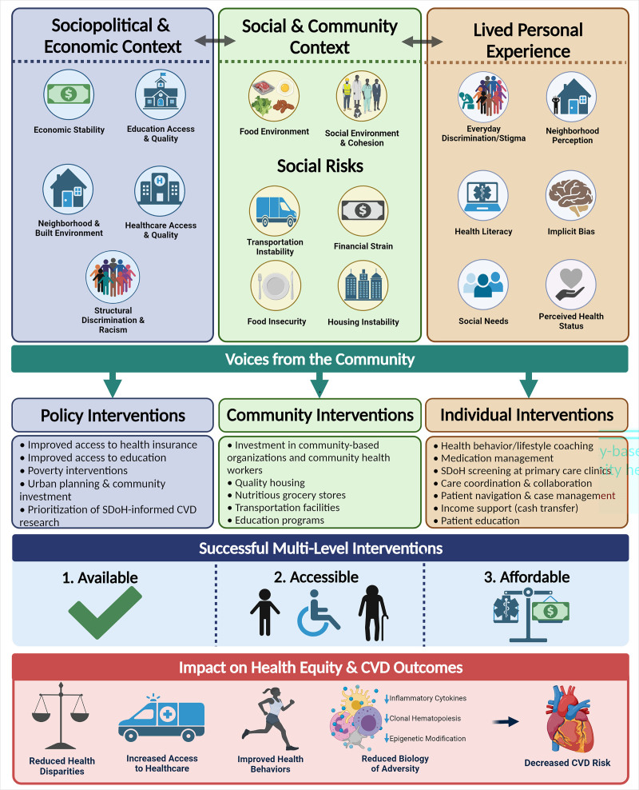

Figure 17: Integration of the social determinants of health (SDoH) into multilevel cardiovascular health interventions, from Powel-Wiley et al.[90]

#### Deprivation

Deprivation is strongly associated with multiple CVD risk factors, rates of CVD and poor outcomes from CVD. Smoking, lower physical activity and obesity are all more common in more deprived areas, and these in turn increase risk of hypertension, atrial fibrillation and high cholesterol – all health risk factors for CVD. People from across the more deprived areas in England are 30% more likely to have hypertension compared to those living in the least deprived areas.

Statistics from GP registers show that Tower Hamlets has high levels of deprivation and the majority of the population is in the two most deprived quintiles (Figure 18). In numbers terms this group makes up the highest number of people with long-term conditions (Figure 19). However, in proportional terms the most deprived group has the highest rates of long-term conditions in Tower Hamlets (Figure 20).

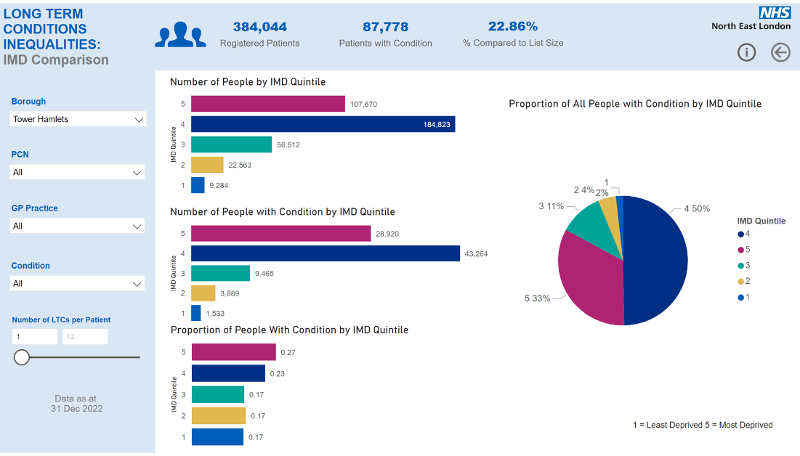

Figure 18: Number of GP-registered patients by national IMD quintile (NEL LTC dashboard)



Number of people with a long-term condition, by deprivation quintile

Figure 19: Number of GP-registered patients with a long-term condition by IMD quintile (NEL LTC dashboard)



Proportion of people with a long-term condition, by deprivation quintile

Figure 20: Proportion of GP-registered patients with a long-term condition by IMD quintile (NEL LTC dashboard)

**In London, as is the case across England, there is a clear trend that local authority deprivation level is associated with higher levels of premature mortality from CVD. In this chart, Tower Hamlets is highlighted as a black triangle and our neighbouring boroughs in NEL ICB are highlighted.**

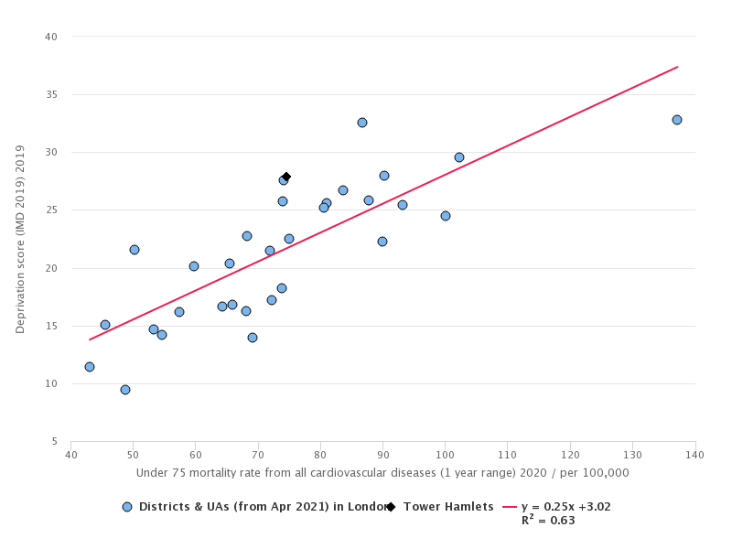

Barking & Dagenham

Newham

Hackney

Tower Hamlets

Waltham Forest

Redbridge

Havering

Figure 21: London local authorities by deprivation score (y) and under-75 mortality from CVD, 2020/21 (directly standardised rate per 100,000 population). Source: Fingertips.

CVD is one of the biggest single causes of the mortality gap between least and most deprived groups in Tower Hamlets (Figure 23, 24), and the gap in life expectancy between most and least deprived quintiles in Tower Hamlets is widening over time (Figure 22).

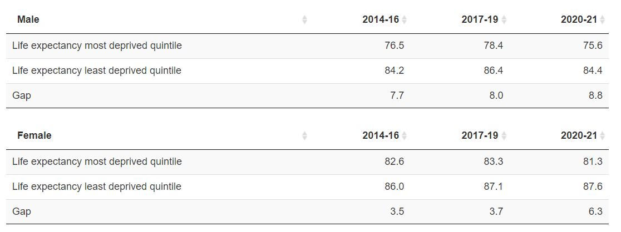

Figure 22: Inequality in life expectancy overall between the most and least deprived quintile of Tower Hamlets, 2014 to 2016 to 2020 to 2021. Source: Office for Health Improvement and Disparities based on ONS death registration data and mid year population estimates for the relevant years, and Department for Levelling Up, Housing and Communities Index of Multiple Deprivation 2019 (for 2017 to 2019 and 2020 to 2021 data) and Index of Multiple Deprivation 2015 (for 2014 to 2016 data). Where provided, results for 2020-21 are based on 2020 population data.

For both men and women, circulatory diseases have been a major contributor to this gap from 2014-2019. COVID-19 was then the largest contributor to the life expectancy gap between most and least deprived quintiles in 2020/21, and importantly CVD is a major risk factor for COVID-19 mortality.

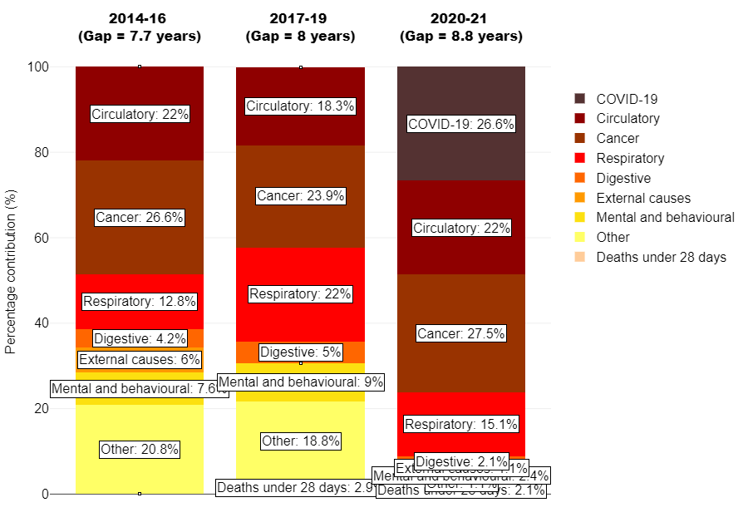

Figure 23: Breakdown of the life expectancy gap between the most and least deprived quintiles of Tower Hamlets by cause of death, 2014 to 2016 to 2020 to 2021, Males

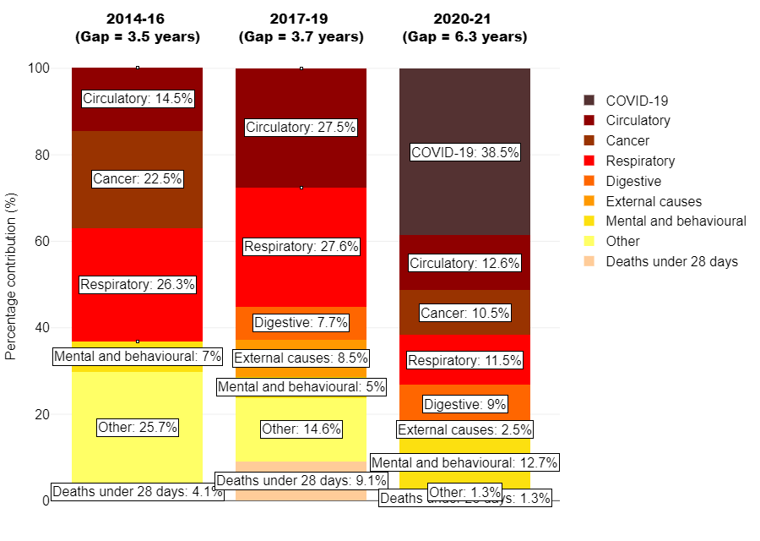

Figure 24: Breakdown of the life expectancy gap between the most and least deprived quintiles of Tower Hamlets by cause of death, 2014 to 2016 to 2020 to 2021, Females

#### Homeless populations

A 2020 global systematic review found that people experiencing homelessness have an approximately three times greater risk of CVD than housed individuals, and an increased CVD mortality (age-standardised mortality ratio range: 2.6–6.4).[91] Compared with non-homeless individuals, hypertension was more likely in homeless people, but at a pooled odds ratio of 1.38–1.75 this does not explain the entirety of difference in CVD prevalence or mortality.

Latest QOF data on rates of some cardiovascular diseases for patients registered to the E1 Health Centre, a specialist homeless practice, shows that[92]:

* 0.18% of registered patients had heart failure, which is lower than the wider Tower Hamlets population prevalence of 0.4% recorded on the Long Term Conditions Register[93]
* 7.1% of registered patients had hypertension, similar to the wider population prevalence of 7.13% recorded on the Long Term Conditions Register
* 1.33% of registered patients had coronary heart disease, similar to the wider population prevalence of 1.44% recorded on the Long Term Conditions Register.

However, this data is partial and is highly unlikely to cover the totality of the homeless population in Tower Hamlets – though the extent to which it does represent the population is unknown as data is so limited. Data on homeless groups across NEL is however continually improving: recently, NEL ICB added a flag for “ever homeless” in the latest version of their patient master index.[94]

#### Learning disabilities

*The following summarises information on CVD risks for those with a learning disability set out in the 2018 PHE report ‘*[*Health Inequalities: Cardiovascular Disease’*](https://www.google.com/url?sa=t&rct=j&q=&esrc=s&source=web&cd=&cad=rja&uact=8&ved=2ahUKEwjl4eqf4Or9AhUmhf0HHX6jDwEQFnoECAgQAQ&url=https%3A%2F%2Ffingertips.phe.org.uk%2Fdocuments%2FHealth_inequalities_cardiovascular_disease.pdf&usg=AOvVaw3tfd3DgKZJla2BeQFpQPx0)*.*

**Prevalence**

Primary care records of nearly 15,000 adults with learning disabilities in England indicate that the prevalence of ischemic heart disease (IHD) is lower than in the general population (prevalence ratio 0.65 (95% CI 0.57, 0.74) but rates of heart failure are higher (prevalence ratio 2.26 (95% 1.84, 2.78) as are rates of stroke and transient ischemic attack (TIA) (prevalence ratio 1.74 (95% CI 1.52 to 1.98).[95] Cardiovascular disease was the second-most most frequently reported long-term health condition for people with LD who died in 2021 and received an initial review.[96]

**Mortality**

After adjusting for age and gender, death rates for MI and chronic ischaemic heart disease in people with learning disabilities were **double** those in the general population. The Confidential Inquiry into Premature Deaths of People with Learning Disabilities (CIPOLD) found that heart and circulatory disorders were the most common underlying cause of death of people with learning disabilities (**22%** of deaths) and the second most common immediate cause of death (21% of deaths) after respiratory disorders (**34%**). The LeDeR Annual Report for 2021 found that deaths occurred 22 years early for men and 26 years early for women with LD, compared to the general population.[97] A systematic review on causes of death of people with Down’s syndrome found that congenital heart anomalies were reported as the leading primary or underlying cause of mortality in the majority of the studies.

**Risks**

CVDs are associated with some genetic causes of learning disabilities. For example, almost half of all people with Down’s syndrome are affected by congenital heart defects.

Risk factors for CVD are also common in people with learning disabilities. People with learning disabilities may have poor diets, high rates of obesity, low levels of physical activity. Whilst amongst the overall population of people with learning disabilities known to specialist services rates of smoking and drinking alcohol are lower than the general population, rates of smoking and drinking are higher amongst the sub-set of those with mild learning disabilities. Evidence also suggests a significantly higher prevalence of diabetes in people with learning disabilities than in the general population.

# CVD in Tower Hamlets

Summary:

* In spite of our young population, 22.7% of people in Tower Hamlets are on a long-term conditions register. Across NEL ICB boroughs this is even higher at 26.1%.[98] CVD and its risk factors are among the highest contributors long term conditions in Tower Hamlets, with hypertension, obesity, CHD, stroke/TIA, atrial fibrillation and heart failure all appearing in the top 15 list of long term conditions.[99]
* CVD is a major cause of poor health, mortality and inequality in life expectancy between the most and least deprived groups in Tower Hamlets.
* CVD is also likely to continue to be a major issue for the population in Tower Hamlets in years to come. The population in NEL is set to grow by 364,000 people over next 20 years, with the largest increases in 40+ age groups.[100]

## Prevalence

Tower Hamlets has below the England average prevalence of all-age, age-standardised coronary heart disease (CHD), stroke, atrial fibrillation and heart failure recorded via GP Quality Outcomes Framework reporting (see trend charts below).[101]

### Inequalities

In Tower Hamlets men account for two thirds of CVD cases , and there is a higher rate in the Bangladeshi population that other ethnic groups.[102]

However, local analysis has determined that of those who die from a heart attack, without having had any contact with secondary care in the two years prior to the event, the majority are white men.[103]

### Geographical comparisons

Tower Hamlets has lower estimated heart/circulatory disease prevalence (5%) than many of its neighbours – likely due to its young population.[104] All NEL boroughs have a significantly lower proportion of patients diagnosed with CHD than the England average.[105]

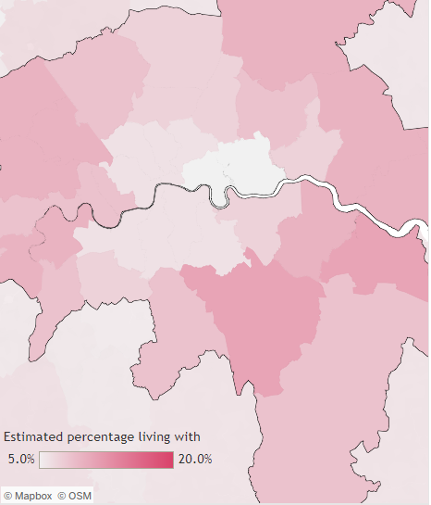

Figure 25: BHF estimates of the % of people living with heart or circulatory diseases, based on latest prevalence data from NHS Digital. Source: BHF statistical compendium

### Trends over time

Age-standardised rates of CHD, stroke, and heart failure are consistently lower than England over time, but this is likely due to our young population. For CHD, there is a downward trend in prevalence in line with England averages. For stroke, rates locally are reducing whilst England rates rise. England averages for heart failure QOF prevalence have risen more sharply in recent years, which has not been seen in Tower Hamlets.

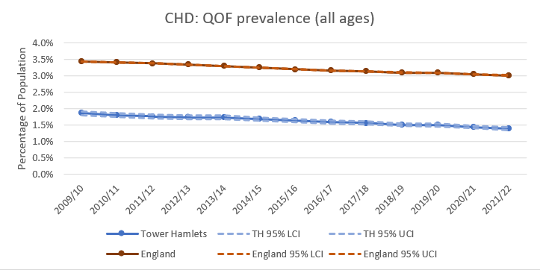

Figure 26: % of GP-registered population in Tower Hamlets (blue) and England (red) with CHD recorded over time. Source: QOF.

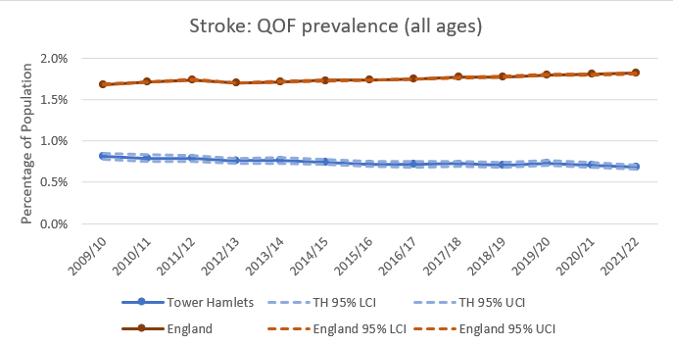

Figure 27: % of GP-registered population in Tower Hamlets (blue) and England (red) with stroke recorded over time. Source: QOF.

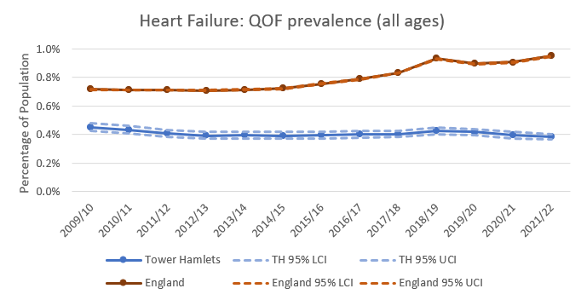

Figure 28: % of GP-registered population in Tower Hamlets (blue) and England (red) with heart failure recorded over time. Source: QOF.

## Admissions

### Trends over time

* Tower Hamlets has similar Directly Standardised Rates (DSR) of admissions to England and NEL ICB for myocardial infarction, ischaemic heart disease (elective and emergency admissions), and cerebrovascular disease (elective and emergency admissions).
* Ischaemic heart disease emergency admissions in Tower Hamlets (and across NEL ICB boroughs) were previously higher than the England average (2015-17) but have come down in recent years and are closer to national averages (Figure 29).

Figure 29: Directly standardised rate per 100,000 population of ischaemic heart disease emergency admissions in Tower Hamlets, NEL ICB and England over time. Source: HES.

* However ischaemic heart disease elective admissions are rising, and above national averages, in the most recent year of data (2021/22) (Figure 30). It is too early to say if this trend will continue upwards.

Figure 30: Directly standardised rate per 100,000 population of ischaemic heart disease elective admissions in Tower Hamlets, NEL ICB and England over time. Source: HES.

* Due to low numbers, it was not possible to calculate DSRs for cardiac arrest or stroke admissions and so crude rates were used. These show both Tower Hamlets and the wider NEL ICB area historically experiencing lower cardiac arrest admissions per 100,000 population than the England rate, with some variation in this from 2019/20 to 2021/22 as national rates of cardiac arrest admissions fell sharply in the first year of the COVID19 pandemic before rising again in 2021/22 (Figures 31, 32).

Figure 31: Crude rate per 100,000 population of all stroke admissions in Tower Hamlets, NEL ICB, Hackney and England over time. Source: HES.

Figure 32: Crude rate per 100,000 population of cardiac arrest admissions in Tower Hamlets, NEL ICB, Hackney and England over time. Source: HES.

### Inequalities

#### Deprivation

CVD admissions rise with levels of deprivation, with those in the lowest two locally-adjusted quintiles showing a significant difference in age-standardised admission rates compared to those in the highest two (figure 33).

Note: This analysis compares IMD scores at a local rather than national level, so the below graph shows the more and least deprived halves of the Tower Hamlets population compared to one another.

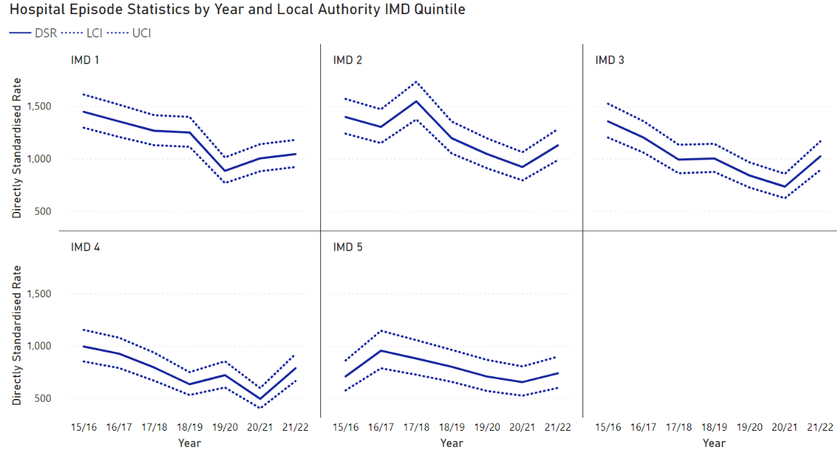

Figure 33: Directly standardised rates (European Standard Population) of CVD admissions in Tower Hamlets by locally-compared IMD grouping, with 95% confidence intervals. Source: HES.

#### Ethnicity

Splitting CVD-related admissions by ethnicity (and again using directly standardised rates), Bangladeshi and other Asian ethnic groups have higher admissions than Black/Black-British, White or Other ethnic groups. (Mixed ethnic group had numbers too small to calculate a directly standardised rate with confidence.) Confidence intervals are not shown on this graph as they render it difficult to read, however it is worth noting that the fluctuations in the graph below for the ‘other Asian’ groups are not statistically significant at the 95% confidence level.

Figure 34: Directly standardised rates (European Standard Population) of CVD-related admissions by ethnic group. Source: HES for admissions; ethnicity denominator figures from the CEG dashboard via the East London Database.

#### Sex

CVD-related admissions are consistently and considerably higher for men than women.

Figure 35: Directly standardised rates (European Standard Population) of CVD-related admissions by sex. Source: HES.

## Mortality

In Tower Hamlets, heart and circulatory diseases kill 1 in 4 people and someone dies from heart and circulatory diseases every 31 hours.[106]

For those aged over-65, the mortality rate from all cardiovascular diseases is similar in Tower Hamlets to its statistical neighbours, but higher than the London average (though confidence intervals overlap so it is hard to tell if this shows a true difference).[107]

Looking across all UK local authorities, Tower Hamlets is in the **highest third** (115th out of 372 local authorities) for age-standardised death rate from coronary heart disease, and the lowest 40% of local authorities (226th) for age-standardised death rate from all heart and circulatory diseases combined (219.6 per 100,000 population per year, with 256 annual deaths on average from 2018-20).[108] Tower Hamlets has historically had higher mortality rates from circulatory diseases than the England average, though in 2019 and 2021 they fell closer in line with national rates (Figure 36).

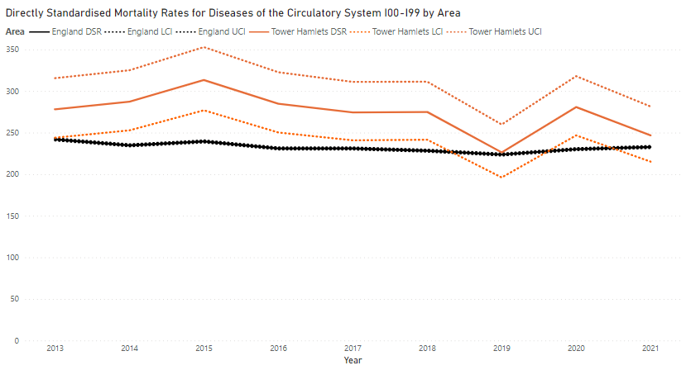

Figure 36: Directly Standardised mortality rates for diseases of the circulatory system (ICD codes 100-199) in Tower Hamlets (orange) and England (black). Source: NOMIS.

Ischaemic heart diseases and cerebrovascular diseases make up the majority of CVD mortality in Tower Hamlets. Both have been declining over the past decade but with a slight rise in 2020-21, likely linked to the COVID19 pandemic.

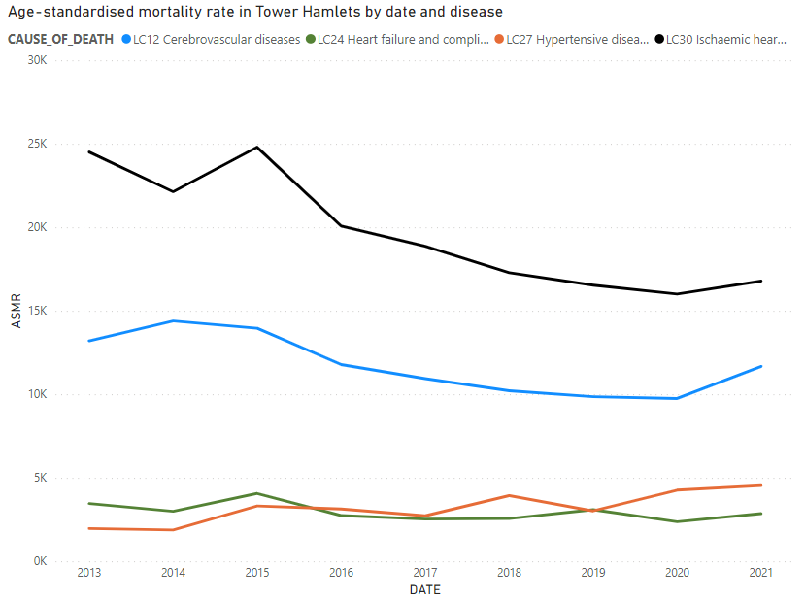

Figure 37: Age-standardised mortality rates for cerebrovascular diseases (light blue), heart failure (green), hypertensive diseases (orange) and ischaemic heart disease (black) (ICD codes 100-199) in Tower Hamlets. Source: NOMIS.

### Inequalities

#### Sex

For all diseases of the circulatory system, all ages, age-standardised mortality rates by gender and area over time:

* Premature mortality in both men and women has been reduced dramatically since 2001-3, at a faster rate for men (though starting from a higher rate at the outset) (Figure 38). This mirrors national trends so is likely due to changes in lifestyle factors, detection of risk and support to reduce risks and recover from CVD events rather than from population changes (as the wider national population has been ageing since 2001-3).[109]
* Men have consistently higher mortality than women, and the gap is similar in Tower Hamlets to our statistical and geographical neighbour, Hackney, and to England and London (Figure 39). The gap between women and men varies by age band, with smaller gaps in younger and older age groups and larger gaps from 45-55 years and 65-75 years.[110]
* The gap between men and women is clear for ischaemic heart diseases but not for cerebrovascular diseases (Figure 40).
* There appears to be an uptick in both age-standardised mortality rate and admissions in 2021, though we would need to see data from 2022 and (in time) 2023 once available to assess whether this trend holds.

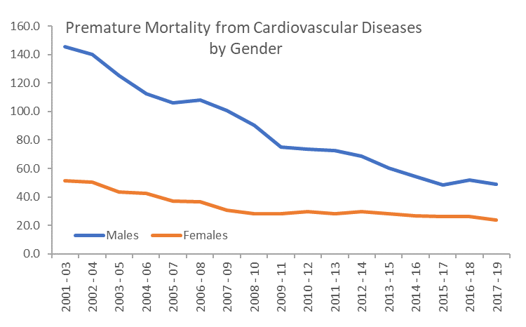

Figure 38: Premature mortality from CVD by sex, Tower Hamlets. Source: Fingertips (PHOF indicators).

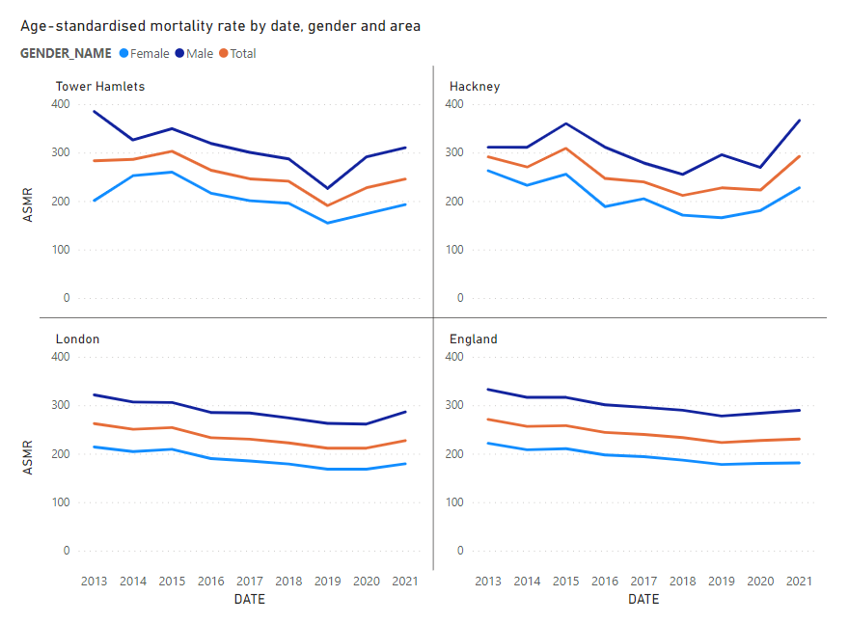

Figure 39: Age-standardised mortality rate by date and sex across Tower Hamlets, Hackney, London and England. Source: NOMIS.

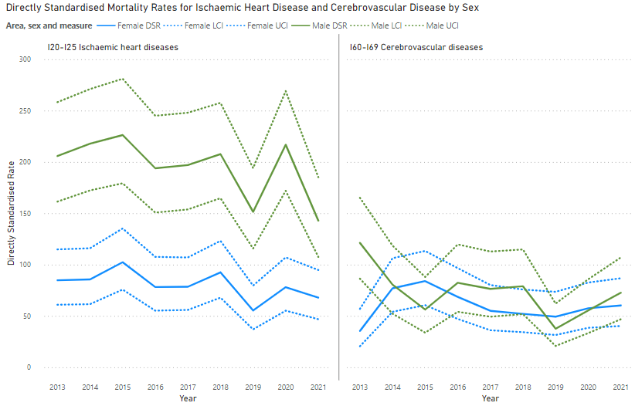

Figure 40: Directly standardised mortality rate for ischaemic heart disease (left) and cerebrovascular disease (right) by date and gender, with 95% confidence intervals. Source: NOMIS.

### Premature mortality

Although Tower Hamlets is in the bottom 40% of UK local authorities for age-standardised all-age mortality from heart and circulatory diseases (219.6 per 100,000 population per year), it is in the **highest third** of UK local authorities for **premature deaths** from heart and circulatory diseases (80.5 deaths per year per 100,000 population). The number of premature deaths from CVD in any local authority is much lower than the number of all-age deaths, so it is possible to have relatively high premature mortality rates and relatively low all-age mortality rates. Importantly, the borough also has the second-worst premature mortality rate in London from all causes, so this issue is not distinct to CVD-related deaths (though there will be overlap between the two as CVD is such a major cause of premature mortality).[111]

Comparing age-standardised rates to London for under-75s mortality from CVD, Tower Hamlets has consistently higher rates but these are reducing over time and are now in line with London rates.

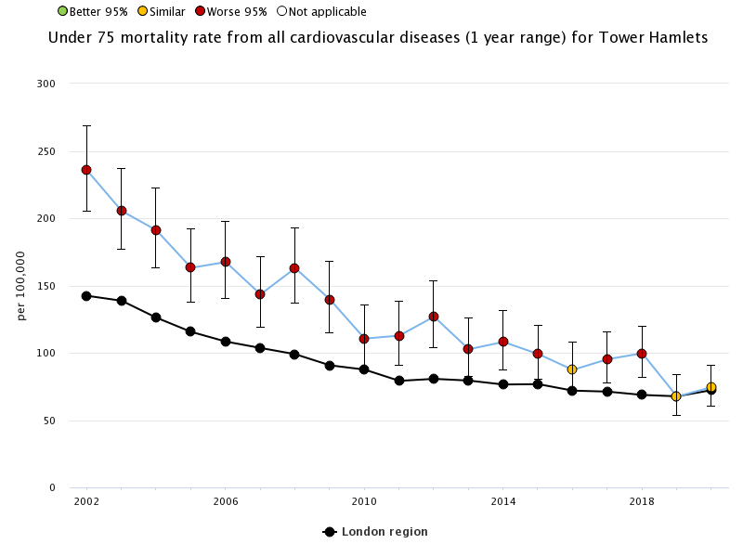

Figure 41: Under-75 mortality rate from all CVDs in Tower Hamlets and London. Source: Fingertips.

OHID now publishes data for 2021 on CVD mortality in under-75s considered preventable.[112] Tower Hamlets is in the worst four London local authorities for this measure – though confidence intervals for all local authorities are wide and overlapping, so it is difficult to tell for many local authorities if a true difference exists.[113]

#### Inequalities

CVD premature mortality is dropping for men but progress is beginning to slow. TOWER HAMLETS remains in London’s worst 4 local authorities for premature mortality rate from CVD for men, and in the worst 5 for women – though confidence intervals for all local authorities are wide and overlapping, so it is difficult to tell for many local authorities if a true difference exists.[114]

# Policy context

The following focuses on CVD-specific policies and strategies, however there is a much wider policy context on initiatives to reduce modifiable CVD risk factors such as smoking, obesity, poor diet and limited physical activity.

## National

The **NHS Long Term Plan** focuses on tackling health inequalities and the prevention of ill health and aims to prevent 150,000 strokes and heart attacks as a result of CVD, over the next ten years. There is also a commitment to tackle obesity, alcohol dependence and smoking. This includes specific funding and support for three key at-risk groups: inpatients, pregnant people, and those in community mental health services.

The national **Core20PLUS5 framework** to reduce inequalities also highlights CVD risk factors, defining a target population for further support as:

* ‘Core20’, the most deprived 20% of the population
* ‘PLUS’, locally-agreed priority population groups such as those with a learning disability
* The 5 clinical areas needed accelerated improvement – which include minimising CVD risk through hypertension case-finding and optimal management, and lipid optimal management, and ensuring annual health checks for 60% of those living with SMI.[115]

King’s Health Partners have also highlighted CVD risk factors in their ‘**Vital 5’ initiative** to improve population health: blood pressure, obesity, mental health, smoking status and alcohol intake.[116]

The **National Cardiovascular Disease (CVD) Prevention Recovery plan** for 2022-2023 focusses on four high-impact areas, to restore detection, monitoring and treatment of high-risk conditions. These are:

* Monitoring and targeting unwarranted variation
* Supporting a system-wide response
* Enabling system leadership
* Increasing public education

The **NHS England National Prevention Programme** has set out the most effective interventions to reduce CVD risk factors which have a robust evidence base, which are outlined below under section 6: ‘what works’.[117]

In addition, **the Fuller Stocktake** has highlighted the particular needs of developing primary care and local support offers, which is relevant to the detection and prevention of CVD.[118]

The development of ICSs presents opportunities to develop aligned approaches across primary care (with its reach into communities), secondary and tertiary care (which have daily contact with some of the highest risk people). There is also an opportunity to build on community insights gained during the Covid-19 pandemic, and to gain deeper understanding of local issues through joined up data (in Tower Hamlets, for example, the new Health Determinants Research Collaboration).

## Local

The **Tower Hamlets Strategic Plan 2019-2022** identifies healthy life expectancy as an important headline measure of the Health & Wellbeing Strategy and the Strategic Plan of the Council – taking action on CVD will be key to increasing healthy life expectancy.

The **Tower Hamlets Health and Wellbeing Strategy 2021-25** has ambitions to make Tower Hamlets a place where everyone including people with CVD can live physically and mentally healthy and active lives, and a place where people get the support to do so.

**Tower Hamlets Living Well** programme, linking to the Localities Programme under Tower Hamlets Together, has the following vision for localities and neighbourhoods:

* Improve the overall health and wellbeing for the Tower Hamlets population ​
* Reduce inequality of access to services and reduce inequalities in health and social outcomes for the Tower Hamlets population ​
* Focus on the wider social and economic determinants of health for the whole population enhancing early intervention & prevention models ​
* Coordinate and plan services with residents around their individual needs​
* Create empowered communities who are better able to support themselves ​
* Prevent ill-health and increase their ability to sustainably manage their own wellbeing ​
* Listen to and act on what matters to residents and patients ​
* Improve the quality of care received and patient experience in a sustainable way​:

The **Tower Hamlets Together ‘I Statements’** which were brought together by residents include:

* ‘I understand the ways to live a healthy life’, linking to reducing obesity, smoking, substance misuse and increasing physical activity and uptake of primary checks.’
* ‘Regardless of who I am, I can access care services for my physical health’, linking to issues of inequality and healthy life expectancy.

The **North London Cardiovascular Disease Prevention Strategy 2023/24**, which has been set out by the North London ODN, includes the following ambitions for North London[119]:

* Improve detection of atrial fibrillation to 85% of expected prevalence[120] and ensure appropriate stroke risk reduction through anticoagulation;
* Improve detection of undiagnosed hypertension (to 80% of expected prevalence[121]) and ensure those with hypertension are controlled to target;
* Ensure 40% of eligible patients take up NHS Health Check per 5-year cycle;
* Ensure patients who have a history of CVD are on optimal lipid lowering therapy;
* Improve detection of Familial Hypercholesterolaemia to 25% of expected prevalence[122]
* Improve diagnosis of Heart Failure (HF), ensure optimal management of these patients
* Improve uptake of cardiac rehabilitation to 85% of eligible patients, by 2028 in line with Long Term Plan ambitions.

In addition, the **NEL ICB Integrated Care Strategy** focuses on tacking deprivation and inequality, supporting those living with long term conditions, expanding social prescribing, tackling digital exclusion and preventing Long-Term Conditions in order to improve healthy life expectancy and identify and address unmet need.[123]

NEL ICB is bringing together its **NEL ICB CVD Prevention Plans 2023-24** in line with both the ODN CVD Prevention Strategy and the NEL ICB Integrated Care Strategy. Hypertension, Atrial Fibrillation, Lipid Management, Cardiac Rehabilitation and Heart Failure are priority conditions, with an overall focus on targeting interventions for detection and early identification of CVD and CVD risk factors and their optimum management. In line with NEL’s Integrated Care Strategy, projects are primarily place-based.

# What works, what is on offer in TOWER HAMLETS, and have any gaps or issues been flagged?

The below sets out, for different offers detecting and reducing CVD risk:

* An outline of offers in Tower Hamlets to detect and reduce CVD risks and manage CVD.
* The evidence base – does it work?
* A summary of performance indicators (where these are available), possible gaps and issues flagged by stakeholders
* Recommendations.

**Note**: This report is a needs assessment. This means the report seeks to investigate and understand what the impact of CVD is on the population of Tower Hamlets, the level of need for a range of CVD services, and the range of interventions in place to address this need. The report is not an evaluation; it has not been designed or resourced to assess the quality or impact of existing services.

## Overview: cost-effective and evidence-based preventative interventions

NHS England, OHID and NICE have jointly produced a summary of evidence-based and cost-effective preventative interventions for CVD as part of the national CVD Prevention Programme.[124] These are calculated to deliver the greatest benefits in terms of:

* Health inequalities
* Excess mortality
* Admission rates
* A return on investment over 3 years.

Interventions to detect CVD risks[125]:

* Community pharmacy hypertension case finding. PHE estimates that for a 20% improvement in management of hypertension, to 140/90 mmHg target, system net savings would be estimated to be c£14 p.a. per controlled patient over a 5 year horizon. Of these, c£5.75 would accrue to the NHS and c£7.91 would accrue to local authorities[126]
* Cholesterol search and risk stratification. This involves case finding and treatment of hypercholesterolaemia in people with high CVD-risk conditions, post-acute CVD event and in those with familial hypercholesterolaemia. Every 1mmol/l reduction in low-density lipoproteins (LDL) cholesterol reduces risk of a cardiovascular event by 25%.[127]
* NHS health check. Across England, 1 in 4 NHS Health Check attendees are identified as at risk of CVD. NHS England calculates that at a 50% take up rate, every £1 spent on the current NHS Health Check programme achieves a return of £2.93.[128]
* Case finding and direct-acting oral anticoagulation to prevent atrial fibrillation related strokes. To note, the National Screening Committee is currently reviewing evidence on the risks and benefits of expanding atrial fibrillation case finding.

Interventions to reduce modifiable CVD risks[129]:

* **Tobacco dependence identification and treatment**. According to the NHS Secondary Prevention Programme, opt-out tobacco treatment reduces readmission (6%) and A&E attendance (3%) at 1 year and reduces smoking-related physician visits (specialist 5% and GP 2%).[130]
* **Weight management services** for those suffering from obesity, particularly those with diabetes and/or hypertension, with effective weight management leading to improvements in blood pressure, blood glucose, HbA1C and triglycerides.[131] A review on the long-term effects of weight-reducing diets in people with hypertension found that a reduction in body weight of approximately 4 kg would achieve a reduction of approximately 4.5 mmHg systolic blood pressure and of approximately 3.2 mmHg diastolic blood pressure.[132]
* **Identification of people with alcohol dependency**, provision of specialist interventions and referral into community services for ongoing support and treatment. The NHS Secondary Prevention Programme focuses this recommendation on acute hospitals, with a pilot of alcohol care teams in acute hospitals showing a 3% reduction in readmissions during its first year and a return on investment of £3.85 for every £1 invested in the programme.[133]

Interventions to manage CVD[134]:

* **Cardiac rehabilitation** for patients post-ACS and diagnosis of heart failure. According to the NHS Secondary Prevention Programme, Cardiac rehab reduces readmissions by an estimated 31% over 6-12 months.[135]
* **Optimisation of hypertension treatment.** NICE references a major systematic review which found that, in populations whose high blood pressure was corrected, every 10mmHg reduction in BP resulted in a 17% reduction in coronary heart disease, a 27% reduction in stroke, a 28% reduction in heart failure, and a significant 13% reduction in all-cause mortality.

Out of scope for this HNA:

* Optimisation of heart failure treatment through annual reviews
* Optimising management post ACS, including lipid management.
* Implementing the diabetes 9 care processes. According to the NHS Secondary Prevention Programme, this is associated with reductions in all types of emergency admissions by 22-26%.[136]

The NHS RightCare and PHE CVD Prevention Pathway also summarises evidence-based and high impact interventions to prevent and manage CVD and reduce inequalities[137]:

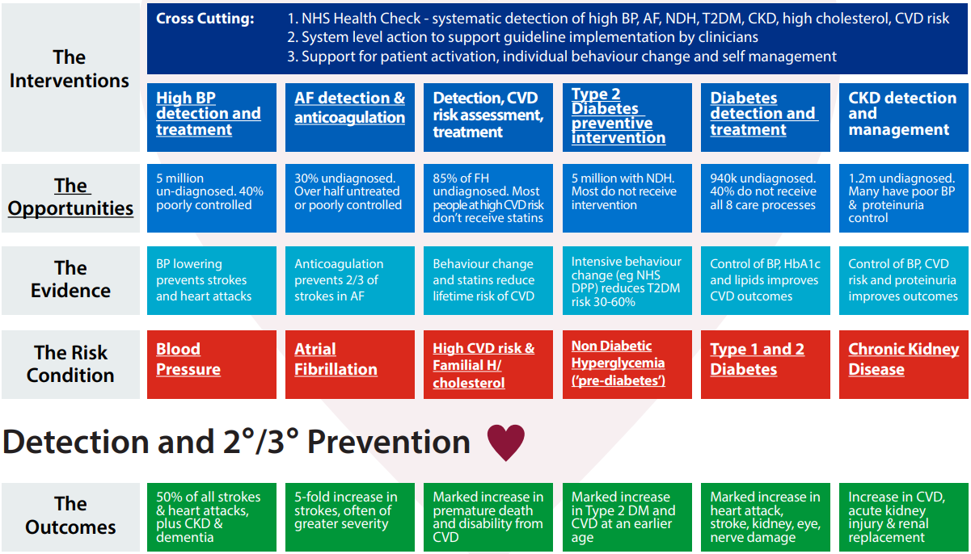

Figure 42: NHS RightCare and PHE CVD Prevention Pathway.

The pathway highlights the need for:

* Managing high risk conditions
* Cross-cutting interventions to prevent CVD events
* High value interventions for hypertension, atrial fibrillation, high cholesterol, diabetes, non-diabetic hyperglycaemia and chronic kidney disease. These conditions impact stroke and heart attack incidence, and require early diagnosis and treatment - most of which takes place through primary care.

Alongside this, NICE has produced guidelines for professionals on detecting higher risk, prescribing treatment like statins, supporting lifestyle changes and reducing exposure to modifiable risk factors.[138]

## Context for CVD support offers: the COVID19 pandemic

The COVID19 pandemic is important context as we review local data comparing year-on-year performance in CVD detection and management. It impacted CVD risk factor detection and treatment across England, and in many cases this has not yet returned to normal performance.

CVDPREVENT data from 93% of GP practices in England shows that from March 2020-21[139]:

* Hypertension diagnoses were 30% lower than the previous year
* Blood pressure monitoring reduced by 25.2 percentage points (see Figure 43), and a similar pattern of reduction was seen for cholesterol readings (Figure 44);
* Treatment of hypertension to target dropped 21.4 percentage points;
* The drops were similar across deprivation quintiles and ethnic groups.

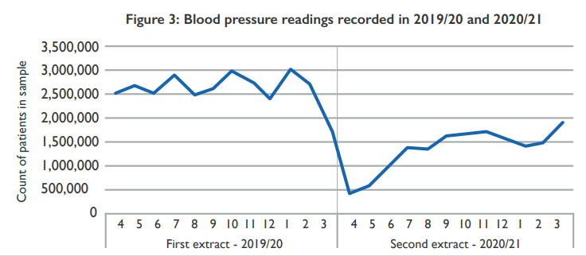

Figure 43: Number of blood pressure readings recorded by month from 2019-21, England total. Source: CVD Prevent.

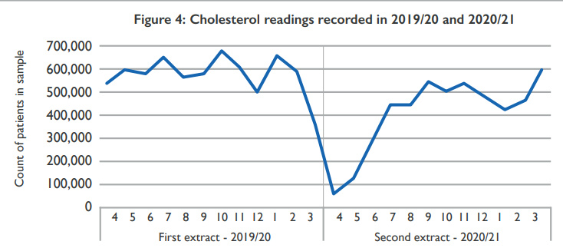

Figure 44: Count of cholesterol readings recorded by month from 2019-21, England total. Source: CVD Prevent.

## Detecting CVD risk

### NHS Health Checks

#### What is it

NHS Health Checks are for people aged 40 to 74, to identify risks related to CVD and other conditions, and to support lifestyle risk management. Those with pre-existing relevant conditions are not eligible; those without are invited every 5 years. Health checks are provided by GPs and results are included in the primary care record to enable ongoing management.

For more information on the Health Checks programme see https://www.healthcheck.nhs.uk/.

There are also online NHS tools available such as the Heart Age Test[140] or the How Are You Now quiz[141].

#### Does it work?

National research shows that the health checks programme is cost effective, can prevent illness and has the potential to save 250 – 500 lives each year across England.[142],[143] It also shows that there is equitable take up of checks among high CVD risk groups and prioritising these groups is cost effective.[144]

#### Tower Hamlets offer

Alongside the standard health checks offer, Tower Hamlets has also added a 'high risk health check' package to fund annual reviews for anyone with moderate risk for CVD (a QRisk score >10) who are not on another care package like hypertension or diabetes. Primary care dashboards by CEG flag for GP practices which patients may be at higher risk or needing review, for example for statins prescriptions.

The only standard blood check is cholesterol, but there has been a move to monitor HB1aC in Tower Hamlets and in some practices they run QDiabetes score with partial figures to see if HB1AC check helpful – not widespread at present but could be.

#### Performance, gaps and issues

The below sets out summary statistics from the OHID Fingertips tool which summarises GP-reported data on the % of all eligible people invited for an NHS Health Check in the year 2021/22, the % of all eligible people receiving one, and the % of those invited taking them up.[145]

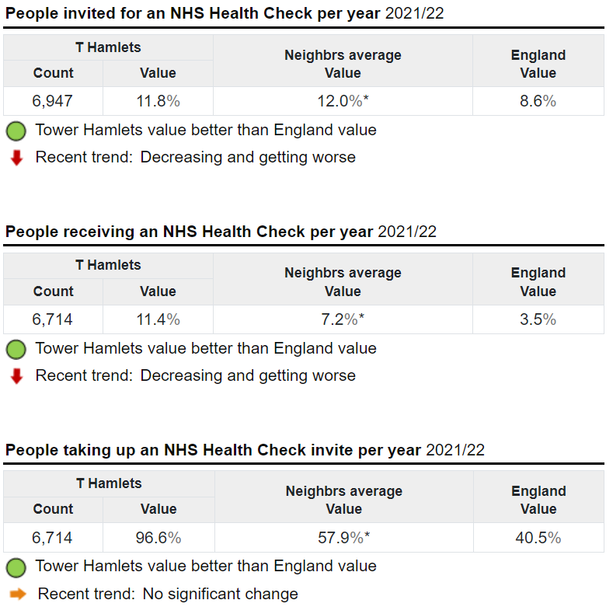

Figure 45: Summary of Tower Hamlets NHS Health Checks performance, compared with CIPFA statistical neighbours average and England average values. Source: Fingertips

##### Follow-up actions from health checks

The following summary of follow-up actions from health checks uses data from the CEG Health Checks Dashboard.[146]

**Lifestyle referrals**

The national target is for 80% of those eligible for a health check to have had a discussion about a lifestyle referral (such as weight management or smoking cessation, depending on their individual risk factors). In Tower Hamlets, for the latest report in February 2023 this was just 51%, with variation across GP practices from 10%-96%. This is similar to City & Hackney (48%).

**Annual review**

The national target is for 70% of those with a QRisk score over 20 to receive an annual review in any 15-month period. In Tower Hamlets, for the latest reporting year February 2022-23, this was 33.2% - but with variation across GP practices from none recorded or just 2.4%, to 79.7%.

In addition to national targets and incentive schemes, the local enhanced specification for GPs (the ICCQ LES) includes a financial incentive for annual care planning for those with type 2 diabetes or established CVD.

**Statins prescription**

The national target is for 60% of those with a QRisk score over 20 to be prescribed statins. In Tower Hamlets for the latest reporting year February 2022-23, this was 58.6% - but with substantial variation across GP practices from 37.5% to 83.3%.

**Pulse check recorded**

Most GP practices in Tower Hamlets are above the national target of 80% for the % of those with a recent NHS Health Check over 65 years old with a pulse check recorded.

**Carer status recorded**

Tower Hamlets performs well on recording carer status for those undergoing health checks, with 92.1% having their carer status recorded overall and all GP practices above the national target of 80%.

**Blood pressure recording**

The % of patients whose blood pressure was recorded over the past 5 years has previously been higher in Tower Hamlets than the national average, but this has been reducing steadily over the past 8 years, markedly so during the Covid-19 pandemic, and is now below the England average.[147]

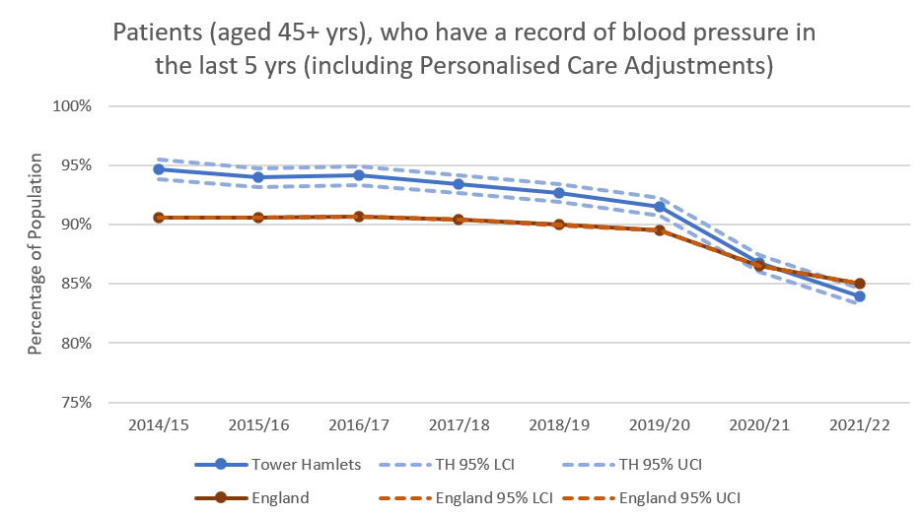

Figure 46: Percentage of patients aged over 45 with a QOF-reported record of blood pressure in the last 5 years. Source: Fingertips

**Smoking status recording**

The below graph outlines what % of patients with the following conditions had their smoking status recorded over the past year: coronary heart disease, PAD, stroke or TIA, hypertension, diabetes, COPD, CKD, asthma, schizophrenia, bipolar affective disorder or other psychoses. These include types of CVD, and also risk factors for CVD such as diabetes and hypertension. Tower Hamlets has previously had similar rates to national averages but dipped below national levels in 2019-22. This may signal a particularly strong local impact of the Covid-19 pandemic. The trend is now upwards but Tower Hamlets remains below the national average.

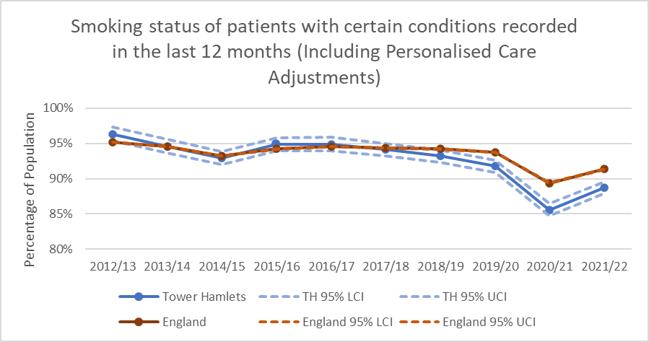

Figure 47: Percentage of patients with a QOF-reported record of smoking status in the last 12 months. Source: Fingertips

**Support for smokers**

Tower Hamlets has been falling below England average for the % of recorded smokers (15+ years old) who have an offer of support and treatment recorded in the last 24 months. Of course, this metric depends on GP recording of both smokers and interventions to support them – it does not necessarily represent either the true number of smokers in Tower Hamlets or the true level of support offered to them. However, recording is of itself important as it enables local and national health systems to track offers of support to smokers.

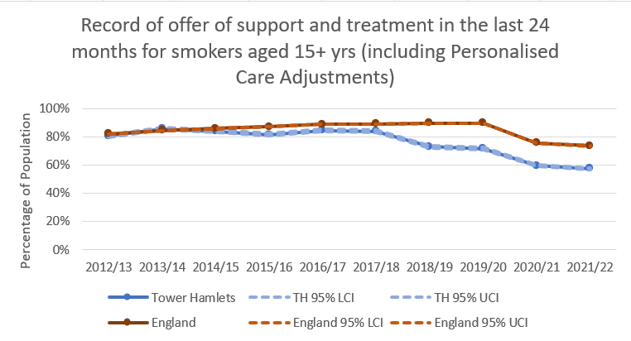

Figure 48: Percentage of patients with a QOF-reported record of smoking support/treatment offer (15+ years) in the last 24 months. Source: Fingertips

#### Recommendations

A health checks equity audit and analysis of age of diagnosis for key CVDs and CVD clinical risk factors, split by demographics, is underway for Tower Hamlets. Early findings indicate differences in the age of diagnosis across different demographics for a number of CVDs and CVD-related clinical risk factors. Once findings from both analyses are finalised, these should be considered in further service design – for example whether there is a local ‘add on’ to the scheme to provide health checks at a younger age for those in demographics at higher risk of developing CVD early in life. Service design needs strong community input (coproduction) so design fits local population access requirements.

### NHS Community Pharmacy Hypertension Case Finding Service

#### What is it

The NHS Community Pharmacy Blood Pressure Check Service is a national programme that is being rolled out across localities to support risk identification and prevention of cardiovascular disease (CVD).[148] The NHS Delivery Plan for recovery of access to primary care highlights expansion of blood pressure services in community pharmacy in 2023/24.[149]

This service aims to:

* identify people over the age of 40 who have previously not been diagnosed with hypertension (high blood pressure), and to refer those with suspected hypertension for appropriate management.
* promote healthy behaviours to service users.
* refer people identified as likely to have high blood pressure to general practice, for ongoing care to manage their blood pressure.

A community pharmacist will opportunistically measure the blood pressure of consenting adults who come into the pharmacy, by offering anyone a free blood pressure check who:

* appears to be over the age of 40;
* has not previously been identified as having hypertension or a related condition; and
* has not had their blood pressure measured by a health professional within the previous six months.

General practices can also refer patients to a participating community pharmacy for a clinic blood pressure reading or for 24-hour ambulatory blood pressure monitoring. Pharmacies can also check under-40s if they judge it to be appropriate, for example if they have other relevant risk factors.

At the end of a consultation, where readings indicate:

* normal blood pressure, the pharmacist will promote healthy behaviours.
* high blood pressure, the pharmacist will offer Ambulatory Blood Pressure Monitoring (ABPM) from the pharmacy and will also promote healthy behaviours.
* very high blood pressure, the pharmacist will urgently refer the patient to see their GP within 24 hours and the pharmacist will inform the patient’s GP practice by NHS mail or via another locally agreed platform.
* low blood pressure, the pharmacist will provide appropriate advice and may also refer the patient to their GP if there are any concerns.

All blood pressure readings are sent to the general practice from the community pharmacy so records can be updated and appropriate action taken.[150]

#### Does it work?

The NHS service is based on published research, previous pilots and the NICE guidance for high blood pressure, which includes using ambulatory measurement to confirm a diagnosis of hypertension.

#### Tower Hamlets offer

This service started in Tower Hamlets late 2022/early 2023 and has been taken up by 44 of the 49 pharmacies on the Public Health Pharmacy Contract.[151] Efforts are underway to link the programme and its outputs more closely to GP practices and community groups, so that they are aware and signposting people to the service and can also provide appropriate follow-up support where high blood pressure is found. There is an automated referral process for GP practices; referral processes could be developed for community groups.

#### Performance, gaps and issues

Data on performance is not currently available as this is a new programme, but data on referral numbers should begin to become available from late Spring 2023.

#### Recommendations

As part of this HNA we spoke to colleagues in primary care who suggested the following recommendations:

* NEL ICB to map participating pharmacies to help inform 1) local stakeholders (like GPs) and 2) further expansion of the programme into areas with limited coverage.
* Ongoing review with pharmacists as the service rolls out to understand how they are giving healthy lifestyle advice to those with normal or high blood pressure, and share best evidence-based practice on this. (For example, exploring any needs for training or toolkits on culturally-competent discussions on risk or for frontline universal training in health coaching.)
* Ongoing review of data collected on the care pathway following a blood pressure check at a pharmacy.

### Tower Hamlets Health Festivals and outreach events

#### What is it?

Tower Hamlets organises ad hoc health events that include healthy activities, health checks and health education. Events involve local and national VCS organisations alongside public health staff and local health professionals. Some events are targeted towards particular demographics or health issues.

In addition, Tower Hamlets local authority set up a Health and Wellbeing Ambassadors programme during the COVID19 pandemic. This initially focused on increasing vaccine uptake, but later moving to broader health and wellbeing topics such as mental wellbeing and cost of living. Fifteen local ambassadors went out to local thoroughfares across the borough (such as markets and Idea Stores), engaging the public in discussions about health and wellbeing and signposting them to local offers and services.

Ambassadors then recorded demographic details and key themes arising in their discussions with members of the public. A review of this data from November 2022-February 2023[152] shows:

* Diabetes, alcohol consumption and exercise were listed in the top ten most common discussion topics, whilst high blood pressure, diabetes, depression and anxiety were the top four most common single health issues noted.
* Ambassadors signposted people to a wide variety of services and offers, including local charities, food banks, health services such as A&E, a mental health crisis line, or for less urgent issues the NHS website. The most commonly signposted offers were council services and websites, and GPs (21%, 12% and 17% respectively).
* Those stopping to talk to ambassadors were more likely to be middle-aged and older people (Figure 49).

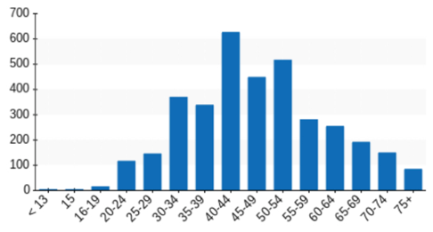

Figure 49: (Left) Tower Hamlets GP-registered population by age band (source: NEL LTC dashboard) and (Right) Count of discussions with residents by health and wellbeing ambassadors by age band (source: LBTH PH team health/wellbeing ambassadors programme).

* Slightly more women than men were recorded as engaging with ambassadors
* Of those recorded as engaging with ambassadors, there were slightly more women than men (54% vs 46%) and a wide range of ethnic groups but most common were Bangladeshi ethnicity (36%) and White British ethnicity (22%).

#### Does it work?

A recent local review of the evidence base on community outreach and health trainer models found that:

* Health trainers, particularly when engaging outside usual health settings (for example meeting people through community centres or job centres), can be helpful in engaging those not already seeing local services such as GPs, and in particular supporting those from socioeconomically disadvantaged groups to reach health-related goals.[153]
* Signposting to local services is a critical part of the offer.[154]
* A person-centred approach with non-clinical peers has been shown to inspire behaviour change. However, training is important and volunteer-led models can suffer from a lack of long-term commitment.[155]

#### Performance, gaps and issues

Local data on the impact of outreach programmes is limited. There is data on the types of issues raised and signposting made through the Tower Hamlets Health and Wellbeing Ambassadors programme, but CVD risk factors are not systematically recorded during these interactions, nor is there currently any data on health outcomes following the interactions.

There is some data from outreach events with specific health checks. For example, in December 2022 an event at the East London Mosque run jointly with NEL ICB and including local pharmacists conducted 71 opportunistic blood pressure checks, finding 46 people (65%) with high blood pressure and in need of further support to manage this. However, only 9 of these people (20%) were not already aware of their high blood pressure.

#### Recommendations

Trial a community outreach programme for health checks and advice, with a focus on blood pressure checks and rigorous data collection to determine cost effectiveness. Such a programme should:

* Have carefully planned target populations, using local GP data on health check coverage, information from this HNA about higher risk groups and demographics (such as homeless populations), and local knowledge of existing events, forums and settings that are likely to offer the best opportunistic interactions.
* Consider the optimum training, skill mix and cultural competence of any outreach team to deliver not only health checks but also provide risk communication and lifestyle advice.
* Ensure that there are links back to relevant health services for follow-up, for example updates into primary care on high blood pressure results, and be set up with appropriate interoperable data systems to enable this (as for example in the Community Pharmacy Hypertension Case Finding Service).

### Barts Health NHS Trust East London PrEvention programme (ELoPE)

#### What is it?

The CVD Prevention Department at Barts Health NHS Trust offers lipid management, hypertension support, cardiac rehab, community nursing and pharmacy-led prevention for those diagnosed with CVD. It also hosts the East London PrEvention programme (ELoPE), a secondary-care-led initiative bringing together a number of CVD prevention offers across Barts to detect and reduce CVD risk factors (and in doing so, reduce premature CVD mortality and health inequality in East London).

ELoPE runs programmes to reduce CVD risk (see below section 6.4: Reducing CVD risk) and also the following two projects to detect CVD risk.

1. A staff and patient CVD Health Check project, which includes a repository of local health and wellbeing services.
2. A ‘Make Every Contact Count’ style programme with non-CVD secondary care services. The programme is primarily based on communications (for example posters) in clinics encouraging clinicians to follow up on CVD risk factors and patients to ask about their CVD risk factors. The programme paused during the COVID19 pandemic but is now starting up again and a consultant at Barts Health is leading its expansion. To note: high blood pressure detection always needs follow up to confirm if it is hypertension or a temporary rise in blood pressure. This is particularly true in secondary care (for example due to patients having an infection).

#### Performance, issues and gaps

A pilot of the project detecting CVD risk in Barts staff, running April-May 2021, noted:

* 135 people were screened (64% were BAME, 36% male)
* 20% were found to be smokers, 21% hypertensive and 71% overweight or obese.
* Of the 27 smokers, 17 were referred to stop smoking services and 5 were recorded as quitting.
* Of the 29 hypertensives, one malignant hypertension was referred to A&E, and all have been placed on high blood pressure management pathways (such as loaning blood pressure monitoring machines and GP referrals for follow-up).[156]

#### Recommendations

Continue to evaluate the ELoPE programme and instigate potential improvements, including linking to Public Health, primary care, VCS colleagues, community groups (such as faith groups) and to new local CVD initiatives. This could include for example linking the project to detect CVD risks in Barts staff to any expansion of local community pharmacy support for those with hypertension, and to the new secondary care social prescribing offer under ELoPE.

## Reducing CVD risk

Tower Hamlets has a website summarising local offers to support healthier living, and in turn reduce CVD risk factors.[157] The NHS also hosts public-facing advice on a range of risk factors, including healthy diets, exercise and smoking cessation, on its various websites. These are helpful repositories of evidence-based guidance and signposting that people can act on immediately.

However, reducing risk is a complex process. People need to be supported to understand their personal risks and the rationale to adjust lifestyle factors, not all of which are necessarily in their control (such as pollution or deprivation). Importantly, motivation and self-confidence are key to changing habits, particularly when those habits may be coping mechanisms for the stresses that person is exposed to.[158]

The process of moving to a healthier lifestyle is not as simple as being informed of risk – but this is an important first step.

The below local offers are grouped under:

1. Education
2. Connecting people to services
3. Reducing non-clinical risk factors
4. Reducing clinical risk factors

### Education

The ELoPE programme at Barts includes a heart education offer to all schools across the Barts NEL catchment area, jointly developed with BHF, to educate children and young people on CVD risk factors. This is conducted by volunteer Barts staff, who are trained to deliver interactive sessions with children. Around 50% of schools offered have now taken up the offer. Barts staff also volunteer to support CPR education in schools. ELoPE also arranges heart health talks for local businesses.

In addition, there is healthy environments work on the Barts hospital estate to reduce risk factors like smoking, inactivity or poor diet among staff and patients. Physical activity offers for staff are outlined in more detail below under ‘reducing non-clinical risk factors’.

### Connecting people to services

#### Social prescribing and community connector roles in Tower Hamlets

Social prescribing connects people to activities, groups, and services in their community to meet the practical, social and emotional needs that affect their health and wellbeing, following individual discussions with people about their need with motivational interviewing techniques.[159]

Social prescribing and community-based approaches are being embedded across the NHS under the Long Term Plan, and personalisation is a key part of implementing recommendations from the Fuller Report.

In 2018, an economic evaluation of a Tower Hamlets social prescribing pilot estimated that the programme generated savings across the health system and a 12% reduction in GP attendances.[160] A more recent systematic review and meta-analysis of randomised control trials on social prescribing to increase physical activity found that it likely increased physical activity, though not obesity, blood pressure, glucose and serum lipid.[161] There were no eligible studies that primarily targeted unhealthy diet, smoking and excessive alcohol drinking behaviours.

##### What’s the Tower Hamlets offer?

Tower Hamlets has at least two full time equivalent social prescribers in each PCN (more in some PCNs), who receive about 90% of their referrals from GP practices, though there is an option to self-refer and professionals outside primary care can also refer people to social prescribers. Tower Hamlets sees the highest activity of all NEL boroughs, with just under 7,000 individuals referred in the first three quarters of 2022/23 – though there is variation in numbers referred by GP practice.

In addition, there is a NEL-wide initiative called the Community Chest small grants programme that enables social prescribing services to award micro-grants to VCS organisations to develop and deliver local community services where there are gaps in provision. There is a focus on addressing health inequalities at local and hyper-local levels. The programme is running in the first half of 2023, with an aim to use evaluations of projects to seek further health inequalities funding the following year.

There is a dashboard developed by NHS England and NEL ICB which brings together NEL-wide data on activity levels, needs and types of referrals through social prescribing.[162] Using this dashboard alongside data locally extracted from the EMIS data system, we can see that in the first three quarters of 2022/23:

* Over a quarter of patients referred had hypertension; 24% had diabetes, 6% had ischaemic heart disease and 3% had atrial fibrillation.
* There are a proportionally greater number of Asian and Black groups referred to social prescribing than their background population numbers, though this reflects the proportion of people in these groups with a long-term condition (see above: Our Population; see below, Figures 50, 51).
* There is a slightly higher proportion of women referred than expected from figures of women with long term conditions (60% of those referred to social prescribing are women vs 52% of those with long term conditions), and the age spread of those referred reflects the general population.[163]
* The majority of support offers were diet education, which is of course a key intervention to reduce CVD risk, followed by signposting to the voluntary sector (though this could include a range of offers) and exercise education.

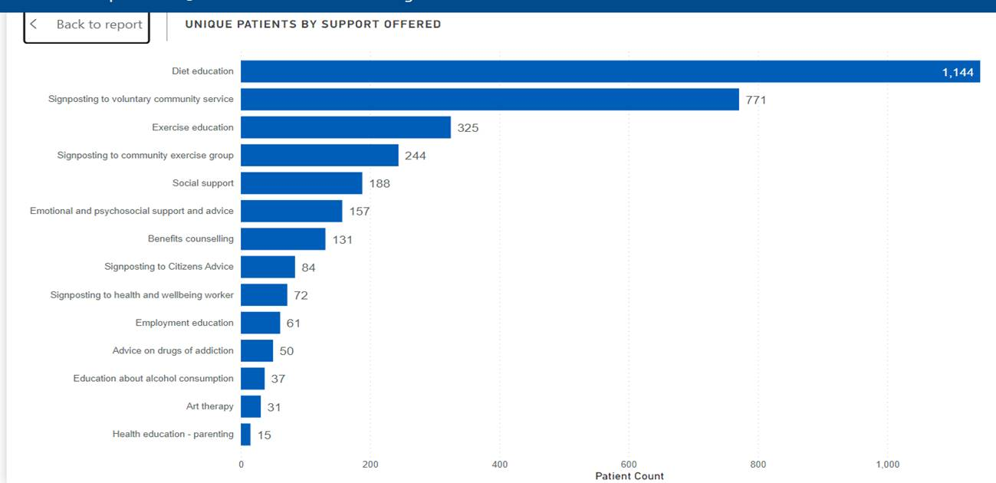

Figure 50: Number of unique patients offered support by social prescribing in Tower Hamlets, by support offered, Q1-3 2022/23. Source: NEL social prescribing dashboard.

Figure 51: % of population referred to social prescribing by ethnic group, Q1-3 2022/23 (Source: NEL social prescribing dashboard)

Barts is also setting up social prescribing in secondary care under the ELoPE programme. The project is in the early stages of development, and will offer four pathways for social prescribing in secondary care across NEL. One of these is a pathway for patients with a recent heart attack in Barts. It offers post-discharge monitoring for up to one year to those who have experienced a heart attack, tracking wider determinants of health such as housing or financial insecurity, either via a digital survey or in-person with a nurse practitioner. Those whose responses highlight wider needs are linked to a community connector in Barts, who in turn will link closely to colleagues in primary care to offer social prescribing. The community connector will also link people to cardiac rehab (see section 6.5.2 below).

##### Gaps, issues and performance

Discussion with the social prescribing commissioner highlighted the following issues.

**Unknown unmet needs or gaps in offers from social prescribing.** The NEL social prescribing dashboard enables social prescribers to input ‘reasons for referral’ and the type of support offered under pre-determined categories. However, it does not capture data on whether those needs were met or whether there are gaps in services. In Tower Hamlets, there are efforts to capture such data locally but data quality is currently poor. In addition, the majority of patients referred to social prescribing are only seen once, and it is not currently clear whether this is due to limited social prescriber capacity (and there would be benefit in follow-up) or if this indicates a relatively straightforward interaction without need for follow-up.

**The need to return to face to face support.** During the COVID19 pandemic there was a necessary shift to remote consulting approaches during lockdowns; there is now an ambition to get social prescribing back to a face-to-face offer but the majority of consultations remain online across NEL.

**Capacity in social prescribing is also an ongoing issue.** For example, the service has stopped actively encouraging referrals from outside primary care (for example from mental health or musculoskeletal services) due to capacity issues.

**Future funding is unclear.** The Network Contract Directed Enhanced Service (DES) – (GP contract), which includes the Additional Roles Reimbursement Scheme that funds social prescribers and other personalisation roles, ends in 2024.. Although Tower Hamlets social prescribing is funded by both the ICB and the NHSE DES, and it is likely that some form of funding will continue under the DES, there will be a need to review funding and commissioning for social prescribing as and when NHS England clarify funding plans. This could also be a good opportunity to review different community connector roles in Tower Hamlets (what these roles are in different areas, their responsibilities, training, different referral pathways and support offers), to bring together a coordinated social prescribing/community connector offer across the area. Some of this broader mapping of community connector roles has already been initiated by Tower Hamlets local authority.

**There is a need to evaluate the cost effectiveness of social prescribing** – and this is an ongoing national challenge. A review of eight studies published in the BMJ in late 2022, involving 6500 people across the UK and the US, noted insufficient evidence to assess the effectiveness of social prescribing and none on the cost–effectiveness.[164] It also noted that there are no agreed outcomes or measures for social prescribing and recommended high-quality trials determining cost–effectiveness of social prescribing. As an early adopter of social prescribing, Tower Hamlets may have a role in supporting the expansion of the evidence base. At present all NEL boroughs all use the same outcome measure (ONS4) in social prescribing, but data is only collated on the first use of this measure and so it is not possible to see changes in scores following the intervention (and so assess impact). There are plans to address this in upcoming development of the NEL dashboard.

In addition, a recent workshop with residents to help plan the ELoPE social prescribing programme highlighted:

* Accessibility of materials to patients on CVD offers and CVD itself
* Considering the specific needs of those with CVD who are also carers
* Ensuring that the current focus on inpatients having experienced cardiac events does not systematically exclude women, who are less likely to be presenting with cardiac events but among whom there may nevertheless be important preventative actions.
* Setting clear expectations for patients on timelines and offers under social prescribing, primary care support and cardiac rehab.

##### Recommendations

NEL ICB Tower Hamlets social prescribing commissioners to work with Barts and the GP Care Group to:

* Continually review improvements to data collection systems and the NEL social prescribing dashboard where possible. This is in order to better assess population needs from social prescribing and any gaps in the local offer available to meet those needs, and should also incorporate co-design with those groups affected.
* Continue to press for a return to face to face support.
* Where possible, support national efforts to evaluate the cost effectiveness of the Tower Hamlets social prescribing model as well as opportunities for community assessment of effective social prescribing, and bring latest evidence on this back into local service commissioning and design.

ELoPE social prescribing lead to work jointly with NEL ICB social prescribing commissioners and the GP Care Group to:

* Continually review the accessibility of materials to patients and opportunities for co-design of services;
* Consider the specific needs of those with CVD who are also carers;
* Consider whether the current focus on inpatients having experienced cardiac events does not systematically exclude women, who are less likely to be presenting with cardiac events but among whom there may nevertheless be important preventative actions.

#### Barts Integrated Approach to CVD Prevention project

Secondary care settings offer an important opportunity to detect and reduce CVD risk. There is evidence that some healthcare contacts provide a potent ‘teachable moment’ in which patients and visitors are more likely to engage with advice on risk factors.[165]

Clinicians have an important role here, both in informing people about their risks and in supporting people to change habits. However, research has highlighted that some clinicians feel uncomfortable giving advice to patients and could be supported by easy-to-access information and tools to communicate with patients.[166]

To support both staff and patients in having these conversations and making sustainable health behaviour changes, the Barts Integrated Approach to CVD Prevention project (in partnership with ELoPE, see below), starting early 2023, will enable interventions and referrals into specialist services, for example to smoking cessation services.[167] The programme will undertake a mapping exercise and develop a repository where details of local Health and Wellbeing Services will be stored.

* A health and wellbeing coach will provide personalised, age appropriate, one-to-one and group healthy eating, behaviour change and physical activity advice.
* In addition to speaking directly with patients and visitors at the hospital, they will also train hospital staff and volunteers to allow them to better engage patients in conversations about improving their health, including discussing risks such as alcohol, diet, physical activity and tobacco use.
* The project will be piloted in the Royal London hospital with a focus on renal patients.

#### ‘Primary prevention’ nurses

There is also a team of four ‘primary prevention’ nurses in TOWER HAMLETS who offer support (both prescribing and lifestyle advice) to people with CVD risk factors flagged but not yet diagnosed with CVD. These nurses link closely to both primary and secondary care, offering support to Barts staff as well as residents (for example through NHS health checks).

### Reducing non-clinical risk factors

#### Frontline universal training in health coaching

In addition to this programme, there is also frontline universal training in health coaching and motivational interviewing available to clinicians including those in primary care. Across NEL, PCN pilot sites are rolling out this training and identifying further training needs across all staff to embed health promoting conversations in all frontline roles. Alongside this, existing roles in primary care such as health coaches and social prescribers focus on having supportive conversations and motivational interviewing.

Training modules under the Core20PLUS5 programme also include guidance on culturally competent conversations, for example on the risks arising from hypertension, and how to convey risks in a clear way to people unfamiliar with some clinical terminology.

A NICE decision-support tool also supports in-depth discussions on risk, providing staff with different ways to explain risk.

#### Smoking cessation

Quitting smoking is one of the highest impact interventions to reduce risk of developing or worsening CVD. For those who quit, the risk of heart attack is halved after one year of quitting.[168] CVD mortality reduces by up to 45% at 5 years in sustained quitters versus smokers (with a 32% reduction in al-cause mortality), and between 5-15 years of abstinence the risk of stroke and coronary heart disease is “normalized” to that of never smokers.[169]

##### Tower Hamlets offer

**Local authority-funded offers**

The Tower Hamlets local authority website sets out the local authority-funded smoking cessation offers, which are outlined below, alongside details of the Stop Smoking London helpline and website which offers free support and advice.[170]

From April 2023, a single supplier (Queen Mary University, London) manages four elements of the local authority-funded smoking cessation offer:

1. **Specialist tobacco cessation service.** This is a 12-week programme of behaviour support and nicotine replacement therapy or e-cigarette. This is targeted towards those with COPD, SMI, pregnant women, young people and BAME people. It provides culturally sensitive services for people from the Somali, South Asian and migrant communities who chew tobacco or use paan. Female advisors are available and a specialist service is available (self-referred or via GP referral) for pregnant women and those with high levels of addiction who may need extra support. The programme’s primary outcome indicator is the carbon monoxide reading for participants when followed up four weeks after the programme ends.
2. **Social marketing and training**. This includes stop smoking campaigns throughout the year including New Year, No Smoking Day, Ramadan and Stoptober. Alongside this there is a training offer of brief advice sessions to wider stakeholders and training to sub-contractors such as pharmacies on smoking cessation.
3. **Service level agreements** with community pharmacies and/or other community suppliers. This includes an 8-week behaviour change support programme available through community pharmacy in Tower Hamlets, which opportunistically invites people who are flagged as smokers through other pharmacy services or interactions. The programme offers a weekly one-to-one session with a pharmacist that includes discussions of barriers and support such as nicotine-replacement therapy. E-cigarettes are not currently offered through community pharmacy, though they are cheaper than NRT and are an evidence-based intervention. There is a requirement for QMUL to ensure at least 12 pharmacies to sign up across Tower Hamlets.
4. Servicemanagement**, leadership, coordination and partnership working**.

The new service also includes efforts to:

* Make the service culturally appropriate, by recruiting multilingual staff some of whom are fluent in Bengali, adjusting the content and language of leaflets and social media materials, and recruiting female advisors to support women if needed.
* Target outreach to manual occupations which have particularly high smoking rates.
* Work closely with ELFT which offers mental health community clinics and inpatient support for smoking cessation, and with Barts Health to support pregnant smokers and inpatients.

**NHS-funded offers**

Under the Commissioning for Quality and Innovation (CQUIN) scheme in the NHS, providers of NHS services are financially incentivised to identify smokers and give brief advice, including an offer of nicotine replacement therapy (NRT) and referral to stop smoking support.[171]

Alongside this, NHS England is funding a new community pharmacy 12-week smoking cessation service for over-18s who have started treatment for tobacco dependence in hospital and choose to continue their treatment in community pharmacy after discharge, including pregnant women and those with non-complex mental health needs.[172] Those with complex mental health needs or who have completed a 12-week smoking cessation programme in hospital are not eligible for this service. Under the service, a trained pharmacist provides weekly or fortnightly consultations with carbon monoxide monitoring, behavioural support and nicotine replacement therapy. A quit date is agreed at the outset and support is available for up to 12 weeks following this date, including nicotine replacement therapy and follow-up reviews to check carbon monoxide levels. This programme was set up in NEL in early 2023 so there is not yet data on its performance locally.

There is also a smoking cessation programme under the NHS Long Term Plan funding at the NEL ICB level, which is targeted towards inpatients, pregnant women and those with SMI or a learning disability.[173] The programme is in the early stages of development and so does not have data on performance, but it aims:

1. That by 2023-24 all people admitted to hospital who smoke will be offered NHS-funded tobacco treatment services. It includes stop smoking advisors supporting patients in wards and for 6 weeks post-discharge after which they are referred on to the smoking cessation service In Tower Hamlets, this is jointly led by Barts and the East London Foundation Trust.
2. That pregnant smokers in secondary care are placed on a dedicated smoking cessation pathway once picked up by maternity services. This is led by Barts.
3. That a new universal smoking cessation offer will also be available as part of specialist mental health services for long-term users of specialist mental health, and in learning disability services. This is led by ELFT, which has set up two community clinics (Montague St Clinic and Glasshouse Fields Centre), working closely with QMUL to ensure supply of NRTs and e-cigarettes.

There is a new nationwide drive to provide e-cigarettes alongside behavioural support to almost 1 in 5 smokers under the national ‘swap to stop’ scheme launched in April 2023, which local authorities will be invited to join later in 2023 with locally-designed interventions. The wider programme, which has an ambition to reduce smoking rates to 5% or less by 2030, also includes financial incentives for pregnant women to help them quit smoking and a wider crackdown on illicit vape sales – particularly to children. NHS figures for 2021 cited by the programme showed that 9% of 11 to 15 year old children used e-cigarettes, up from 6% in 2018.[174]

**VCS offers**

There are also offers from the voluntary and charity sector, and efforts to coordinate and align at a strategic level across London. For example, the London Tobacco Alliance, under its plan to make London smoke-free by 2030, has initiated:

* Programmes targeting higher smoking prevalence groups for smoking cessation efforts (such as the LGBTQ+ community and those working in the construction industry).
* A Stop Smoking London website that signposts to local services
* An add-on to the NHS national helpline to call people back and offer behavioural support to quit smoking over phone consultations
* An app with a chat function to talk to advisors about smoking cessation
* Social media marketing and campaigns to encourage smoking cessation

##### Performance, issues and gaps

Tower Hamlets is in the top 5 London boroughs for 4-week quit rates with 3,976 quits per 100,000 smokers, almost double the London region average of 1,665 per 100,000 smokers (2019/20).[175] However, smoking status recording for those with CVDs has been falling recently.

The below graph outlines what % of patients with the following conditions had their smoking status recorded over the past year: coronary heart disease, PAD, stroke or TIA, hypertension, diabetes, COPD, CKD, asthma, schizophrenia, bipolar affective disorder or other psychoses. These include types of CVD, and also risk factors for CVD such as diabetes and hypertension. Tower Hamlets has previously had similar rates to national averages but dipped below national levels in 2019-22. This may signal a particularly strong local impact of the Covid-19 pandemic. The trend is now upwards but Tower Hamlets remains below the national average (Figure 47, above)

Tower Hamlets has been falling below England average for the % of recorded smokers (15+ years old) who have an offer of support and treatment recorded in the last 24 months. Of course, this metric depends on GP recording of both smokers and interventions to support them – it does not necessarily represent either the true number of smokers in Tower Hamlets or the true level of support offered to them. However, recording is of itself important as it enables local and national health systems to track offers of support to smokers. (Figure 48, above)

A recent local authority-funded tobacco cessation services review[176] found that:

* Residents in the E2 and E3 postcodes are less likely to access local tobacco cessation services (either under community pharmacy or QuitRight).
* White ethnic groups are less likely to access the service, and once accessed less likely to successfully quit
* Younger age groups are less likely to access the service. 25-34 year olds are the age group with highest smoking rates (38.3%, from 2018 data) but low service engagement (20.3%).

The ELFT-run mental health smoking cessation support service (outlined above under NHS-funded services) is newly established and so does not have performance data. However, feedback from ELFT’s stop smoking advisor suggests an issue with non-attendance following discharge. ELFT plans to review the pathway and conduct an evaluation in due course.

##### Recommendations

* The new service under QMUL should incorporate the above findings of the local authority tobacco cessation services review, for example targeting support efforts in the E2 and E3 postcodes and to White ethnic groups and younger people.
* There is evidence that group sessions with peer support have the highest quit rates, however behaviour support sessions under the QuitRight programme are currently offered on a primarily one-to-one basis (telephone and face to face).[177] Efforts should be made to return to group sessions with peer support under the new programme run by QMUL.
* There are several complementary, and sometimes overlapping, offers from local authority-funded and NHS-funded services (for example in community pharmacy). As ICBs develop further, they may take on a greater role in coordinating smoking cessation efforts between local authorities and the NHS, bearing in mind 1) their unique position bringing local organisations together and setting strategic direction and 2) the scale of health impacts and inequalities arising from smoking. As an example, the London Tobacco Alliance is working with some ICBs in London to expand inpatient support programmes to those on waiting lists as a potentially receptive audience to smoking cessation advice and support.

#### Alcohol and substance misuse

Note: there is a separate Substance Misuse Needs Assessment that sets out the below local offers in more detail alongside information on performance, gaps, issues and recommendations. The below offers a brief summary of local service offers only.

##### Tower Hamlets offer

The Substance Misuse Needs Assessment outlines the following local offers in Tower Hamlets:

* RESET is the branded name for adult drug and alcohol services with three contracts comprised of outreach and referral, treatment and recovery support services to the local population and began operation in 2016. The service was re-commissioned in 2019 with a change in provider for RESET treatment.
* RESET Outreach provision aims to engage drug and alcohol users into structured treatment while also providing information about harm reduction and brief advice thereby supporting individuals prior to accessing treatment.
* RESET Treatment provide a comprehensive range of interventions including pharmacological and psychosocial interventions. The range of provision is consistent with guidance for substance misuse provision.
* RESET Recovery Support provides a range of support interventions to aid service users through treatment and post-treatment and includes support for families and significant others affected by substance misuse.
* P-RESET is a primary health-based service that provides Shared Care and annual health checks for opiate, crack and alcohol dependent service users in treatment.
* Maternity support through a dedicated midwife at the Royal London Hospital

In addition, there is a universally-available screening and intervention tool called Drink Coach available to Tower Hamlets residents, which includes the WHO recommended alcohol screening tool ‘AUDIT’. The tool offers people advice on how to cut down alcohol and drink in safer limits, and if people score over a certain level they are signposted to local services. Evidence has shown that providing simple alcohol advice results in reductions in weekly drinking by between 13% and 34%, (2.9 to 8.7 fewer units per week) with one in eight adults reducing their drinking to low-risk levels.[178]

Separately, under the NHS commissioning for quality and improvement (CQUIN) scheme, providers of NHS services have a financial incentive to identify patients drinking above low risk levels and give brief advice or offer a referral for further assessment and specialist support (if the patient is possibly alcohol dependent).[179]

##### Recommendations

The Substance Misuse Needs Assessment has highlighted the need for improved lines of communication and reduced duplication across the above offers and the need to align incentives and priorities to long-term outcomes. It also flags the need for increased capacity in RESET treatment and better cultural competency across the wider alcohol and substance misuse support system.

#### Weight management, physical activity and healthy diet

Weight management for those who are overweight or obese is particularly important in reducing CVD risks for those with diabetes or hypertension, with effective weight management leading to improvements in blood pressure, blood glucose, HbA1C and triglycerides.[180] A review on the long-term effects of weight-reducing diets in people with hypertension found that a reduction in body weight of approximately 4 kg would achieve a reduction of approximately 4.5 mmHg systolic blood pressure and of approximately 3.2 mmHg diastolic blood pressure.[181]

Weight management services are organised into the following ‘tiers’[182]:

* **Tier 1:** This is universal interventions focused on prevention and reinforcement of healthy eating and physical activity messages, which includes public health and national campaigns and providing brief advice.
* **Tier 2:** This is usually time-limited lifestyle community weight management services that provide community-based diet, nutrition, lifestyle and behaviour change advice, normally in a group setting environment.
* **Tier 3:** This involves a clinician-led multi-disciplinary team providing medical support from, for example, a physician (like a GP or consultant with expertise in weight management), a specialist nurse, dietician, psychologist and physiotherapist.
* **Tier 4:** This is largely surgical interventions performed in secondary care, with pre-operative assessment and post-operative care and support. Tier 4 weight management services are largely beyond the scope of this health needs assessment as a specialist medical intervention, as this needs assessment focuses on secondary (and to some extent primary) prevention. An obesity clinic at Barts offers bariatric surgery, where appropriate, for residents with a BMI over 40.

##### Tier 1

There are universally-available offers to support weight management and physical activity: the NHS Better Health Programme, the Tower Hamlets Connect website page with advice on weight management, and finally a local physical activity and sports offer on the Tower Hamlets website.[183]

Over-18s with a BMI of 25 or more (or 23.5 or more for those from BAME groups) can access the **NHS Weight Loss Plan app**, which offers a free 12-week diet and exercise plan.

The plan, which has been downloaded more than 7 million times, is designed to help people lose weight safely and keep it off.[184]

##### Tier 2

Over-18s in Tower Hamlets with a BMI over 30 (or 27.5 for South Asian groups) can self-refer or be referred via their GP surgery to the **Weight Action Programme** provided by Queen Mary University.[185] This is a 12-week in-person or online (via Zoom) programme run by specialists from the Health and Lifestyle Research Unit which offers a range of ‘tasks’ for participants to try, mostly focused on diet, and then embed with ‘buddies’ on the programme, sharing successes and failures as a group throughout the 12 weeks.

Government funding was previously allocated, but has now elapsed, for expansion of tier 2 weight management services, and in Tower Hamlets this focused on services for people with physical disabilities (the Eat Well and Move Programme) and people with learning disabilities (Shape Up Programme).

Over-18s resident in Tower Hamlets with overweight or obesity and physical disabilities can self-refer or be referred via their GP to the **Eat Well and Move Programme**. This offers a 12-week programme of focused one-to-one and small group exercise and nutrition sessions aimed at increasing physical activity levels with and develop healthy eating habits by working with a dietician to manage participants’ weight.

Over-18s resident in Tower Hamlets with a BMI of 30 or more (or 27.5 or more for South Asian groups) and a learning disability can self-refer or be referred via their GP to the Shape Up Programme, provided they are able to consent to the programme. This 12-week programme maps out a personalised weekly timetable and goals around physical activity and healthy eating. It includes weekly group sessions with a fitness instructor alongside one-to-one support and access to other health and fitness professionals, and online information. There is follow-on support to maintain goals achieved after the programme finishes. Family members, carers, key workers and support workers are encouraged to support the person to reach their goals.

##### Tier 3

The Tier 3 weight management offer in Tower Hamlets was decommissioned in 2022 because it was not achieving expected outcomes.

This is a notable gap in the local offer, which was also flagged by GPs interviewed for this needs assessment. There is work underway to commission a service across NEL. Previously, the Tower Hamlets Tier 3 offer wasfor residents who have a body mass index (BMI) of 35 or more (or 33 or more for South Asian groups) and have a long-term condition such as diabetes, or with a BMI of 40 without a long-term condition.

##### Diabetes weight management offers

Over-18s with pre-diabetes who are able to take part in light/moderate physical activity (or women with a previous gestational diabetes diagnosis) can either self-refer or be referred via their GP to the **NHS Diabetes Prevention Programme**. This is a 9-month tailored, personalised programme offering support to reduce risk of type 2 diabetes through structured education on healthy eating, weight management and lifestyle, including physical exercise component. Those who are currently pregnant are not eligible. Patient information is available in 16 languages.

Over-18s with diabetes and/or hypertension and a BMI of 30 or above (or 27.5 or above for BAME groups) can be referred via their GP surgery to the **NHS Digital Weight Management Programme**, a 12-week online behavioural and lifestyle programme. Those who are pregnant, have an eating disorder, a significant unmanaged comorbidity, bariatric surgery within the past 2 years or moderate/severe frailty are not eligible. The service is particularly helpful for those who do not traditionally access face to-face weight management services. NHS England has calculated that average weight change in those who complete the 12-week programme is estimated between 3-4kg lost.[186]

People can access it via a smartphone or computer with internet access. This programme offers digital weight management support via a 12 week intervention at 3 intensity levels:

• Level 1: Digital support only

• Level 2: Digital support + human coaching

• Level 3: Digital support + enhanced human coaching

The online ‘Referral Hub’ run by NHS Digital triages patients to one of three levels of intervention based on demographic features associated with greater likelihood of non-completion of a weight management programme (based on evidence from the NHS Diabetes Prevention Programme). Service users will have a choice of digital provider for a 12-week digital weight management service.[187]

Those with type 2 diabetes diagnosed in the past 6 years and undergoing diabetes monitoring reviews, with a BMI of 27 or above (or 25 or above for BAME groups) can be referred (again via their GP) to the **NHS Low Calorie Diet Programme**, which is being piloted in NEL.

This is a 12-month face-to-face programme (currently delivered online) with three phases including 12 weeks low-calorie total diet replacement with shakes and soups, followed by food reintroduction and maintenance phases. Those who are pregnant, have specified comorbidities, have weight loss greater than 5% in the past 6 months or are on another weight management programme, have undergone bariatric surgery or are assessed as unable to understand or meet the demands of the programme, are not eligible.

The service includes:  
  
• An initial one-to-one assessment

• 20 sessions with your Health & Wellbeing diabetes practitioner

• 26 online support modules

• Final one-to-one assessment

##### Other offers

The ELoPE programme in Barts has a project to optimise risk factor control and management with pharmacy teams in primary care networks across NEL. This includes an app, ‘Obesity Navig8’ which promotes obesity self-care, and includes a resource library, self-referral links (including to wider services such as sleep support, and from the voluntary sector), self-assessment tools, peer support and options for self-initiated follow-up. The platform can also map resources according to locality, comorbidities and responses, and the app has some community-relevant adaptations such as translations into locally-used languages.

##### Physical activity offers

A range of (mostly local authority supported) physical activity offers are summarised on the Tower Hamlets website.[188]

They include a number of universal offers such as Park Run as well as more targeted support for specific groups either at higher risk of certain conditions, or less likely to use routine leisure services. For example:

* The Young at Heart 50+ community activity programme offers tailored and relatively cheap exercise sessions (starting from £3) to residents over 50. These include short tennis (played on a smaller court with large rackets and foam balls), walking netball, pilates, aerobics, body conditioning and yoga, offered at leisure centres across the borough.[189]
* Weekly swimming sessions for people with disabilities are also offered at local leisure centres, and Ability Bow gym offers classes for those with a variety of disabilities and health conditions.[190]
* The Good Moves 8-week diet and exercise course for those with long term conditions living in Tower Hamlets, including CVD.[191]

A move to bring leisure services under direct local authority control from 2023 onwards will represent some costs to the local authority but may also present an opportunity to provide more targeted programmes for secondary prevention, for example ‘exercise prescription’ for those at risk of or with CVD.

In addition, some employers in the area have physical activity offers for their staff – most notably Barts Health Trust, which offers:

* A self-funded programme of heavily discounted exercise classes (£1 per class) to staff at 5 sites across the Trust, for which there are plans to expand;
* A Barts Charity-funded bike hire programme for staff and patients which has installed hire docks on every hospital site in NEL as well as wider promotion of cycling by for example providing secure cycle storage and promoting active travel for staff. This programme has provided bike hire to over 1500 staff and 100 patients across Tower Hamlets and Waltham Forest.
* Campaigns run by the Trust such as ‘car-free June’ to encourage a switch from driving to cycling for staff on their commute.

The CVD Prevention Programme at the Trust, detailed elsewhere in this document, also promotes Park Run among staff and provides outreach in schools promoting Junior Park Run.

##### Performance, gaps and issues

The below table summarises outcomes data and gaps identified for Tier 2 weight management services in a recent service review by the Tower Hamlets Public Health Weight Management Commissioner.

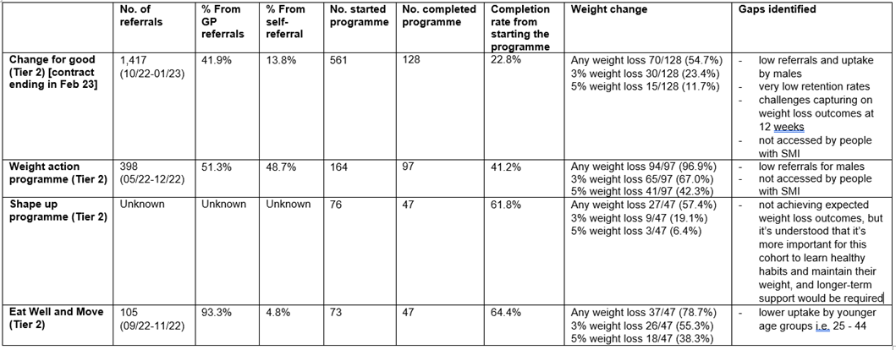

In 2021 the VCS organisation Social Action for Health conducted a review of the barriers, concerns and gaps in understanding around accessing weight management services for Tower Hamlets residents.[192] It included with 3,346 one-to-one conversations with Tower Hamlets residents living with, or at risk of obesity, and engagement with 15 local partner organisations.

It found that, of those residents polled:

* 29.1% would prioritise being a healthy weight if a health professional suggested it, rising to 35.4% if they had a condition or illness that would improve as a result and 68.4% if people felt their weight was affecting them.
* 62.5% believed they have some control over their weight, but personal choices are not the only important factor – perceived barriers included time to exercise, plan and cook meals (39.7% of respondents), emotional or physical energy (35.9%), cost (25.6%), lack of motivation (21.8%), lack of certainty about how to lose weight or where to get help (16.7%).
* 75% were not aware of the ‘Better Health’ campaign to support weight loss and physical activity.

Case studies highlighted:

* Difficulty for some residents accessing English-only or online-only resources.
* The importance of tailored offers, for example a 61-year-old Bangladeshi heritage respondent with multiple health problems saying ‘there is nothing for me; I need things for an old person like me.’
* Group offers were often cited as positive motivators: “There were people there with the same issues as me”. Loneliness and a desire to interact with similar peers were also cited in case studies as barriers to starting physical activity.

In addition, in early 2023 an internal review into weight management services was conducted by the Tower Hamlets Local Authority Public Health team. This involved discussion primarily with service commissioners and providers to map out the current service offer and discuss gaps and issues. Service providers fed back that:

* There was limited support for those with BMI under 30 (but over 25) – though some cohorts (such as people of south Asian heritage) are eligible for the programme at a lower BMI of 27.5;
* The Change for Good programme showed high dropout rates;
* A limited targeted support offer for some groups – such as those with severe mental illness;
* White British groups were less likely to remain on the programme at 12 weeks (12.3%) compared with Bangladeshi groups (27.7%).

##### Recommendations

Recommission Tier 3 services – this is underway at NEL ICB level.

Recommendations arising from the internal Tower Hamlets weight management service review undertaken in early 2023:

* Where there is capacity, consider lower eligibility criteria for individuals with other health conditions, such as comorbidities, including type 2 diabetes, as per NICE guidance for commissioning Tier 2 weight management services.[193]
* As part of weight management service re-procurement, Tower Hamlets Public Health commissioners to review latest evidence and guidelines to optimise the delivery model, and engage with the public and suppliers to achieve this.
* Review data on uptake of programmes by demographics and other health conditions, and explore tailored programmes for sub-groups with low uptake.

Recommendations from the Social Action for Health weight management review included:

* Onboarding events and workshops on topics of interest, perhaps via GP surgeries
* A focus on in-person as well as online provision
* Ongoing support following time-limited programmes
* Targeting courses for specific groups and considering accessibility needs
* A focus on group support led by peers with lived experience, alongside one-to-one support and coaching
* The importance of holistic offers including health, wellbeing and nutrition.

Continue to keep professionals updated – particularly in GP surgeries which are a key referral route – on weight management offers in Tower Hamlets, and continue to streamline referral processes (for example, by providing automated referrals). To note: the Tower Hamlets weight management offer is routinely updated on the Local Authority website, Tower Hamlets Connect.[194]

The insourcing of leisure provision into Tower Hamlets Local Authority from 2023 onwards provides an opportunity to review strategies for targeted physical activity support from leisure centres in the borough.

#### Poor sleep

Alongside advice and support to implement good sleep hygiene, NICE recommends cognitive behavioural therapy for insomnia (CBT-I) for treatment of both short- and long-term insomnia in adults of all ages.

CBT-I is not currently offered under IAPT services, but there is an option for GP referral to UCL’s insomnia clinic. PCNs in Tower Hamlets previously offered evidence-based digital interventions but GP stakeholders reported that funding for this was non-recurrent and so this is no longer available.

### Reducing clinical risk factors

#### Community Cardiovascular Prevention team

A Barts Community Cardiovascular Prevention team which runs clinics for people with CVD and complex needs, hypertension and raised cholesterol. This includes discussions about both non-clinical and clinical risks, including physical activity, diet, smoking, and medication adherence (particularly for hypertensives). Referrals are predominantly from GP surgeries but the service also links to community pharmacy. The offer does not have a time limit per patient.

The service links people into CVD services, for example referrals to social prescribing, flagging patients to Cardiac Rehab if they have not had an invite already, or encouraging patients to get a blood pressure check at their local pharmacy if they are not doing so with their GP already. It also runs community outreach events such as running a stand in shopping centres to advertise keeping healthy during Ramadan. Finally, the service offers informal teaching in GP surgeries.

Activities were paused during the COVID19 pandemic, but have now returned to pre-pandemic levels (with around 1100 appointments per year).[195] The team includes a Bengali advocate, though the service lead highlighted that advocacy needs and patient demographics vary markedly across the borough in terms of ethnicity, dominant languages and the age of patients seen.

##### Recommendations

Consider targeting outreach events and support for patients by higher risk demographics. Continue to support wider learning across linked teams and professionals, for example providing teaching for GP practice teams or linking to social prescribers.

#### Hypertension

NICE guidelines on hypertension treatment and care set out the key elements of effective hypertension management and reduction of blood pressure[196]:

1. **Measuring blood pressure and diagnosing hypertension**

To support this, there are a number of interventions to detect high blood pressure outlined above under ‘detecting CVD risks’, national targets under the QOF scheme, and also an incentive in the GP DES contract to follow up anyone who has had an elevated blood pressure without diagnosis of hypertension since April 2020.[197] One GP consulted for this HNA flagged that this incentive is complex to understand and would warrant a simple flow chart or guide for GPs to interpret its requirements.

The North London Cardiovascular Disease Prevention Strategy 2023/2024 includes a target to detect 80% of the expected population with hypertension. Comparing OHID-estimated hypertension prevalence for Tower Hamlets (15.8%) with QOF-recorded diagnosed hypertension (7.7%), we are currently only recording 48% of expected hypertension.[198]

Using national data from the QOF scheme, we can see that the % of patients whose blood pressure was recorded over the past 5 years has previously been higher in Tower Hamlets than the national average, but this has been reducing steadily over the past 8 years, and markedly reduced during the Covid-19 pandemic (Figure 46, above).[199]

1. **Lifestyle interventions** – these are outlined above under ‘reducing non-clinical risk factors’.
2. **Assessing cardiovascular risk** and organ damage.

This is partly covered under the health checks section above, and is also supported by a local enhanced specification incentive for GPs to provide annual care planning for those flagged as ‘high risk’ in their health check, those with chronic kidney disease (level 3 or worse), those with hypertension, or those on antipsychotic medications.

1. **Choosing and starting antihypertensive drug treatment**.

In the locally enhanced specification (LES) contract for GPs, there is an incentive to intensify statins. The updated NEL Long Term Conditions Outcomes Framework also includes indicators on statin prescription and control of hypertension. Alongside this, there is a national target for 60% of those with a QRisk score over 20 to be prescribed statins. In Tower Hamlets for the latest reporting year February 2022-23, this was 58.6% - but with substantial variation across GP practices from 37.5% to 83.3%.

The following chart breaks down hypertension treatment gaps in Tower Hamlets by PCN, showing variation in treatment levels across Tower Hamlets PCNs:

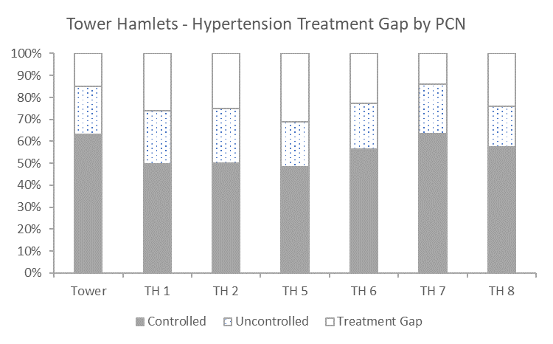

Figure 52: % of GP-registered patients in Tower Hamlets with controlled, uncontrolled hypertension and estimated treatment gap, by PCN. ‘Treatment gap’ is defined as the % of those on the hypertension register in Tower Hamlets who do not have a BP measured in the last 12 months, ‘uncontrolled’ is defined as the % of people on the hypertension register for whom the last blood pressure measured was greater than 140/90 (under-80s) or 150/90 (80 and older). Source: QOF data for 2019-20.

1. **Monitoring treatment and blood pressure targets**

There is routine blood pressure monitoring at GP surgeries, and in addition many GP surgeries have an agreement in place with pharmacies to conduct an annual hypertension review for registered hypertensives.

The LES contract for “High quality outcomes for people with long-term conditions (LTCs)” covers all those with hypertension, CVD, Heart Failure and CKD and sets out care planning as a core component of clinicians working jointly with people to develop the knowledge, skills and confidence to manage their health and wellbeing.

There is also a Blood Pressure at Home monitoring programme offered to Tower Hamlets hypertensive residents – though this is only offered to 12.9% of hypertensives (12 months up to March 2023).[200] The percentage of hypertensives offered this service ranges 7-25.5% across different PCNs in Tower Hamlets.

The North London Cardiovascular Disease Prevention Strategy 2023/2024 includes the following targets at ICB footprints:

* Ensure 77% of patients aged 79 years or under, with hypertension, in whom the last blood pressure reading (measured in the preceding 12 months) is 140/90 mmHg or less.[201] Data for 2021/22 suggests that NEL ICB, in common with other North London ICBs, is not meeting this target (59%).
* Ensure 80% of patients aged 80 years or over, with hypertension, in whom the last blood pressure reading (measured in the preceding 12 months) is 150/90 mmHg or less (QOF HYP007). Data for 2021/22 suggests that NEL ICB, in common with other North London ICBs, is not meeting this target (71%).

#### Cholesterol and lipid management

Cholesterol search and risk stratification is recommended under the NHS England CVD Prevention Plan. This involves case finding and treatment of hypercholesterolaemia in people with high CVD-risk conditions, post-acute CVD event and in those with familial hypercholesterolaemia. Every 1mmol/l reduction in low-density lipoproteins (LDL) cholesterol reduces risk of a cardiovascular event by 25%. National guidance for lipid management is available from the NHS Accelerated Access Collaborative, alongside NICE guidelines on lipid modification for CVD prevention.[202],[203]

In Tower Hamlets, lipid management is available through primary care, supported by an incentive in the DES GP contract to identify people with possible familial hypercholesterolaemia for tertiary lipid clinic referral.[204] It is also offered by the Barts CVD Prevention Department for patients in secondary care.

NHS Long Term Plan ambitions for cholesterol are:

* By 2029, 75% of eligible people aged 40 to 74 without established CVD (such as a previous heart attack or stroke), have a validated CVD risk assessment and cholesterol reading recorded on a primary care data system in the last 5 years.
* By 2029, 45% of people aged 40 to 74 without established CVD who are identified as having a 20% or greater 10-year risk of developing CVD in primary care are treated with statins.
* By 2024, 25% of people with familial hypercholesterolaemia are diagnosed and treated in line with the NICE guideline on familial hypercholesterolaemia.

The North London Cardiovascular Disease Prevention Strategy 2023/2024 includes a target at ICB level to:

Ensure 60% of patients aged between 25 and 84 years with a CVD risk score greater than 20 percent are on lipid lowering therapies (CVDP003CHOL, To June 2022). NEL is meeting this currently at 67%.

80% of patients with a history of CVD have been issued lipid lowering therapy in the last 6 months. (CVDP009Chol, To June 2022). NEL is meeting this currently, at 84%.

CVDPrevent data shows a substantial level of variation across NEL ICB PCNs in the % of people with CVD with controlled cholesterol levels, from as low as 11.2% in Shoreditch Park PCN to 41% in Tower Network PCN (Figure 53). 6/7 Tower Hamlets PCNs are in the top third of PCNs in NEL ICB for this metric.

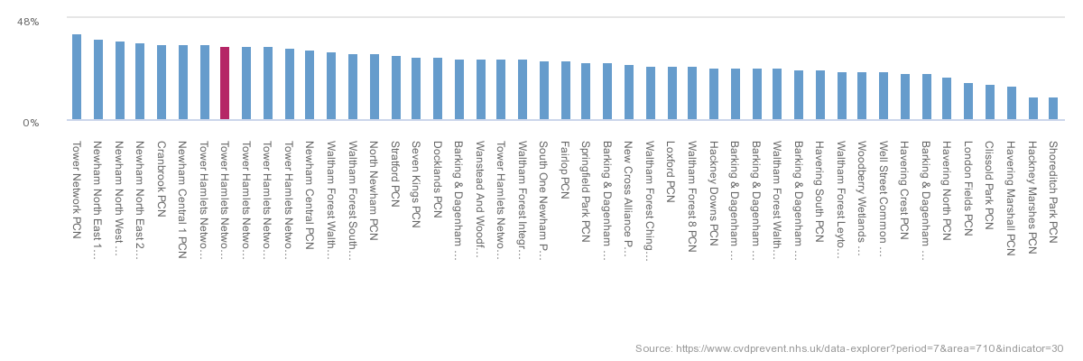

Figure 53: % of CVD patients with controlled cholesterol by PCN across NEL ICB. Defined as: Percentage of patients aged 18 and over, with GP recorded CVD (narrow definition), in whom the most recent blood cholesterol level (measured in the preceding 12 months) is non-HDL cholesterol less than 2.5mmol/l or LDL-cholesterol less than 1.8mmol/l. Source: CVDPrevent.[205]

#### Atrial fibrillation

AF is controlled through anticoagulants which are prescribed and delivered predominantly through primary care.

NICE guidelines on detecting, treating and managing atrial fibrillation outline actions for detection, diagnosis, assessment of stroke and bleeding risks, stroke prevention, preventing recurrence after ablation and preventing and managing postoperative atrial fibrillation.[206] In addition, the NHS RightCare Atrial Fibrillation High Impact Intervention Tool provides local health systems with an interactive dashboard to help measure the value of identifying and treating patients with Atrial Fibrillation (AF), including the impact of detection and treatment-based interventions.[207] Importantly, however, there has been some debate about the value of expanding detection of atrial fibrillation due to the potential for overtreatment, and the National Screening Committee does not currently recommend a national screening programme for atrial fibrillation.[208] Atrial fibrillation also does not necessarily indicate CVD risk – the NICE ‘grasp’ tool supports clinicians to assess this.

In Tower Hamlets, there are incentives to anticoagulate those with atrial fibrillation in the GP population heath medicines optimisation specification and a local enhanced specification for GP-delivered anticoagulation. However, community anti-coagulation services, commissioned via individual practices, are not offered by all GPs as it requires extensive training and is a high risk prescription.

The North London Cardiovascular Disease Prevention Strategy 2023/2024 includes a target to:

* Detect 85% of the expected population with atrial fibrillation – this requires a manual calculation using PHE/OHID modelling and actual detected prevalence on QOF/CVDPREVENT, and performance data is not currently available.
* 90% of patients with AF to have a risk assessment in the last 12 months, in line with QOF AF006, 2021/2022.
* 90% of those with a score of >=2 to be on anticoagulation, in line with QOF AF007, 2021/2022. Tower Hamlets is just below this target at 85.8% in 2021/22, and this has been at a stable rate for the past 6-7 years.[209]
* In addition, QOF data shows that Tower Hamlets is performing similarly to the England average for the percentage of stroke patients on anti-platelet or anti-coagulants (87% vs 90% in 2021/22), and this has been at a stable rate for the past 6-7 years.[210]

#### Diabetes management

Details of diabetes management and care processes, including the diabetes educational programme, and Tower Hamlets performance under these, are detailed in the Diabetes HNA.[211]

## Managing CVD

The acute response to CVD events and treatment of CVD is not covered in this HNA; instead it focuses on longer-term management of CVD and support to continually reduce ongoing risk factors (such as physical inactivity and smoking). But it is worth noting that time to intervention for CVD events has a major impact on mortality particularly for stroke and heart attacks.

As well as the below interventions, following a CVD event people are also advised (and supported) to reduce their modifiable CVD risks – such as smoking, obesity, hypertension and so on. Interventions focused on this are outlined above in ‘Reducing CVD risks’ and are not repeated in this section.

### Summary of CVD management data

Tower Hamlets, in a similar trend to national averages, saw a dip in the % of those with hypertension, CHD, or a history of stroke/TIA showing blood pressure within range from 2019/20 to 2020/21. This is likely linked to the Covid-19 pandemic, with improvements seen in 2021/22 but the proportion remaining around 10% lower than 2019/20 levels (around 60-80% compared to previous rates of 70-90%).[212]

For the % of patients with CHD who had a record that aspirin, APT or ACT is taken, Tower Hamlets is similar to national trends with both showing a sharp decline in 2020/21 and a rebound in 2021/22 but with rates not yet at previous levels. Rates of treatment with ACE-I or ARB for those with heart failure have been similar to England averages and remained stable over the past decade. [213]

In a similar pattern to England averages, for the % of patients with heart failure 1) whose diagnosis was confirmed by ECG/specialist assessment, 2) who were treated with beta-blockers when required, there appears to be a slight increase from 2020/21 to 2021/22 from c.70-80%. The % of patients with heart failure who had a review (including assessment of functional capacity) in the last 12 months has risen more sharply from 2020/21 to 2021/22, from c.25% - 40%. Confidence intervals are however relatively wide. [214]

The % of patients with stroke taking an anti-platelet agent or anticoagulant in Tower Hamlets is in line with national averages and stable over time at around 90%. The % of patients with atrial fibrillation treated with anti-coagulation therapy has similarly tracked England averages and risen over the past 6 years from 80-90%.[215]

### Cardiac rehab

#### What is it?

Cardiac rehab is a programme to enable physical, psychological and social recovery from a CVD event or cardiac intervention. A multidisciplinary team offers advice and support on diet, exercise, smoking cessation and other modifiable CVD risk factors. BACPR sets standards and guidelines for the service, including recommended multidisciplinary team mixes and patient groups included, training and accreditation.[216] Provision of cardiac rehab varies considerably according to local circumstances, and across NEL there is inequality in the provision of cardiac rehab. The Tower Hamlets service is relatively well established compared to other boroughs.

#### Does it work?

There is strong evidence that cardiac rehabilitation reduces cardiac-related morbidity, which in turn reduces re-admissions and the need for cardiac follow-up consultation. Cardiac rehabilitation is a cost effective service to effectively manage patients in the community and reduce unnecessary demand on acute services. (NICE 2007, Jolliffe et al 2000, Lamm et al 2011 & Lawler et al 2011).

Cardiac rehabilitation also supports patients’ return to work, functional capacity, physical activity status and perceived quality of life, and supports the development of self-management skills.

#### Tower Hamlets offer

In Tower Hamlets, Barts offers cardiac rehab to those who have experienced a cardiac event, which includes a heart attack, heart failure and cardiac surgery. There is evidence that other groups may benefit from cardiac rehab such as those with atrial fibrillation, but the capacity and cost implications of this are considerable bearing in mind the size of that population and could severely impact the availability of the service to those having experienced a cardiac event. At present the service does not extend to those with atrial fibrillation.

The programme starts in hospital when the cardiac rehab team contacts inpatients in the Barts Heart Centre who have experienced a cardiac event to review their risk factors and their initial plans following discharge (for example returning to work). Patients are then contacted by phone within 72 hours of discharge to review their risks and start a plan for recovery, starting cardiac rehab in the following 1-2 weeks. The first part of the service (for inpatients) is commissioned by Barts Health; after this, the service is commissioned by NEL ICB as a community health service.

There are then a range of offers depending on the person’s individual goals and preferences. Some offers are tailored to local groups – for example a face-to-face gym programme in local leisure centres for Bangladeshi heritage men, another for women, and a one-to-one gym session if people prefer or cannot make group times. Group times have been adjusted to align with participants’ diaries – for example avoiding prayer times and factoring in Ramadan dates for Muslim participants. Virtual programmes were offered during the COVID19 pandemic but participants have fed back to service leads that they prefer face to face sessions, which are now the predominant offer with the exception of some virtual classes that remain for those who cannot make face to face sessions (for example on cooking, healthy diet and exercise).

The team also refers patients to other support offers where appropriate. Recently they have begun referring patients to local social prescribers (for example if they have ongoing financial or housing concerns), as well as to psychology (predominantly for those with anxiety following a CVD event), smoking cessation services and local voluntary sector services such as food banks or Ability Bow to support those with disabilities.

Patients attending cardiac rehab may have substance misuse histories, be experiencing homelessness, have severe mental illness or other disabilities such as a learning disability. The service requires that all attending are clinically stable and the team supports those with additional needs (for example supporting any patients with substance misuse problems who relapse whilst at cardiac rehab).

The team in Barts includes physiologists, dieticians, psychologists, pharmacists and occupational therapists. They have received relevant training and accreditation from BACPR. There are also Bengali advocates in the team, and further communication support is brought in where needed for example for those with learning disabilities.

The programme is ‘completed’ when participants meet their personalised goals, which happens on different timelines depending on the person’s goals but is usually within 2-3 months. The cardiac rehab team then does a final assessment with the patient and updates their GP with a summary of their risk review at the outset and completion of the programme, and offers longer-term support where relevant. This could be a set programme – such as a cycling programme or park runs – or more individual, such as gym sessions with a BACPR-qualified instructor who can discuss wider risk factors such as diet and smoking. Completers have access to a reduced price 6-week gym pass at local leisure centres.

#### Performance, gaps and issues

All patients with a cardiac event seen through the Barts Heart Centre are offered cardiac rehab. There is a national target under the Long Term Plan (also reflected in the North London Cardiovascular Disease Prevention Strategy 2023/2024) to reach 85% of eligible patients by 2028, and in Tower Hamlets uptake for 2021/22 was 59.3%.[217] This is similar to many areas; the England average is estimated to be around 50%.[218] There are a number of NEL initiatives and funding from NHS England to meet this national target by 2028. The North London Cardiovascular Disease Prevention Strategy 2023/2024 also includes a target to ensure 85% patients who have accessed CR complete the programme.

During the time of writing this HNA (January – May 2023) it was not possible to get up-to-date data on uptake of cardiac rehab and outcomes for those doing the programme, nor to get data on how this was split by key demographic variables such as sex, age and ethnicity. This is key gap for reviewing, evaluating and improving cardiac rehab services.

For this HNA, we visited the cardiac rehab service in Whitechapel and spoke to staff and patients. One patient was a returner to cardiac rehab after three CVD events, and highlighted the importance of face-to-face support and a tailored offer that takes account of multiple health issues. Staff highlighted the following barriers to service access for patients:

* Transport – this was highlighted as a key barrier for patients on a low income
* Time available to attend, particularly for those providing care to others at home. Uptake among Bangladeshi women was noted as being particularly low and staff thought this could be linked to caring duties. Those in unstable or casual employment or financially precarious situations also fed back to staff that they were unable to attend due to prioritising work. Those living with homelessness also faced challenges attending due to often being required to attend appointments (such as for housing) at short notice.
* Other health needs which sometimes made patients anxious about engaging in exercise classes (though sessions are tailored to different health needs)

Staff also discussed the demographic makeup of those attending cardiac rehab in Tower Hamlets, and noted that it is a younger cohort than that seen in neighbouring boroughs (for example through the Whipps Cross cardiac rehab service). Finally, staff fed back the often considerable impact of the Covid-19 pandemic on their patients, with some people experiencing rapid weight gain, loneliness, higher alcohol consumption, inactivity and mental health problems during the pandemic.

#### Recommendations

There is a need to improve data systems so that complete and high quality data on cardiac rehab uptake and outcomes is available to local services and commissioners at speed, including splitting this by demographic factors such as sex, age and ethnicity.

The North London Operational Delivery Network for cardiac rehab has a number of plans to develop the offer, including:

* A resource library of videos and information on reducing CVD risks
* A review of administrative processes in cardiac rehab across North London to identify efficiencies, which is due to report in June 2023
* Webinars for GPs and social prescribers across NEL (this has not been well-attended in the past so there is a need for further outreach).

The cardiac rehab lead nurse and other team members highlighted some important gaps and issues to address in the service:

* **Access.** Funding transport would support those living in poverty to attend cardiac rehab.
* **Eligibility**. This is defined as being clinically stable, having undergone a CVD event, and having a Tower Hamlets postcode. This may impact access for some groups, for example the Gypsy-Traveller community or those experiencing homelessness – though staff at the service confirmed that they do take service users experiencing homelessness.
* **Referrals**. Patients are primarily referred to cardiac rehab via the Barts Heart Centre, with some (minimal) referrals from primary care. Soon patients will also be referred by the ELoPE secondary care social prescribing programme, but this also takes patients from the Barts Heart Centre. This may be missing those experiencing cardiac events who see other services (such as community care for the elderly).
* **Digital exclusion**. Digital offers were important to continuing some form of cardiac rehab support during the COVID19 pandemic but they introduced some inequalities where people were digitally excluded.
* **Attendance** at some groups and events has been limited – for example women’s only groups – so there is an ongoing need to review and understand the reasons for this, and adapt services accordingly for example to ensure they are **culturally and practically appropriate** for the target group. Staff highlighted that uptake of online offers was very low.
* **Links to community offers.** This needs to be continually reviewed; there is also an opportunity to do this via the Barts social prescribing programme which will link to cardiac rehab.

### Stroke

The following focuses on the NEL ICB footprint as stroke numbers are relatively low at a borough level and stroke support is strategically managed at the ICB level.

It is a NEL ambition to reduce the number of people experiencing stroke by better management of related health conditions, and ensure that NEL residents who experience a stroke have access to consistent, high quality care across the stroke pathway, by focusing on the following key areas:

* Rehab and life after stroke
* Prevention
* AF and TIA
* Pre-hospital video triage
* Acute pathway standards and flow
* Thrombectomy and NOSIP
* Workforce

Recent achievements in reducing and treating stroke across NEL include:

* Ambulance Video triage Project, now live in NEL, has supported more than 100 patients to receive rapid specialist stroke care via video link.
* There is a NEL-wide atrial fibrillation hub bringing together secondary and primary care work together to support GPs to ensure those with atrial fibrillation are assessed and prescribed the correct anticoagulation.

However, workshops with professionals run by NEL at the end of 2022 highlighted some challenges across the stroke pathway, such as variable availability of community rehab teams.[219]

### Ongoing support in primary care

It is important that people with CVD have joined-up care and access to the right staff groups to support them in managing their condition, which is a part of care planning under the LES contract. PCNs 6, 7 and 8 are trialling different ways to offer person-centred care to people with long term conditions with different staffing mixes. This builds on the work of population health teams set up during the Covid-19 pandemic, linking those with long term conditions to multidisciplinary teams who can offer a range of non-clinical support to manage long term conditions. The exact staffing mix is decided at a PCN level and may include care coordinators, social prescribers, home health teams, physiotherapists and health and wellbeing coaches. Network 8 has begun a quality improvement programme to evaluate the effectiveness of this approach.

The UCLP Proactive Care Risk Stratification Framework also supports primary care to stratify the level of risk for different patients with CVD and the most appropriate staffing groups to support each risk level. It is not yet universally rolled out in Tower Hamlets. GP stakeholders interviewed for this HNA fed back that this was in part because different GP practices have different staff group mixes, some of which more readily lend themselves to this framework, and in part because implementation requires changes to existing call and recall systems which may be easier for some GP practices than others to implement.

There is a QOF target that 90% of those with heart failure have had an annual review including an assessment of function capacity and a review of medication to ensure medicines optimisation at maximal tolerated doses. Interim figures for NEL show the recorded figure is just 47%.[220]

#### Recommendations

GP stakeholders interviewed for this HNA suggested that GP practices should continue to share learning on models (under the UCLP framework and otherwise) of risk stratification, recall systems (including for example recalling a person in their birthday month so they know when they will be contacted), and appropriate staff mixes.

## Support for specific groups

This section sets out support available for those in Tower Hamlets:

* With severe mental illness (SMI)
* Experiencing homelessness
* With a learning disability
* Who are carers

This section gives an overview, but for further understanding of the particular issues and recommendations to improve support for these groups, an additional needs assessment is recommended.

### Mental health and severe mental illness

This section focuses on severe mental illness, however as noted above other mental health problems can also increase:

* Risk factors
* Risks from medication – for those on antipsychotic medications
* The need for appropriate CVD pathways for those with a mental health need, and for trauma-informed care.[221]

#### What’s recommended, and what is the policy context?

The NHS RightCare Toolkit for physical ill-health and Cardiovascular Disease (CVD) prevention in people with severe mental illness (SMI) defines the core components of an optimal service for people with SMI who are at risk of developing CVD: [PowerPoint Presentation (england.nhs.uk)](https://www.england.nhs.uk/rightcare/wp-content/uploads/sites/40/2019/03/nhs-rightcare-toolkit-cvd-prevention.pdf)

Although not very recent, the guidance on integrated support for people with mental and physical health problems such as CVD developed jointly by The King’s Fund and the Centre for Mental Health also remains a key document in this area.[222]

Screening, monitoring and prompt treatment of chronic disease risk factors in people with SMI are key to reducing health inequalities for this group. The NHS physical health checks programme for those with SMI incentivises health checks to pick up physical health risks and issues early. Annual physical health checks (which include checks on blood pressure, smoking, drug and alcohol history) are offered through GPs and, more recently, this is also offered through secondary care in Tower Hamlets. There is a national target for GPs to be giving these checks to 60-70% of those with SMI. There was significant reduction in health check numbers in 2019/20 and 2020/21 during the Covid-19 pandemic, though numbers are now recovering.[223]

To support the expansion of physical health checks for SMI, the NHS Long Term Plan included a support package to increase access to health checks, as well as support for employment and community mental healthcare transformation.[224] NHS England has also invested in tailored outreach and engagement for people with SMI to increase uptake of physical health checks. Uptake is also a priority under the national CORE20PLUS5 initiative to reduce health inequalities.

However, detecting risk is not in itself enough. The Covid-19 Mental Health and Wellbeing Recovery Action Plan made holistic and joined up support for people with SMI a priority area for action – but the investment and staffing support to achieve this is considerable.[225]

**Tower Hamlets strategic context:**

* Tower Hamlets has incorporated improving physical health in its Adult Mental Health Strategy. It sets out an objective for people with mental health problems to have good physical health and experience more holistic treatment of their mental and physical health.
* Actions include (i) developing new integrated models of primary and community care to ensure the holistic needs of people with mental health problems are met in one place, and (ii) increasing the number of people with SMI who access enhanced physical health checks; reaching out to those in most need through more targeted initiatives.

#### Detecting CVD risks: physical health checks for SMI

**Completeness of health checks:**

* In the most recent local data (for the year ending October 2022), the % of people on the GP SMI register in Tower Hamlets receiving some type of physical health check ranged 62.9%-67.9%. However, the % receiving *all six* physical health checks was only 46.7%, well below the national target of 60%.

Figure 54: % of all those on the GP SMI register in LBTH in the 12 months ending October 2022 that received different physical health checks. Source: QOF data.

**Coverage of health checks:**

* There is not currently local data on inequalities in health checks uptake by demographic and socioeconomic factors, so it is difficult to determine where there may be inequalities in uptake of physical health checks.
* There are plans to expand the physical health checks programme further with outreach to those with SMI not currently reached through the primary care offer.
* There is also a local addition to the programme to offer health checks to those on antipsychotics (some of whom may not have a SMI).
* There is also a physical health check included as part of quarterly ADHD medication reviews which includes a blood pressure, pulse and BMI check (due to the risk of weight loss, high blood pressure and fast pulse from commonly prescribed ADHD medications).

**Barriers and enablers for physical health checks uptake in Tower Hamlets:**

A quality improvement scoping project in 2022 sought to understand the barriers and enablers to physical health check uptake in Tower Hamlets and make recommendations to improve uptake, reduce inequalities in uptake, and improve the quality of pathways of care following a physical health check.[226]

The project gathered feedback from staff in 15 GP practices, one Primary Care Networks and in the East London Foundation Trust using online questionnaires.

It found that:

* Most GP practices maintain an up-to-date SMI register and know the number of patients needing physical health checks to meet their target, and those who had been offered these checks​ as well as which components of physical health checks have been offered

​

* GP practices and ELFT have a structured local template for recording completed physical health checks and for recording interventions offered in patient records.
* Most GP practices and PCNs have a plan and performance oversight process in place to monitor delivery of the upper threshold of all physical health checks in the SMI QoF incentives (at a component level: weight, blood pressure and pulse check, blood lipid, blood glucose, alcohol consumption and smoking status)​
* Most GP practices and ELFT have clear pathways for referring patients to 1) community services: social prescribing, stop smoking services, alcohol services and drug misuse service & some of weight management services (Tier 2), and 2) specialist services: cancer screening programmes, specialist consultant led services and LTC clinics
* A variety of communication methods are used to reach out and invite/remind patients on the SMI register of physical health checks (such as letters and text messages -in English-, and phone calls using interpreters when needed) ​

​

* A few practices have active DNA process (3 follow ups / reminders) for patients who do not take up the offer of physical health checks

Respondents highlighted areas for improvement:

* Risk stratifying patients on the SMI register based on clinical risks and level of engagement – the UCLP Primrose model was suggested.
* Staff capacity is needed to follow up on results, offer interventions and support those with SMI to navigate clinical pathways – for example by using health and wellbeing coaches, HCAs, social prescribers or community connectors (ELFT)
* More local engagement with service users and carers to understand barriers and facilitators to taking up physical health checks and follow up care, co-produce culturally and logistically appropriate services tailored to their needs.
* Training for primary and secondary care staff on making every contact count (HEE and CEPN options for this).

In addition, GPs we spoke to for this HNA flagged two key gaps in this programme:

1. It encourages detection of risk but there is no incentive or funding included to follow up and reduce those risks.
2. The programme is for those with SMI, which is a group with particularly high risk of developing CVD. At a population level it is also worth considering the health gains to be made by expanding this to those with long-term depression – a much more common MH need and one which also carries risk of developing CVD. However, this is a national decision and one that would require significant capacity and funding to achieve.

##### Reducing CVD risk for those with MH needs

MH personal budgets have been launched in Tower Hamlets, which enable those with MH needs in secondary care to determine how their own health budget is spent with the support of care coordinators - for example on a gym or swimming membership. There is relatively low take-up so far and expanding take-up was flagged as a priority by the MH GP Clinical Lead locally in interviews for this HNA.

Neighbourhood MH teams in secondary care, who tend to support those with SMI and relatively severe MH needs, and IAPT services for those with more moderate MH needs, can both signpost people to other local services as needed – for example weight management or smoking cessation support. However, both services are under pressure and this depends on relevant offers being available and appropriate for this group.

Some GP practices also use the UCLP Primrose Model which uses health coaching and peer support to improve physical health and make lifestyle changes. Primary Care Network 1 is running a quality improvement project to understand how this could work in Tower Hamlets, and how it could link to secondary care as a joint neighbourhood MH project.

More broadly, there is a move in Tower Hamlets primary care and MH services to fund more peer support workers to support those with MH needs to improve their physical health.

IAPT offers a pathway for those with a long term condition, including CVD, where the person’s mental health need is related to their long term condition.

#### Conclusion

* **Problem**: Those with SMI are at heightened risk of CVD, both because they tend to have higher rates of environmental and other modifiable risk factors such as smoking, and also through antipsychotic medications raising the risk of CVD (particularly ischaemic heart disease).[227] Wider determinants of health are important drivers of MH needs, as well as physical health needs for those with a MH problem, both of which have a clear deprivation gradient. Local clinicians consulted for this HNA fed back that due to technical difficulties doing outreach and the complexity of motivation for this patient group, it is difficult to complete physical health checks for those with SMI.
* **Solution**: There is a need to strengthen outreach for SMI health checks and peer support to improve service user engagement and motivation. It is also a core ambition of the NHS Long Term Plan to strengthen social prescribing particularly in primary care, and alongside this other community connector roles such as health coaches will have an important part to play.[228]
* **Gap**: The nationally-mandated programme to run physical health checks for people with SMI is an important way to detect CVD risk, but current funding packages and nationally-set targets on this leave limited space to expand the physical health offer to Tower Hamlets residents with other MH needs, to other types of interventions, or to earlier preventative interventions. New QOF targets focus on physical health checks for SMI, but there remains limited incentivisation of follow-up actions following health checks through this type of scheme.
* **Next steps**: The recently-formed MH Partnership Board, which includes primary and secondary care, third sector organisations, service users and local commissioners, seeks to incorporate population needs and inequalities into local decision-making on support for those with MH needs, and to focus more on prevention. There may also be opportunities to adjust the physical health offer for those with MH needs as NEL ICB establishes the place agenda focused on local population needs.

#### Recommendations

NEL ICB to review the need for further outreach for physical health checks for those with severe mental illness, and peer support to improve service user engagement and motivation.

### People experiencing homelessness

#### Tower Hamlets offer

There is currently a specialist GP practice, the E1 Health Centre, set up to provide outreach health support for those homeless or rough sleeping. In its most recent CQC inspection, the Centre was rated as good for the care of people with long-term conditions, noting:

* Nursing staff had lead roles in chronic disease management and patients at risk of hospital admission were identified as a priority.
* 87% of patients with diabetes, on the register, had a last blood pressure reading (measured in the preceding 12 months) of 150/90 mmHg or less, compared to a local average of 91% and a national average of 87%.
* 82% of patients with diabetes, on the register, had had an influenza immunisation in the preceding 1 August to 31 March (local average 81% national average 78%).
* Longer appointments and home visits were available when needed.
* All these patients had a named GP and a structured annual review to check their health and medicines needs were being met. For those patients with the most complex needs, the named GP worked with relevant health and care professionals to deliver a multidisciplinary package of care.

However, street outreach from the E1 Health Centre is limited due to limited capacity. NEL ICB is in the process of commissioning a pan-NEL outreach service to serve rough sleepers, hostels and asylum settings.

There is also a GP outreach team commissioned by ELFT to go into hostels and provide outreach, however the contract for this is renewed every 3 months and issues with recruitment have been flagged as a result of this.

The local authority also funds quarterly ‘health fairs’ in rough sleeping day services that provide a range of health and wellbeing services, including NHS health checks but also more targeted services such as liver scanning due to the high risk of alcohol and substance misuse in this population, mental health assessment and referral, substance misuse and alcohol assessment and referral. GP registration and immediate primary care support is also available, which is an opportunity to pick up CVD risks (though this may fall into follow-up appointments if there are more urgent needs on the day). These are ordinarily attended by 60-95 people experiencing homelessness/rough sleeping. There are roughly 50 people registered as sleeping rough in Tower Hamlets at any given time so this suggests the health fairs attract those who don’t ordinarily use services.

There was also a short-term commission of Doctors of the World to provide health outreach and build relationships with those experiencing homeless who were not in touch with primary care.

Outreach workers:

1. Supported people with urgent needs (with assessment and treatment on the spot where possible or referral to A&E)
2. Coordinated care and follow up (such as referral to other services, follow up with patients to provide support and ensure meds compliance and appointment attendance)
3. Delivered engagement ahead of vaccine clinics and other health appointments.

The service ran for 6 months, and service data was reported to NEL ICB to support their plans for commissioning a pan-NEL outreach service. The ICB has also conducted analyses of secondary care use among homeless groups and an evaluation of programmes supporting rough sleepers with mental health needs (though the findings are not specific to CVD).

#### Recommendations

It is unclear how well current outreach services are reaching or serving homeless populations in Tower Hamlets, and the extent to which they are picking up CVD-related (as well as other) health risks in this group.

Tower Hamlets Local Authority to conduct a health needs assessment for people experiencing homelessness in Tower Hamlets. As part of this needs assessment, it would be helpful to consider the best chances for opportunistic engagement with this group and the most appropriate professionals or peers to engage and provide outreach.

Related recommendations in other sections

* The recommendation under ‘Health Festivals and outreach events’ for an expanded community outreach programme for health checks and advice includes homeless groups in its potential target populations.
* The section on Cardiac Rehab notes that those without a Tower Hamlets postcode are not eligible, so access may be restricted for homeless groups – however anecdotally the service does include those experiencing homelessness.

### Learning disabilities

This section focuses on learning disabilities due to disproportionate exposures to CVD risk factors and high rates of CVD in this group, but it is worth noting that there are needs across the disability spectrum (for example in terms of accessibility) that are important for all providers of CVD detection and support services to consider.

In Tower Hamlets, the Living Well group oversees the Embedding Disability Access Pilot Programme, which aims to improve equity of access to health services through piloting co-produced training on the social model of disability and accessible communications. This pilot conducted Enter and View surveys with GP practices and worked with Practice teams to support GPs with making reasonable adjustments for Disabled adults. This is additional to Enter and View assessments with the Create Quality Checkers team of Tower Hamlets residents with Learning Disabilities.

A systematic programme of targeted NHS Annual Health Checks are offered to people with a Learning Disability with a take up rate of 80% of all adults with learning disabilities on GP registers in the year 2022-2023

Across NEL ICB, there is a targeted smoking cessation programme under NHS Long Term Plan funding for inpatients, pregnant women and those with SMI or a learning disability.

Tower Hamlets residents with **obesity and a learning disability** can self-refer or be referred via their GP to the Shape Up programme hosted by Tower Hamlets Community Learning Disabilities Service, a 12-week programme that aims to support participants to develop and review their personalised weekly timetable and goals. Participants are supported to increase levels of physical activity, to try new sports and make healthy eating choices. This includes weekly group sessions with a fitness instructor plus weekly sessions covering a range of topics to support participants to eat healthily, to be more active and to take more control of their lifestyle choices. One to one support and access to a range of health and fitness professionals is also offered along with online content covering health information and fitness sessions. Support is offered to maintain gains made after the programme finishes. Inclusion of family members, carers, key workers, support workers etc. who can support the person to reach their goals.

#### Performance, gaps, issues

There are significant gaps identified by Public Health Commissions including the EDAP programme above on making reasonable access and the commission on Loneliness and Disabilities.

Communication barriers without easy read invitations or a special telephone line access for simple direct contact for appointments, lack of specialist clinics with a quieter / calmer environment and the ability to bring carers/ family to attend appointments, language and financial barriers of insufficient PA time and lack of access to affordable appropriate transport or a transport buddy, frustration due to long waiting times in busy environments and insufficient explanations / advocacy / follow up support concerning medication or lifestyle advice, all cause on-going barriers.

A systematic programme of training on disability access and accessible communications for commissioners, managers and front line health, Council and VS partners delivering services, plus resources to implement reasonable adjustments and an accreditation kite-mark process would be beneficial to create change.

Consistent access to longer-term health and well-being support with trusted advocates and long term support for key VCS agencies which have built consistent relationships with residents and carers, are required to address barriers.

#### Recommendations

Cross-system partners (via the Living Well Forum) to consider a systematic programme of training on disability access and accessible communications for commissioners, managers and front-line health, Council and VCS partners delivering services. This could include resources to implement reasonable adjustments and an accreditation kite-mark process – to note, many organisations have developed training materials and guides, such as the REAL Good Access Guide.

### Carers

Unpaid carers often support people with CVD with a range of psychosocial and care and support needs.[229] Most people diagnosed with CVD will have some information needs, many may have psychosocial needs, and those who have suffered a stroke or heart failure may need longer term support, such as with medication administration or home help.

In Tower Hamlets, 7.3% of those eligible for NHS Health Checks whose carer status is recorded (which is 92.1% of those eligible for NHS Health Checks) are carers.

#### What support is there in Tower Hamlets?

As well as national offers such as the Carers Trust, Carers UK, Careline, or the BHF Heart Helpline and online community, there is also support from social services which may carry out a carer’s assessment and needs assessment, as well as local support groups.[230] The Carers Centre Tower Hamlets, for example, informs, connects and supports unpaid carers as well as providing a Carers Wellbeing Academy to improve the wellbeing of unpaid carers.[231]

# Recommendations summary

## Overall recommendations

To develop a Heart Health Strategy for Tower Hamlets which links closely to related CVD Prevention Plans at the NEL ICB level, sets out clear milestones and timelines for actions building on the below recommendations, and proceeds with the following broad principles.

**A population health approach** that considers the highest risk groups both in terms of CVD risks (as set out in this HNA: those with a severe mental illness, experiencing homelessness, or with a learning disability) and those at risk of not accessing services (such as carers, those in extreme loneliness or extreme poverty, or with communication needs or disabilities).[232] An NHS Secondary Prevention Review engagement process in January 2023 highlighted the importance of both patient-level data and local insights to target high risk groups.[233]

A **focus on existing assets** across the borough, with a review of VCS offers on CVD to support this – for example the possible role of the community grant to train and enable VCS organisations to deliver CVD prevention programmes.

A focus on **secondary prevention** but with links to primary prevention efforts, for example reducing poor quality fast food around schools, reducing pollution exposure, or programmes to encourage physical activity particularly in high-risk groups and starting at an early age. An NHS Secondary Prevention Review engagement process in January 2023 highlighted up-stream investment as a key opportunity to improve CVD prevention. [234]

A **cross-system approach** to prevention, detection and management of CVD risk factors across local authority, NHS and VCS services, primary and secondary care, and locality/borough/ICB footprints (linking to the Barts CVD Prevention Programme and the NEL ICB CVD Prevention Strategy). This could for example include joint commissioning of services across NHS/local authority/VCS partners. An NHS Secondary Prevention Review engagement process in January 2023 highlighted lack of consensus on prevention priorities between partners as a key barrier to improving secondary prevention. [235]

A renewed focus on **community outreach** targeting high risk groups, especially for hypertension.

**Cross-professional collaboration (particularly across community connector roles) and clear, shared pathways** for reducing risks that are well communicated with professionals, and opportunities for professionals across the system to share learning and good practice.[236] Resources mapping pathways should be considered at a locality level as well as borough-wide resources and sharing, and link to North London-wide care pathway reviews being undertaken by the North London ODN group. Digital access will be an integral part of many pathways but this needs to be accompanied by an understanding of needs for digital support for certain groups.

## Topic-specific recommendations

### Detecting risk factors

#### Health checks

Tower Hamlets Local Authority to conduct a review of GP practice health checks uptake variation and possible causes, a review of high risk CVD annual review variation by GP practice, and a review of post-health check referral rates to different programmes. To note: practices have only returned to their ‘business as usual’ offer on long term conditions in this financial year, and have been asked to prioritise clinically complex cases, which may be behind variation in health check uptake in recent data.

#### Community Pharmacy Hypertension Case Finding Service

1. PCN community pharmacy leads to liaise with community pharmacy on effective ways to promote lifestyle changes following blood pressure checks, linking this to existing GP and VCS offers.
2. NEL ICB, LPC and PCN community pharmacy leads to jointly review care pathways following BP checks under the scheme and continually review any variation in uptake of the service across pharmacies and follow-up support offers. This could include learning from other local authorities working on similar issues, for example the Lambeth centralised recall system pilot to reduce variation in hypertension detection.[237]
3. Community pharmacy to continually link this service to other related community pharmacy services – like smoking cessation.

#### CVD risk detection community outreach programme

Tower Hamlets Local Authority to trial a community outreach programme for CVD risk factor detection and reduction, with a focus on blood pressure checks and rigorous data collection to determine cost effectiveness. Such a programme should:

* Have carefully planned target populations, using local GP data on health check coverage, information from this HNA about higher risk groups and demographics (such as homeless and Gypsy-Traveller populations), and local knowledge of existing events, forums and settings that are likely to offer the best opportunistic interactions.
* Consider the optimum training, skill mix and cultural competence of any outreach team to deliver not only health checks but also provide risk communication and lifestyle advice.
* Ensure that there are links back to relevant services for follow-up, for example updates into primary care on high blood pressure results, and be set up with appropriate interoperable data systems to enable this.
* Link to wider NEL ICB CVD Prevention plans and the development of place-based offers locally.
* Community engagement at the earliest stage will be important in terms of gaining ownership, building trust and shaping the intervention from planning right through to evaluation. This could be done through the establishment of a health panel, or through focus groups, interviews and questionnaires or world café type/open space events. Resources will be required for participation throughout.

#### ELoPE

ELoPE colleagues at Barts NHS Trust to continue to evaluate the ELoPE programme and instigate potential improvements, including linking to Public Health, primary care and VCS colleagues and to new local CVD initiatives. This could include for example linking the project to detect CVD risks in Barts staff to any expansion of local community pharmacy support for those with hypertension, and to the new secondary care social prescribing offer under ELoPE.

### Reducing risk factors once found

#### Connecting people to services

NEL ICB Tower Hamlets social prescribing commissioners to work with Barts and the GP Care Group to:

* Continually review improvements to data collection systems and the NEL social prescribing dashboard where possible. This is in order to better assess population needs from social prescribing and any gaps in the local offer available to meet those needs, and should also incorporate co-design with those groups affected.
* Continue to press for a return to face to face support.
* Where possible, support national efforts to evaluate the cost effectiveness of the Tower Hamlets social prescribing model as well as opportunities for community assessment of effective social prescribing, and bring latest evidence on this back into local service commissioning and design.

ELoPE social prescribing lead to work jointly with NEL ICB social prescribing commissioners and the GP Care Group to:

* Continually review the accessibility of materials to patients and opportunities for co-design of services;
* Consider the specific needs of those with CVD who are also carers;
* Consider whether the current focus on inpatients having experienced cardiac events does not systematically exclude women, who are less likely to be presenting with cardiac events but among whom there may nevertheless be important preventative actions.

#### Reducing non-clinical risk factors

##### Smoking cessation

The service provider, QMUL, to:

* Continually review and encourage uptake of the programme among Tower Hamlets pharmacies.
* Incorporate the findings of the local authority tobacco cessation services review into service design, for example targeting support efforts in the E2 and E3 postcodes and to White ethnic groups and younger people.
* Review the offer for group session with peer support, which have the highest quit rates.
* Liaise with other smoking cessation programmes in doing this, for example inpatient smoking cessation support offered by Barts.

In addition, NEL ICB has a role in coordinating smoking cessation efforts across local authorities, VCS organisations and the NHS, and across local and regional footprints.

##### Alcohol and substance misuse:

The Substance Misuse Needs Assessment has highlighted the need for improved lines of communication and reduced duplication across the above offers and the need to align incentives and priorities to long-term outcomes. It also flags the need for increased capacity in RESET treatment and better cultural competency across the wider alcohol and substance misuse support system.

##### Weight management and physical activity

NEL ICB to recommission Tier 3 services – this is underway.

Tower Hamlets Public Health Commissioners to liaise with linked programmes (for example Barts leads on offers to patients and staff) to:

* Review data on uptake of programmes by demographics and other health conditions, and explore tailored programmes for sub-groups with low uptake.
* Review latest evidence and guidelines to optimise the delivery model, and engage with the public and suppliers to achieve this. For example, there may be opportunities to review physical activity offers with the upcoming insourcing of leisure provision into Tower Hamlets Local Authority.
* Where there is capacity, consider lower eligibility criteria for individuals with other health conditions, such as comorbidities, including type 2 diabetes, as per NICE guidance for commissioning Tier 2 weight management services.[238]
* Ensure professionals, particularly in primary care, are updated on service changes and clear on referral pathways, and that these are streamlined wherever possible.

Service providers to:

* Ensure face to face provision continues, and consider the role of peer support and coaching in weight management offers
* Ensure support is appropriately targeted and considers different accessibility needs.

Tower Hamlets public health, with NEL ICB long-term conditions commissioners, should review the need for and provision of subsidised exercise offers to those with or at risk of long-term conditions (including CVD), in order to inform in-house provision of leisure centres.

### Reducing clinical risk factors

Barts CVD Secondary Prevention team to systematically assess secondary prevention of patients moving through Barts services, and to consider targeting outreach events and support for patients by higher risk demographics, and to continue to support wider learning across linked teams and professionals, for example providing teaching for GP practice teams or linking to social prescribers.

Tower Hamlets PCNs to:

* Review the causes of variation in uptake of blood pressure monitoring at home service by GP practice, linking to NEL ICB long-term conditions commissioners who are reviewing eligibility and targeting under the programme;
* Consider whether there are training needs among GPs to enable anticoagulation prescription, and share these findings with NEL ICB and Barts.

### Managing CVD

Cardiac Rehab team at Barts to continue to review the following areas for development in the service:

* Improve data systems so that complete and high quality data on cardiac rehab uptake and outcomes is available at speed, including splitting this by demographic factors such as sex, age and ethnicity.
* Opportunities for funding transport to support those living in poverty to attend cardiac rehab. To note – those on benefits should be able to claim back transport costs, so efforts need to be made to support people with this process.
* Whether current eligibility criteria (in particular the requirement for a Tower Hamlets postcode) impacts access for some groups, for example the Gypsy-Traveller community or those experiencing homelessness.
* Referral pathways into cardiac rehab, and where these can be expanded.
* Support to those digitally excluded to access digital offers under the programme.
* Ongoing review of offers under cardiac rehab with poor attendance and adaptation of the offer to ensure it is culturally and practically appropriate for the target group.
* Link to other community offers, including local authority-funded and VCS supported.

GP practices to continue to share learning on models of support for those with CVD, including risk stratification, recall systems and appropriate staff mixes – including at an ICB level.

PCNs to conduct a health outcomes evaluation of care planning in primary care.

### Support for specific groups

NEL ICB to review the need for further outreach for physical health checks for those with severe mental illness, and peer support to improve service user engagement and motivation.

Tower Hamlets Local Authority to conduct a health needs assessment for people experiencing homelessness in Tower Hamlets. As part of this needs assessment, it would be helpful to consider the best chances for opportunistic engagement with this group and the most appropriate professionals or peers to engage and provide outreach.

Cross-system partners (via the Living Well Forum) to consider a systematic programme of training on disability access and accessible communications for commissioners, managers and front-line health, Council and VCS partners delivering services. This could include resources to implement reasonable adjustments and an accreditation kite-mark process – to note, many organisations have developed training materials and guides, such as the REAL Good Access Guide.

**References**

1. Prioritised based on NHSE CVD Prevention Programme evidence, review of TOWER HAMLETS priority areas for improvement, and wider review of evidence on CVD risk factors in this HNA.
2. [Smokers urged to swap cigarettes for vapes in world first scheme - GOV.UK (www.gov.uk)](https://www.gov.uk/government/news/smokers-urged-to-swap-cigarettes-for-vapes-in-world-first-scheme)
3. [Public health profiles - OHID (phe.org.uk)](https://fingertips.phe.org.uk/search/smoking#page/3/gid/1/pat/6/par/E12000007/ati/402/are/E09000030/iid/1210/age/164/sex/4/cat/-1/ctp/-1/yrr/1/cid/4/tbm/1)
4. [B1590-cvd-high-impact-interventions.pdf (england.nhs.uk)](https://www.england.nhs.uk/wp-content/uploads/2022/12/B1590-cvd-high-impact-interventions.pdf)
5. [London PCN eradicates blood pressure inequality - The Pharmacist](https://www.thepharmacist.co.uk/clinical/cardiovascular/london-pcn-eradicates-blood-pressure-inequality/)
6. [BHF UK CVD Factsheet](https://www.bhf.org.uk/-/media/files/for-professionals/research/heart-statistics/bhf-cvd-statistics-uk-factsheet.pdf?rev=e771367bf0654a4dae85cbc9dbefae17&hash=76C0182379BB6EE118EC6F76FA35A158)
7. [B1590-iii-Modifiable-Risk-Factors-High-Impact-Interventions.pdf (england.nhs.uk)](https://www.england.nhs.uk/wp-content/uploads/2022/12/B1590-iii-Modifiable-Risk-Factors-High-Impact-Interventions.pdf)
8. <https://www.cochranelibrary.com/cca/doi/10.1002/cca.3626/full>
9. [NHS England » Secondary prevention: reducing disparities and improving life expectancy](https://www.england.nhs.uk/ourwork/prevention/secondary-prevention/)
10. [B1590-iii-Modifiable-Risk-Factors-High-Impact-Interventions.pdf (england.nhs.uk)](https://www.england.nhs.uk/wp-content/uploads/2022/12/B1590-iii-Modifiable-Risk-Factors-High-Impact-Interventions.pdf)
11. [B1590-cvd-high-impact-interventions.pdf (england.nhs.uk)](https://www.england.nhs.uk/wp-content/uploads/2022/12/B1590-cvd-high-impact-interventions.pdf)
12. [B1590-cvd-high-impact-interventions.pdf (england.nhs.uk)](https://www.england.nhs.uk/wp-content/uploads/2022/12/B1590-cvd-high-impact-interventions.pdf)
13. [Mental health and your heart | BHF - BHF](https://www.bhf.org.uk/informationsupport/risk-factors/mental-health)
14. <https://www.england.nhs.uk/rightcare/wp-content/uploads/sites/40/2017/11/rightcare-pathway-diabetes-reasonable-adjustments-learning-disability-2.pdf>
15. [Cardiovascular disease in homeless versus housed individuals: a systematic review of observational and interventional studies | Heart (bmj.com)](https://heart.bmj.com/content/106/19/1483)
16. [Mechanisms by which diabetes increases cardiovascular disease - PMC (nih.gov)](https://www.ncbi.nlm.nih.gov/pmc/articles/PMC2504760/)
17. [Blood cholesterol and vascular mortality by age, sex, and blood pressure: a meta-analysis of individual data from 61 prospective studies with 55,000 vascular deaths - PubMed (nih.gov)](https://pubmed.ncbi.nlm.nih.gov/18061058/)
18. [B1590-cvd-high-impact-interventions.pdf (england.nhs.uk)](https://www.england.nhs.uk/wp-content/uploads/2022/12/B1590-cvd-high-impact-interventions.pdf)
19. [General health by age, sex and deprivation, England and Wales - Office for National Statistics (ons.gov.uk)](https://www.ons.gov.uk/peoplepopulationandcommunity/healthandsocialcare/healthandwellbeing/articles/generalhealthbyagesexanddeprivationenglandandwales/census2021#general-health-at-a-regional-and-local-authority-level-2021)
20. [Managing high blood pressure - a resource for primary care staff - BHF](https://www.bhf.org.uk/for-professionals/healthcare-professionals/data-and-statistics/managing-high-blood-pressure)
21. Office for national statistics. Death registrations summary tables – England and Wales, 2015
22. NHS Long Term Plan
23. [Heart and circulatory disease in context - BHF](https://www.bhf.org.uk/what-we-do/our-research/heart-and-circulatory-diseases-in-numbers/heart-and-circulatory-disease-in-context)
24. [NHS England » NHS Community Pharmacy Blood Pressure Check Service](https://www.england.nhs.uk/primary-care/pharmacy/pharmacy-integration-fund/nhs-community-pharmacy-bp-checks-and-hypertension-case-finding-advanced-service/)
25. BHF statistical compendium
26. NHS Long Term Plan
27. Source: NHS Digital, NHS Outcomes Framework
28. NHS Digital. Accident and emergency attendances in England 2014-15
29. BHF factsheet January 2022 using data from NHS England Ambulance Quality Indicators
30. OHID deprivation segment tool: [Segment Tool (phe.gov.uk)](https://analytics.phe.gov.uk/apps/segment-tool/)
31. [Primary prevention of cardiovascular disease: A review of contemporary guidance and literature - PMC (nih.gov)](https://www.ncbi.nlm.nih.gov/pmc/articles/PMC5331469/)
32. [Cardiovascular diseases (CVDs) (who.int)](https://www.who.int/news-room/fact-sheets/detail/cardiovascular-diseases-(cvds))
33. [Prevention | Local Government Association](https://www.local.gov.uk/our-support/our-improvement-offer/care-and-health-improvement/integration-and-better-care-fund/better-care-fund/integration-resource-library/prevention)
34. [Abdominal aortic aneurysm: A comprehensive review - PMC (nih.gov)](https://www.ncbi.nlm.nih.gov/pmc/articles/PMC3076160/)
35. [Cardiovascular diseases (CVDs) (who.int)](https://www.who.int/news-room/fact-sheets/detail/cardiovascular-diseases-(cvds))
36. [Gender medicine: effects of sex and gender on cardiovascular disease manifestation and outcomes. - Abstract - Europe PMC](https://europepmc.org/article/MED/36316574)
37. [Gender identity, England and Wales - Office for National Statistics (ons.gov.uk)](https://www.ons.gov.uk/peoplepopulationandcommunity/culturalidentity/genderidentity/bulletins/genderidentityenglandandwales/census2021)
38. [338 CVDPREVENT Second Annual Audit Report FINAL.pdf](https://s3.eu-west-2.amazonaws.com/nhsbn-static/CVDPREVENT/2022/338%20CVDPREVENT%20Second%20Annual%20Audit%20Report%20FINAL.pdf)
39. [Blood pressure - NDRS (digital.nhs.uk)](https://digital.nhs.uk/data-and-information/publications/statistical/health-survey-england-additional-analyses/ethnicity-and-health-2011-2019-experimental-statistics/blood-pressure)
40. [Diabetes and heart disease in Bangladeshis and Pakistanis | East London Genes & Health (genesandhealth.org)](https://www.genesandhealth.org/genes-your-health/diabetes-and-heart-disease-bangladeshis-and-pakistanis)
41. [Diabetes and heart disease in Bangladeshis and Pakistanis | East London Genes & Health (genesandhealth.org)](https://www.genesandhealth.org/genes-your-health/diabetes-and-heart-disease-bangladeshis-and-pakistanis)
42. <http://www.ncbi.nlm.nih.gov/pubmed/19151713>
43. [Blood pressure - NDRS (digital.nhs.uk)](https://digital.nhs.uk/data-and-information/publications/statistical/health-survey-england-additional-analyses/ethnicity-and-health-2011-2019-experimental-statistics/blood-pressure)
44. [338 CVDPREVENT Second Annual Audit Report FINAL.pdf](https://s3.eu-west-2.amazonaws.com/nhsbn-static/CVDPREVENT/2022/338%20CVDPREVENT%20Second%20Annual%20Audit%20Report%20FINAL.pdf)
45. [Family history of cardiovascular disease - PMC (nih.gov)](https://www.ncbi.nlm.nih.gov/pmc/articles/PMC4229162/)
46. [Home | East London Genes & Health (genesandhealth.org)](https://www.genesandhealth.org/)
47. [BHF UK CVD Factsheet](https://www.bhf.org.uk/-/media/files/for-professionals/research/heart-statistics/bhf-cvd-statistics-uk-factsheet.pdf?rev=e771367bf0654a4dae85cbc9dbefae17&hash=76C0182379BB6EE118EC6F76FA35A158)
48. Fingertips
49. [Public health profiles - OHID (phe.org.uk)](https://fingertips.phe.org.uk/search/smoking#page/4/gid/1938132885/pat/6/par/E12000007/ati/402/are/E09000030/iid/92443/age/168/sex/4/cat/-1/ctp/-1/yrr/1/cid/4/tbm/1/page-options/car-do-0)
50. LTC Workshop - Pre-Reading Pack.pdf
51. [What we are monitoring and why (towerhamlets.gov.uk)](https://www.towerhamlets.gov.uk/lgnl/environment_and_waste/environmental_health/pollution/air_quality/Advanced_information_on_air_quality/What_we_are_monitoring_and_why.aspx); BHF CVD Factsheet
52. [What we are monitoring and why (towerhamlets.gov.uk)](https://www.towerhamlets.gov.uk/lgnl/environment_and_waste/environmental_health/pollution/air_quality/Advanced_information_on_air_quality/What_we_are_monitoring_and_why.aspx)
53. [Recreational substance use among patients with premature atherosclerotic cardiovascular disease | Heart (bmj.com)](https://heart.bmj.com/content/107/8/650)
54. Fingertips alcohol profile
55. [Public health profiles - OHID (phe.org.uk)](https://fingertips.phe.org.uk/search/cardio#page/3/gid/1938132848/pat/6/par/E12000007/ati/401/are/E09000030/iid/93769/age/1/sex/4/cat/-1/ctp/-1/yrr/1/cid/4/tbm/1/page-options/car-do-0)
56. Public Health England: Risk Factors Intelligence (RFI) team (from published data from the Home Office).
57. Fingertips
58. Fingertips tool: [Physical Activity - Data - OHID (phe.org.uk)](https://fingertips.phe.org.uk/profile/physical-activity/data#page/4/gid/1938132899/pat/6/par/E12000007/ati/401/are/E09000030/iid/93014/age/298/sex/4/cat/-1/ctp/-1/yrr/1/cid/4/tbm/1)
59. [BHF UK CVD Factsheet](https://www.bhf.org.uk/-/media/files/for-professionals/research/heart-statistics/bhf-cvd-statistics-uk-factsheet.pdf?rev=e771367bf0654a4dae85cbc9dbefae17&hash=76C0182379BB6EE118EC6F76FA35A158)
60. Fingertips Obesity Profile, OHID
61. Note: this data may be slightly biased as weight is more likely to be recorded for adults over 40 through the health checks offer than those aged 18-40, who may have their weight taken only opportunistically if and when a they present to their GP.
62. [Know Your Risk for Heart Disease | cdc.gov](https://www.cdc.gov/heartdisease/risk_factors.htm#:~:text=Your%20lifestyle%20can%20increase%20your,diet%20can%20raise%20blood%20pressure.)
63. Willett W, Koplan J, Nugent R, Dusenbury C, Puska P, Gaziano T. Prevention of Chronic Disease by Means of Diet and Lifestyle Changes. In: Disease control priorities in developing countries. 2006
64. Jepson RG, Harris FM, Platt S, Tannahill C. The effectiveness of interventions to change six health behaviours: a review of reviews. *BMC Public Health* 2010; 10: 538
65. [Wider Determinants of Health - OHID (phe.org.uk)](https://fingertips.phe.org.uk/profile/wider-determinants)
66. [Insomnia with objective short sleep duration and risk of incident cardiovascular disease and all-cause mortality: Sleep Heart Health Study | SLEEP | Oxford Academic (oup.com)](https://academic.oup.com/sleep/article/41/6/zsy047/4924334?login=false)
67. [Sleep Duration as a Risk Factor for Cardiovascular Disease- a Review of the Recent Literature - PMC (nih.gov)](https://www.ncbi.nlm.nih.gov/pmc/articles/PMC2845795/)
68. [Gender differences in the association of insomnia symptoms and coronary artery calcification in the multi-ethnic study of atherosclerosis | SLEEP | Oxford Academic (oup.com)](https://academic.oup.com/sleep/article/44/10/zsab116/6275477?itm_medium=sidebar&itm_source=trendmd-widget&itm_campaign=Sleep&itm_content=Sleep_0)
69. [Blood Pressure Award Programme – British Heart Foundation - BHF](https://www.bhf.org.uk/for-professionals/healthcare-professionals/innovation-in-care/blood-pressure-award-programme)
70. [Hypertension prevalence estimates for local populations - GOV.UK (www.gov.uk)](https://www.gov.uk/government/publications/hypertension-prevalence-estimates-for-local-populations)
71. Fingertips CVD profile: [Cardiovascular Disease - Data - OHID (phe.org.uk)](https://fingertips.phe.org.uk/profile/cardiovascular/data#page/1/gid/1938133106/pat/15/ati/221/are/nE54000029/iid/219/age/1/sex/4/cat/-1/ctp/-1/yrr/1/cid/4/tbm/1)
72. [The interplay between atrial fibrillation and acute myocardial infarction | British Journal of Hospital Medicine (magonlinelibrary.com)](https://www.magonlinelibrary.com/doi/full/10.12968/hmed.2020.0584#:~:text=Atrial%20fibrillation%20can%20contribute%20to,resulting%20in%20demand%E2%80%93supply%20mismatch)
73. [Atrial fibrillation prevalence estimates for local populations - GOV.UK (www.gov.uk)](https://www.gov.uk/government/publications/atrial-fibrillation-prevalence-estimates-for-local-populations)
74. [Mechanisms by which diabetes increases cardiovascular disease - PMC (nih.gov)](https://www.ncbi.nlm.nih.gov/pmc/articles/PMC2504760/)
75. [Public health profiles - OHID (phe.org.uk)](https://fingertips.phe.org.uk/search/diabetes#page/1/gid/1/pat/15/ati/167/are/E38000255/iid/241/age/187/sex/4/cat/-1/ctp/-1/yrr/1/cid/4/tbm/1)
76. https://assets.publishing.service.gov.uk/government/uploads/system/uploads/attachment_data/file/612306/Diabetesprevalencemodelbriefing.pdf
77. [High Cholesterol - Symptoms, Causes & Levels - BHF](https://www.bhf.org.uk/informationsupport/risk-factors/high-cholesterol)
78. [Blood cholesterol and vascular mortality by age, sex, and blood pressure: a meta-analysis of individual data from 61 prospective studies with 55,000 vascular deaths - PubMed (nih.gov)](https://pubmed.ncbi.nlm.nih.gov/18061058/)
79. [CVD prevention: CVD risk assessment and treatment (nice.org.uk)](https://stpsupport.nice.org.uk/cholesterol/index.html#:~:text=High%20cholesterol%20is%20one%20of,is%20attributable%20to%20high%20cholesterol.)
80. CVDPrevent data
81. [Mental health and your heart | BHF - BHF](https://www.bhf.org.uk/informationsupport/risk-factors/mental-health)
82. <https://publichealthmatters.blog.gov.uk/2018/12/18/health-matters-reducing-health-inequalities-in-mental-illness/>
83. Office for Health Improvement and Disparities. (2022). Premature mortality in adults with severe mental illness (SMI). Available at: <https://www.gov.uk/government/publications/premature-mortality-in-adults-with-severe-mental-illness/premature-mortality-in-adults-with-severe-mental-illness-smi> 
84. <https://www.england.nhs.uk/rightcare/wp-content/uploads/sites/40/2017/11/rightcare-pathway-diabetes-reasonable-adjustments-learning-disability-2.pdf>
85. OHID Fingertips tool: [Mental Health and Wellbeing JSNA - OHID (phe.org.uk)](https://fingertips.phe.org.uk/profile-group/mental-health/profile/mh-jsna/data#page/3/gid/1938132922/pat/6/par/E12000007/ati/402/are/E09000030/iid/90581/age/1/sex/4/cat/-1/ctp/-1/yrr/1/cid/4/tbm/1/page-options/car-do-0)
86. Office for Health Improvement and Disparities. (2022). Premature mortality in adults with severe mental illness (SMI). Available at: <https://www.gov.uk/government/publications/premature-mortality-in-adults-with-severe-mental-illness/premature-mortality-in-adults-with-severe-mental-illness-smi> 
87. Office for Health Improvement and Disparities. (2022). Premature mortality in adults with severe mental illness (SMI). Available at: <https://www.gov.uk/government/publications/premature-mortality-in-adults-with-severe-mental-illness/premature-mortality-in-adults-with-severe-mental-illness-smi> 
88. [Mortality Profile - Data - OHID (phe.org.uk)](https://fingertips.phe.org.uk/profile/mortality-profile/data#page/3/gid/1938133009/pat/6/par/E12000007/ati/401/are/E09000030/iid/108/age/163/sex/4/cat/-1/ctp/-1/yrr/1/cid/4/tbm/1)
89. [CVD risk factors and ethnicity—A homogeneous relationship? - ScienceDirect](https://www.sciencedirect.com/science/article/abs/pii/S1567568806000043)
90. [Social Determinants of Cardiovascular Disease - PubMed (nih.gov)](https://pubmed.ncbi.nlm.nih.gov/35239404/)
91. [Cardiovascular disease in homeless versus housed individuals: a systematic review of observational and interventional studies | Heart (bmj.com)](https://heart.bmj.com/content/106/19/1483)
92. [QOF search | NHS Digital](https://qof.digital.nhs.uk/search/index.asp)
93. NEL ICB Long Term Conditions Dashboard (internal resource)
94. <https://www.opencodelists.org/codelist/primis-covid19-vacc-uptake/homeless_cod/v.1.5.3/#full-list>
95. [*Health Inequalities: Cardiovascular Disease’*](https://www.google.com/url?sa=t&rct=j&q=&esrc=s&source=web&cd=&cad=rja&uact=8&ved=2ahUKEwjl4eqf4Or9AhUmhf0HHX6jDwEQFnoECAgQAQ&url=https%3A%2F%2Ffingertips.phe.org.uk%2Fdocuments%2FHealth_inequalities_cardiovascular_disease.pdf&usg=AOvVaw3tfd3DgKZJla2BeQFpQPx0)
96. [leder-main-report-hyperlinked.pdf (kcl.ac.uk)](https://www.kcl.ac.uk/ioppn/assets/fans-dept/leder-main-report-hyperlinked.pdf)
97. [leder-main-report-hyperlinked.pdf (kcl.ac.uk)](https://www.kcl.ac.uk/ioppn/assets/fans-dept/leder-main-report-hyperlinked.pdf)
98. NEL LTC dashboard
99. Source: NEL ICB LTC dashboard, updated 30-01-2023. Data from Discovery Data Service. Definitions for LTCs based on QOF case register definitions.
100. LTC Workshop - Pre-Reading Pack.pdf
101. Fingertips CVD data
102. LTC Workshop - Pre-Reading Pack.pdf
103. Internal slides produced by NEL ICB for a Long-Term Conditions Workshop using data and information from JSNA, Population Health Profile, Insights from resident feedback and information contained within local Health and Wellbeing Strategies
104. Heart/circulatory diseases refers to all diseases affecting the heart and blood vessels, which is set out in more detail in the [BHF Data Compendium](https://www.bhf.org.uk/-/media/files/for-professionals/research/heart-statistics/bhf-statistics-compendium-2022.pdf?rev=e1586d015a014ecc83cfcabd2f6d2ddf&hash=37559314C795E570D64DF0BAAAB1E2E5).
105. [BHF data compendium](https://www.bhf.org.uk/what-we-do/our-research/heart-statistics/heart-statistics-publications/cardiovascular-disease-statistics-2022) data visualisations, 2022. Heart and circulatory disease prevalence is estimated using official health and survey data from NHS Digital.
106. BHF factsheet: BHF analysis of latest mortality statistics as of January 2022: Office for National Statistics (ONS)/National Records of Scotland (NRS) /Northern Ireland Statistics and Research Agency (NISRA)
107. [Public health profiles - OHID (phe.org.uk)](https://fingertips.phe.org.uk/search/cardio#page/3/gid/1938133253/pat/6/par/E12000007/ati/401/are/E09000030/iid/92718/age/27/sex/4/cat/-1/ctp/-1/yrr/1/cid/4/tbm/1/page-options/car-do-0)
108. [Death rates - by local authority - BHF](https://www.bhf.org.uk/what-we-do/our-research/heart-and-circulatory-diseases-in-numbers/death-rates-by-local-authority)
109. [England's CVD Challenge - Healthcare Professionals - BHF](https://www.bhf.org.uk/for-professionals/healthcare-professionals/data-and-statistics/the-cvd-challenge/the-cvd-challenge-in-england#:~:text=Today%2C%20cardiovascular%20disease%20(CVD),year%20%E2%80%93%20are%20caused%20by%20CVD.)
110. Internal analysis using NOMIS data.
111. [Mortality Profile - Data - OHID (phe.org.uk)](https://fingertips.phe.org.uk/profile/mortality-profile/data#page/3/gid/1938133009/pat/6/par/E12000007/ati/401/are/E09000030/iid/108/age/163/sex/4/cat/-1/ctp/-1/yrr/1/cid/4/tbm/1)
112. Preventable mortality is where all or most of the deaths could mainly be avoided by avoiding risk factors developing (i.e. primary prevention). This overlaps with but is not the same as ‘treatable’ mortality, which includes deaths which could potentially be avoided through effective healthcare interventions (i.e. secondary prevention). Preventable mortality and treatable mortality are the two components of ‘avoidable’ mortality.
113. Fingertips public health profile: [Public health profiles - OHID (phe.org.uk)](https://fingertips.phe.org.uk/search/cardio#page/3/gid/1938133009/pat/6/par/E12000007/ati/401/are/E09000030/iid/40401/age/163/sex/2/cat/-1/ctp/-1/yrr/1/cid/4/tbm/1/page-options/car-do-0)
114. Fingertips public health profile: [Public health profiles - OHID (phe.org.uk)](https://fingertips.phe.org.uk/search/cardio#page/3/gid/1938133009/pat/6/par/E12000007/ati/401/are/E09000030/iid/40401/age/163/sex/2/cat/-1/ctp/-1/yrr/1/cid/4/tbm/1/page-options/car-do-0)
115. [NHS England » Core20PLUS5 (adults) – an approach to reducing healthcare inequalities](https://www.england.nhs.uk/about/equality/equality-hub/national-healthcare-inequalities-improvement-programme/core20plus5/)
116. [Vital 5 (kingshealthpartners.org)](https://www.kingshealthpartners.org/our-work/value/vital-5)
117. [NHS England » Secondary prevention: reducing disparities and improving life expectancy](https://www.england.nhs.uk/ourwork/prevention/secondary-prevention/)
118. [NHS England » Next steps for integrating primary care: Fuller stocktake report](https://www.england.nhs.uk/publication/next-steps-for-integrating-primary-care-fuller-stocktake-report/)
119. This has not yet been published and is currently an internal document.
120. [Atrial fibrillation prevalence estimates for local populations - GOV.UK (www.gov.uk)](https://www.gov.uk/government/publications/atrial-fibrillation-prevalence-estimates-for-local-populations) – Published December 2019 using data from a 2013 study and from 2019.
121. [Hypertension prevalence estimates for local populations - GOV.UK (www.gov.uk)](https://www.gov.uk/government/publications/hypertension-prevalence-estimates-for-local-populations) – Published March 2020 using data from 2017.
122. Awaiting confirmation of expected prevalence at March 2023.
123. [Interim North East London Integrated Care Strategy | North East London Health & Care Partnership (northeastlondonhcp.nhs.uk)](https://www.northeastlondonhcp.nhs.uk/aboutus/interim-north-east-london-integrated-care-stategy/)
124. [NHS England » Cardiovascular disease (CVD))](https://www.england.nhs.uk/ourwork/clinical-policy/cvd/)
125. [B1590-cvd-high-impact-interventions.pdf (england.nhs.uk)](https://www.england.nhs.uk/wp-content/uploads/2022/12/B1590-cvd-high-impact-interventions.pdf)
126. [Local health and care planning: menu of preventative interventions - GOV.UK (www.gov.uk)](https://www.gov.uk/government/publications/local-health-and-care-planning-menu-of-preventative-interventions)
127. [B1590-cvd-high-impact-interventions.pdf (england.nhs.uk)](https://www.england.nhs.uk/wp-content/uploads/2022/12/B1590-cvd-high-impact-interventions.pdf)
128. [B1590-cvd-high-impact-interventions.pdf (england.nhs.uk)](https://www.england.nhs.uk/wp-content/uploads/2022/12/B1590-cvd-high-impact-interventions.pdf)
129. [B1590-iii-Modifiable-Risk-Factors-High-Impact-Interventions.pdf (england.nhs.uk)](https://www.england.nhs.uk/wp-content/uploads/2022/12/B1590-iii-Modifiable-Risk-Factors-High-Impact-Interventions.pdf)
130. [NHS England » Secondary prevention: reducing disparities and improving life expectancy](https://www.england.nhs.uk/ourwork/prevention/secondary-prevention/)
131. [B1590-iii-Modifiable-Risk-Factors-High-Impact-Interventions.pdf (england.nhs.uk)](https://www.england.nhs.uk/wp-content/uploads/2022/12/B1590-iii-Modifiable-Risk-Factors-High-Impact-Interventions.pdf)
132. <https://www.cochranelibrary.com/cca/doi/10.1002/cca.3626/full>
133. [B1590-iii-Modifiable-Risk-Factors-High-Impact-Interventions.pdf (england.nhs.uk)](https://www.england.nhs.uk/wp-content/uploads/2022/12/B1590-iii-Modifiable-Risk-Factors-High-Impact-Interventions.pdf)
134. [B1590-cvd-high-impact-interventions.pdf (england.nhs.uk)](https://www.england.nhs.uk/wp-content/uploads/2022/12/B1590-cvd-high-impact-interventions.pdf)
135. [NHS England » Secondary prevention: reducing disparities and improving life expectancy](https://www.england.nhs.uk/ourwork/prevention/secondary-prevention/)
136. [NHS England » Secondary prevention: reducing disparities and improving life expectancy](https://www.england.nhs.uk/ourwork/prevention/secondary-prevention/)
137. [CVD pathway v5 (england.nhs.uk)](https://www.england.nhs.uk/rightcare/wp-content/uploads/sites/40/2018/02/cvd-pathway.pdf)
138. [Cardiovascular disease risk assessment and prevention | Treatment summaries | BNF | NICE](https://bnf.nice.org.uk/treatment-summaries/cardiovascular-disease-risk-assessment-and-prevention/)
139. [338 CVDPREVENT Second Annual Audit Report FINAL.pdf](https://s3.eu-west-2.amazonaws.com/nhsbn-static/CVDPREVENT/2022/338%20CVDPREVENT%20Second%20Annual%20Audit%20Report%20FINAL.pdf)
140. [Calculate your heart age - NHS (www.nhs.uk)](https://www.nhs.uk/health-assessment-tools/calculate-your-heart-age)
141. [How Are You? quiz - NHS (www.nhs.uk)](https://www.nhs.uk/better-health/how-are-you-quiz/#EgH2JmspGQv5Ldyf.97)
142. <http://dx.doi.org/10.1136/bmjopen-2015-008840>
143. <http://dx.doi.org/10.1016/j.ypmed.2015.05.022>
144. <http://www.healthcheck.nhs.uk/document.php?o=1293>
145. [NHS Health Check - Data - OHID (phe.org.uk)](https://fingertips.phe.org.uk/profile/nhs-health-check-detailed/data#page/1/gid/1938132726/pat/6/par/E12000007/ati/402/are/E09000030/iid/91040/age/219/sex/4/cat/-1/ctp/-1/yrr/1/nn/nn-12-E09000030/cid/4/tbm/1)
146. This is a dashboard run by the Clinical Effectiveness Group at Queen Mary University London, which displays data for boroughs across North East London. Local authorities can access the dashboard online using: [Dashboards - Clinical Effectiveness Group (qmul.ac.uk)](https://www.qmul.ac.uk/blizard/ceg/dashboards/).
147. The recording of blood pressure is important because it enables local health systems to record and monitor high blood pressure; it is not quite the same as whether blood pressure was taken – GPs may have been taking blood pressure but not recording it during this period.
148. <https://www.england.nhs.uk/wp-content/uploads/2021/11/B0953-NHS-community-pharmacy-blood-pressure-check-service-specification.pdf>
149. [NHS England » Delivery plan for recovering access to primary care](https://www.england.nhs.uk/long-read/delivery-plan-for-recovering-access-to-primary-care-2/)
150. See Newham case study: [NHS England » Case study: NHS community pharmacy blood pressure check service](https://www.england.nhs.uk/primary-care/pharmacy/pharmacy-integration-fund/pharmacy-integration-fund-case-studies/community-pharmacy-blood-pressure-check-service/)
151. [https://psnc.org.uk/national-pharmacy-services/advanced-services/hypertension-case-finding-service/](https://gbr01.safelinks.protection.outlook.com/?url=https%3A%2F%2Fpsnc.org.uk%2Fnational-pharmacy-services%2Fadvanced-services%2Fhypertension-case-finding-service%2F&data=05%7C01%7CPolly.Ashmore%40towerhamlets.gov.uk%7Cc0e47373aea44941f2c608db4cf593ba%7C3c0aec87f983418fb3dcd35db83fb5d2%7C0%7C0%7C638188389863018307%7CUnknown%7CTWFpbGZsb3d8eyJWIjoiMC4wLjAwMDAiLCJQIjoiV2luMzIiLCJBTiI6Ik1haWwiLCJXVCI6Mn0%3D%7C3000%7C%7C%7C&sdata=zvY4S81EXZSKauwzD0LoA6bYaPD7tj9wlgHEFsUrLKQ%3D&reserved=0)
152. Internal analysis using Health and Wellbeing Ambassador collected data from outreach Nov 2022-Feb 2023.
153. [**https://journals.sagepub.com/doi/10.1177/1757913912453669**](https://gbr01.safelinks.protection.outlook.com/?url=https%3A%2F%2Fjournals.sagepub.com%2Fdoi%2F10.1177%2F1757913912453669&data=05%7C01%7CPolly.Ashmore%40towerhamlets.gov.uk%7Cb66a7bfa1410489e7a2208db23a9c2fd%7C3c0aec87f983418fb3dcd35db83fb5d2%7C0%7C0%7C638142984272847463%7CUnknown%7CTWFpbGZsb3d8eyJWIjoiMC4wLjAwMDAiLCJQIjoiV2luMzIiLCJBTiI6Ik1haWwiLCJXVCI6Mn0%3D%7C3000%7C%7C%7C&sdata=vJ64aftCcGns9kF%2Bn6Ud%2B9canak2SC%2BAlBLMkMfTRzI%3D&reserved=0)
154. [https://academic.oup.com/jpubhealth/article/36/4/635/1528709?login=false](https://gbr01.safelinks.protection.outlook.com/?url=https%3A%2F%2Facademic.oup.com%2Fjpubhealth%2Farticle%2F36%2F4%2F635%2F1528709%3Flogin%3Dfalse&data=05%7C01%7CPolly.Ashmore%40towerhamlets.gov.uk%7Cb66a7bfa1410489e7a2208db23a9c2fd%7C3c0aec87f983418fb3dcd35db83fb5d2%7C0%7C0%7C638142984272847463%7CUnknown%7CTWFpbGZsb3d8eyJWIjoiMC4wLjAwMDAiLCJQIjoiV2luMzIiLCJBTiI6Ik1haWwiLCJXVCI6Mn0%3D%7C3000%7C%7C%7C&sdata=%2ByWBH4%2B17%2B0vdOIoM3rLmSvTkLFdZTsm4JXW8kvYGTI%3D&reserved=0)
155. [https://journals.sagepub.com/doi/10.1177/0145721712440332](https://gbr01.safelinks.protection.outlook.com/?url=https%3A%2F%2Fjournals.sagepub.com%2Fdoi%2F10.1177%2F0145721712440332&data=05%7C01%7CPolly.Ashmore%40towerhamlets.gov.uk%7Cb66a7bfa1410489e7a2208db23a9c2fd%7C3c0aec87f983418fb3dcd35db83fb5d2%7C0%7C0%7C638142984272847463%7CUnknown%7CTWFpbGZsb3d8eyJWIjoiMC4wLjAwMDAiLCJQIjoiV2luMzIiLCJBTiI6Ik1haWwiLCJXVCI6Mn0%3D%7C3000%7C%7C%7C&sdata=YKUbD%2BliZ3ojrYy9HNIZzrequ750NLkfQtW%2BK5Vp2NA%3D&reserved=0)
156. ELoPE overview slide pack (document shared by Barts Health, not currently online)
157. Making healthy choices [website](https://www.towerhamletsconnect.org/i-want-to-make-healthy-choices/#4)
158. Fund TK. Motivation and Confidence: what does it take to change behaviour? 2008 https://www.kingsfund.org.uk/sites/default/files/field/field_document/motivation-confidence-health-behavious-kicking-bad-habits-supporting-papers-anna-dixon.pdf.
159. [NHS England » Social prescribing](https://www.england.nhs.uk/personalisedcare/social-prescribing/)
160. [Social Prescribing Service (towerhamletstogether.com)](https://www.towerhamletstogether.com/our-work/social-prescribing-service)
161. [Effectiveness of social prescribing for chronic disease prevention in adults: a systematic review and meta-analysis of randomised controlled trials | Journal of Epidemiology & Community Health (bmj.com)](https://jech.bmj.com/content/77/4/265?utm_source=alert&utm_medium=email&utm_campaign=jech&utm_content=latest&utm_term=26022023)
162. To access this, a request can be logged via: https://nhsnelccg.freshservice.com/support/home
163. Analysis for this HNA using the NEL LTC dashboard and NEL social prescribing dashboard data for Q1-3 2022/23.
164. [Effect of social prescribing link workers on health outcomes and costs for adults in primary care and community settings: a systematic review | BMJ Open](https://bmjopen.bmj.com/content/12/10/e062951)
165. [Surgery as a teachable moment for smoking cessation. | Scinapse](https://www.scinapse.io/papers/2082759631)
166. Huepenbecker SP, Wan L, Leon A, *et al.* Obesity counseling in obstetrics and gynecology: provider perceptions and barriers. *Gynecol Oncol reports* 2018; 27: 31–4
167. Hooker S, Punjabi A, Justesen K, Boyle L, Sherman MD. Encouraging Health Behavior Change: Eight Evidence-Based Strategies. *Fam Pract Manag* 2018; 25: 31–6.
168. [Smokers urged to swap cigarettes for vapes in world first scheme - GOV.UK (www.gov.uk)](https://www.gov.uk/government/news/smokers-urged-to-swap-cigarettes-for-vapes-in-world-first-scheme)
169. [B1590-iii-Modifiable-Risk-Factors-High-Impact-Interventions.pdf (england.nhs.uk)](https://www.england.nhs.uk/wp-content/uploads/2022/12/B1590-iii-Modifiable-Risk-Factors-High-Impact-Interventions.pdf)
170. [Stop smoking support (towerhamlets.gov.uk)](https://www.towerhamlets.gov.uk/lgnl/health__social_care/public_health/tobacco_control/stop_smoking_support.aspx)
171. [Screening and brief advice for alcohol and tobacco use in inpatient settings - GOV.UK (www.gov.uk)](https://www.gov.uk/government/publications/preventing-ill-health-commissioning-for-quality-and-innovation/guidance-and-information-on-the-preventing-ill-health-cquin-and-wider-cquin-scheme)
172. [NHS England » Advanced service specification: NHS community pharmacy smoking cessation service](https://www.england.nhs.uk/publication/advanced-service-specification-nhs-community-pharmacy-smoking-cessation-service/)
173. [NHS Long Term Plan » Smoking](https://www.longtermplan.nhs.uk/online-version/chapter-2-more-nhs-action-on-prevention-and-health-inequalities/smoking/)
174. [Smokers urged to swap cigarettes for vapes in world first scheme - GOV.UK (www.gov.uk)](https://www.gov.uk/government/news/smokers-urged-to-swap-cigarettes-for-vapes-in-world-first-scheme)
175. [Public health profiles - OHID (phe.org.uk)](https://fingertips.phe.org.uk/search/smoking#page/3/gid/1/pat/6/par/E12000007/ati/402/are/E09000030/iid/1210/age/164/sex/4/cat/-1/ctp/-1/yrr/1/cid/4/tbm/1)
176. Internal document
177. [Models of delivery for stop smoking services: options and evidence (publishing.service.gov.uk)](https://assets.publishing.service.gov.uk/government/uploads/system/uploads/attachment_data/file/647069/models_of_delivery_for_stop_smoking_services.pdf)
178. [Alcohol Identification and Brief Advice - elearning for healthcare (e-lfh.org.uk)](https://www.e-lfh.org.uk/programmes/alcohol/)
179. [Screening and brief advice for alcohol and tobacco use in inpatient settings - GOV.UK (www.gov.uk)](https://www.gov.uk/government/publications/preventing-ill-health-commissioning-for-quality-and-innovation/guidance-and-information-on-the-preventing-ill-health-cquin-and-wider-cquin-scheme)
180. [B1590-iii-Modifiable-Risk-Factors-High-Impact-Interventions.pdf (england.nhs.uk)](https://www.england.nhs.uk/wp-content/uploads/2022/12/B1590-iii-Modifiable-Risk-Factors-High-Impact-Interventions.pdf)
181. <https://www.cochranelibrary.com/cca/doi/10.1002/cca.3626/full>
182. [NHS Tiered Care Weight Management Pathway – Obesity Empowerment Network (oen.org.uk)](https://oen.org.uk/managing-obesity/nhs-tiered-care-weight-management-pathway/)
183. <https://www.nhs.uk/better-health/>; <https://www.towerhamletsconnect.org/information-and-advice/looking-after-yourself/eating-well/managing-your-weight/>; https://www.towerhamlets.gov.uk/lgnl/leisure_and_culture/sport_and_physical_activity/sport_and_physical_activity.aspx
184. [Lose weight - Better Health - NHS (www.nhs.uk)](https://www.nhs.uk/better-health/lose-weight/?WT.mc_ID=SEARCH_LOSEWEIGHT&gclid=EAIaIQobChMIrNmdrImJ9gIVgrbtCh1eVAyTEAAYASAAEgIJr_D_BwE&gclsrc=aw.ds)
185. [Managing your weight | Tower Hamlets Connect](https://www.towerhamletsconnect.org/information-and-advice/looking-after-yourself/eating-well/managing-your-weight/)
186. [B1590-iii-Modifiable-Risk-Factors-High-Impact-Interventions.pdf (england.nhs.uk)](https://www.england.nhs.uk/wp-content/uploads/2022/12/B1590-iii-Modifiable-Risk-Factors-High-Impact-Interventions.pdf)
187. https://www.england.nhs.uk/digital-weight-management/nhs-digital-weight-management-programme/
188. [Sport and physical activity (towerhamlets.gov.uk)](https://www.towerhamlets.gov.uk/lgnl/leisure_and_culture/sport_and_physical_activity/sport_and_physical_activity.aspx)
189. [50+ activities (towerhamlets.gov.uk)](https://www.towerhamlets.gov.uk/lgnl/leisure_and_culture/sport_and_physical_activity/Our_programmes/50_activities.aspx)
190. [Disability sport (towerhamlets.gov.uk)](https://www.towerhamlets.gov.uk/lgnl/leisure_and_culture/sport_and_physical_activity/Our_programmes/disability_sports.aspx)
191. [Good Moves — Social Action for Health (safh.org.uk)](https://www.safh.org.uk/good-moves)
192. Internally reported findings by Social Action for Health.
193. https://assets.publishing.service.gov.uk/government/uploads/system/uploads/attachment_data/file/737905/Tier2_adult_weight_management_services__guide.pdf
194. [Healthy weight: physical activity and healthy eating in adults (towerhamlets.gov.uk)](https://www.towerhamlets.gov.uk/lgnl/health__social_care/public_health/healthy_lifestyle,_adults.aspx)
195. Annual appointments as estimated by lead CVD Prevention team nurse
196. [Overview | Hypertension in adults: diagnosis and management | Guidance | NICE](https://www.nice.org.uk/guidance/ng136)
197. PCN DES IIF CVD1
198. [Hypertension prevalence estimates for local populations - GOV.UK (www.gov.uk)](https://www.gov.uk/government/publications/hypertension-prevalence-estimates-for-local-populations)
199. The recording of blood pressure is important because it enables local health systems to record and monitor high blood pressure; it is not quite the same as whether blood pressure was taken – GPs may have been taking blood pressure but not recording it during this period.
200. CEG Integrated Care dashboard
201. QOF HYP003, 2021/2022
202. <https://www.england.nhs.uk/aac/publication/summary-of-national-guidance-for-lipid-management/>
203. [Lipid modification - CVD prevention | Health topics A to Z | CKS | NICE](https://cks.nice.org.uk/topics/lipid-modification-cvd-prevention/)
204. PCN DES IIF CVD 4
205. [Data Explorer | CVDPREVENT](https://www.cvdprevent.nhs.uk/data-explorer?period=7&area=710&indicator=30)
206. [Overview | Atrial fibrillation: diagnosis and management | Guidance | NICE](https://www.nice.org.uk/guidance/ng196)
207. [NHS RightCare » Page not found (england.nhs.uk)](https://www.england.nhs.uk/rightcare/products/nhs-rightcare-intelligence-tools-and-support/af-tool/)
208. [Atrial fibrillation - UK National Screening Committee (UK NSC) - GOV.UK (view-health-screening-recommendations.service.gov.uk)](https://view-health-screening-recommendations.service.gov.uk/atrial-fibrillation/)
209. Source: OHID Fingertips CVD tool
210. Source: OHID Fingertips CVD tool
211. Not yet published.
212. Fingertips
213. Fingertips
214. Fingertips
215. Fingertips
216. [BACPR Standards and Core Components 2023 Edition | BACPR](https://www.bacpr.org/news/bacpr-standards-and-core-components-2023-edition)
217. Internal data provided by the service, reported to them by NACR
218. BHF/BACPR estimates
219. LTC Workshop - Pre-Reading Pack.pdf
220. QOF HF007, 2021/2022
221. <https://www.adph.org.uk/wp-content/uploads/2022/09/ACES-Guidance-for-the-Health-Sector-1.pdf>
222. Long-term conditions and mental health: The cost of co-morbidities, 2012 published jointly by The King's Fund and the Centre for Mental Health
223. NHS England. (2022). Physical Health Checks for people with Severe Mental Illness. Available at: <https://www.england.nhs.uk/statistics/statistical-work-areas/serious-mental-illness-smi/> 
224. NHS England. (2019). The NHS Long Term Plan. Available at: [https://www.longtermplan.nhs.uk](https://www.longtermplan.nhs.uk/) 
225. Department of Health and Social Care and Cabinet Office. (2021). COVID-19 mental health and wellbeing recovery action plan. Available at: <https://www.gov.uk/government/publications/covid-19-mental-health-and-wellbeing-recovery-action-plan> 
226. Currently an internal document in draft; carried out by Public Health Registrar Dr Easter Joury.
227. [Cardiovascular risk management in patients using antipsychotics: it is time to take action | BMC Medicine | Full Text (biomedcentral.com)](https://bmcmedicine.biomedcentral.com/articles/10.1186/s12916-020-01811-7)
228. [NHS England » Social prescribing](https://www.england.nhs.uk/personalisedcare/social-prescribing/)
229. [Supportive care needs in patients with cardiovascular disorders - PubMed (nih.gov)](https://pubmed.ncbi.nlm.nih.gov/23391685/)
230. [Caring for a heart patient - BHF](https://www.bhf.org.uk/informationsupport/support/support-for-carers/caring-for-a-heart-patient)
231. [Home – CARERS CENTRE TOWER HAMLETS (ccth.org.uk)](https://ccth.org.uk/)
232. On the health impacts of loneliness, see: [Reconceptualising-Loneliness-Final-for-Pub-29Mar22.pdf (campaigntoendloneliness.org)](https://www.campaigntoendloneliness.org/wp-content/uploads/Reconceptualising-Loneliness-Final-for-Pub-29Mar22.pdf)
233. Presentation from NHS Secondary Prevention Programme to ICB Roundtable on Secondary Prevention, February 2023
234. Presentation from NHS Secondary Prevention Programme to ICB Roundtable on Secondary Prevention, February 2023
235. Presentation from NHS Secondary Prevention Programme to ICB Roundtable on Secondary Prevention, February 2023
236. See, for example, pathway mapping conducted for South East London CCG on hypertension pathways using a behavioural change model to understand barriers and inequalities as well as clarify existing pathways [PowerPoint Presentation (selondonccg.nhs.uk)](https://selondonccg.nhs.uk/wp-content/uploads/2023/01/Pathfinder-PPIE-final-report.pdf)
237. [London PCN eradicates blood pressure inequality - The Pharmacist](https://www.thepharmacist.co.uk/clinical/cardiovascular/london-pcn-eradicates-blood-pressure-inequality/)
238. https://assets.publishing.service.gov.uk/government/uploads/system/uploads/attachment_data/file/737905/Tier2_adult_weight_management_services__guide.pdf