Background papers – LB Tower Hamlets Poverty Review (September 2021)

Table of Contents
Background paper A: Scope 4
Background paper B: Review process and stakeholder engagement 8
Background paper C: Local Mapping 20
Background Paper D: updated Poverty Profile 32
D.1 Updated poverty profile. Key messages. 33
Indices of Multiple Deprivation 34
Indices of Multiple Deprivation – Map 35
Indices of Multiple Deprivation – Deprivation by ward 36
Indices of Multiple Deprivation – deprivation by subdomain 37
Child Poverty – Income Deprivation Affecting Children 38
Child Poverty – Income Deprivation Affecting Children 39
Older People Poverty – Income Deprivation Affecting Older People 40
Older People Poverty – Income Deprivation Affecting Older People 41
Households Below Average Income – London data 42
Child Poverty – Children In Low Income Families 43
London Living Wage 44
Fuel Poverty 45
LIFT Dashboard – Overview 46
LIFT Dashboard – Debt 47
LIFT Dashboard – Bedroom Tax and Benefit Cap 47
Experian Mosaic 48
Experian Mosaic – Finding it hard to manage on Income 49
D.2 Poverty trends. Key messages. 50
Poverty trends to 2020 51
Poverty trends: Tower Hamlets Child poverty numbers and rates 2014/15 – 2018/19 52
Poverty trends: Tower Hamlets changes in households with cash shortfall 2016 – 2019 53
D.3 Who lives in low income households? Key messages. 54
Who lives in low income households? Age 55
Who lives in low income households? Disability 56
Who lives in low income households? Demographic characteristics 57
Who lives in low income households? Ethnicity 58
Who lives in low income households? Destitution 59
D.4 Drivers of poverty. Key messages 60
Drivers of poverty in Tower Hamlets 61
Children living in working, mixed and workless households 63
D.5 Poverty, deprivation and life chances: key messages 64
D.6 The impact of the pandemic on poverty 65
Impacts of the pandemic on poverty (national) 66
Impacts of the pandemic on poverty in Tower Hamlets - labour market impacts 67
Impacts of the pandemic on poverty in Tower Hamlets - social security impacts 68
Impacts of the pandemic on poverty in Tower Hamlets – potential impacts 70

Background paper A: Scope

1. Introduction
1.1 Tackling poverty and its impacts is a priority for the Mayor of Tower Hamlets and his administration. The council has a good track record in supporting people experiencing poverty through a range of programmes and projects. Alongside a range of practical measures designed to support residents to benefit from the economic dynamism of the borough, and to the most vulnerable residents from the impact of austerity, the 2018 manifesto included a commitment to
“set up an independent Child Poverty Commission to examine what the Council, local partners, the GLA and Government should do to reduce the shocking levels of child poverty in our borough”
1.2 The council’s strategic plan for 2020-23, agreed in July 2020, reflects the impact of the pandemic on poverty and inequality in the borough, noting a rise in residents using food banks, accessing welfare and debt advice, claiming universal credit, increasing isolation for residents who are digitally excluded, with potential for rising levels of unemployment, deprivation and poverty. It points to the success of collaborative work between council, partners and the wider community in meeting the needs of the most vulnerable during the pandemic. The plan includes a commitment to:
“Explore options on the borough's approach to tackle poverty and address the additional impact of the pandemic in the borough”
This scope sets out how the strategic plan commitment will be delivered through a poverty review.
1.3 The review will take account of and complement the findings of the Tower Hamlets BAME Inequality Commission, the cross-partnership recovery programme being developed by the Tower Hamlets Partnership Executive Group, the recommendations of the Tower Hamlets Brexit Commission and the medium term impacts of both Brexit and the pandemic on Tower Hamlets residents. The review will be informed by the participation and perspectives of residents of all ages.
2. Objective
2.1 The objective of the Poverty Review is to develop strategic recommendations to inform future short term and longer-term poverty reduction interventions by the council and its partners, with a particular focus on child poverty and poverty affecting older residents.
3. Scope
3.1 Timeframe: the proposed focus on the period 2022 onwards reflects the need to focus on protecting vulnerable residents over a medium term period likely to involve considerable hardship and volatility, in order to protect them from long term damage to their life chances and quality of life.
3.2 Poverty: for the purposes of the review, we will take a broad understanding of poverty, as a complex and dynamic process, affecting individuals and households in different ways. Income is central to LBTH’s understanding of poverty, but recommendations will also take account of wider material deprivation, social exclusion, asset-based understandings of deprivation and poverty and issues such as digital exclusion. An expected outcome of the review will be a locally agreed understanding of poverty, and clarity on how poverty definitions are used.

3.3 All residents: the primary focus of the review and recommendations will be on child poverty and poverty affecting older residents. However, the review it will also include a brief assessment of the likely impact of the Covid-19 emergency on poverty pressures for all residents. Whilst the emergency has impacted many of Tower Hamlets’ most vulnerable residents, it is important that local organisations are equipped to monitor and respond to the emergence of new vulnerabilities (for example, amongst young adults in the precarious economy) with long term consequences across the life course.
3.4 Equality, cohesion and fairness: drawing on the emerging findings of the BAME Inequality Commission, the review and recommendations should address the impact of the current crisis in intensifying inequalities in the borough and the options appraisal should include a focus on how poverty-focused interventions contribute to reducing other forms of inequality and enhancing cohesion and social solidarity.
3.5 Local actions: the review will focus on the local actions that the council and its partners can take to reduce poverty and mitigate its impacts. These may include options for lobbying or other approaches to influencing national or regional policies. The recommendations of the poverty review will feed into the next steps regarding the council’s approach to tackling poverty.
4. Activities
Two phases are proposed:
4.1 Phase one: background evidence and analysis
The product of this phase will be a background to the review setting out the poverty challenge in Tower Hamlets, a mapping of LBTH’s approaches to poverty reduction to date, and an overview of policy and programme responses to poverty in other local and regional areas. This will be supported by four individual background papers.
  - Policy briefing: concise overview of recent national, regional and local policy responses to child poverty and older people poverty, impacts, lessons learned and impact on poverty, with a strong focus on identifying interventions which are sustainable and feasible in a context where budgets are very limited.
  - Mapping evidence: pulling together existing mapping of poverty at a very local level in the borough, together with recent evidence about residents’ lived experience of poverty, and relevant findings from the BAME Equality Commission.
  - Scenario-planning: focusing on 2022 onwards mapping the likely impacts of the Covid-19 emergency and Brexit on child poverty, older people’s poverty and household poverty, and the emergence of new vulnerabilities, taking into account a range of different scenarios.
  - An overview and mapping of poverty reduction and mitigation activity: this will focus on the council’s poverty-focused work, including that carried out in partnership with other organisations in the borough and in London. It will provide a brief overview of other poverty-related work in the borough, with the potential to provide more detail on key areas that may not be covered elsewhere.
4.2 Phase two: Options appraisal and recommendations
  - Drafting an options paper for discussion. The options paper will include a proposed strategic approach to poverty reduction, proposals for defining and monitoring poverty, and a focus on identifying approaches and interventions which demonstrate:
    - High impact and value for money in poverty reduction/alleviation
    - Impact on the short/medium term
    - Sustainability: that is, can continue to have community impacts without continuing public sector funding
    - A strong focus on community-based and volunteer led action
  - Lived experiences: local workshops and listening exercises to understand the experiences and priorities of children and adults living in low income communities in the borough, drawing on planned/recent listening exercises
  - Opportunities for all residents and local stakeholders to engage with the review through the Let’s Talk platform.
  - Small virtual focus groups with different stakeholder groups including residents, specific groups including children and young people and older people, lead members, ward councillors, partner organisations, officers to generate proposals on future directions.
  - Identifying key policy ‘asks’ for regional and national lobbying and influencing
  - Virtual half day workshop bringing together guest speakers, members of thematic partnership boards and other related forums to review and build consensus around recommendations.
5. Process and governance
5.1 Cllr Bustin, Cabinet Member for Planning and Social Inclusion (Job Share) and Lead on Social Inclusion, will lead the review. Cllr Blake, Cllr Uz-Zaman, and Cllr Begum will make up the review team. A reference group of key local stakeholders and experts, including experts by experience and young people will provide advice and challenge to the development of recommendations and oversee engagement during phase two.
5.2 Team: Sharon Godman and Vicky Clark are jointly leading the coordination of this work. The SPP lead is Layla Richards, the service lead is Ellie Kershaw, and the communications lead is David Harding.
5.3 Dates: the dates below are provisional. In the case of further disruption linked to Covid-19, implementation of the review could be extended, or a more focused exercise could be completed with limited stakeholder engagement.
Scope agreed | By end Nov 2020
Reference group identified and scope published | By end January 2021
Background papers drafted, reviewed and finalised | By end February 2021
Review team first meeting with Reference Group | By mid- March 2021
Listening exercise completed | By end April 2021
Virtual focus groups completed | By end April 2021
Virtual workshop | By end May2021
Review team second meeting with Reference Group | By mid-June 2021
Review and recommendations to DLT | June 2021
Review and recommendations to CLT | July 2021
Review and recommendations to Mayor’s Advisory Board | July 2021
Launch | September 2021

5.4 The Partnership Executive Group, the Growth and Economic Development Board, and the Children and Families Board, will be key stakeholders in the review, providing opportunities for engagement with partner organisations, young people and parents/carer

February 2021

Background paper B: Review process and stakeholder engagement

1. The review was led by Cllr Mufeedah Bustin, Cabinet Member for Planning and Social Inclusion (Job Share) and Lead on Social Inclusion. She was supported by Councillor Asma Begum, Statutory Deputy Mayor and Cabinet Member for Children, Youth Services and Education, Councillor Rachel Blake, Deputy Mayor and Cabinet Member for Adults, Health and Wellbeing, and Councillor Motin Uz-Zaman, Deputy Mayor and Cabinet Member for Work and Economic Growth. In order to inform the review and recommendations, the review team drew on different sources of information and insight. The team would like to thank the young people, adults and colleagues from different organisations and the council who generously gave their time to contribute to the review.

2. Desk review.
In preparation for the review, a poverty profile was compiled using publicly available data, a policy briefing was developed based on a desk review of other local areas’ approaches to poverty reduction, and a mapping exercise was conducted drawing together information about relevant services and interventions.

3. External reference group
An external reference group made up of residents, local and national organisations met in March and June 2021 to provide insight and challenge to the review team. They were Anabel Palmer (Southern Housing/ Tower Hamlets Housing forum), Fahim (Youth Council), Farida Yesmin (The Limehouse Project), George Dunstall (Children’s Society), Jane Caldwell (Age UK, East London), Joy (Older People’s Reference Group), Joyce Archbold (Society Links), Khoyrul Shaheed (Shadwell Response), Shahana (Parent and Carer Council), Sophie Howes (Child Poverty Action Group), Xia Lin (Toynbee Hall), Yasmin Alam (East End Citizens Advice Bureau), Sufia Alam (Maryam Centre, East London Mosque/London Muslim Centre).

The review team are very grateful to all members of the reference group and have benefited enormously from their insights. Members of the reference group do not necessarily endorse all the views expressed in the report, or its recommendations.

4. Review team meetings
The review team had the opportunity to hear presentations and have discussions with a number of council staff involved in the delivery of services and interventions within the scope of the review, through a series of themed review meetings. These were: employment and skills; early intervention through financial inclusion and income maximisation; support for children and families; support for older residents; addressing food and fuel poverty; and crisis support.

5. Partnership board discussions.
The team made presentations and sought feedback at the Children and Families Partnership Board; the local Economy group; the Tower Hamlets Housing Forum; the Partnership Executive Group; and the Somali Task and Finish Group. Around 115 people participated in these discussions.

6. Focus group discussions with Tower Hamlets residents, staff and local organisations
Focus group discussions were held with the Tower Hamlets Voluntary Sector Children and Youth Forum; organisations working with and representing disabled residents and carers; school leaders; Tower Hamlets Youth Council; Tower Hamlets Parent and Carer Council; staff working with the Parent and Family Support Service; residents working with the Parent and Family Support Service; the Somali Parent and Carers group; students at Mulberry Academy Shoreditch; students at Mulberry School for Girls. Approximately 120 people attended these discussions (including 35 young people; 60 residents; 25 staff from partner organisations or council staff)

7. Call for evidence
A call for evidence was launched on 7 May and ran until 21 June 2021. Residents, people working and volunteering locally, and local organisations were invited to contribute evidence, views and suggestions via https://talk.towerhamlets.gov.uk/povertyreview , by email or post, or in writing through post boxes set up in Idea Stores across the borough. Residents were provided contact details to request alternative formats or support providing their evidence. 38 responses were received to the call for evidence, including 24 residents, and 14 people who worked or volunteered in Tower Hamlets. The people who responded to the call for evidence included different age groups, a balance of women and men, people who identified as disabled or having term health conditions. People from White backgrounds were overrepresented and people from a Bangladeshi background were underrepresented relative to the population of Tower Hamlets as a whole.

8. Toynbee Hall Community Research
Toynbee Hall were commissioned by the review team to run three workshops with adult residents. These workshops and the process of analysing findings were led by resident community researchers. The aim was to provide an opportunity for residents who have experience of living on low incomes to share their experiences in the most open and frank way, and to suggest their own solutions and approaches to the issues. 27 residents and 11 peer researchers participated in this research. The report from this exercise is included as a separate background paper.

Findings from resident and stakeholder engagement

Although questions for residents and stakeholders varied between different discussions, they broadly focused on four areas
- The causes of poverty and what it is like living on a low income in Tower Hamlets
- The impact of the pandemic on residents’ financial situation
- Residents’ experiences of services provided by the council and other organisations
- Residents’ ideas about how poverty could be tackled or how services could be improved.

Answers to the Let’s Talk survey and notes from focus group discussions were collated and categorised. It is not possible to include every comment. The findings from workshops with residents on a low income carried out by Toynbee Hall are presented in full in a separate report.

The review was broad in scope, and spoke to residents, staff and stakeholders from a variety of backgrounds. The comments below covered a wide range of topics and reflected different opinions.

The causes of poverty and what it is like living on a low income in Tower Hamlets
Most people said there were multiple causes of poverty: with a particular focus on unemployment, low pay, low welfare benefits, housing costs, disability and poor mental health.
“There are SO many reasons! Just as there are SO many types of poverty.”
“Lack of job opportunities. Covid-19 Pandemic has impacted low income families. Housing; lack of affordable housing in the borough. Childcare: high childcare costs, that prevent residents from entering employment. Child poverty. Language skills; lack of English prevents some residents from being employed. Education; lack of education.”
“Poverty has many interlinked features that mean there are also different impacts on different individuals and groups. Causal factors include low income including poverty/low income whilst in work; lower income directly affects your ability to stay health (food and home); being unemployed and fall in income; ill health that affects ability to work; substance abuse and addictions affecting ability to work and impact on personal health/lifechances. Age still remains a factor - children will be affected by their parents and older people with reduced income/poor health.”
Some people said that poverty was the result of the social and political system
“Structural racism, aka top jobs go to white public school educated MALES.”
“It is always the elderly and poor who are suffering, the government does not care.”
“The economy is deliberately rigged by Central Govt to give tax cuts to the highest earners”
Population change was mentioned in several contexts:
“Gentrification is rampant which is forcing people to move away or making their life hard due to increased cost.”
A smaller number of people linked poverty to aspirations or social barriers, and some felt that a reluctance to leave the borough for higher education or work meant that some young people’s opportunities, earning potential and social mobility was limited:
“Lack of inspiration to young children - they need to be encouraged to look at different fields.”
“Lifestyle of those who live in traditional relationships, which are centred around having lots of children.“
Others highlighted the importance placed by families on education as a route out of poverty and some of the pressures this created within families:
“With BAME families, and the British school system, … there’s so much pressure that’s placed on education. A lot of the parents [say] you have to study because that’s the only way you will do better, you can earn more. And if you are a child, that’s not what you want to do, there are other options, they are just as good.”
There were many references to employment, wages and barriers to progression@
“Some [people] are employed on poverty wages. Some have intermittent employment / work in the poorly paid GIG economy.”
“Attainment doesn’t translate into good employment for young people. Lack of knowledge for students prevents people from making the jump into world of employment: this is a scary jump. Need to consider how race discrimination prevents our young people from getting good jobs.”
The combination of caring responsibilities and inflexible, low-paid employment, made it difficult for many residents – particularly women – to increase earnings. Some people noted the difficulties families have in balancing work and care responsibilities.
“The amount of caring people do is a barrier to other opportunities such as paid work and training and qualifications. This is beyond childcare, but includes other caring responsibilities - including those that are hidden.”
“There’s no opportunities for single mothers to get a job within school times. I’m finding it really hard to find a job. Obviously, I can get my children to breakfast club and after school club. But everything is nine to five.”
“Childcare is an important driver of high costs of living in London (alongside housing costs), and a big challenge for women who want to return to work. Many residents rely on family and friends, but they are excluded from paying back the costs under Universal Credit.”
“Lower than average levels of employment across the borough, particularly within the BAME community, especially for those families who have a sibling/s who have high support needs - during the pandemic people with LDD have been at home and have needed more family-based care than previously due to the restrictions on face to face support.”
“The government cut backs to local authority budget means that the council cannot provide the support, the care packages it did 7 or 8 years ago, which means carers have to pick up more and more each day which prevents them from going to work.”
“I’ve noticed that [children] from 5 to year 8 - the ones that are starting to get a bit independent, but they still need that touching base with a parent at home, we’re noticing, mum’s not at home, dad’s not at home, in terms of coming home from school, picking up their siblings, homework. … suddenly mum’s not there, there is that kind of anxiety around it. There was a lot of that during the second lockdown coming into the third, where the young people were kind of just a bit lost overall. … But at the same time, because they’re earning, there’s money but they don’t see it. … Being in that in between stage where money is coming in but it’s not disposable income in the same way.”
Many people referred to the high cost of living:
“Affordable rents that are not affordable to most TH residents’
“I am a disabled individual and the council does not cover my full rent. I work as can driver due to which I am addressed as self employed however I only earn £50 a week due to which I have to pay the full council tax of £130 a month!”
“There is hardly any activity to help people with their housing for common people.”
There were many references to the inadequate and poorly designed social security system
“The benefit system does not adequately provide for people in need - the 5 week delay before Universal Credit payments can be received is particularly a problem.”
“I know they say ‘oh we give you an extra £20 a week in your universal credit for the coronavirus. But really and truly what is £20 a week? When the children are home that just covered the electric. That’s without the water and anything else that they need. And the option isn’t even there to do overtime. Sometimes you can’t even do overtime, because the more you work, the more your money gets stopped.”
“My school is a 14 to 19 school. We do have to do re-assessments when young people reach 16 and support is withheld from many families who really need it, just because their family income is £1000 over the line.”
“My children’s bunkbeds broke, my bed broke and I just got out of a domestic violence relationship, so I was on my own. I’d just applied for universal credit, and this happened a few months after that. So even though I got the budget in advance, that had to keep me going for six weeks until I got my payment. And then, when I realised the children’s beds were broken and I needed new beds, I tried to apply for a budget in advance. And because I worked, I’m not entitled to it.”
A very small number disagreed that poverty was such a big problem
“The measurements are incorrect. More people claiming poverty aren’t not necessarily poverty stricken.”
The experience of poverty
Stigma and dignity were big themes in the way people talked about poverty
“To be honest, you shouldn’t have to tell people your private stuff to get something”,
“Our parents wouldn’t just randomly go to a community organisation, there’s lots of pride and lots of gossip from others”.
Many people talked about the connections about the difference that not having money meant to their quality of life.
“Those relying on support to access the community face having to pay for their carer to go places with them, such as cinema and leisure activities. Support agencies do not contribute to the costs and this limits what people can do and this contributes to social isolation.”
“Look now, everything’s lifted, the children are going to want to go out and all the theme parks are opening, the cinemas are opening, the zoos are opening, but it all costs money. And there’s only so many times that you can take children to the park before they get bored.”
Housing costs, quality and overcrowding were a recurrent theme
“You can educate people, you can get them jobs, fantastic. But if they are then coming back to a home that’s full of mould, broken windows, broken doors, or whatever it is – I’m exaggerating to make a point – that doesn’t help.”
“Since this last 2 years, the service charges and the rent, in Tower Hamlets … has doubled, service charges have doubled. And how are people supposed to pay the service charges, without the services being increased?”
“There has to be work done in the council on the link between poverty and housing. We have two bubbles down at the moment: year 5 and nursery. Our Year 5 year group has missed 10 weeks of school because of this. It’s really linked to overcrowded housing.”
“Those who are able to have a secure income are no longer eligible for social housing, but cannot afford to buy their own homes and so often move out from the borough”
There was a lot of discussion about digital and language barriers to accessing support.
“If you are already living in poverty essentially having to pay for data, even assuming you have a useable phone which you quite possibly have not. Even if you do have a phone, you ‘ve probably not paid for the insurance so if it gets broken you can’t replace it and the data is expensive even if you’re on one of the cheapest giff-gaffs. £8 a month probably means somebody has to go hungry, you know.”
“When you are trying to support somebody over the phone to use a computer which they may never have touched before in their lives, that’s actually a really, really hard thing to do. [It requires] a really deep level of support, it’s something there isn’t really enough resource for at the moment.”
“For somebody who hasn’t got that admin or technology skill, how scared they are to use it. Some years ago I thought ‘ if I touch that, it’s going to wipe everything off.’ … And if you’re scared of something, you’re not going to ask, you don’t want to be a burden.”
Fairness and transparency was a big focus, particularly in relation to the distribution of laptops and free school meals support to families during the pandemic.
“I know a family that came out with three laptops from the same household, whereas other families that didn’t have eligibility didn’t have a single laptop.”
Throughout the call for evidence and focus groups, people linked poverty to wider quality of life issues and other issues linked to deprivation: particularly safety, activities for young people, the environment and wellbeing, and children’s development:
“We have complained about our broken bin situation so many times but now we are in a state where we started to have a lot of rat, mice and foxes running around in our property.”
“Poverty is not just measured in monetary values, but also in aspiration (or lack of), lack of social structures such as youth clubs, green spaces and sports pitch's … this adds to crime as youngsters have nothing to do - all of which add to the poverty and fear that the borough is steeped in.”
“We see the impact of poverty in our school on children particularly through SEND issues: SEMH and Speech and Language difficulties which are linked to poverty and are our biggest SEND categories, similar to other schools in the borough.”
The impact of the pandemic on people living on low incomes
Multiple issues were reported:
“I volunteer at a foodbank and have seen the number of people accessing the service rocket – at least five-fold - since the beginning of the Pandemic in early 2020.”
“We have seen in some areas our enquiries triple in demand with regards to residents accessing support from us. One example for a resident who was unable to isolate due to fear of losing their job and not being able to provide for their families. Being at home has caused extra demand on the household; having extra bills to pay such as gas and electric have impacted residents financially.”
“I used my sister’s laptop which was very old and very slow. So my daughter used that for the whole time. And I didn’t think that was nice or fair because we couldn’t afford to buy one, it was a struggle. It was always breaking down, slowing down. .. My daughter’s going to secondary school and she didn’t get the help when she needed it, so basically, I had to struggle with that. Because she needed help and she was falling behind.”
“Our year 6 children recently had their group photos taken [post lockdown]. They look poorer. Our school support workers say that parents are struggling to afford clothes. Lots of people are accessing our Friday food banks. The impact of the pandemic is really becoming evident now – we haven’t seen the worst of it yet.”
Several people talked about the difficulties faced by people who had previously been ‘just getting by’ and had lost work: often they did not know how to claim benefits or where to get help.
“Quite a lot of families, dad was working – he might have been an uber driver, or working in hospitality. They have no security blanket, they weren’t being furloughed, they weren’t able to access the self-employment scheme.”

There were many references to the working poor or those working in the informal economy who had not been able to access support:
“The working poor have not had much support as they often do not meet thresholds.”
“Residents are employed informally in some cases, and may not have been able to access government support.”
There is also a great impact on those who work in the sector where they are probably not even officially employed - eg. such as folk who work in cleaning pubs/restaurant.”
Lockdowns, restrictions on face to face services, illness and bereavement had combined to place huge pressures on families with caring responsibilities
“The pandemic has caused an increase in caring responsibilities. For example, to the closure of respite opportunities, day centres, and reduced homecare, and providing additional assistance to help those they care for adapt to social distancing or travel adaptations. Client have reported that they had to give up paid employment due to their caring responsibility during the pandemic.”
“One family had 3 disabled children. Dad passed away from Covid and mum was really sick, she spent a couple of days in hospital. And in the end, the older sister had to leave her job to look after those three, because all services were closed – the daycare service, the homecare service.”
Residents faced extra costs because of the need to stay away from busy places, or keeping children occupied during lockdown:
“You go into the shop and products cost a bit more, and you might have to buy an additional lotion or moisturiser because you have - I don’t know – a problem with your skin. Or if you’ve got mental health issues you might need to engage in therapy and wait a long time, so you look for a low cost option, and that costs a little bit more. It’s housing but it’s also all those extra little costs that make up the world feeling more expensive. Or it’s the extra data you have to pay to get to the GP.”
“You had to give [children] what they want to keep them occupied. There’s only so much you can do on a laptop, otherwise they’ll be sitting there all day. So you had to get the little extra things like little games here, board games, colouring pens, pencils, other essentials to go back to basics with them, just to keep them occupied, you know trying to juggle everything.”
“Some disabled people have had to purchase additional personal protective equipment for themselves and carers alongside maintaining an increased supply of cleaning equipment, turn to expensive convenience food, or rely on taxis to appointments in order to avoid public transport. The reintroduction of shielding for medically vulnerable people has not been accompanied by food boxes, which were a lifeline for many, yet the health risk remains as acute.”
There were a number of comments about the accessibility of information and services, particularly those provided online
“Online access can do many things. But it cannot replace human touch and connection. Children crave to be in school with their peers, Adults want to go to work, or to day centres, to see their friends.”
Some people commented on the stigma associated with pandemic support
“Many families wouldn’t have taken food parcels because they were very embarrassed and they felt belittled. And then when the vouchers came up and it was sent home or it was a code, that was a more dignified way of supporting families”.
“Families really appreciated [the option to apply online for their Easter boxes] giving people the opportunity to apply on line. Sometimes they feel .. it’s almost like embarrassment, can I go to the school and say ‘I need some food’.”
People reported that some specific groups had been particularly affected:
“Young people, especially first time graduates, elderly people and people who did not have any digital access were impacted negatively most.”
“The over 50’s have been hard hit by redundancies and there is a risk that this group will not work again, with an even greater impact on poverty because of the raising of the pension age.”
“Without physical attendance of school, our youngest children do not develop physically well – fine & gross motor skills, speech and language development. Older children who already had a reasonable base of development – ability to read, speak, write, etc have not fallen as far behind as the younger children.”
“We have seen families struggle with mental health issues, access to healthy food and lack of opportunities for socialising which have all impacted negatively on children, removing the basic needs which are vital for creating effective conditions for learning and developing.”
“Inclusion has slipped down people’s agenda. Because [businesses] are having to reduce themselves and really think about what they’re able to afford and there’s a perception that introducing reasonable adjustments will cost more and that they won’t be able to support somebody. And that creates an extra barrier towards disabled people finding work”.
Experience of council and other services
A number of comments highlighted different perspective about fairness:
“Misunderstanding about the mayor's meals meant that a high number of families, who thought they were entitled, didn't get the FSM vouchers. Some children were given laptops, which the schools accessed from charities or grants but it wasn't the same across all schools.”
“I know folk whom have been born and bred in TH, whose children have given up trying to get social housing - and have to move out of the borough.”
“A shout out to council’s Housing Options team. We [housing provider] have been working with them on a couple of years on a pre-court intervention. If there are issues building up, they come and talk to the resident and have a full on conversation with them about the consequences of not working with us to deal with the debt.”
There were concerns about the impact of reductions in services and increased charging:
“One of the things that we’ve heard quite a few times is – as well as the increase in charging, is also the reduction in the packages that people are receiving, so they are potentially paying more for less services.”
There were some comments about how far services considered financial issues and unmet needs:
“When social workers put their plans together for people for social care, they’re not always recording whether there’s unmet need and in fact that would be really useful, because then we’d have the data to say we know that we’re meeting these needs, but we don’t think these needs are being met here”.
There were a number of comments about the time and complexity of accessing services
“With our member group particularly, having a couple of children per household within the Somali community, in particular, autism is quite a big issue. Even having one child per household with autism brings a whole element … it’s not fully the financial cost although that is probably an element, but them also the time it takes for them to keep chasing that EHCP or getting that referral. We’ve seen it over and over again. That could be made better, especially when language is a barrier. It’s complicated enough and it can be difficult.”
Partners also wanted more straightforward support and more efficient administration
“We had extensive dealings [on a safeguarding issue] with the LA – lots of talk and forms, some in multiple forms, and hard to get the local authority to act. More recognition is needed that schools require assistance in an efficient way. Otherwise give us the money. Ditto with the national tutoring programme. The social worker in schools programme is working very well and was simple and it had such an impact.”
“Funding payments being delayed, errors made and difficulties in getting errors corrected have made it very difficult for organisations to cope and plan for the future and to support vulnerable people.”
“Frustration at the lack of a coordinated approach. It seems that so many places are doing such good work but we [schools] are all working incredibly hard to receive the same output in our different settings.”
For residents who rely on services and do not have the income to purchase additional support, pressures on service levels was reported to be leading to a lack of flexibility, choice and inclusion:
“People with learning and developmental disabilities told us that they have little money to do things, support is often not available at the times they need it, information about key health issues and what is available is not produced in an accessible format, staff don’t support them to do the things they want to do, they don’t have a choice on who supports them, little choice about what to do with their time - no money to spend on doing things, such as cinema and leisure, not having enough friends or time to socialise - they are told when to go to the service and when to go home.”
Some highlighted the long term implications of the pandemic for the way services are structured and delivered:
“I think there’s potentially a perception that since people have coped since the services have been closed that maybe the services aren’t needed. There’s actually lots of people that haven’t been coping and haven’t been doing so well, especially people who have been shielding or felt isolated or don’t have digital access and I think there’s people who don’t have access to that because they don’t have the skills or because their impairments prevent them but also people that choose not to and are being excluded”
“There is a lack of foresight - why has it taken a massive crisis for us to see the digital poverty that families are living in? There should be more insight and planning for future trends.”
There were concerns about gaps in provision which left some particular residents vulnerable to poverty and exclusion:
“We [school] have one young person who has been estranged from their family and living independently since they were 16. We and others were supporting them quite intensively, but when they reached 18, all the council support was withdrawn and adult social care weren’t interested. We’ve been really supporting them, but they will leave school soon. Young adults with EHCP’s can get support until up to 25 years, but some of the most vulnerable and homeless young people can’t. The council really ought to be providing more positive, tapered support.”
Some people pointed to ‘trusted organisations’ who they felt residents were comfortable approaching for support, particularly during the pandemic:
“Schools do a huge amount. So many people are working at home. Schools are the place where there are still people and people do come in.”
“Parents see schools as safe places and with less stigma than an actual food bank.”
“I came here when my daughter was 5 and she didn’t have a school place. I went to idea store and got a library card, I didn’t have any idea about how any thing works. When students come here, they don’t know how anything works. When my daughter got a place in primary school, I got all the information, if you want to get this, you go there.”
Suggestions
There were relatively few specific suggestions.
Stakeholders wanted to see more partnership working on employment:
“The key thing that could be really developed is a closer alignment around employment. It’s wider and needs a strategic approach, with the council engaging with us and creating a joined up strategic platform where we can join up and begin to make a clear offer.”
“To actually form a local talent pipeline between our students and the really well-paying brilliant city and canary wharf companies. It’s actually a project we are going to try and start to work on from 2022 from our charity. But we are only a small charity and so we can only do so much. If there was council involvement or supporting us, or working with local employers based in tower hamlets to take on a proportion of young people working in the borough every year into graduate roles, higher level apprenticeships or prestigious school leaver programme. That alone would be a brilliant start and maybe retain high performing young people in our borough.”
“Supporting second earners to return to work and to progress is an important area for development: on average, a household needs 1.5 people in work to move out of poverty. Many women sacrifice their careers to care for their family.”
While others pointed out that employment is not the answer for all:
“Stop this endless focus on getting everyone with learning and developmental disabilities into work. Work isn’t for everyone as they have often quite complex needs, work is often seen as an endpoint or solution without understanding what someone’s needs actually are. Stop work placements in menial jobs for low pay – it’s actually having a negative impact.”
There were a number of comments about the accessibility of information and services, particularly those provided online
“It’s about developing ways that parents can access things really quickly within their phone, services like apps. We should have an app that people can access things on very quickly to make the website and services more accessible. People give up, they want things to be quick and efficient.”
“We don’t have one place where anyone apart from Google, where any resident can just go ‘ok what’s there if I’m worried about this, or what can help me straight away can help make those decisions. In the children’s world we have the local offer, it’s not responsive it’s clunky but it’s kept up to date. If we were to invest in anything, a directory which was really responsive and really,really tied to local needs. For those that know where to start, that would really make a difference. And then it’s going back to, how do we encourage children and families to ask for help at a time when it’s going to make a difference and now in crisis.”

Background paper C: Local Mapping

The mapping was prepared at the end of March 2021 for the review team. It includes information about a number of programmes relevant to the poverty review. The interventions include council services and activities funded by the council but delivered by other organisations. It does not include the vital work carried out by other public sector organisations, the voluntary, community and faith sectors, and the mutual support that residents also provide one another.
The year 2020 – 20212 was not a normal year. Some of the activities in the table were implemented in response to the pandemic. Many other activities were severely disrupted during 2020/21, and many did not reach as many residents as normal. It is important to note that services change, and the table may not reflect current provision.
Each activity is categorised using the framework used by the poverty review (overleaf). In reality, many do not fit neatly in a single category. Many interventions are holistic: the diagram and mapping focused on the activities which are most directly relevant to poverty.
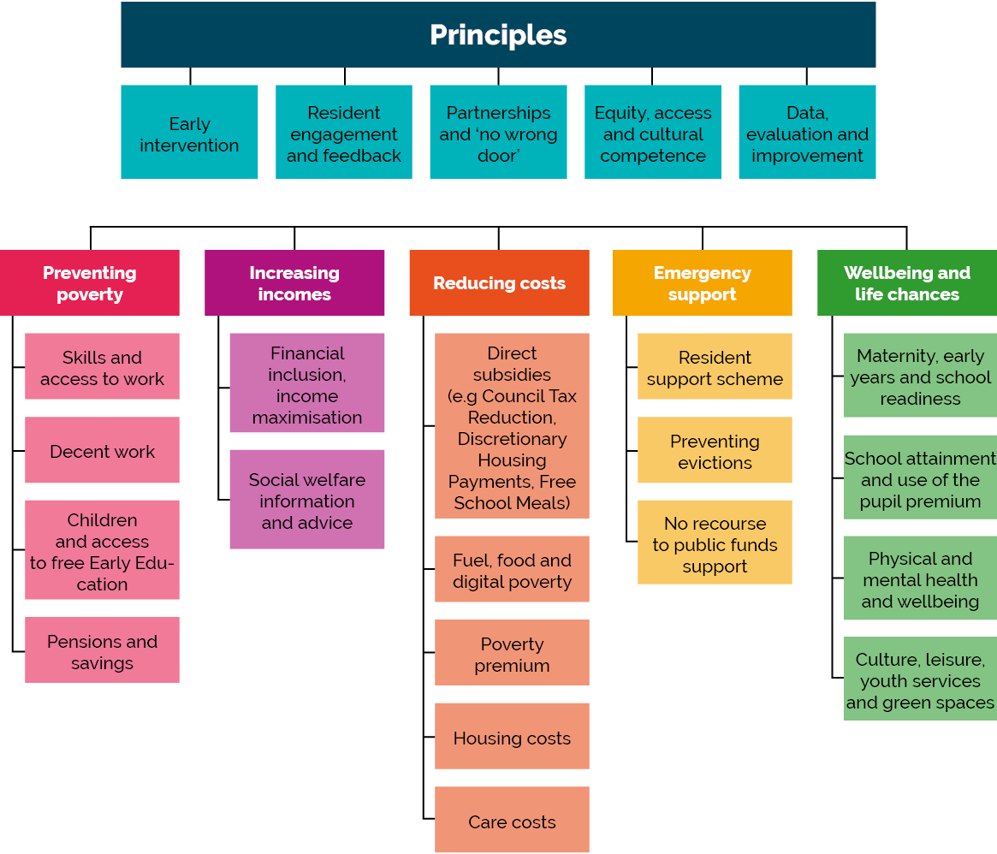
Preventing Poverty (employment and skills)
Intervention | Description | Expenditure | Target group | Number of residents reached
Workpath  Council (Employment and Skills team) | Range of employment support: information advice and guidance; employer engagement; supported employment. |  | Working age adults: includes women aged 50+ care leavers, residents into health and social care roles | Job outcomes:  504 (2019/20)  679 (2018/19)  721 (2017/18).
ESOL and functional skills  Council (Employment and Skills (Workplace) and Adult Learning Services) | Basic skills support for residents to access employment, vocational and supported employment.  Implemented by Employment and Skills (Workplace) and Adult Learning Services | Innovation Fund - £500,000 for 2 years (£250,000 from GLA; £250,000 from S.106) | Working age adults who require skills to access work. | Target : 200 qualifications per annum.
JET (Job Enterprise and Training Service)  Council and other funders | Employment support for residents with a learning disability or autism | 2020: £591,345  2019: £461,349  (council funding) | Young adults and adults with learning disability or autism
Childcare sufficiency  Council (Integrated Early Years Service) provides sector support | Childcare so that parents can work, study and train for employment. | Capital place creation expenditure (£1.8m). | Parents/carers who need childcare, with a focus on eligible two year olds. | Council does not provide services directly
Holiday Childcare scheme  Council (Parent and Family Support Service) | Holiday childcare for children aged 3 to 13 years. |  | Working parents/low income parents.
London Living Wage | LBTH is an accredited London Living Wage employer. |  |  | Employed, outsourced, agency staff

Increasing incomes
Intervention | Description | Expenditure | Target group | Number of residents reached
Benefits take-up  Council (Tackling Poverty) | Targeted support for residents to claim benefit entitlements. | Mailout costs | Residents eligible for pension credit (first campaign) | 80 new claims, increased income £156,170 p.a.
Integrated information, advice and advocacy service  Consortium managed by Age UK | Free, independent, quality-assured information, advice  and advocacy on matters relating on health, social welfare, and social care. Includes new online portal Tower Hamlets Connect. | Contract for 3 years with provision for extension up to 5 years. | Adult residents  Service provides front door to Adult Social Care.
Tower Hamlets Advice Consortium  Consortium managed by Citizens Advice East End. 12 other consortium members. | Access to advice on welfare benefits, housing, debt, employment rights, immigration issues and other social welfare advice | £3.2m for 3.5 years October 2019 to March 2023 | All residents | 12 months to Sept 2020: 19,828 clients received social welfare advice, 4,772 increased incomes.
Linkage Plus  Consortium led by Toynbee Hall, includes 4 additional organisations | Holistic service for older people. information and support dealing with official agencies (eg. DWP, LBTH). Advice referrals to Age UK, Toynbee Hall, Local Link. | 2019 – 22: £643,378 p.a. for 3 years | Older residents | 2020/21: 998  2019/20: 1024
Local Link  Consortium led by Real DPO (& 5 additional partners) | Information and social welfare advice advice plus general advocacy and Care Act Advocacy. | £485,000 per annum | Residents with support needs, (Aged 14 years and over. | Decommissioned July 2021 with introduction of IAA service
Tower Hamlets Health and Advice Link  Funded by Clinical Commissioning Group. Consortium led by Social Action for Health (& 4 additional organisations) | Information and advice on welfare benefits, debt and housing delivered from 17 GP practices. | £195,000 per annum | All residents | Decommissioned July 2021 with introduction of IAA service.
Housing Support for New Migrants  Delivered by council Tackling Poverty and Environmental Health teams, in partnership with ELATT, Limehouse Project, Account 3. | Advice and assistance on housing and employment |  | New | Year 1 objectives included support for 200 vulnerable migrants; outreach support visits to 1000 HMOs

Reducing costs
Intervention | Description | Expenditure | Target group | Number of residents reached
Council tax reduction scheme (working age residents)  Council (Revenues) | Reduction of up to 100% in council tax for working-age residents on low incomes. | est. £31.8m (2020/21). £26.7m (2019/20). | Working age households (includes care leavers) | 31 March: 37,920 claims & 21,965 cases with 100% discount.
Council tax reduction scheme (pensioners)  Council (Revenues) | Reduction of up to 100% in council tax for pension-age residents on low incomes. |  | Pension age households
Discretionary reductions in Council Tax  Council (Revenues) | Additional council tax reductions for households in exceptional hardship. | £45,000 (2018/19) | Working age households | 109 households (2018/19)
Council tax arrears support (pilot)  Citizens Advice East End commissioned by Council Tackling Poverty Team | Proactive support for residents with council tax arrears. January to October 2020 pilot. | £75000 | Residents in significant and persistent council tax arrears. | 979 residents contacted; 101 received £85,850 total support.182 clients assisted with council tax issues.
Free School Meals for Key Stage 2  Council (Public Health) | Extends the Free School Meals programme to all children in Key Stage 2. | £3m. per year. | Children years 3-6 ineligible for FSM. | 19,000 children
School clothing grant  Council (Revenues) | Grant of £110 for children starting secondary school. | £210,000 (2019/20) | 11 year olds who are FSM eligible | Approx 1900 claims each year
Discretionary Housing Payments  Council (Revenues) | Payments for households whose housing benefit/rent element of Universal Credit does not meet rent costs. Nationally funded. | 2020/21: allocation £1,927,869 | Low income households facing rent shortfall. | 2019/20: 1761 awards  2018/19: 2172 awards
Discretionary Housing Payments: Support (pilot)  Council (Tackling Poverty and Revenues teams) | Proactive support to reduce eviction and homelessness. |  | Residents with rent arrears. | 33 residents supported by Residents Support Scheme received £81,715 in awards.
Support for London Community Credit Union  Council (Mayor’s Tackling Poverty fund) | Safe and affordable credit and access to banking. One off contribution to reserves. | 2020/21: £100,000 | Adult residents, particularly those excluded by traditional banks. | c. 3500 active adult members are TH residents
Food Partnership and Food Poverty Actions  Council contribution to partnership | Strategic support: action plan includes holiday hunger; healthy start up uptake; developing low cost food activities. | £20,000 initial contribution | All
Food Pantry  Council contribution to Poplar Harca and partnership | Membership-based access to food pantry, plus holistic support. | 2019/20: £25,000 allocated | Residents living near Limborough Gardens on the Burdett Estate. | 60 residents, with plans to enrol 60 more .
Local Energy Advice Programme  Council (Sustainable Development) | Home visits address energy wastage, bill problems, tariff switching and applications for a Warm Home discount. Referrals to IncomeMax for entitlements check. |  | Households who meet income, health or vulnerability criteria | 2020/21: 17 calls & 4 visits - est. £34,650 savings  2019/20: 57 visits - est. £61,782 savings
Boiler replacement programme  Council (Sustainable Development) | Free replacement for old inefficient gas boilers. | £267564 spent with £24363 funding claimed back from ECO | Homeowners where someone living in the property is on qualifying benefits. | 97 households had boilers replaced
Tower Hamlets Energy Community Power  Council (Sustainable Development) | Residents register and can access more competitive energy tariffs through collective switching programme. | No cost to council | All residents | 231 households switched energy providers since 2018, average £148 p.a. saving.

Emergency or welfare assistance
Intervention | Description | Expenditure | Target group | Number of residents reached
Residents Support Scheme  Administered by Northgate Public Services on behalf of the council. | Short term living costs for households in crisis, at risk of crisis, or who need immediate help.  Acted as a vehicle for food and fuel grants during pandemic. | 2020/22: 769,050 (main programme)  and £190,203 (Covid fuel and food support) | Applicants over 16 years, with priority to those experiencing domestic abuse; families with young children; older people  people with longer term illnesses; people with disabilities; people with mental health needs;  households with a pregnant person. Those subject to immigration control are excluded. | April 2019 - end Feb 2020. 745 applications paid (1813 applied)  2020/21:122 awards  Covid food & fuel grant to end February 2021: 2,139 awards (327 turned down).
Resident Support Scheme: Outreach (pilot)  Council (Tackling Poverty Team) | Information and support for residents transitioning onto Universal Credit, delivered from community settings. | Staffing costs. There are no other direct project costs. | Working age residents transitioning onto Universal Credit. | 595 clients support to claim £1,162,300 in welfare support and crisis grants
Food distribution hub and pandemic response  Council (Tackling Poverty Team) | Access to food during pandemic. |  | Residents needing support with access to food during pandemic, via food banks.
Support for families with no recourse to public funds (section 17 support)  Council (Family Support and Protection) | Accommodation & support where child assessed as in need and parents have No Recourse to Public Funds. | 2020/21: (forecast) £523,294  2019/20: £619,954 | Families (with children) subject to immigration control and not entitled to mainstream welfare benefits | Current caseload is around 45 - 50 children
Support to residents with no recourse to public funds  Council support via Praxis | Support via Praxis at start of lockdown | 2020/21: £12,000
Poverty Proofing the School Day (pilot)  Council (Tackling Poverty team) in partnership with Children North East, Toynbee Hall and 7 primary schools | Audit of processes and structures to promote inclusion for children from low-income families at school. | 2019/20: £41,000 | Primary school aged children

Supporting children from low income households
Intervention | Description | Expenditure | Target group | Number of residents reached
Holiday Activities and Food  Council (Tackling Poverty Team) in partnership with local organisations and East End Community Foundation | Holiday activities and food programme.  Nationally funded programme Provided for 6 weeks over Easter, summer and Christmas holidays (2021) | 2021/22: £1,805,130 Summer 2020: £700,000 | All children eligible for benefits-related Free School Meals.  Other children able to attend.
Healthy Start  National programme  Uptake promoted through council (public health) | Weekly vouchers (£3.10 or £6.20 for children aged 0-1) for fruit and vegetables, cow’s milk or infant formula.  Distribution of vitamins through children's centres.  Vouchers rose to £4.25 in April 2021. | National funding | Pregnant women & children under 4 if in receipt of certain benefits and tax credits. All pregnant women under 18. | January 2021: 2483 out of 4244 eligible families (59%) were receiving vouchers. 2018 uptake was 70-85%.
Supporting Stronger Families  Council (Early Help & Children and Families Service) | Intensive whole family support for families with complex problems, through key workers with early intervention focus. Includes employment support from DWP. | Funded by MHCLG as the Troubled Families programme on a payment by results basis:  2021/22: £1.57m upper limit.  2015/20: total claimed £1.8m. | Intensive whole family support for families with complex problems, including unemployment. | 2021/22: target 639 families;  2020/21: target 613 families;  2015- 20: 2287 families 'turned around' out of a target of 3660 and 43 achieved ‘continuous employment'.
Children's and Families centres  Council (Integrated Early Years’ Service) with many other partners | 12 Children’s and family centres (plus 3 spoke sites) include support for parents of under 5's to access training, learning and volunteering opportunities; plus school readiness, parenting, health | Revenue expenditure in the form of salaries for 150 council employees (children's centres teams) | All parents/carer residents: universal services for pre-birth to 5 years; specific services for 5 - 11 years. | 2019/20: 140,000 contacts with children and over 112,000 contacts with adults. 1000 families received targeted family support.
Tower Hamlets Tackling Poverty Innovation Fund  Council (Tackling Poverty) with East End Community Foundation and grantees. | Test and learn from small initiatives. | 2019: £200,000 (plus £16,000 for review) | All low income households particularly pensioners, unemployed, in-work poverty. | 2000 residents (majority working age)

Background Paper D: updated Poverty Profile

This updated poverty profile is part of the evidence base for the London Borough of Tower Hamlets Poverty Review. It should be read alongside the summary of resident engagement for the review, and the Tower Hamlets Borough profile (2020).

D.1 Updated poverty profile. Key messages.

- Tower Hamlets became significantly less deprived relative to other areas between the 2015 and 2019 Indices of Multiple Deprivation. Deprivation among children and older people is much higher than deprivation as a whole.
- Other data, such as children in low income families continues to show a very high extent of poverty in the local population.
- 29,000 employees earn less than the London Living Wage and the proportion of employees earning less than the London Living Wage has increased in recent years.
- At 14.2%, Fuel Poverty rates are above the national average. In some parts of the borough as many as a quarter of households are in fuel poverty.
- Analysis of other data shows thousands of households are struggling to meet their costs. This includes some households on higher incomes.

Indices of Multiple Deprivation

- The Indices relatively rank each small area in England from most deprived to least deprived. The main index combines seven domains (income, employment, education, health, crime, barriers to housing and services, living environment). The indices can be used for comparing different small areas and local authorities in England. They cannot be used for measuring absolute change in deprivation over time.
- Tower Hamlets has seen lessening deprivation on almost all measures relative to other parts of England.
- Virtually all of the borough has become relatively less deprived based on deprivation rank (142 of 144 areas).
- Only 1.4% of the borough is now in 10% most deprived areas in England (Had been 40% in 2010).

Tower Hamlets IMD rankings, local authority summary measures, (MHCLG, English Indices of Deprivation 2019)
 | 2015 ranking | 2019 ranking | Change
Rank of average score | 10 | 50 | +40
Rank of average rank | 6 | 27 | +21
Extent | 3 | 57 | +54
Local concentration | 80 | 134 | +54
Proportion in most deprived 10% | 24 | 175 | +151

Indices of Multiple Deprivation – Map

Tower Hamlets was the 50th most deprived local authority area in England (of 317) on the Indices of Multiple Deprivation employment domain in 2019, having been 10th most deprived in 2015. These maps illustrate the change in relative deprivation of different small areas in Tower Hamlets between 2015 and 2019.
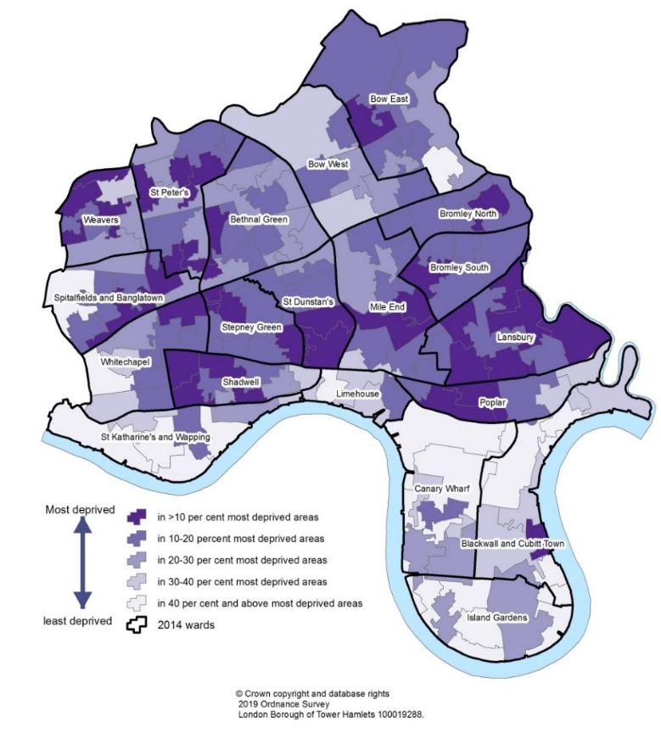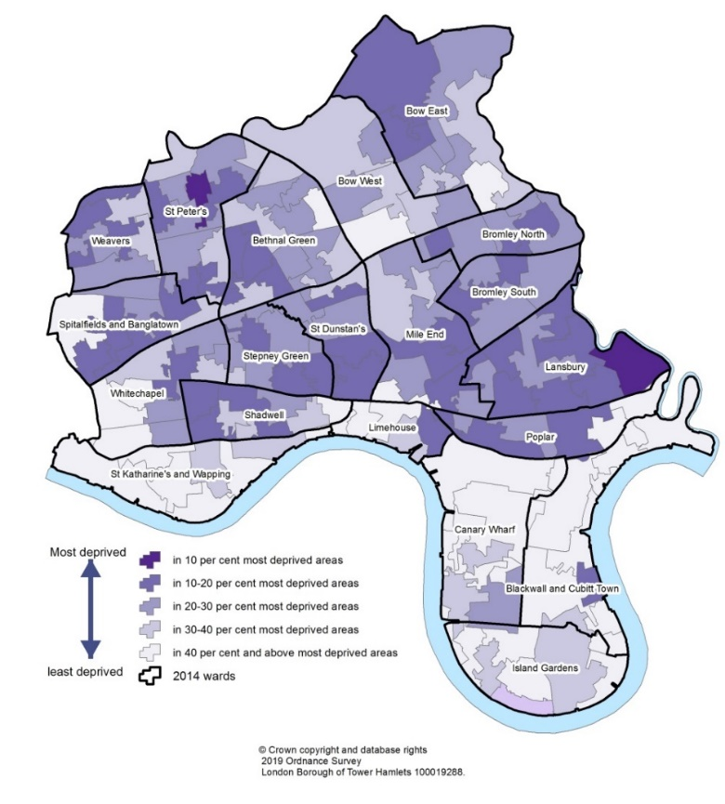
Figure 1: Indices of Multiple Deprivation (IMD) 2015, by small area Figure 2: Indices of Multiple Deprivation (IMD) 2019, by small area

Indices of Multiple Deprivation – Deprivation by ward

- According to GLA analysis of the 2019 IMD, the most deprived ward in Tower Hamlets was Lansbury Ward which was the 12th most deprived ward in London out of 633, placing it within the most deprived 2% of wards in the capital.
- 4 (of 20) wards were among the 10% most deprived in London.
- 12 wards are among the 20% most deprived in London, while a total of 16 wards are among the 50% most deprived in London
- Lansbury ward is also the most deprived in the borough on both the income rank (where it is in the most deprived 1% of London wards) and the employment rank (where it is in the most deprived 2% of London wards.

Deprivation by Ward (2019) | Rank of Average Score (of 633 wards across London)
Lansbury | 12
Bromley North | 48
Poplar | 53
St. Dunstan's | 54
Stepney Green | 69
Shadwell | 72
St. Peter's | 75
Weavers | 80
Bromley South | 92
Spitalfields & Banglatown | 95
Mile End | 114
Bethnal Green | 126
Bow East | 145
Bow West | 199
Whitechapel | 222
Limehouse | 294
Blackwall & Cubitt Town | 369
Canary Wharf | 383
Island Gardens | 466
St. Katharine's & Wapping | 473

Indices of Multiple Deprivation – deprivation by subdomain

- The figure below from Policy in Practice provides a visual representation of Tower Hamlets' score on the 2019 Indices of Multiple Deprivation against the different domains in the index.
- It shows high deprivation levels in some domains: income affecting children and older people, crime, housing and the outdoor environment. In other domains, and particularly in education, outcomes are good relative to other areas.
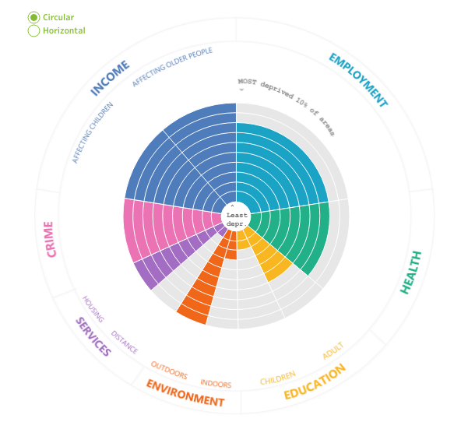
Figure 3: visual representation of Tower Hamlets' ranking against different domains of the IMD, 2019

Child Poverty – Income Deprivation Affecting Children

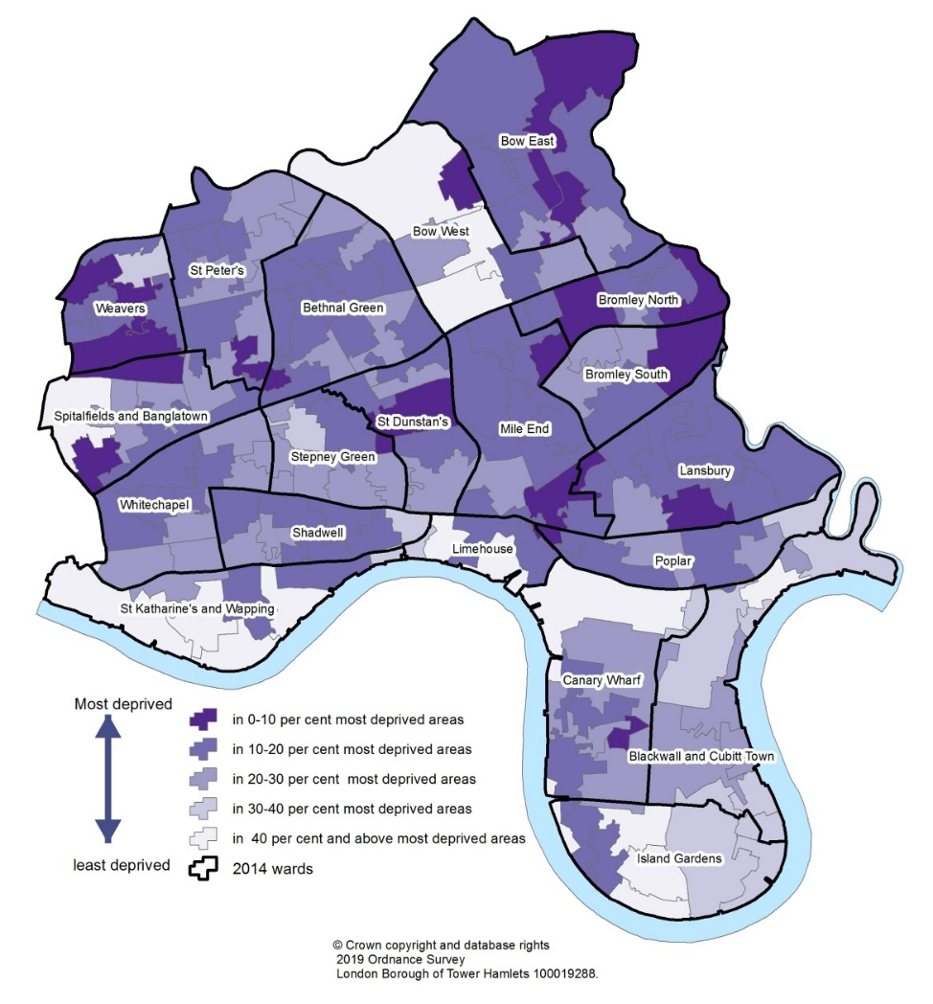
Figure 4: Income Deprivation Affecting Children Index (IDACI) 2019, by small area

Child Poverty – Income Deprivation Affecting Children

- IDACI (Income Deprivation Affecting Children) Rank fell from 1st to 14th in England on Rank of Score. However, Tower Hamlets remained 1st on Rank of Rank – meaning less areas with the very highest deprivation but consistently high deprivation across the borough.
- This is illustrated in the rank of Tower Hamlets wards within London where 7 of the 20 wards are among the 10% most deprived in London and 14 wards are within the 20% most deprived in London on the IDACI measure. Only one ward is outside of the most deprived 50% of London wards.

IDACI rank by ward (2019) | Rank (of 633 wards across London)
Bromley North | 26
Lansbury | 27
Bow East | 30
Weavers | 33
St. Dunstan's | 53
Mile End | 55
Poplar | 60
Bethnal Green | 65
Shadwell | 77
Bromley South | 81
Spitalfields & Banglatown | 88
St. Peter's | 100
Whitechapel | 108
Canary Wharf | 113
Stepney Green | 140
Bow West | 170
Limehouse | 215
Blackwall & Cubitt Town | 233
St. Katharine's & Wapping | 271
Island Gardens | 320

Older People Poverty – Income Deprivation Affecting Older People

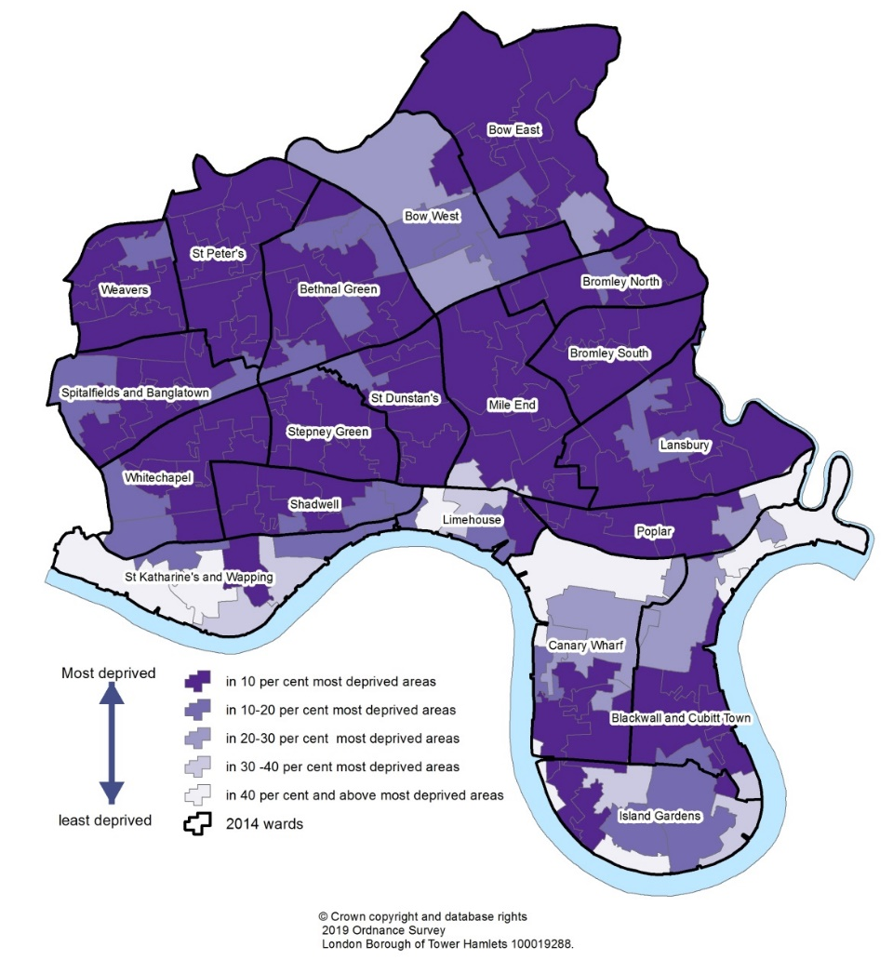
Figure 5: Income deprivation affecting older people index (IDAPI) 2019, by small area

Older People Poverty – Income Deprivation Affecting Older People

- 44% of older people live in income deprived households. This is the highest proportion in England and more than double the average.
- This is the only area of the IMD with no change in relative level of deprivation between 2015 and 2019.
- The ward rankings illustrate the scale of older people deprivation with Tower Hamlets wards making up all of the ten most deprived wards in London. 15 wards are within the 10% most deprived wards in London and every ward is within the 50% most deprived wards on this measure.

IDAOPI Rank (2019) | Rank (of 633 wards across London)
Spitalfields & Banglatown | 1
Whitechapel | 2
Poplar | 3
St. Dunstan's | 4
Bromley South | 5
St. Peter's | 6
Stepney Green | 7
Bromley North | 8
Shadwell | 9
Mile End | 10
Lansbury | 13
Weavers | 14
Bethnal Green | 33
Bow East | 55
Canary Wharf | 81
Blackwall & Cubitt Town | 100
Bow West | 109
Island Gardens | 142
Limehouse | 147
St. Katharine's & Wapping | 290

Households Below Average Income – London data

Relative Poverty (income below 60% of contemporary median income)
- Between 2017/18 and 19/20 the proportion of persons living in relative low income before housing costs in London was 16% equating to 1.4million people. This was slightly below the UK average of 17%. However, when housing costs are taken into account, 27% of Londoners were living in relative low income – much higher than the UK where 22% where in relative poverty after housing costs.
Persistent Poverty
- Between 2015 and 2019, 9% of Londoners were living in persistent poverty (defined as living in poverty in both the current year and at least two out of three preceding years) before housing costs, the same as the UK average. After taking into account housing costs 16% were living in persistent poverty, higher than the UK average of 13%. Persistent poverty among children in London before housing was much higher at 19% before housing costs and 29% after housing costs.
Absolute Poverty (income below 60% of real terms median income)
- Between 2017/18 and 19/20 the proportion of persons living in absolute low income before housing costs in London was 14% and the proportion of persons living in absolute low income after housing costs was 24%. As with relative poverty this was similar in proportion to the UK before housing costs but higher than the UK after housing costs.

Child Poverty – Children In Low Income Families

- 29.0% of children in Tower Hamlets were in relative low income families in 2019/20. This was the 25th highest rate among local authorities in the United Kingdom (of 382) and the second highest rate among London boroughs. The rate was well above average for the United Kingdom.
- The proportion of children living in relative low income families has increased from 22% in 2014/15 to 28%. This represents an increase from 12,846 children living in relative low income households in 2014/15 to 18,342 in 2019/20.
- 22.1% of children were in absolute low income families in 2019/20. this is the 30th highest rate in the UK and the 3rd highest rate in London.

London Living Wage

- According to the ONS Annual Survey of Hours and Earnings, there were 29,000 employees in Tower Hamlets earning less than the London Living Wage in 2018, which was 11.7% of employees.
- As the London Living Wage has increased the number of employees whose wage falls below the rate has also gradually increased and the proportion of employees whose wages are below the LLW is now twice what it was in 2005 (11.7% in 2018 compared with 5.8% in 2005).

Employees in Tower Hamlets earning less than the London Living Wage
Year | London Living Wage | Number employees earning less than London Living Wage | Percentage employees earning less than London Living Wage
2005 | 2005 LLW: £6.70 | 10,000 | 5.8%
2006 | 2006 LLW: £7.05 | 12,000 | 6.2%
2007 | 2007 LLW: £7.20 | 12,000 | 6.1%
2008 | 2008 LLW: £7.45 | 9,000 | 4.7%
2009 | 2009 LLW: £7.60 | 10,000 | 4.8%
2010 | 2010 LLW: £7.85 | 11,000 | 5.5%
2011 | 2011 LLW: £8.30 | 13,000 | 6.0%
2012 | 2012 LLW: £8.55 | 18,000 | 7.9%
2013 | 2013 LLW: £8.80 | 18,000 | 7.7%
2014 | 2014 LLW: £9.15 | 22,000 | 9.6%
2015 | 2015 LLW: £9.40 | 22,000 | 10.5%
2016 | 2016 LLW: £9.75 | 26,000 | 12.3%
2017 | 2017 LLW: £10.20 | 25,000 | 9.8%
2018 | 2018 LLW: £10.55 | 29,000 | 11.7%

Fuel Poverty

- More than 15,000 households in Tower Hamlets were in fuel poverty in 2019. This amounted to 14.2% of households – above the England average of 13.4%.
- There is a significant difference across the borough with the proportion of fuel poor households ranging from as little as 3% in some areas to over 25% in others.

LIFT Dashboard – Overview
The LIFT dashboard is supported by Policy in Practice and combines datasets, to provide information about approximately 36,800 households in Tower Hamlets. Information is broadly representative of lower income households, although it does not include all low income households.
Most of the households on the database are of working age but a significant number are of pension age (22%).
Age | Under 25 years | 25 – 64 years | 65+ years
Number | 784 | 27,814 | 8,257
% | 2% | 75% | 22%

Slightly fewer than half of households have children (45%). Of these, 6,102 were not in work due to disability,7,850 were of pension age, 429 were not in work due to caring responsibilities and 1,844 were in work.
Family | Couple with children | Couple without children | Lone parent | Single
Number | 9549 | 3024 | 7006 | 17274
% | 26% | 8% | 19% | 47%

The most common tenancy type for households is social rented (including council and registered social landlords)
Housing | Social tenant | Private | Temporary acomm. | Owner occupier | Supported Accomm. | Unknown
Number | 23201 | 2447 | 2400 | 1371 | 1117 | 6317
% | 63% | 7% | 7% | 4% | 3% | 17%

LIFT Dashboard – Debt

- 2270 households in rent arrears (median arrears £446.24)
- 5174 households in Council Tax arrears (median arrears £102.75)
- 277 households in both rent and Council Tax arrears (median combined arrears £709.51)
- The large majority of those in rent arrears are of working age (89%, 2029 households) and the same is true of those in Council Tax arrears (89%, 4592 households)
- 65% or 1,471 households in rent arrears had children and just over half of the households in Council Tax arrears had children (52%, 2,677 households)

LIFT Dashboard – Bedroom Tax and Benefit Cap
- Of the 1934 households on the database impacted by the removal of the spare room subsidy, widely referred to as the ‘Bedroom Tax’, 1544 (80%) are either single or a couple with no children, 210 are lone parents and 180 are couples with children.
- 99 of the households affected by the Bedroom Tax are in rent arrears and 366 are in Council Tax arrears. More than a fifth of households impacted by the bedroom tax are in some kind of rent or council tax arrears.
- Of the 821 households on the database impacted by the Benefit Cap, 614 (75%) have children and 358 (44%) are lone parents
- 91 of those impacted by the Benefit Cap are in rent arrears and 106 are in Council Tax arrears. As with the Bedroom Tax, more than a fifth of households impacted by the Benefit Cap are in some kind of rent or Council Tax arrears.

Experian Mosaic

Experian Mosaic provides customer insight analysis by segmenting Tower Hamlets residents into ten national types. The characteristics of these national types are then applied to the resident population to provide data and insight about those communities that would otherwise not be available. The national types represented in Tower Hamlets are:
O65 – City Diversity (30.2%)
C12 – Metro High-Flyers (24.8%)
C11 – Penthouse Chic (16.2%)
J44 – Flexible Workforce (8.5%)
O66 – Inner City Stalwarts (6.6%)
J41 – Central Pulse (4.8%)
C13 – Uptown Elite (2.5%)
H33 – New Foundations (2.0%)
J43 – Student Scene (1.3%)
I36 – Culture and Comfort (0.9%)
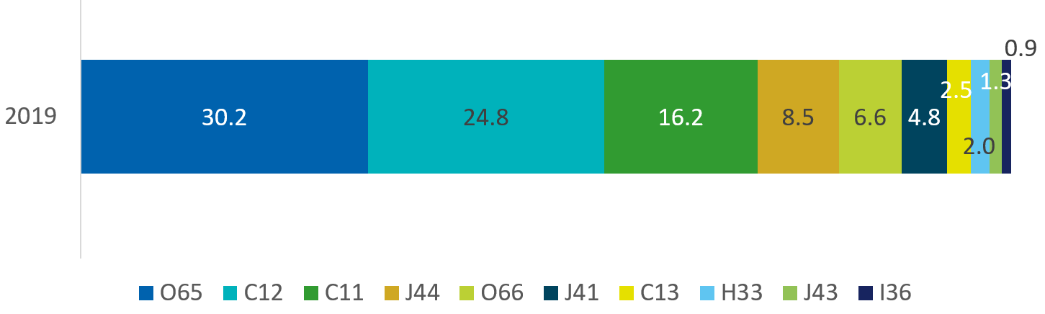

Experian Mosaic – Finding it hard to manage on Income

Overall, the Experian analysis estimates that 21.6% of Tower Hamlets households find it difficult to manage on their household income and 12% find it very difficult to manage on their household income. The groups that find it hardest to manage on their income are:
- C12 - Metro High Flyers (28%). It is interesting that a large proportion of this group find it hard to manage because they are much less likely to have children or to have an elderly person in the household than other households. They have a relatively low proportion of disability/health problems. The income of this group is also well above average. However, this group are far more likely to rent privately (around four times the national average) so housing costs may be a significant factor in financial hardship among this group
- J44 - Flexible Workforce (28%). As with group C12, this group are relatively unlikely to have children or an elderly person in the household and they are below the national mean for the proportion of people with a disability. This group have a fairly high level of transience with a high proportion of residents having lived in the area for less than a year. Again this group are much more likely to be in privately rented accommodation.
- O65 - City Diversity (27%). This group has a very high proportion of households with children. The large majority of residents in this group live in Council and other social rented housing. Income levels among this group are much lower than some other groups. The proportion of households without a current account is much higher than the national average (15% compared to 6% nationally).
- O66 – Inner City Stalwarts (23%) This group has a high proportion of older and elderly people and a very high proportion of people with a disability. There are very few children in this group. This group has low income levels.

D.2 Poverty trends. Key messages.

- Levels of income poverty in Tower Hamlets remained stubbornly high over the last decade.
- There is evidence that persistent poverty and deep poverty are on the increase nationally and across London.
- High living costs and precarious employment meant growing financial insecurity for many households in Tower Hamlets prior to 2020.

Poverty trends to 2020

- Levels of income poverty in Tower Hamlets remained stubbornly high over the last decade. This is similar to the pattern across London, poverty rates have remained high but broadly stable over much of the last decade. (JRF; 2020) 27.3% of children in Tower Hamlets were in relative low-income families (before housing costs) in 2019/20. Once housing costs are accounted for, 55.8% of children in Tower Hamlets live in low-income households, the highest rate in England. (Hirsch & Stone; 2020) Population growth meant there were more than 6000 additional under 16’s living in low income households in 2019/20 compared to five years previously. 44% of older people live in income deprived households. This is the highest proportion in England and more than double the average. (Borough profile; 2020).
- Around 11% of the UK population is living in persistent poverty. This means they are in poverty now and in at least two of the last three years. This figure has not changed. Deep poverty has increased in the last two decades. 7% of the population in the UK now living more than 50% below the poverty line. (SMC; 2020) Local data on deep and persistent poverty are not available.
- Destitution. An estimated 1.21% of Tower Hamlets households were destitute in 2019. This meant the borough was amongst the 20 boroughs with the highest rate of destitution. Destitution was increasing before the pandemic. Single adults under 25 are at the greatest risk of destitution, but the number of destitute families and lone mothers has grown. (JRF 2020)
- High living costs and precarious employment meant growing financial insecurity for many households in Tower Hamlets prior to 2020. Financial resilience in London is being eroded (pre-pandemic) as a result of rising rents and living costs, frozen benefits, and insecure work.. (TfL; 2017, TfL; 2018b).

Poverty trends: Tower Hamlets Child poverty numbers and rates 2014/15 – 2018/19

(Sources: Before housing costs data - Children in low income families: local area statistics, HMRC/DWP 2020; After housing costs data: Stone and Hirsch (2020) Local indicators of child poverty after housing costs, 2018/19, End Child Poverty Coalition)

Poverty trends: Tower Hamlets changes in households with cash shortfall 2016 – 2019

- The number of households in Tower Hamlets whose income does not meet their outgoings has increased over time.
- In 2019, an estimated 18.6% of low income households - or 5.3% of all households - in the borough faced a cash shortfall. Between 2016 and 2019 the number of households unable to meet their outgoings increased by 1356. This is a 40% increase, one of the steepest increases in London.
- The map shows percentage increases/decreases in households with cash shortfalls by ward. The highest increases are seen in the east of the borough.
Source: Policy in Practice Living Standards Index for London

D.3 Who lives in low income households? Key messages.

- Across London, children are more likely than adults to live in poverty.
- Tower Hamlets has the highest proportion of older adults living in low-income households in England.
- Across London, having a disabled person in the household increases the likelihood the household will be in poverty.
- Londoners from Black and Minority Ethnic backgrounds, lone parents with children, and workless families have a higher than average risk of being in poverty.
- In Tower Hamlets, a high and rising number of low-income working age households face cash shortfalls: including non- disabled households, non-working households who are carers, lone parent and particularly non-working lone parent households, social and private tenants, and residents in temporary accommodation.
- Tower Hamlets has one of the highest proportions of destitute households in the country.

Who lives in low income households? Age

- This chart shows the age profile of Londoners living in low income households.
- It shows that children in London are more likely than adults to be living in poverty.
- The number of older people living in poverty is much greater in London than in the rest of England.
- Data on the age profile of Tower Hamlets residents living in poverty is not available, but we know that a high proportion of children and older adults live in poverty in the borough.

Who lives in low income households? Disability

- This chart shows the association between poverty and having a disabled person in the family in London.
- In the 3 years to 2019/20, 35% of families that included a disabled person were in poverty compared to 25% of those without a disabled household member. This gap has not changed in a meaningful way over last decade.
- Nationally, half of people in poverty are disabled or living in a household where somebody is disabled, compared to one-third of people who are not poor (JRF 2021).
- Data on poverty and disability for Tower Hamlets residents is not available.

Who lives in low income households? Demographic characteristics

- This chart shows that Londoners from Black and Minority Ethnic backgrounds, lone parents with children, and workless families have a higher than average risk of being in poverty. Families with children (a large group) also have higher than average rates of poverty.

Who lives in low income households? Ethnicity

- With limited data on ethnicity and poverty at a local or even a regional level, we use national data to explore the relationship between poverty and ethnicity.
- Figure 1 (ONS; 2020) shows that children in Bangladeshi and Pakistani households were most likely to live in low-income households. Similar disparities are also seen for children living in households with persistent low income, and children living in low income and material deprivation.
- Joseph Rowntree Foundation UK Poverty Report 2020/21 (JRF; 2020) highlights high rates of in-work poverty for Black, Asian and minority ethnic workers, with the highest rates in households headed by Bangladeshi and Pakistani workers, of whom around 35% were in poverty. Workers from BAME backgrounds were more likely work in low-paid sectors, and were more likely to be paid less than workers from a White British background within the same low-pay sector.

Who lives in low income households? Destitution

- Using a definition of destitution designed to capture people who cannot afford to buy the absolute essentials that we all need to eat, stay warm and dry, and keep clean, the Joseph Rowntree Foundation’s ‘Destitution in the UK’ 2020 report reports that destitution was increasing and intensifying prior to the pandemic.
- Nationally, single people remained at the highest risk of destitution in 2019, but families living in destitution, especially lone mothers, had become more common since 2017. Young people under the age of 25 were highly over-represented within the destitute population, while destitution continued to be extremely rare for the over-65s.
- Tower Hamlets ranked 19th out of all authorities in Great Britain in Joseph Rowntree Foundation’s Destitution in the UK report, with 1.21 per cent of all households in Tower Hamlets were expected to meet the definition of destitution in 2019, of which
  - 0.28 per cent of households were migrant households and destitute
  - 0.47 per cent of households had complex needs and were destitute
  - 0.47 per cent of households were UK-born households without complex needs
- These are point-in-time figures. The report estimates that the absolute percentages of households experiencing destitution over the course of a year would be around five times higher than this figure: that is, approximately 6 per cent of all households in Tower Hamlets would experience destitution over the course of a year.

D.4 Drivers of poverty. Key messages

- Worklessness has historically been a major driver of poverty in Tower Hamlets.
- In-work poverty is high.
- Costs – and particularly housing costs - are a key driver of income poverty.
- Changes to the social security system since 2010 have contributed to rising poverty amongst children and working age adults.

Drivers of poverty in Tower Hamlets

- Despite a recent stalling of progress, high poverty levels are not inevitable. The main drivers of poverty are employment, earnings, benefits and other income, and housing costs. National policies can and have made a difference to poverty levels: between 1996/7 and 2004/5, relative poverty fell by 5% (JRF, 2020). Councils have limited scope to influence these drivers, but understanding how they affect residents and families can help focus where and how local governments and their partners intervene.
- Worklessness has been historically been a major driver of poverty in TH. In 2017, 23,137 households (20.9%) had nobody in work. By 2019, this had fallen dramatically to 16,689 households (14.8%), just above the inner London average of 13.6%. (ONS; 2020). However, the proportion of children living in workless households hardly fell between 2015 and 2019 Residents with no qualifications, and those with poor proficiency in English are more likely to be workless (Borough Profile 2020) The gender gap in employment is greater than the London average (85% of men and 61% of women are employed), and this is accounted for by a very low number of women from BME backgrounds - 38% - who are employed (Borough Profile 2020).
- In-work poverty is high. Between 2013/14 and the first quarter of 2020 the proportion of London children in poverty who were living in working families rose from 68% to 76% (Trust for London; 2020). In TH, this figure is higher at 78.5% of children in poverty. However, the percentage of jobs below the London Living Wage is the lowest in London (excl. City of London). (ONS; 2018). There is a strong link between low hourly rates of pay and part-time work in the borough (Borough Profile 2020).
- Costs – and particularly housing costs - are a key driver of income poverty. In Tower Hamlets, the difference between the proportion of children living in low income households measured before housing costs (27.3%) and after housing costs (55.4%) was 28.1%: higher than any other local authority in England (Stone & Hirsch; 2020) Rising rents combined with freezing the amount of support available to pay for housing is identified as a key driver of falling living standards, with Tower Hamlets facing one of the largest gaps in London between rents and LHA rates in 2018 (Trust for London 2018b)

- Changes to the social security system since 2010 have been an important factor in reversing the decline of child poverty experienced in the 1990’s and 2000’s (Howes, 2020). In a series of reports examining the impact of welfare policy on low-income residents in London, Policy in Practice found:
  - four different welfare reforms (the under-occupation charge, the LHA cap, the benefit cap, and reduction in council tax support), would lead to an average weekly loss of £6 per low-income household, with around 1.5% of the population affected losing more than £30 per week.
  - the introduction of the benefit cap risked a considerable deterioration in the living standards of affected households – with many households moving into relative poverty, financial risk, and temporary accommodation. Lone parents out of work were five times more likely than the average low-income Londoner to be affected by the benefits cap, twice as likely to be on Universal Credit, and 1.8 times as likely to be impacted by the two-child limit.
  - Self-employed low-income households were likely to be particularly affected by the transition to universal credit, with four in five affected by the introduction of the minimum income floor with an average annual loss of over £4100 per household per year.

Children living in working, mixed and workless households

- This chart shows the proportion of children who live in households in different economic circumstances. In Tower Hamlets,
  - 16.6% of children live in workless households - much higher than the London average
  - 31% of children live in a household where all adults work - the lowest proportion in London
  - 52% of children live in ‘mixed’ households, where at least one adult works and one is unemployed or inactive.
- In Tower Hamlets, these percentages changed little between 2015 to 2019. This contrasts with England and London where the percentage of children in working households increased by 5 percentage points over the same five-year period.

D.5 Poverty, deprivation and life chances: key messages

- Low incomes are linked to poor outcomes in childhood and life chances.
- For some dimensions of wellbeing, development and social mobility, there is evidence that outcomes are better than might be expected in Tower Hamlets, as well as in some other deprived parts of London.
For example
- Despite continuing high levels of income poverty, the number of neighbourhoods in Tower Hamlets who were in the most deprived 10% of neighbourhoods (using a composite index) relative to others in England declined rapidly between 2015 and 2019 - more than any other local authority. (MHCLG; 2019)
- The educational outcomes gap between TH children eligible for free school meals and their more advantaged peers nationally is amongst the smallest in England (EPI, 2020)
- People from the most deprived income decile in London have higher (and rising) life expectancy, relative to their deprived counterparts elsewhere (IHE, 2020)
- Despite strong correlation between child poverty and ACE’s, and population density and ACE’s, many other boroughs have a worse ranking on a composite score of reported Adverse Child Experiences (Lewer et al, 2019)
- Londoners from deprived areas generally have better access to shared goods such as transport, green spaces, high performing GP surgeries than people living in deprived areas elsewhere (Trust for London; 2020)
- Tower Hamlets is ranked as amongst the ten most socially mobile local areas in the England: with median earnings of disadvantaged children growing up in Tower Hamlets amongst the highest in the country. (SMC; 2020)

D.6 The impact of the pandemic on poverty

(This evidence was compiled in March 2021)
- The impact of the pandemic on poverty rates will not be known for some time.
- Nationally, workers already in poverty before the pandemic have been disproportionately affected by job losses.
- In Tower Hamlets, there was a steep and sustained increase in unemployment between March and December 2020.
- Over the same period, available vacancies in Tower Hamlets declined by an estimated 40%.
- In May 2020, it was estimated that 7000 households in Tower Hamlets would be unemployed in 2021.
- April 2020’s uplift to welfare benefits protected many households from hardship, although not for the estimated 715 households subject to the benefit cap. Private renters and households with children were most likely to be subject to the benefit cap.
- Beyond the employment and social security impacts of the pandemic, other consequences including for the local childcare market, children’s development and attainment, and the resources available to public and voluntary sectors, may all have an impact on poverty in the medium/long term.

Impacts of the pandemic on poverty (national)

- Time lags mean that 2020/21 poverty rates will not be known until end of 2022. In the meantime, there is a great deal of short/medium-term uncertainty about the duration of restrictions, their impact on unemployment and underemployment, and how long labour market support and additional benefits support and other protections will last.
- Although older adults have been vulnerable to Covid-19 and have faced isolation, additional costs and hardship during lockdown, the pandemic is less likely to have a direct impact on their income in the medium-term. The impact of unemployment and underemployment is likely to fall on working age adults and their dependents.
- Longer-term, the impact of disrupted school closures and a difficult job climate for young adults are likely to have consequences for social mobility, children’s life chances and the opportunities for children and young people from low-income families to move out of poverty and earn a decent income as adults.
- Workers already in poverty before the pandemic have been disproportionately affected by job losses. Workers in the lowest income quintile had the largest drop in mean hours worked at the start of the pandemic. During the first lockdown, the low-paid were twice as likely to either be on furlough or have had their hours reduced – with two thirds of all low-paid employees (nearly 4 million people) seeing their work affected in one of these ways. (IES 2021)
- 4 in 10 of minimum wage workers were estimated to be at high/very high risk of job losses (compared to 1% of those earning more than £41,500 per year) (JRF 2000).
- Pre-pandemic, 17% of workers in London, and 13% of workers nationally were in poverty. Particularly high levels of in-work poverty were found in certain sectors. 23% workers in accommodation and food, and 17% workers in wholesale and retail were in in-work poverty. These sectors are also those where jobs are at high risk due to high levels of contact with the public.
- Family type: Lone parents were most likely to be in poverty pre-pandemic: they tended to be women, working in low wage sectors, underemployed, and restricted in their work options by childcare and transport.
- Ethnicity: one third of Pakistani and Bangladeshi workers are in poverty. One-third of Bangladeshi men work in catering, restaurants and related businesses (Khan 2020; quoted in JRF, 2020). After the 2008 recession, underemployment increased dramatically amongst Bangladesh/Pakistan women and men. (Rafferty 2014, quoted in JRF); (IES 2020)

Impacts of the pandemic on poverty in Tower Hamlets - labour market impacts

- Significant numbers of residents were protected by the Coronavirus Job protection scheme: 31,100 residents were furloughed as of 31 July 2020, falling to 16,100 by 31 October. (data) Residents in Tower Hamlets took up these protections at roughly the same rate as the London average.
- Claimant count data shows a steep and sustained rise in unemployment in Tower Hamlets between March and December 2020. The claimant count increased particularly sharply amongst 16 – 24-year-olds. (see table)
- In common with other areas of London, the job market for Tower Hamlets residents has been hit hard, with more workless residents chasing fewer vacancies. Between March and October 2020, available vacancies in Tower Hamlets declined by 40.7% (IES 2020). The ratio of unemployed people in Tower Hamlets per vacancy rose from 5.9 in March 2020 to 30.8 in June 2020 (Adzuna 2020). Across Central London, vacancies in October were lower than they were during lockdown and recovering only very slowly.
- Prior to the pandemic, 19% of residents worked in the distribution, hotel and restaurant sector, which continue to be hit hard. 23% of residents worked in public administration, education and health sectors: a sector providing more job security, but likely a greater risk of occupational exposure to Covid. (Borough Profile 2020)
- In May 2020, Policy in Practice estimated the number of households likely to be unemployed in 2021, ranging from 7000 (if furloughed households return to work) and 19,000 if furloughed households did not return to work. (Policy in Practice 2020)
- The impact of the pandemic can also be seen in a rise in the number of children who became eligible for Free School Meals. The percentage of children in Tower Hamlets schools identified in the school census as eligible for Free School Meals increased: from 33% in January 2020 to 36% in October 2020, and 37.8% in January 2021.

Impacts of the pandemic on poverty in Tower Hamlets - social security impacts

- In response to the pandemic, the government made a series of changes in April 2020
  - increased support for those in receipt of Universal Credit or Working Tax Credits by £20/week.
  - raised the maximum support available to private renters by realigning Local Housing Allowance (LHA) rates to the cheapest 30% of market rents.
  - suspended the Minimum Income Floor for self-employed Universal Credit claimants.
- These changes were in effect a partial reversal of reductions in benefit levels over the past decade. For many households, these changes had a beneficial effect. Policy in Practice (2020) estimated that these temporary changes prevented 6% of low income working age households from going into cash shortfall, and added £85 per month to the average income after household costs of a low-income working age household in London.
- For households subject to the benefit cap, the positive impact of the changes has been substantially limited. Prior to April 2020, an estimated 483 households (and 1252 children) in Tower Hamlets were affected by the benefit cap. The increased level support provided during the pandemic is likely to have increase the number of households subject to the benefit cap by half to 715 households (0.7% of the borough’s population). Private renters and households with children were most likely to be affected by the benefit cap, thereby missing out on this support. (Policy in Practice; 2020) A large number of households in Tower Hamlets receive legacy benefits, and these households did not benefit from the uplift.
- If the uplift and other changes are reversed in September the impact on low-income households will be severe, particularly if there are few work opportunities.

- The chart below uses information provided by Policy in Practice based on data on households who receive council tax reduction and/or housing benefit. The proportion of this group of low income households who are facing a cash shortfall or take home monthly income of less than £100 appears to have changed little over the first six months of the pandemic.

Impacts of the pandemic on poverty in Tower Hamlets – potential impacts

Possible medium to long term impacts are still evolving and being monitored. The pandemic has affected residents from different backgrounds differently, with some pre-existing inequalities exacerbated, and new vulnerabilities created. Those impacts which have the greatest potential to impact on poverty include
- Lower take up of early education and childcare places, and the costs of providing Covid-safe childcare places may impact on parental (especially women’s) employment and early childhood development and school readiness
- Children – particularly from lower-income families - may experience lasting impacts from time spent away from face-to-face learning, affecting their education outcomes and learning potential.
- Poor parental mental and physical health may reduce employment and earnings in families with children
- Young adults may have spent a long time out of work and are reported to have experienced larger pressures on their mental health: this may have a lasting effect on their earnings and well-being.
- Resource pressures on local government, and the public sector, schools and voluntary sectors may reduce resources for early intervention, information and advice, pastoral and welfare support, and funding for emergency and council tax support.

References

Adzuna, Tora Turton, London job market hit hardest by Coronavirus pandemic
All Party Parliamentary Group on Poverty (2021) The impact on poverty of not maintaining the £20 uplift in universal credit and working tax credits, and of not extending the uplift to legacy and related benefits
Cameron, C. et al (2020) The First 500: The impact of Covid-19 on families, children aged 0-4 and pregnant women in Tower Hamlets. Interim briefing report. Thomas Coram Research Unit, UCL Social Research Institute, University College London
Education Policy Institute Education in England: Annual Report 2020
Gov.uk Coronavirus Job Retention Scheme statistics: December 2020
Hirsch, D, and Stone, J. (2020) Local indicators of child poverty after housing costs, 2018/19, End Child Poverty/Centre for Research in Social Policy, Loughborough University
Howes, S. (2020) Making the links: Poverty, austerity and children’s social care. Dartington: Research in Practice
Institute for Employment Studies, Papoutsaki D, Wilson T Monthly vacancy analysis: Vacancy trends to week ending October 2020
Joseph Rowntree Foundation Destitution in the UK 2020
Joseph Rowntree Foundation UK Poverty Profile 2020/21
Khan, O. The Colour of Money: How racial inequalities obstruct a fair and resilient economy, The Runneymede Trust
Lewer, D. et al The ACE Index: mapping childhood adversity in England, Journal of Public Health, Volume 42, Issue 4, December 2020, Pages e487–e495, https://doi.org/10.1093/pubmed/fdz158
London Borough of Tower Hamlets Borough Profile 2020
Marmot, M et al (2020) Build Back Fairer: The Covid-19 Marmot Review, Institute of Health Equity
Office for National Statistics (2020) Child poverty and education outcomes by ethnicity, Economic review: February 2020
Office for National Statistics Employees earning below the London Living Wage (accessed via London Datastore, 1 Feb 2021)
Office for National Statistics Households by combined economic activity status of household members by local authority: Table A1 LA (accessed 1 Feb 2021)
Policy in Practice, COVID-19 analysis for Tower Hamlets
Policy in Practice Living Standards Index for London
Social Metrics Commission (2020) Measuring Poverty 2020
Trust for London London’s Poverty Profile 2020

