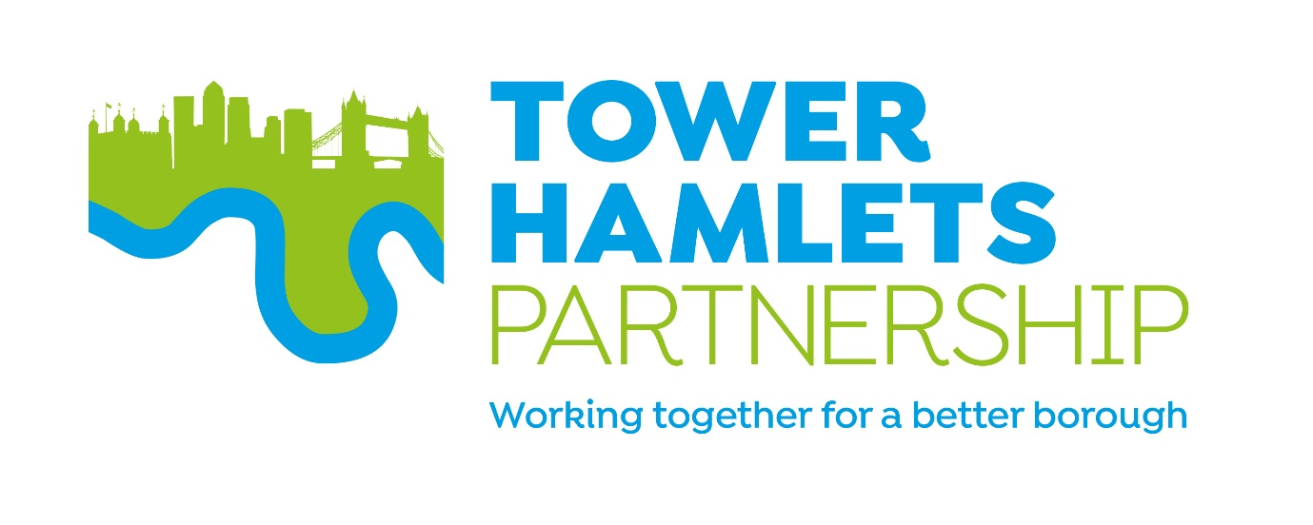

Tower Hamlets Partnership – Terms of Reference

Purpose
The Tower Hamlets Strategic Partnership is the borough's Local Strategic Partnership. It brings together key stakeholders to improve services and outcomes for local residents. It aims to provide residents with opportunities to shape, influence and inform the development of the borough’s main partnership plans. It seeks to improve the way services are designed and delivered as well as achieving key outcomes.

Partners want to work together to identify creative and innovative new ways of delivering effective and efficient services and providing strategic leadership on complex, cross-cutting issues.

Objective
In November 2023 the Partnership published the Tower Hamlets Partnership Plan ‘A Tower Hamlets for All’. The five-year plan sets a new shared vision: ‘Residents and partners working together to improve quality of life, advance equality, opportunity, and
empowered communities’.

‘A Tower Hamlets for All’ sets out five key cross-cutting calls to action (priorities) which focus on the issues that matter most to residents and where the partnership can achieve most by working together. It brings partners together to harness opportunities and promote the economic, social and environmental well-being of the borough.

Call to action 1: Tower Hamlets will be a fair, inclusive and an anti-racist borough.
Call to action 2: Everyone in Tower Hamlets should be able to enjoy good mental health and wellbeing.
Call to action 3: Everyone in Tower Hamlets should feel safe and live in good-quality homes and healthy, inviting neighbourhoods
Call to action 4: Everyone in Tower Hamlets should have access to good work and skills and an income that meets their needs
Call to action 5: A child-friendly borough where children and young people from all backgrounds thrive, achieve their best, have opportunities, and are listened to

How it works
The Partnership is not a service provider in its own right. It works through the activities of all the partners, co-ordinating and facilitating improvements and joining up work where needed.

Our approach is to tap into the resources and expertise of individuals and organisations within the local community to develop creative solutions and to be ready to grasp the many opportunities available in Tower Hamlets.

The Tower Hamlets Partnership comprises a number of partner-groups: the Partnership Board, the Partnership Executive Group, and a number of thematic partnership groups (shown diagrammatically below). Twice-yearly partnership congresses also involve a wider range of residents and partners in finding solutions for the biggest issues that face Tower Hamlets.

Governance
The PEG, on behalf of the Tower Hamlets Partnership, will publish an annual report each year outlining activities, and performance against the Tower Hamlets Partnership Plan.

The priorities in the partnership plan will be delivered by the borough’s thematic partnership boards. These thematic partnerships are the bodies primarily responsible for the progress against the priorities and delivering the partnership strategies within their portfolio area.

The thematic partnership boards will provide regular updates of the work of their boards to PEG (including reporting against agreed targets on the Partnership’s plan and within pre-determined timescales). They will provide an update at least annually to the
Partnership Plan Executive Group, drawing out any opportunities or challenges
which the wider partnership needs to come together to solve.

Where needed on an ad hoc basis, thematic boards may also bring items to PEG to be resolved.

All groups (PEG, and thematic boards) will provide their work programmes (including meeting dates) for the upcoming year, by 30 June – and publish these on the Council’s partnership webpage. All groups will also publish agendas and minutes for their meetings.

The Partnership Board
The Partnership Board has an oversight role for the borough’s strategic partnership arrangements, ensuring that partner-members maintain good relationships, information-sharing and decision-making that is co-ordinated and integrated across the system leadership.

Purpose
- To provide leadership for local public services and act as the forum for developing borough-wide strategies in response to national legislation and local needs
- To provide overall leadership, direction and steer to the Tower Hamlets Partnership Plan, key objective and areas of focus ensuring that a strategic approach is taken to focusing attention and resources on areas of concern
- To ensure sufficient resources are released or made available as required, ensuring efficient delivery of services across partners
- To formulate shared views on local issues of mutual interest and concern
- To co-ordinate communication across the Tower Hamlets Partnership and raise the visibility of the work of the partnership, highlighting progress and outcomes, in order to facilitate and deliver wider engagement

Principles of Membership
There are a number of principles that all Partners will adhere to as Members and in order to ensure momentum and continuous improvement in the delivery of the Tower Hamlets Plan.

The Council is only first amongst equals in having responsibility for the management and delivery of the Partnership. Participation and involvement in Partnership work is defined by a common and agreed set of principles:
- Partners will actively participate in tackling inequality, strengthening cohesion and building community leadership and personal responsibility
- The Partnership is open to all stakeholders who live, work, study and take part in leisure and cultural life in Tower Hamlets
- All partners have personal responsibility and a community leadership role in participating in Partnership arrangements and to leading on the delivery of Partnership work in their own organisations
- All partners are open to challenge and scrutiny

Membership
- The Council’s Cabinet:
- Executive Mayor (Chair)
- Statutory Deputy Mayor and Cabinet Member for Education and Lifelong Learning
- Cabinet Member for Resources and the Cost of Living
- Cabinet Member for Regeneration, Inclusive Development and Housebuilding
- Cabinet Member for Safer Communities
- Cabinet Member for the Environment and the Climate Emergency
- Cabinet Member for Health, Wellbeing and Social Care
- Cabinet Member for Jobs, Skills and Growth
- Cabinet Member for Equalities and Social Inclusion
- Cabinet Member Culture and Recreation

- The Council’s Corporate Leadership Team:
- Chief Executive
- Corporate Director, Resources and Deputy Chief Executive
- Corporate Director, Health and Adult Social Care
- Corporate Director, Children’s Service
- Corporate Director, Housing and Regeneration
- Corporate Director, Communities

- Senior representatives from:
- Barts Health NHS Trust
- Canary Wharf Group
- Department for Work and Pensions
- East London Business Alliance (ELBA)
- East London NHS Foundation Trust (ELFT)
- North East London Integrated Care Board (ICB)
- New City College
- Queen Mary University
- Full Headteacher Consultative Tower Hamlets Council
- London Fire Brigade
- Metropolitan Police
- Tower Hamlets Council for Voluntary Service (THCVS)
- Tower Hamlets Housing Forum
- Tower Hamlets Interfaith Forum
- East London Mosque and London Muslim Centre
- Council of Mosques Tower Hamlets

Meetings and activity
The Partnership Board typically meets once a year to reflect on partnership working across the borough, and review progress in delivering the Tower Hamlets Plan.

The Partnership Executive Group

Purpose
- To deliver on the priorities, objectives and cross-cutting principles of the Tower Hamlets Partnership Plan, through agreed delivery arrangements including how we will review progress against targets and ensure a partnership approach to developing local solutions
- To support a powerful public through pro-active citizen and service user engagement in the delivery of local services
- To share resources and expertise in joint commissioning and delivery arrangements
- To operate in a transparent and accountable way by seeking external and peer challenge to assess and improve performance
- To share knowledge and learning by collecting and sharing data improve service delivery

Membership
- The Council’s Cabinet:
- Executive Mayor (Chair)
- Statutory Deputy Mayor and Cabinet Member for Education and Lifelong Learning
- Cabinet Member for Resources and the Cost of Living
- Cabinet Member for Regeneration, Inclusive Development and Housebuilding

- The Council’s Leadership Team:
- Chief Executive
- Director, Strategy, Improvement and Transformation

- Senior representatives from:
- Barts Health NHS Trust
- Canary Wharf Group
- Department for Work and Pensions
- East London Business Alliance (ELBA)
- East London NHS Foundation Trust (ELFT)
- North East London Integrated Care Board (ICB)
- New City College
- Queen Mary University
- Full Headteacher Consultative Tower Hamlets Council
- London Fire Brigade
- Metropolitan Police
- Tower Hamlets Council for Voluntary Service (THCVS)
- Tower Hamlets Housing Forum
- Tower Hamlets Interfaith Forum
- East London Mosque and London Muslim Centre
- Council of Mosques Tower Hamlets

Meetings
The Chair is the Mayor of the London Borough of Tower Hamlets.

The frequency of meetings is dependent upon need, however this will range from monthly to bi-monthly and as agreed by the Chair.

If PEG members are unable to attend meetings, they may send a proxy with appropriate experience, knowledge and delegated authority to contribute towards discussion, in their stead.

Other individuals may be asked to attend meetings to present agenda item as required by the PEG.

Roles and responsibilities of members
Members are expected to have decision making capacity on behalf of their organisation

Reporting and action notes
Formal agendas and action notes will be issued by LBTH officers, acting as secretariat for the Partnership. It is the responsibility of member organisation’s representatives at the meeting to ensure that they use these to report back to their organisation, to maintain information flows.

Meeting agendas will be agreed by the Chair. Members will be invited to submit items for the agenda and any item which is so submitted will be guaranteed to be placed on the agenda, unless an agreement is reached with the proposer that the item is no longer required.

