|  |
| --- |
| **Age - Unborn to 2**  Please help me share my voice. It is okay if you can’t answer every question. |

|  |  |  |  |  |  |
| --- | --- | --- | --- | --- | --- |
| Is my home clean and free from clutter? | Yes | No | Are there easily accessible toys available, with no obvious choking hazards? | Yes | No |
| Do I have my own safe sleeping area free from clutter? * | Yes | No | Do I feel love and affection? | Yes | No |
| Are there age-appropriate safety measures for me? | Yes | No |  |  |  |
| Am I safe from pets? | Yes | No | Do I have lots of accidents? | Yes | No |
| Do I look physically healthy? i.e. weight, skin condition | Yes | No | Am I exposed to domestic abuse? | Yes | No |
| Are my clothes clean, dry, well-fitting and suit the weather? | Yes | No | Am I around people who abuse substances? | Yes | No |
| Am I taken to my medical appointments? | Yes | No | Is anyone concerned about me being neglected? | Yes | No |
| Is medical advice for my care followed? | Yes | No | Are there any adults in my life who may be unsafe? | Yes | No |

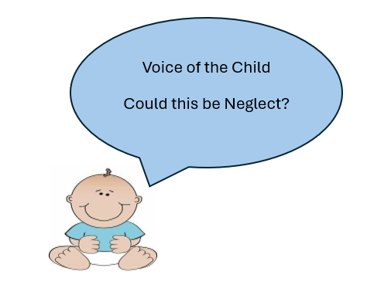

|  |
| --- |
| **If there are any red answers you must consider how you or your service can help the parents/carer to meet this need. You should also consider whether a referral or signposting to another service would be helpful, including Children’s Centres, Early Help or Children’s Social Care.** |

|  |
| --- |
| *\*A safe sleeping area is their own cot/crib/Moses basket. No bed sharing. No objects in or around the sleeping area, i.e. teddy bears, cot bumpers, drapes, washing etc. and the baby should be sleeping with their feet at the bottom of the cot. The environment should be smoke free.* |

|  |
| --- |
| Name of child/ren:  Date of Birth or estimated due date:  Name of practitioner:  Date the tool was completed: |

|  |
| --- |
| **Age – 3 - 11**  Please help me share my voice. It is okay if you can’t answer every question. |

|  |  |  |  |  |  |
| --- | --- | --- | --- | --- | --- |
| Is my home clean and free from clutter? | Yes | No | Am I taken to my medical appointments? | Yes | No |
| Do I have my own sleeping area free from clutter? | Yes | No | Is medical advice for my care followed? | Yes | No |
| Am I given appropriate boundaries/discipline? | Yes | No | Would I feel loved and cared for? | Yes | No |
| Do I attend education regularly with everything I need? | Yes | No |  |  |  |
| Do I look physically healthy? i.e. weight, skin condition | Yes | No | Do I have caring responsibilities? | Yes | No |
| Are my clothes clean, dry, well-fitting and suit the weather? | Yes | No | Am I exposed to domestic abuse? | Yes | No |
| Am I happy to talk about life at home and my carers? | Yes | No | Am I around people who abuse substances? | Yes | No |
| Do I have adequate supervision? | Yes | No | Is anyone concerned about me being neglected? | Yes | No |
| Do I have a range of toys and books to play with? | Yes | No | Are there any adults in my life who may be unsafe? | Yes | No |

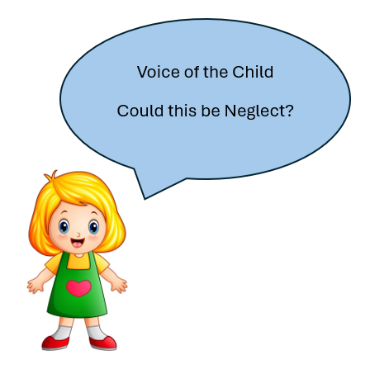

|  |
| --- |
| **If there are any red answers you must consider how you or your service can help the parents/carer to meet this need. You should also consider whether a referral or signposting to another service would be helpful, including Children’s Centres, Early Help or Children’s Social Care.** |

|  |
| --- |
| Name of child/ren:  Date of Birth:  Name of practitioner:  Date the tool was completed: |

|  |
| --- |
| **Age – 12 - 18**  Please help me share my voice. I may be able to answer some questions myself if you talk to me. I am still a child until I am 18 and neglect may be harder to see. |

|  |  |  |  |  |  |
| --- | --- | --- | --- | --- | --- |
| Is my home clean and safe for me? | Yes | No | Am I supported to attend all my medical appointments? | Yes | No |
| Do I have my own sleeping area free from clutter? | Yes | No | Do I or my carers follow medical advice for me? | Yes | No |
| Am I given appropriate boundaries/discipline? | Yes | No | Do my carers know where I am when I’m out? | Yes | No |
| Do I attend education regularly with everything I need? | Yes | No | Am I spending lots of time sleeping at other people’s homes? | Yes | No |
| Do I look physically healthy? i.e. weight, skin condition | Yes | No | Do I have caring responsibilities? | Yes | No |
| Are my clothes clean, dry, well-fitting and suit the weather? | Yes | No | Am I exposed to domestic abuse? | Yes | No |
| Am I happy to talk about life at home and my carers? | Yes | No | Am I around people who abuse substances? | Yes | No |
| Do I feel loved and cared for? | Yes | No | Is anyone concerned about me being neglected? | Yes | No |
| Do I have access to a range of social activities? | Yes | No | Are there any adults in my life who may be unsafe? | Yes | No |

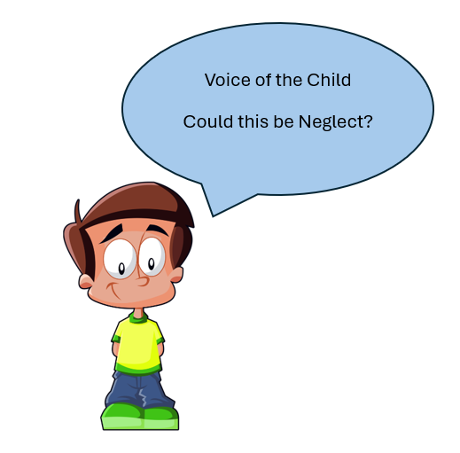

|  |
| --- |
| **If there are any red answers you must consider how you or your service can help the parents/carer to meet this need. You should also consider whether a referral or signposting to another service would be helpful, including Children’s Centres, Early Help or Children’s Social Care.** |

|  |
| --- |
| Name of child/ren:  Date of Birth:  Name of practitioner:  Date the tool was completed: |

|  |
| --- |
| **Actions Taken**  If there were any reds, what actions have you taken? |

