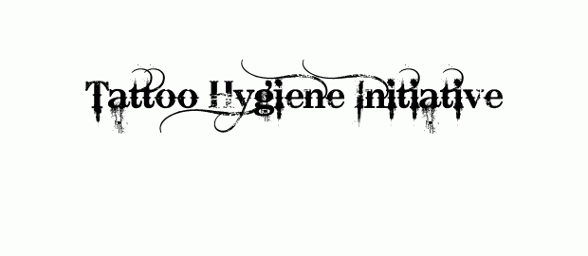

- Name of person offering tattoos:

- Address:

- Telephone numbers:
- Facebook Name:
- Website Address:
- How have you become aware of them?

- If a person has received a tattoo, please give details, if known:

-Date:
-Time:
-Location:
-Part of premise used:
-How much was paid?:

- Are any photographs available?
- Is the person that received the tattoo willing to provide contact details? (Note this information is confidential)
- Would the person that received the tattoo be willing to provide a witness statement?
- Name of person completing this form:

This form should be sent to Mr David Tolley, London Borough of Tower Hamlets, Town Hall, Environmental Health and Trading Standards, 6th Floor Mulberry Place, London, E14 2BG
THANK YOU FOR YOUR CO-OPERATION

